Author: Md Rakeen Murtaza

To run the solution as an example client: Run Java Spring project and visit http://localhost:8080/

Explanation:

For my Vehicle Entity Solution, I started by creating a MySQL Database instance hosted on AWS cloud.

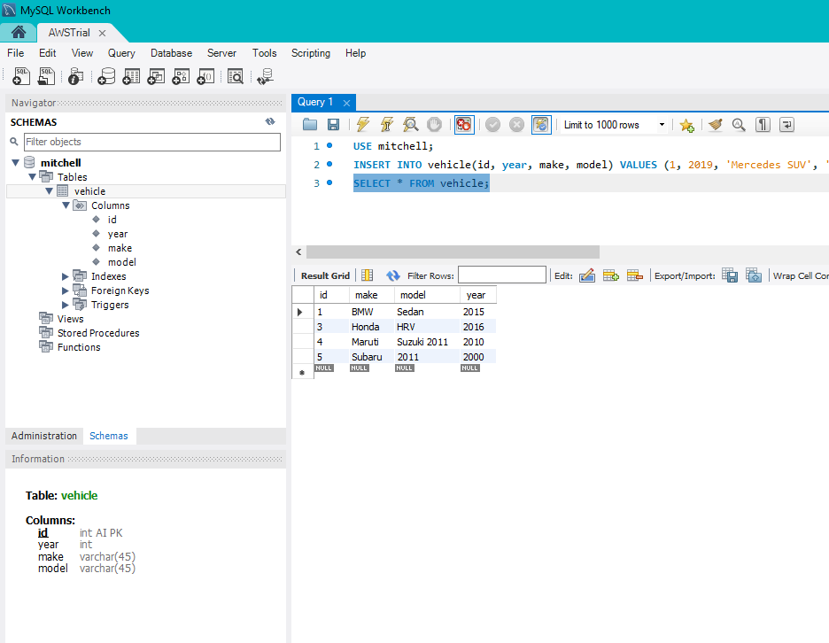

Then, I used a Java Spring Boot application to write the methods that can manipulate this database (CRUD). I also used in-memory persistence for faster communication with my MySQL database. I wrote my Junit tests for Creating Vehicle entries and testing the search feature.

I used Thymeleaf template for the front-end, so my web application solution looks like this:

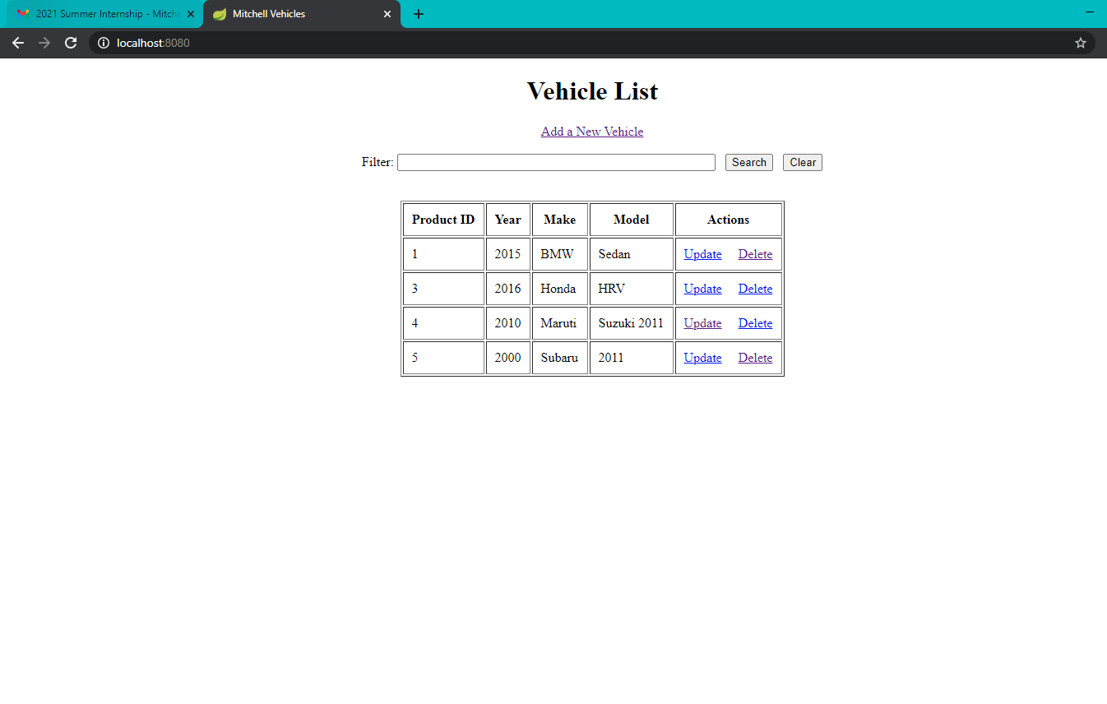

As you can see the table is loaded with data. I can search for Vehicles by make:

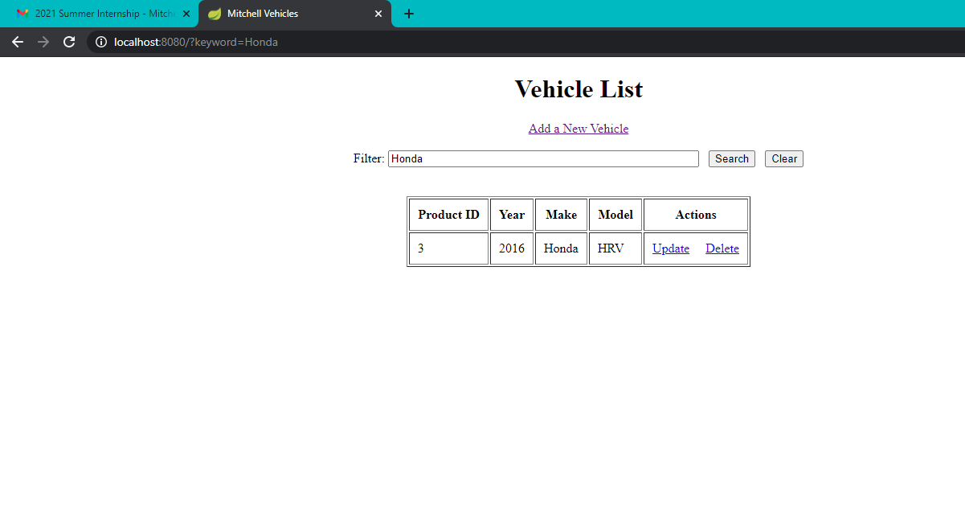

And clearing the search gets me back to the homepage:

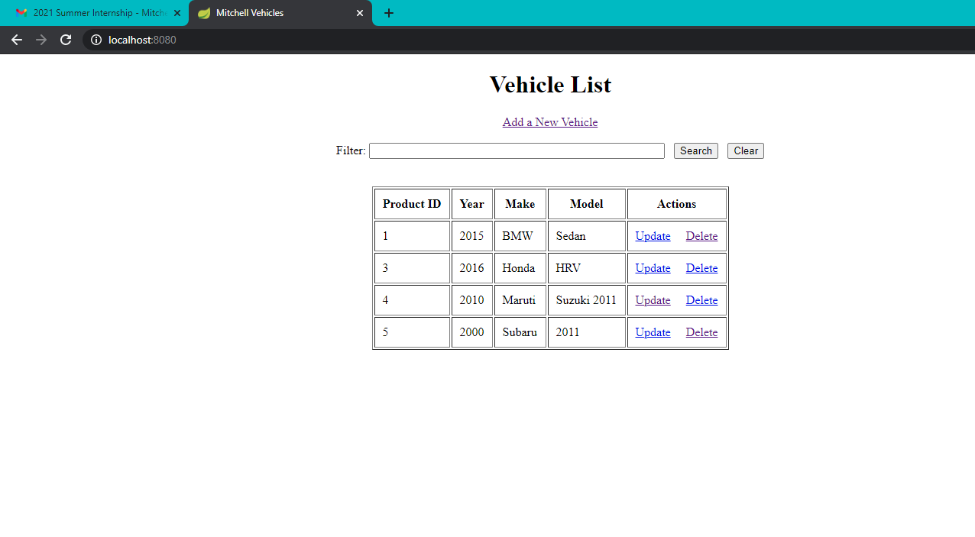

I can Add a New Vehicle (Create)

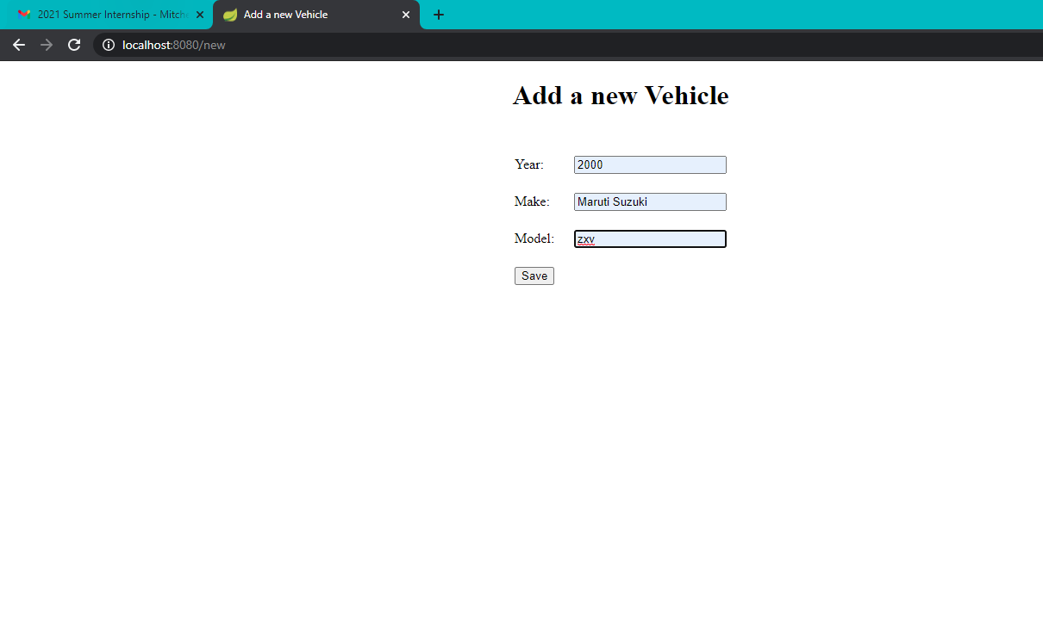

And it has been added:

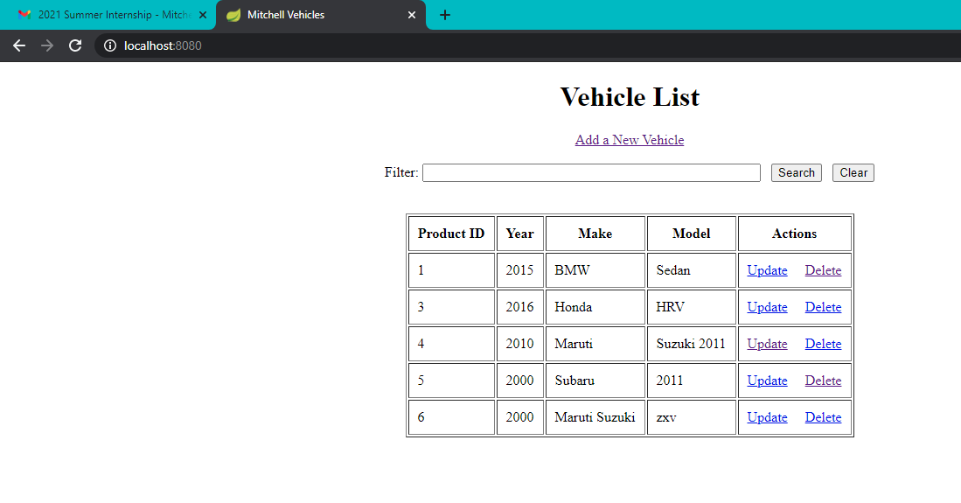

I can update a vehicle (I ensured product ID is free from being manipulated since it must be unique and auto-incremented):

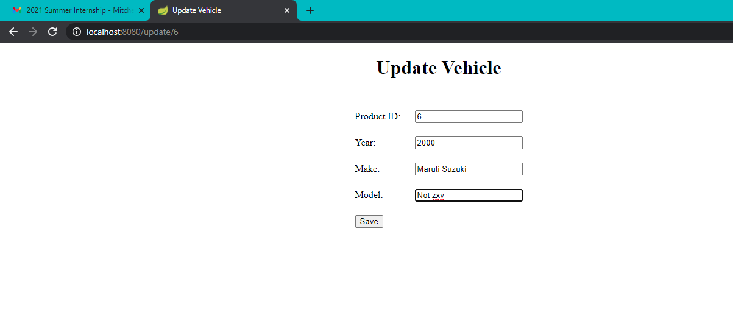

And I can also delete the entities:

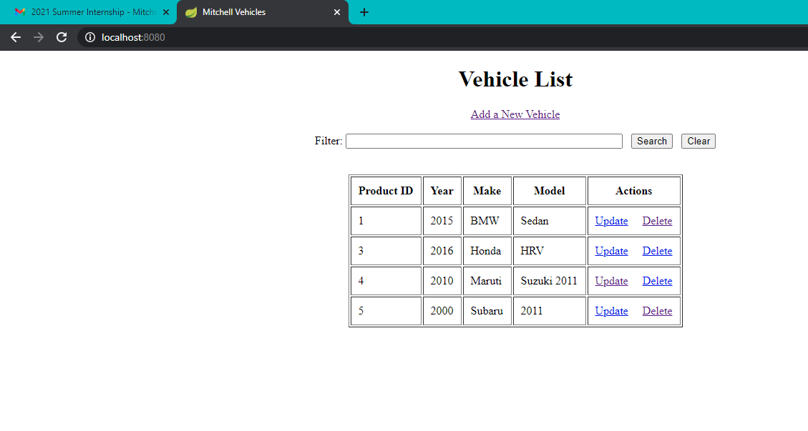

Finally, I ensured the year is between 1950 and 2050, and none of the fields accept null values.