Assignment IV

Exercise 1

Part 1 - Quantile Types
I read Wicklin's 2017 article on the nine sample quantile definitions from Hyndman and Fan. Three of the types round to an actual data point, and the other six use interpolation to blend between two nearby points instead. Both groups come from the same general formula, just applied a bit differently. Rounding types are simpler but less smooth. Interpolation types give a smoother quantile function, since they can land anywhere between two points.

SAS uses type 2 by default, and R uses type 7. The types mostly agree once a sample has around 100 or more points. They disagree more when the sample is small, or when there are large gaps between values. Wicklin's main point was that the choice of type rarely matters for larger samples, but it should still be reported for smaller ones.

For this assignment I used type 7, since it interpolates and gives a smooth quantile function. This fits a continuous distribution like the exponential well. It is also the default in both R and Python, so np.quantile(x, [0.25, 0.75]) already returns type 7 without setting anything extra. R's quantile() defaults to type 7, numpy's quantile() uses method='linear', which is the same as type 7, and pandas uses the same default too.

The nine Hyndman–Fan quantile types on one small sample
Type | Method | Q1 | Q3
1 | inverted_cdf | 1.000 | 4.000
2 | averaged_inverted_cdf | 1.000 | 4.000
3 | closest_observation | 1.000 | 4.000
4 | interpolated_inverted_cdf | 1.000 | 3.000
5 | hazen | 1.000 | 4.000
6 | weibull | 1.000 | 4.250
7 | linear | 1.000 | 3.500
8 | median_unbiased | 1.000 | 4.083
9 | normal_unbiased | 1.000 | 4.062

Part 2 - Bootstrap Bias Corrected Estimator
The two estimators used in this assignment are:
λ_{ML}(X) = 1 / mean(X)
λ_{IQR}(X) = ln(3) / (Q_{0.75}(X) − Q_{0.25}(X))

The bias of an estimator is the average value of the estimator minus the true parameter. Since the true value is unknown, bootstrap bias correction uses the sample itself as a stand-in for the population. The method resamples the data with replacement B times, each resample the same size as the original sample. The IQR estimator is computed on every resample. The average of these bootstrap estimates, minus the original estimate, gives the estimated bias. Subtracting that bias estimate from the original gives the corrected estimator:

λ_{BC}(X) = 2·λ_{IQR}(X) − average of the B bootstrap estimates of λ_{IQR}
B was set to 200 for every sample, as the assignment specifies.

One issue came up at n=5. Bootstrap resamples of only five points often repeat the same value, since resampling is done with replacement. This can make the third and first quartile come out equal, which makes the IQR estimator undefined. Any bootstrap estimate that was not finite was dropped before averaging. This is a standard practical fix for this problem.

Part 3 - Monte Carlo Comparison
For every combination of lambda and n, M samples of size n were generated. All three estimators were computed for each sample, and the mean squared error was calculated across the M samples.

M was set to 2000 for every combination. The standard error of each MSE estimate was also computed, to check how precise it was. For the maximum likelihood and IQR estimators, this error stayed under about ten percent of the MSE itself, which was precise enough to compare the three estimators. Since 2000 replications run the whole grid in only a few seconds, there was no real reason to use fewer.

The exception was the corrected estimator at n=5. Its results were very spread out. Raising M to 10,000 made the MSE estimate larger and less stable, rather than more precise. This means more replications do not fix the problem, since the estimator itself has an extremely heavy tail at this sample size. The result is still reported below, but it should be treated as unreliable.

Estimated MSE for each estimator
λ | n | MSE ML | MSE IQR | MSE BC
0.1 | 5 | 0.0069 | 0.197 | 1738
0.1 | 30 | 0.00039 | 0.00127 | 0.00137
0.1 | 100 | 0.00010 | 0.00025 | 0.00029
1 | 5 | 0.599 | 15.88 | 2,458,700
1 | 30 | 0.0413 | 0.136 | 0.144
1 | 100 | 0.0113 | 0.0257 | 0.0297
10 | 5 | 56.3 | 2656 | 344,700
10 | 30 | 4.16 | 11.8 | 12.8
10 | 100 | 1.06 | 2.49 | 2.83

The maximum likelihood estimator had the lowest MSE in every case. This fits, since it uses every observation and is the most efficient estimator when the model is correct. The IQR estimator was clearly worse across the board, and this gap did not close much as n increased, since it only uses two order statistics rather than the whole sample.

The bootstrap correction did not help at n=30 or n=100. Its MSE was slightly higher than the plain IQR estimator in both cases, most likely because the extra resampling adds variance that outweighs the small amount of bias it removes. At n=5, all three estimators performed much worse, and the corrected estimator became especially unstable, for the reasons discussed above. This suggests bootstrap correction is a poor choice for very small samples. Across all three estimators, MSE scaled roughly with lambda squared, which is expected since these are all scale estimators of a scale parameter.

Exercise 2
The ausbeer dataset comes from the fpp2 R package, sourced from the Australian Bureau of Statistics. It records total quarterly beer production in Australia, in megalitres, from 1956 Quarter 1 to 2010 Quarter 2, giving 218 observations. The data used here was loaded from a CSV copy of the same package data, so it matches the R version.

Part 1 - Frequency
The data is quarterly, with four observations per year. This is stated in the dataset's documentation. It can also be seen in the data itself, since the time variable increases in steps of 0.25 of a year. The time series plot below repeats the same seasonal shape four times every year.
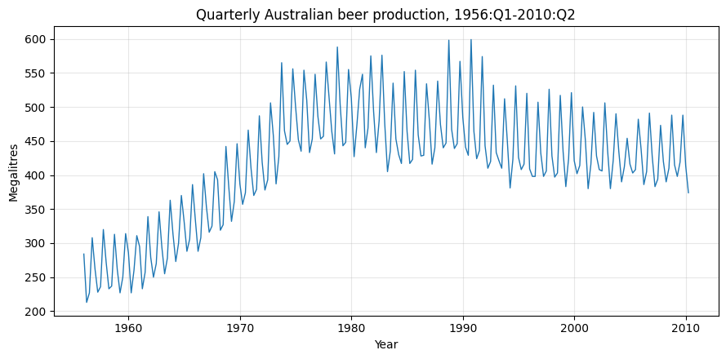

Part 2 - Overall Behaviour
There is a long-term trend, but it is not a straight line. Production rises from around 260 megalitres per quarter in the late 1950s to a peak of about 480 near 1980. It then falls slowly through the 1990s and 2000s, reaching about 390 to 420 megalitres per quarter by 2010. This means the trend looks more like a hump than a steady increase or decrease.
Decade | Mean (ML)
1950 | 262
1960 | 321
1970 | 462
1980 | 478
1990 | 449
2000 | 429
2010 | 394

Part 3 - Seasonality
There is a strong and consistent yearly pattern. The fourth quarter is always the highest, and the second quarter is always the lowest, with the first and third quarters in between. This likely relates to summer and Christmas falling in the fourth quarter in Australia. The pattern repeats in nearly every year, not just on average.
Quarter | Mean | Std dev
Q1 | 417 | 73
Q2 | 373 | 71
Q3 | 387 | 69
Q4 | 485 | 84

Part 4 - Variability
The variability is not perfectly constant over time. The seasonal swing, the difference between the highest and lowest quarter, grows from about 89 megalitres in the 1950s to about 128 in the 1970s and 1980s. This roughly follows the rise in production level, then shrinks again as production falls after 1990. Expressed relative to the production level, the swing stays fairly steady, between about 0.2 and 0.35. This suggests the variance moves a little with the level, but the effect is mild rather than dramatic. A log transform could help smooth this out, although it is not strictly necessary.

Decade | Level | Seasonal range | Range over level
1950 | 262 | 88.5 | 0.338
1960 | 321 | 102.9 | 0.320
1970 | 462 | 120.9 | 0.262
1980 | 478 | 128.0 | 0.268
1990 | 449 | 127.8 | 0.284
2000 | 429 | 94.4 | 0.220

Part 5 - Unusual Observations
A simple additive decomposition was used to separate trend, seasonality, and the remaining residuals. The largest residuals came from three strong fourth quarters in a row, in 1988, 1990 and 1991. The 1990 fourth-quarter value of 599 megalitres is the highest in the entire series, sitting about 49 megalitres above what the trend and seasonal pattern would predict. There is also an early spike in the first quarter of 1981. A few quarters, including the third quarter of 1978 and the fourth quarter of 1980, were unusually low, although the high outliers were more extreme.

Date | Value | Residual
1981 Q1 | 548 | +49.6
1990 Q4 | 599 | +49.0
1988 Q4 | 598 | +41.2
1978 Q3 | 431 | −38.5
1980 Q4 | 526 | −38.0
1991 Q4 | 574 | +37.6

Part 6 - Seasonal Plot
Plotting every year's four quarters on the same axis makes the seasonal shape easier to see than in the raw time series. Most years follow the same pattern: a rise in quarter one, a dip in quarter two, a partial recovery in quarter three, and a sharp rise in quarter four. The whole set of lines moves upward through the 1960s to 1980s and then drifts back down. The unusual years from the previous question also stand out more clearly here, sitting above the rest of the lines at quarter four.
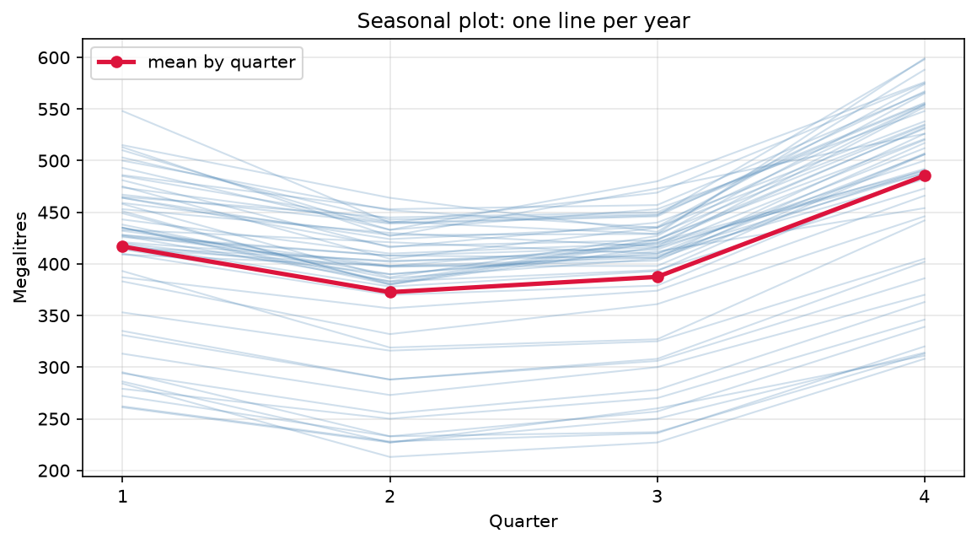

Part 7 - Seasonal Subseries Plot
This plot confirms that quarter four has the highest typical value and quarter two the lowest, matching the earlier table. This ranking barely changes across the 55 years of data. Each panel also shows the same hump-shaped trend as the whole series, just shifted up or down depending on the quarter. This suggests the trend and the seasonal pattern act fairly independently of each other.
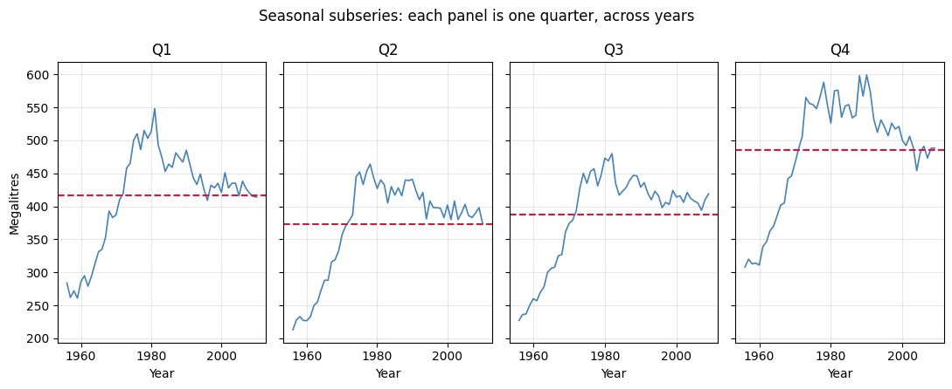

Part 8 - Detrend or transform?
Detrending is clearly needed. The trend changes direction partway through the series, so a model with a fixed linear trend, or no trend at all, would fit badly. Seasonal differencing, or a non-linear trend term, looks necessary here. A transform such as a log is only mildly justified. The seasonal swing grows somewhat with the level in the earlier decades, which is usually a sign to use a log or Box-Cox transform. However, the relative swing does not increase dramatically over the whole 55 years, so the case is not especially strong. A mild transform could still help smooth the residual variance, but it is not essential. No model was fit here, since the instructions ask only for a visual argument.

