1B ANOVA

Introduction
If you want to determine whether there are any statistically significant differences between the means of two or more independent groups, you can use a one-way analysis of variance (ANOVA).

Assumptions
Assumption #1: You have one dependent variable that is measured at the continuous level.
Assumption #2: You have one independent variable that consists of three or more categorical, independent groups.
Assumption #3: You should have independence of observations, which means that there is no relationship between the observations in each group of the independent variable or among the groups themselves.
Assumption #4: There should be no significant outliers in the three or more groups of your independent variable in terms of the dependent variable.
Assumption #5: Your dependent variable should be approximately normally distributed for each group of the independent variable.
Assumption #6. You have homogeneity of variances (i.e., the variance of the dependent variable is equal in each group of your independent variable).

Null and Alternative Hypotheses
The null hypothesis for a one-way analysis of variance is:
H₀: Assumes all treatment groups (ctrl, trt1, trt2) have the same mean weight (μctrl = μtrt1 = μtrt2)
where μ = mean plant weight (in the population)
H_{A}: At least one group mean is different (i.e., they are not all equal)
Dataset and Problem
A researcher is interested in determining whether different treatment settings effect plant development. To test this, plant weight was assessed in three groups: control (ctrl), treatment 1 (trt1), and treatment 2 (trt2). These groupings comprise the independent variable known as group. The dependent variable is weight, which measures the weight of plants in each treatment condition. Higher numbers indicate increased plant growth. The researcher would like to determine if plant weight varies by treatment group. Is there a substantial difference in mean weight between the different groups?

Checking of Assumptions
Assumption #1: You have one dependent variable that is measured at the continuous level.
Remark. The dependent variable is weight, which is measured at a continuous level.
Assumption #2: You have one independent variable that consists of three or more categorical, independent groups.
Remark. The independent variable is group, which consists of three categories: ctrl, trt1, and trt2.
Assumption #3: You should have independence of observations.
Remark. Each observation is independent, as there is no relationship between observations within or between groups.
Assumption #4: There should be no significant outliers in the three or more groups of your independent variable in terms of the dependent variable.

Raincloud plots
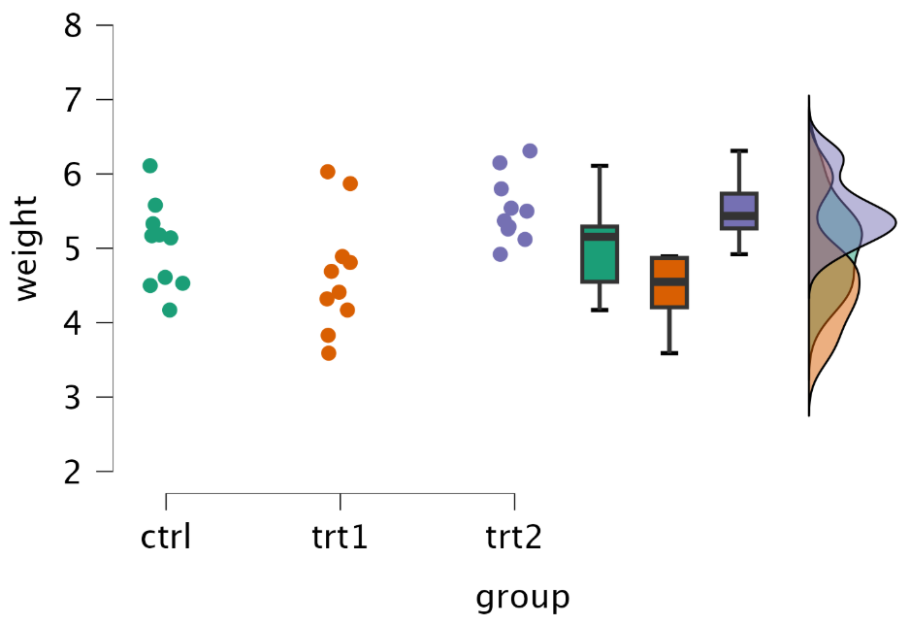
Remark. There were no extreme outliers, as assessed by visual inspection of boxplots.

Assumption #5: Your dependent variable should be approximately normally distributed for each group of the independent variable.
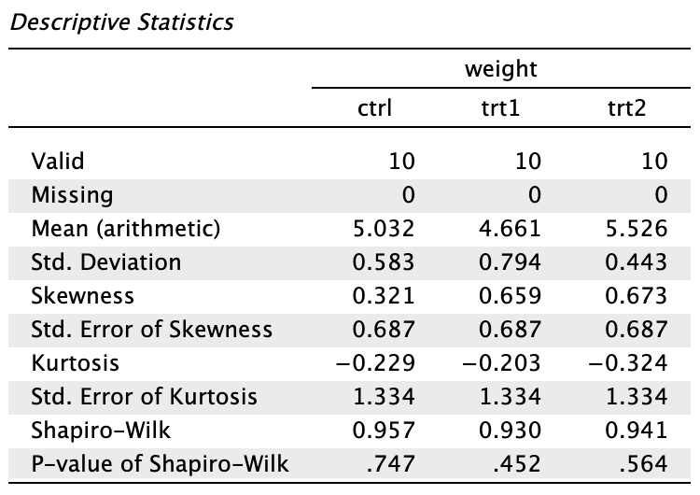
Remark. The weight variable is approximately normally distributed for each group, as assessed by Shapiro–Wilk’s test (p > .05).

Assumption #6: You have homogeneity of variances (i.e., the variance of the dependent variable is equal in each group of your independent variable).
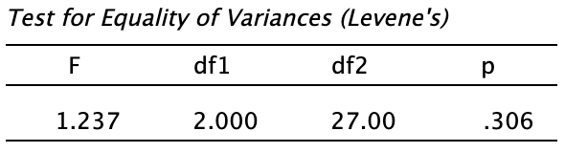
Remark. There was homogeneity of variances, as assessed by Levene’s test (p = 0.306).

Computation
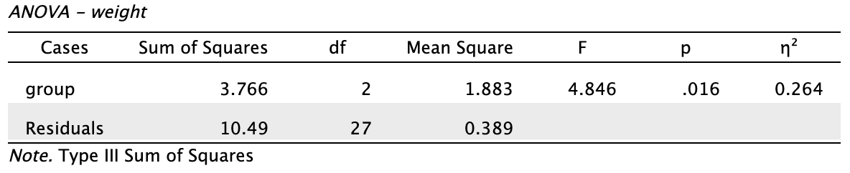
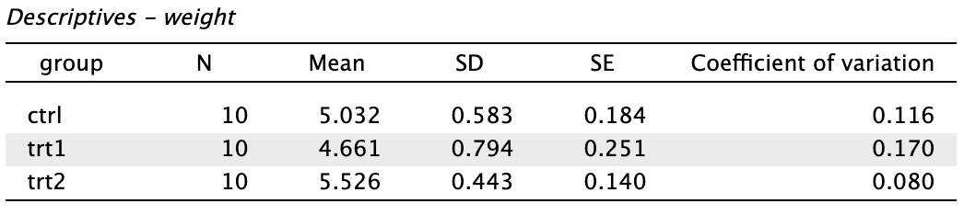
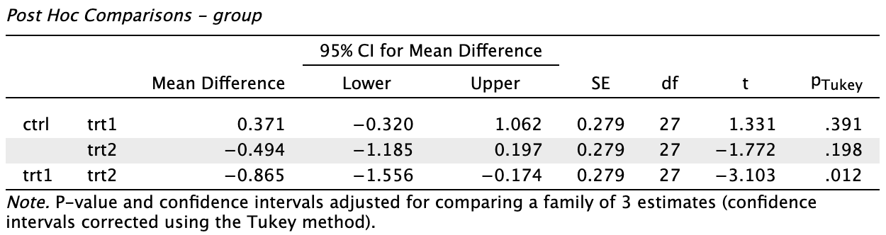

Reporting
A one-way ANOVA was used to see if plant weight differed between treatment groups (control, trt1, trt2). Visual assessment of boxplots revealed no extreme outliers; data for each group were fairly normally distributed, as examined by the Shapiro-Wilk test (p >.05); and variances were homogeneous, as assessed by Levene's test (p = 0.306). Plant weight differed substantially between groups, F(2, 27) = 4.85, p = 0.016, η² = 0.26. The plant weight was highest in the trt2 group (M = 5.53, SD = 0.44), followed by the control group (M = 5.03, SD = 0.58), and lowest in the trt1 group (M = 4.66, SD = 0.79). Tukey post hoc analysis showed a significant difference (p < 0.05) between trt2 and trt1, but no other group differences were found to be statistically significant.

