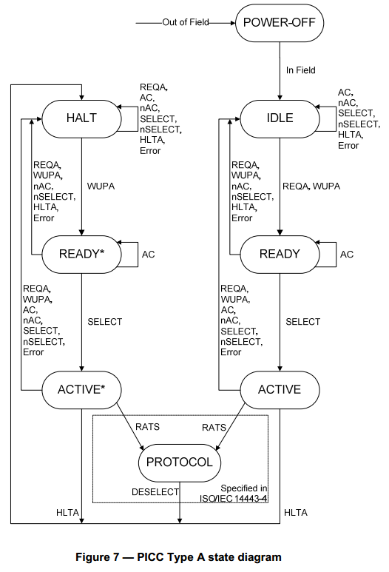

|  |  |
| --- | --- |
| **AC** | ANTICOLLISION command (matched UID) |
| **nAC** | ANTICOLLISION command (not matched UID) |
| **SELECT** | SELECT command (matched UID) |
| **nSELECT** | SELECT command (not matched UID) |
| **RATS** | RATS command, defined in ISO/IEC 14443-4 |
| **DESELECT** | DESELECT command, defined in ISO/IEC 14443-4 |
| **Error** | transmission error detected or unexpected frame |

**Select Sequence:** The purpose is to get the UID from one PICC and to select this PICC for further communication.

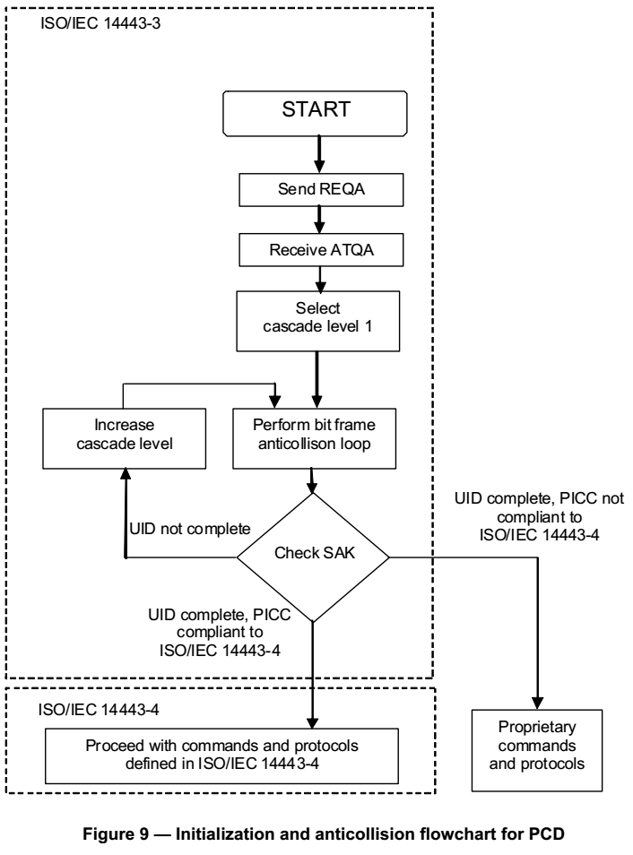

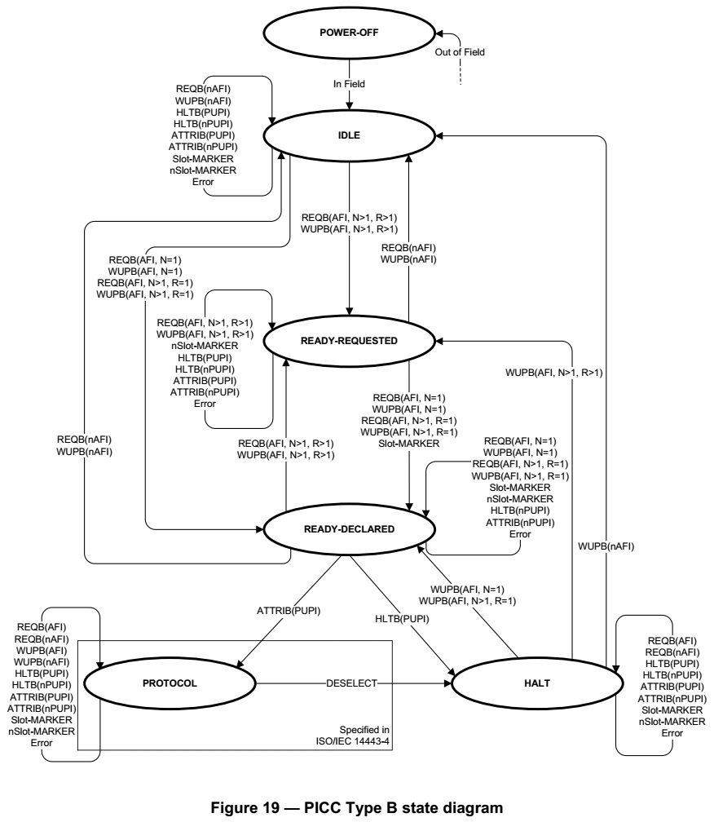

|  |  |
| --- | --- |
| REQB(AFI/nAFI, N, R)/WUPB(AFI/nAFI, N, R) | REQB/WUPB commands with matched/unmatched AFI. |
| AFI | matched AFI |
| nAFI | unmatched AFI |
| Slot-MARKER | Slot-MARKER command with matched slot number. |
| nSlot-MARKER | Slot-MARKER command with unmatched slot number. |
| HLTB(PUPI) | HLTB command with matched PUPI. |
| HLTB(nPUPI) | HLTB command with unmatched PUPI. |
| ATTRIB(PUPI) | ATTRIB command with matched PUPI. |
| ATTRIB(nPUPI) | ATTRIB command with unmatched PUPI. |
| Error | transmission error detected or unexpected frame |

