Architecture of the Kernel-Mode Driver Framework
September 12, 2006
Abstract
This paper provides information about the kernel-mode driver framework (KMDF), which is part of the Windows Driver Foundation (WDF) for the Microsoft® Windows® family of operating systems. WDF is a new model for driver development. KMDF supports the development of kernel-mode drivers that conform to this model. The paper describes the architecture of KMDF and the types of drivers that can be developed with it.
This information applies for the following operating systems:
Microsoft Windows Vista™
Microsoft Windows Server® 2003
Microsoft Windows XP
Microsoft Windows 2000
The current version of this paper is maintained on the Web at:
http://www.microsoft.com/whdc/driver/wdf/KMDF-arch.mspx
References and resources discussed here are listed at the end of this paper.

Contents
Introduction 4
Devices that KMDF Supports 4
KMDF Components 5
Structure of a KMDF Driver 5
Comparison of KMDF and WDM Drivers 6
Device Objects and Driver Roles 7
Filter Drivers and Filter Device Objects 8
Function Drivers and Functional Device Objects 8
Bus Drivers and Physical Device Objects 9
Legacy Device Drivers and Control Device Objects 10
KMDF Object Model 10
Methods, Properties, and Events 10
Object Hierarchy 11
Object Attributes 14
Object Context 14
Object Creation and Deletion 15
KMDF I/O Model 16
I/O Request Handler 17
Create, Cleanup, and Close Requests 17
Read, Write, Device I/O Control, and Internal Device I/O Control Requests 18
I/O Queues 19
Queues and Power Management 20
Dispatch Type 21
I/O Request Objects 21
Retrieving Buffers from I/O Requests 22
Sending I/O Requests 22
I/O Targets 23
Creating Buffers for I/O Requests 24
Canceled and Suspended Requests 24
Request Cancellation 24
Request Suspension 25
Completing I/O Requests 26
Self-Managed I/O 26
Accessing IRPs and WDM Structures 26
Plug and Play and Power Management Request Handler 27
Device Enumeration and Startup 28
Startup Sequence for a Function or Filter Device Object 28
Startup Sequence for a Physical Device Object 30
Device Power Down and Removal 31
Power-Down and Removal Sequence for a Function or Filter Device Object 31
Power-Down and Removal Sequence for a Physical Device Object 33
Surprise Removal Sequence 34
WMI Request Handler 36
Synchronization Issues 37
Synchronization Scope 38
Execution Level 39
Locks 40
Interaction of Synchronization Mechanisms 41
Security 41
Safe Defaults 41
Parameter Validation 42
Counted UNICODE Strings 42
Device Naming Techniques 42
Build and Debug Environment 42
Installation 43
Versioning and Dynamic Binding 43
Resources 44

Disclaimer
This is a preliminary document and may be changed substantially prior to final commercial release of the software described herein.

The information contained in this document represents the current view of Microsoft Corporation on the issues discussed as of the date of publication. Because Microsoft must respond to changing market conditions, it should not be interpreted to be a commitment on the part of Microsoft, and Microsoft cannot guarantee the accuracy of any information presented after the date of publication.

This White Paper is for informational purposes only. MICROSOFT MAKES NO WARRANTIES, EXPRESS, IMPLIED OR STATUTORY, AS TO THE INFORMATION IN THIS DOCUMENT.

Complying with all applicable copyright laws is the responsibility of the user. Without limiting the rights under copyright, no part of this document may be reproduced, stored in or introduced into a retrieval system, or transmitted in any form or by any means (electronic, mechanical, photocopying, recording, or otherwise), or for any purpose, without the express written permission of Microsoft Corporation.

Microsoft may have patents, patent applications, trademarks, copyrights, or other intellectual property rights covering subject matter in this document. Except as expressly provided in any written license agreement from Microsoft, the furnishing of this document does not give you any license to these patents, trademarks, copyrights, or other intellectual property.

Unless otherwise noted, the example companies, organizations, products, domain names, e-mail addresses, logos, people, places and events depicted herein are fictitious, and no association with any real company, organization, product, domain name, email address, logo, person, place or event is intended or should be inferred.

© 2006 Microsoft Corporation. All rights reserved.

Microsoft, Windows, Windows Server, and Windows Vista are either registered trademarks or trademarks of Microsoft Corporation in the United States and/or other countries.

The names of actual companies and products mentioned herein may be the trademarks of their respective owners.

Introduction
The kernel-mode driver framework (KMDF) is an infrastructure for developing kernel-mode drivers. It provides a C-language device driver interface (DDI) and can be used to create drivers for Microsoft® Windows® 2000 and later releases. In essence, the framework is a skeletal device driver that can be customized for specific devices. KMDF implements code to handle common driver requirements. Drivers customize the framework by setting object properties, registering callbacks to be notified of important events, and including code only for features that are unique to their device.
KMDF provides a well-defined object model and controls the lifetime of objects and memory allocations. Objects are organized hierarchically in a parent/child model, and important driver data structures are maintained by KMDF instead of by the driver.
This paper provides an introduction to the architecture and features of KMDF and to the requirements for drivers that use KMDF (sometimes called KMDF-based drivers or simply KMDF drivers). It assumes basic familiarity with the Windows operating system and I/O model.
The Windows Driver Foundation (WDF) also includes a user-mode driver framework (UMDF). If your device does not handle interrupts, perform direct memory access (DMA), or require other kernel-mode resources such as nonpaged pool memory, you should consider writing a user-mode driver instead. For details, see "Introduction to the WDF User-Mode Driver Framework," listed in the Resources.

Devices that KMDF Supports
KMDF was designed to replace the Windows Driver Model (WDM). The initial KMDF release supports most of the same devices and device classes as WDM, except for those that are currently supported by miniport models. Table 1 lists the device and driver types that KMDF supports.
Table 1. Device and Driver Types that KMDF Supports
Device or driver type | Existing driver model | Comments
Control and non-Plug and Play drivers | Legacy | Supported
IEEE 1394 client drivers | Depends on device class | Supported for devices that do not conform to existing device class specifications
ISA, PCI, PCMCIA, and secure digital (SD) devices | WDM driver | Supported, if device class or port drivers do not provide the driver dispatch functions
NDIS protocol drivers | WDM upper edge and NDIS lower edge | Supported
NDIS WDM drivers | NDIS upper edge and WDM lower edge | Supported
SoftModem drivers | WDM driver with upper-edge support for TAPI interface | Supported
Storage class drivers and filter drivers | WDM driver | Supported
Transport driver interface (TDI) client drivers | Generic WDM driver | Supported
USB client drivers | Depends on device class | Supported
Winsock client drivers | WDM driver with a callback interface for device-specific requests | Supported

In general, KMDF supports drivers that conform to WDM, supply entry points for the major I/O dispatch routines, and handle I/O request packets (IRPs). For some device types, device class and port drivers supply driver dispatch functions and call back to a miniport driver to handle specific I/O details. Such miniport drivers are essentially callback libraries and are not currently supported by KMDF. In addition, KMDF does not support device types that use the Windows imaging architecture (WIA).

KMDF Components
KMDF is distributed as part of the Windows Driver Kit (WDK) and consists of header files, libraries, sample drivers, development tools, public debugging symbols, and tracing format files. By default, KMDF is installed in the WDF subdirectory of the WDK root installation directory. KMDF-based drivers are built in the WDK build environment. Table 2 lists the KMDF components that are installed as part of WDF.
Table 2. KMDF Components
Component | Location | Description
Header files | wdf/inc | Header files required to build KMDF drivers
Libraries | wdf/lib | Libraries for x86, x64, and Intel Itanium architectures
Sample drivers | wdf/src | Sample drivers for numerous device types; most are ported from Windows Driver Development Kit (DDK) WDM samples
Tools | wdf/bin | Tools for testing, debugging, and installing drivers; includes the redistributable KMDF co-installer, WdfCoinstallernn.dll
Debugging symbols | wdf/symbols | Public symbol database (.pdb) files for KMDF libraries and co-installer for checked and free builds
Tracing format files | wdf/tracing | Trace format files for the trace messages generated by KMDF libraries and co-installer

To aid in debugging, KMDF is distributed with free and checked builds of the run-time libraries and loader, along with corresponding symbols. However, Microsoft does not provide a checked version of the redistributable co-installer itself.

Structure of a KMDF Driver
A KMDF driver consists of a DriverEntry function that identifies the driver as based on KMDF, a set of callback functions that KMDF calls so that the driver can respond to events that affect its device, and other driver-specific utility functions. Nearly every KMDF driver must have the following:
- A DriverEntry function, which represents the driver’s primary entry point.
- An EvtDriverDeviceAdd callback, which is called when the Plug and Play manager enumerates one of the driver’s devices (not required for drivers that support non-Plug and Play devices).
- One or more EvtIo* callbacks, which handle specific types of I/O requests from a particular queue.

Drivers typically create one or more queues into which KMDF places I/O requests for the driver’s device. A driver can configure its queues by type of request and type of dispatching. For details, see "KMDF I/O " later in this paper.
A minimal kernel-mode driver for a simple device might have these functions and nothing more. KMDF includes code to support default power management and Plug and Play operations, so drivers that do not manipulate physical hardware can omit most Plug and Play and power management code. If a driver can use the defaults, it does not require code for many common tasks, such as passing a power IRP down the device stack. The more device-specific features a device supports and the more functionality the driver provides, the more code the driver requires.

Comparison of KMDF and WDM Drivers
The KMDF model results in drivers that are much simpler and easier to debug than WDM drivers. KMDF drivers require minimal common code for default operations because most such code resides in the framework, where it has been thoroughly tested and can be globally updated.
Because KMDF events are clearly and narrowly defined, KMDF-based drivers typically require little code complexity. Each driver callback routine is designed to perform a specific task. Therefore, compared to WDM drivers, KMDF-based drivers have fewer lines of code and virtually no state variables or locks.
As part of the WDF development effort, Microsoft has converted many of the sample drivers that are shipped with the Windows DDK from WDM drivers to KMDF drivers. Without exception, the KMDF drivers are smaller and less complex.
Table 3 shows "before-and-after" statistics for the PCIDRV, Serial, and OSRUSBFX2 drivers.
Table 3. WDM-KMDF Statistics for Sample Drivers
Statistic | PCIDRV¹ |  | Serial² |  | OSRUSBFX2³
Statistic | WDM | KMDF | WDM | KMDF | WDM | KMDF
Total lines of code | 13,147 | 7,271 | 24,000 | 17,000 | 16,350 | 2,300
Lines of code required for Plug and Play and power management | 7,991 | 1,795 | 5,000 | 2,500 | 8,700 | 742
Locks and synchronization primitives | 8 | 3 | 10 | 0 | 9 | 0
State variables required for Plug and Play and power management | 30 | 0 | 53 | 0 | 21 | 0

¹ The PCIDRV sample supports the Intel E100B NIC card. The WDM and KMDF versions are functionally equivalent.
² The Serial sample supports a serial device. In this case, the WDM sample supports a multiport device, but the KMDF sample supports only a single port. However, the statistics for the WDM driver do not include code, locks, or variables that are required solely to support multiport devices, so the statistics are comparable.
³ The OSRUSBFX2 sample supports the USB-FX2 board built by OSR. The WDM and KMDF versions are functionally equivalent. The WDM version is available at http://www.osronline.com.

As the table shows, converting these drivers from WDM to KMDF resulted in significant reductions in the lines of code—particularly for Plug and Play and power management. The KMDF samples also require fewer locks and synchronization primitives and state variables.
- Lines of code. The KMDF drivers require significantly fewer lines of code both overall and to implement Plug and Play and power management. Less code means a less complex driver with fewer opportunities for error and a smaller executable image.
- Locks and synchronization primitives. Not only are the KMDF drivers smaller, but in all three cases the number of locks and synchronization primitives has been reduced significantly. This change is important because it eliminates a common source of driver problems. WDM drivers use locks to synchronize I/O queues with Plug and Play and power operations and often supply locks to manage I/O cancellation. The locking scenarios typically involve one or more race conditions and can be difficult to implement correctly. KMDF drivers can be implemented with few such locks because the framework provides the required locking.
- State variables. The number of state variables that are required for Plug and Play and power management is a measure of the complexity of the Plug and Play and power management implementation within the driver. A WDM driver receives Plug and Play and power management requests from the operating system in the form of IRPs. When such a driver receives a Plug and Play or power IRP, it must determine the current state of its device and the system and, based on those two states, must determine what to do to satisfy the IRP. Drivers must handle some IRPs immediately upon arrival as they travel down the device stack, but must handle others only after they have been acted upon by drivers lower in the stack. Consequently, a WDM driver must keep track of numerous details about the current state of its device and of current Plug and Play and power management requests. Tracking this information requires 30 variables in the WDM PCIDRV sample, 53 in the Serial sample, and 21 in the OSRUSBFX2 sample.
The KMDF versions of the three sample drivers require no state variables. The KMDF drivers do not maintain such information because the framework does so on their behalf. The framework implements an extensive state machine that integrates Plug and Play and power management operations with I/O operations. A driver provides callbacks that are invoked only when its device requires manipulation. For example, a driver for a device that supports a wake-up signal can register a callback that arms the signal, and KMDF invokes the callback at the appropriate time. By contrast, a WDM driver must determine which power management IRPs require it to arm the signal and at which point in handling those IRPs it should do so.

Device Objects and Driver Roles
Every driver creates one or more device objects, which represent the driver’s roles in handling I/O requests and managing its device. KMDF supports the development of the following types of device objects:
- Filter device objects (filter DOs) represent the role of a filter driver. Filter DOs "filter," or modify, one or more types of I/O requests that are targeted at the device. Filter DOs are attached to the Plug and Play device stack.
- Functional device objects (FDOs) represent the role of a function driver, which is the primary driver for a device. FDOs are attached to the Plug and Play device stack.
- Physical device objects (PDOs) represent the role of the bus driver, which enumerates child devices. PDOs are attached to the Plug and Play device stack.
- Control device objects represent a legacy non–Plug and Play device or a control interface. They are not part of the Plug and Play device stack.

Depending on the design of the device and the other drivers in the device stack, a driver might assume one or more of these roles. Each Plug and Play device has one function driver and one bus driver, but can have any number of filter drivers. In the Plug and Play device stack, a driver sometimes acts as the function driver for one device and as the bus driver for the devices that its device enumerates. For example, a USB hub driver acts as the function driver for the hub itself and the bus driver for each USB device that is attached to the hub. Thus, it creates an FDO for the hub and a PDO for each attached USB device.
The following sections provide more information about the driver types and device objects that KMDF supports.

Filter Drivers and Filter Device Objects
A filter driver receives one or more types of I/O requests that are targeted at its device, takes some action based on the request, and then passes the request to the next driver in the stack. Filter drivers do not typically perform device I/O themselves; instead, they modify or record a request that another driver satisfies. Device-specific data encryption/decryption software is commonly implemented as a filter driver.
A filter driver adds a filter DO to the Plug and Play device stack. A KMDF driver notifies the framework that it is a filter driver when its device is added to the system, so that KMDF creates a filter DO and sets the appropriate defaults.
Most filter drivers are not "interested" in every request that is targeted at their devices; a filter driver might filter only read requests or only create requests. To simplify filter driver implementation, KMDF dispatches only the types of requests that the filter driver specifies and passes all other requests down the device stack. The filter driver never receives them and so does not require code to inspect them or pass them to another driver.
The sample Firefly, Kbfiltr, and Toaster Filter drivers create filter DOs.
KMDF does not support the development of bus filter drivers. Such drivers are layered immediately above a bus driver that creates a PDO and add their device objects to the stack when the Plug and Play manager queries the bus driver for bus relations.

Function Drivers and Functional Device Objects
Function drivers are the primary drivers for their devices. A function driver communicates with its device to perform I/O and typically manages power policy for its device. In the Plug and Play device stack, a function driver exposes an FDO.
To support function drivers, KMDF includes an FDO interface, which defines a set of methods, events, and properties that apply to FDOs during initialization and operation. By using the FDO interface, a driver can:
- Register event callbacks that are related to resource allocation for its device.
- Retrieve properties of its physical device.
- Open a registry key.
- Manage a list of child devices, if the device enumerates one or more children.

When the driver creates its device object, KMDF creates an FDO unless the driver notifies it otherwise.
By default, KMDF assumes that the function driver is the power policy manager for its device. If the device supports wake-up signals, the function driver typically also sets power policy event callbacks to implement this feature.
All of the sample drivers, except the KbFiltr and Firefly drivers, create an FDO.

Bus Drivers and Physical Device Objects
A bus driver typically operates as the function driver for a parent device that enumerates one or more child devices. The parent device might be a bus but could also be a multifunction device that enumerates children whose functions require different types of drivers. In the Plug and Play device stack, a bus driver exposes a PDO.
KMDF defines methods, events, and properties that are specific to PDOs, just as it does for FDOs. By using the PDO interface, a driver can:
- Register event callbacks so that the driver can report the hardware resources that its children require.
- Register event callbacks that are related to device locking and ejection.
- Register event callbacks that perform bus-level operations so that its child devices can trigger a wake signal.
- Assign Plug and Play, compatible, and instance IDs to its child devices.
- Set removal and ejection relations for its child devices.
- Notify the system that a child device has been ejected or surprise-removed.
- Retrieve and update the bus address of a child device.
- Indicate that the driver controls a raw device. (A raw device is driven directly by a bus driver, without a function driver.)

To indicate that it is a bus driver, a KMDF driver calls one or more of the PDO initialization methods before creating its device object. If the driver indicates that it is driving a raw device, KMDF assumes that the driver is the power policy manager for the device.
Writing bus drivers is much simpler with KMDF than with WDM. KMDF manages the state of the PDO on behalf of the driver, so that the driver is only required to notify KMDF when the device is added or removed. KMDF supports both static and dynamic models for enumerating child devices. If the status of child devices rarely changes, the bus driver should use the static model. The dynamic model supports drivers for devices such as IEEE 1394 buses, where the status of child devices might change at any time.
For bus drivers, KMDF handles most of the details of enumeration, including:
- Reporting children to WDM.
- Coordinating scanning for children.
- Maintaining the list of children.

In addition, the KMDF interface through which drivers report resource requirements is easier to use than that provided by WDM.
The sample KbFiltr, OsrUsbFx2/EnumSwitches, and Toaster Bus drivers create PDOs and use both the static and dynamic methods to enumerate their child devices.

Legacy Device Drivers and Control Device Objects
In addition to Plug and Play function, bus, and filter drivers, KMDF supports the development of drivers for legacy devices, which are not controlled by a Plug and Play lifetime model. Such drivers create control device objects, which are not part of the Plug and Play device stack.
Plug and Play drivers can also use control device objects to implement control interfaces that operate independently of the device stack. An application can send requests directly to the control device object, thus bypassing any filtering performed by other drivers in the stack. Such a control device object typically has a queue and might sometimes forward requests from that queue to a Plug and Play device object.
Because control device objects are not part of the Plug and Play device stack, the driver must notify KMDF when their initialization is complete. In addition, the driver itself must delete the device object when the device has been removed because only the driver knows how to control the lifetime of such a device.
The sample NdisProt, NonPnP, and Toaster Filter drivers create control device objects.

KMDF Object Model
KMDF defines an object-based programming model in which object types represent common driver constructs. Each object exports methods (functions) and properties (data) that drivers can access and is associated with object-specific events, which drivers can support by providing event callbacks. The objects themselves are opaque to the driver.
KMDF creates some objects on behalf of the driver, and the driver creates others depending on its specific requirements. The driver also provides callbacks for the events for which the KMDF defaults do not suit its device and calls methods on the object to get and set properties and perform any additional actions. Consequently, a KMDF driver is essentially a DriverEntry routine, a set of callback functions that perform device-specific tasks, and whatever utility functions the driver implementation requires.
Framework-based drivers never directly access instances of framework objects. Instead, they reference object instances by handles, which the driver passes as parameters to object methods and KMDF passes as parameters to event callbacks. Framework objects are unique to the framework. They are not managed by the Windows object manager and cannot be manipulated by using the system’s ObXxx functions. Only the framework (and its drivers) can create and operate on them.

Methods, Properties, and Events
Methods are functions that perform an action on an object, such as creating or deleting the object. KMDF methods are named according to the following pattern:
WdfObjectOperation

Object specifies the KMDF object on which the method operates, and Operation indicates what the method does. For example, the WdfDeviceCreate method creates a framework device object.
Properties are functions that read and write data fields in an object, thus defining object behavior and defaults. Properties are named according to the following pattern:
WdfObject{Set|Get}Data
WdfObject{Assign|Retrieve}Data

Object specifies the KMDF object on which the function operates, and Data specifies the field that the function reads or writes. Some properties can be read and written without failure, but others can sometimes fail. Functions with Set and Get in their names read and write fields without failure. The Set functions return VOID, and the Get functions typically return the value of the field. Functions with Assign and Retrieve in their names read and write fields but can fail. These functions return an NTSTATUS value.
For example, the WDFINTERRUPT object represents the interrupt object for a device. Each interrupt object is described by a set of characteristics that indicate the type of interrupt (message-signaled or IRQ-based) and provide additional information about the interrupt. The WdfInterruptGetInfo method returns this information. A corresponding method to set the value is not available because the driver initializes this information when it creates the interrupt object and cannot change it during device operation.
Events represent run-time states to which a driver can respond or during which a driver can participate. A driver registers callbacks only for the events that are important to its operation. When the event occurs, the framework invokes the callback, passing as a parameter a handle to the object for which the callback is registered. For example, the ejection of a device is a Plug and Play event. If a device can be ejected, its driver registers an EvtDeviceEject callback routine, which performs device-specific operations upon ejection. KMDF calls this routine with a handle to the device object when the Plug and Play manager sends an IRP_MN_EJECT request for the device. If the device cannot be ejected, the driver does not require such a callback.
For most events, a driver can either provide a callback routine or allow KMDF to perform a default action in response. For a few events, however, a driver-specific callback is required. For example, adding a device is an event for which every Plug and Play driver must include a callback. The driver’s EvtDriverDeviceAdd callback creates the device object and sets device attributes.
KMDF events are not related to the kernel-dispatcher events that Windows provides as synchronization mechanisms. A driver cannot create, manipulate, or wait on a KMDF event. Instead, the driver registers a callback for the event and KMDF calls the driver when the event occurs. (For time-related waits, KMDF provides timer objects.)

Object Hierarchy
KMDF objects are organized hierarchically. WDFDRIVER is the root object; all other objects are considered its children. For most object types, a driver can specify the parent when it creates the object. If the driver does not specify a parent at object creation, the framework sets the default parent to the WDFDRIVER object.
Figure 1 shows the default KMDF object hierarchy.
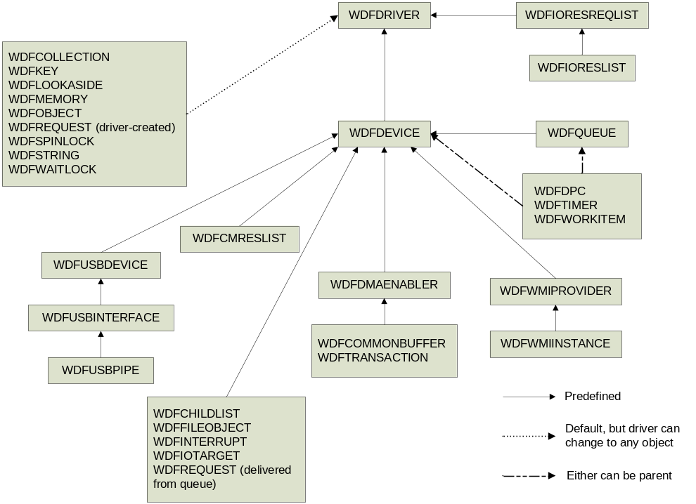
Figure 1. Parent-Child Relationships among the KMDF Objects
For each object, the figure shows which other object(s) must be in its parent chain. These objects are not necessarily the immediate parent but could be the grandparent, great-grandparent, and so forth. For example, the figure shows the WDFDEVICE object as parent of the WDFQUEUE object. However, a WDFQUEUE object could be the child of a WDFIOTARGET object, which in turn is the child of a WDFDEVICE object. Thus, the WDFDEVICE object is in the parent chain for the WDFQUEUE object.
The object hierarchy affects the object’s lifetime. The parent holds a reference count for each child object. When the parent object is deleted, the child objects are deleted and their callbacks are invoked in a defined order. For details, see "Object Creation and Deletion" later in this paper.
Table 4 lists all the KMDF object types.
Table 4. KMDF Object Types
Object | Type | Description
Child list | WDFCHILDLIST | Represents a list of the child devices for a device.
Collection | WDFCOLLECTION | Describes a list of similar objects, such as resources or the devices for which a filter driver filters requests.
Device | WDFDEVICE | Represents an instance of a device. A driver typically has one WDFDEVICE object for each device that it controls.
DMA common buffer | WDFCOMMONBUFFER | Represents a buffer that can be accessed by both the device and the driver to perform DMA.
DMA enabler | WDFDMAENABLER | Enables a driver to use DMA. A driver that handles device I/O operations has one WDFDMAENABLER object for each DMA channel within the device.
DMA transaction | WDFDMATRANSACTION | Represents a single DMA transaction.
Deferred procedure call (DPC) | WDFDPC | Represents a deferred procedure call.
Driver | WDFDRIVER | Represents the driver itself and maintains information about the driver, such as its entry points. Every driver has one WDFDRIVER object.
File | WDFFILEOBJECT | Represents a file object through which external drivers or applications can access the device.
Generic object | WDFOBJECT | Represents a generic object for use as the driver requires.
I/O queue | WDFQUEUE | Represents an I/O queue. A driver can have any number of WDFIOQUEUE objects.
I/O request | WDFREQUEST | Represents a request for device I/O.
I/O target | WDFIOTARGET | Represents a device stack to which the driver is forwarding an I/O request.
Interrupt | WDFINTERRUPT | Represents a device’s interrupt object. Any driver that handles device interrupts has one WDFINTERRUPT object for each IRQ or message-signaled interrupt (MSI) that the device can trigger.
Look-aside list | WDFLOOKASIDE | Represents a dynamically sized list of identical buffers that are allocated from the paged or nonpaged pool. Both the WDFLOOKASIDE object and its component memory buffers can have attributes, as described in "Object Attributes" later in this paper.
Memory | WDFMEMORY | Represents memory that the driver uses, typically an input or output buffer that is associated with an I/O request.
Registry key | WDFKEY | Represents a registry key.
Resource list | WDFCMRESLIST | Represents the list of resources that have actually been assigned to the device.
Resource range list | WDFIORESLIST | Represents a possible configuration for a device.
Resource requirements list | WDFIORESREQLIST | Represents a set of I/O resource lists, which comprises all possible configurations for the device. Each element of the list is a WDFIORESLIST object.
String | WDFSTRING | Represents a counted Unicode string.
Synchronization: spin lock | WDFSPINLOCK | Represents a spin lock, which synchronizes access to data DISPATCH_LEVEL.
Synchronization: wait lock | WDFWAITLOCK | Represents a wait lock, which synchronizes access to data at PASSIVE_LEVEL.
Timer | WDFTIMER | Represents a timer that fires either once or periodically and causes a callback routine to run.
USB device | WDFUSBDEVICE | Represents a USB device.
USB interface | WDFUSBINTERFACE | Represents an interface on a USB device.
USB pipe | WDFUSBPIPE | Represents a pipe in a USB interface.
Windows Management Instrumentation (WMI) instance | WDFWMIINSTANCE | Represents an individual WMI data block that is associated with a particular provider.
WMI provider | WDFWMIPROVIDER | Represents the schema for WMI data blocks that the driver provides.
Work item | WDFWORKITEM | Represents a work item, which runs in a system thread at PASSIVE_LEVEL.

Object Attributes
Every KMDF object is associated with a set of attributes. The attributes define information that KMDF requires for objects, as listed in Table 5.
Table 5. KMDF Object Attributes
Field | Description
ContextSizeOverride | Size of the context area; overrides the value in ContextTypeInfo->ContextSize. Useful for context areas that have variable sizes.
ContextTypeInfo | Pointer to the type information for the object context area.
EvtCleanupCallback | Pointer to a callback routine that is invoked to clean up the object before it is deleted; the object might still have references.
EvtDestroyCallback | Pointer to a callback routine that is invoked when the reference count reaches zero for an object that is marked for deletion.
ExecutionLevel | Maximum interrupt request level (IRQL) at which KMDF can invoke certain object callbacks.
ParentObject | Handle to the object’s parent.
Size | Size of the object.
SynchronizationScope | Level at which certain callbacks for this object are synchronized; applies only to driver, device, and file objects.

The framework supplies defaults for most attributes. A driver can override these defaults when it creates the object by using the WDF_OBJECT_ATTRIBUTES_INIT function.

Object Context
Every instance of a KMDF object can have one or more object context areas. This area is a driver-defined storage area for data that is related to a specific instance of an object, such as a driver-allocated lock or event for the object. The size and layout of the object context area are determined by the driver. When the driver creates the object, it initializes the context area and specifies its size and type. The driver can create additional context areas after the object has been created. For a KMDF device object, the object context area is the equivalent of the WDM device extension.
When KMDF creates the object, it allocates memory for the context areas from the nonpaged pool and initializes them according to the driver’s specifications. When KMDF deletes the object, it deletes the context areas, too. The framework provides macros to associate a type and a name with the context area and to create a named accessor function that returns a pointer to the context area.
If you are familiar with WDM, this design might seem unnecessarily complicated. However, it provides flexibility in attaching information to I/O requests as they flow through the driver. In addition, it enables different libraries to have their own separate context for an object. For example, an IEEE 1394 library could track a WDFDEVICE object at the same time that the device’s function driver tracks it, but with separate contexts. Within a driver, the context area enables a design pattern that is similar to inheritance. If the driver uses a request for several different tasks, the request object can have a separate context area to each task. Functions that are related to a specific task can access their own contexts and do not require any information about the existence or contents of any other contexts.

Object Creation and Deletion
To create an object, KMDF:
- Allocates memory from the nonpaged pool for the object and its context areas.
- Initializes the object’s attributes with default values and the driver’s specifications (if any).
- Zeroes the object’s context areas.
- Configures the object by storing pointers to its event callbacks and setting other object-specific characteristics.

If object initialization fails, KMDF deletes the object and any children that have already been created.
To initialize object attributes and configuration structures, a driver invokes KMDF initialization functions before it calls the object-creation methods. KMDF uses the initialized attributes and structures when it creates the object.
KMDF maintains a reference count for each object and ensures that the object persists until all references to it have been released. If the driver explicitly deletes an object (by calling a deletion method), KMDF marks the object for deletion but does not physically delete it until its reference count reaches zero.
Drivers do not typically take out references on the objects that they create, but in some cases (such as when escaping directly to WDM) such references are necessary to ensure that the object’s handle remains valid. For example, a driver that sends asynchronous I/O requests might take out a reference on the request object to guard against race conditions during cancellation. Before the request object can be deleted, the driver must release this reference.
Object deletion starts from the object farthest from the parent and works up the object hierarchy towards the root. KMDF takes the following steps to delete an object:
1. Starting with the child object farthest from the parent, calls the object’s EvtCleanupCallback. In this routine, drivers should perform any clean-up tasks that must be done before the object’s parent is deleted. Such tasks might include releasing explicit references on the object or a parent object. Note that when the EvtCleanupCallback function runs, the object’s children still exist, even though their EvtCleanupCallback functions have already been invoked.
2. When the object’s reference count reaches zero, calls the object’s EvtDestroyCallback, if the driver has registered one.
3. Deallocates the memory that was allocated to the object and its context area.

KMDF always calls the EvtCleanupCallback routines of child objects before calling those of their parent objects, so drivers are guaranteed that the parent object still exists when a child’s EvtCleaupCallback routine runs. This guarantee does not apply to EvtDestroyCallbacks, however; KMDF can call the EvtDestroyCallback routines in any order, so that the EvtDestroyCallback for a parent might be called before that of one of its children.
Drivers can change the parent of most KMDF objects by setting the ParentObject attribute. By setting the parent/child relationships appropriately, a driver can avoid taking out explicit references on related objects and can instead use the hierarchy and the associated callbacks to manage the object’s lifetime.

KMDF I/O Model
KMDF establishes its own dispatch routines that intercept all IRPs that are sent to the driver.
Figure 2 shows the overall flow of I/O through the KMDF library and driver. For a detailed explanation, see "I/O Request Flow in WDF Kernel-Mode Drivers", which is listed in the Resources section.
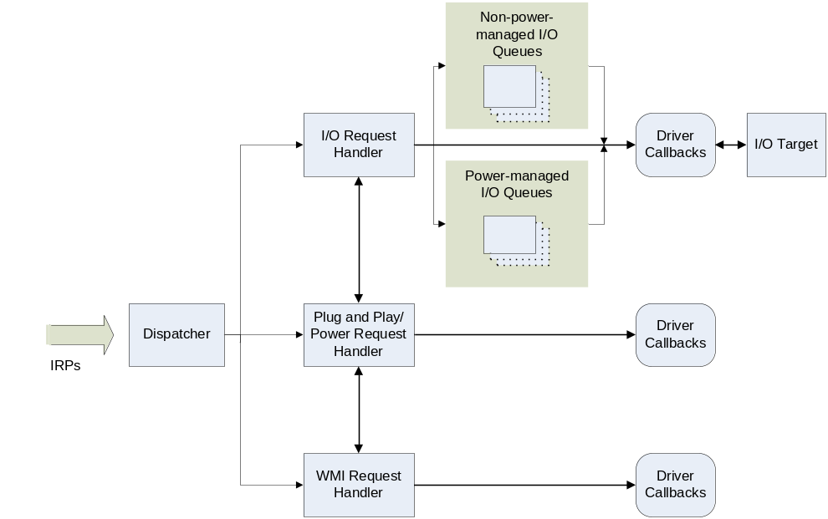
Figure 2. KMDF I/O Flow
When an IRP arrives, KMDF directs it to one of the following components for processing:
- I/O request handler, which handles requests that involve device I/O.
- Plug and Play/power request handler, which handles Plug and Play and power requests (IRP_MJ_PNP and IRP_MJ_POWER requests) and notifies other components of changes in device status.
- WMI handler, which handles WMI and event-tracing requests (IRP_MJ_SYSTEM_CONTROL requests).

Each component takes one or more of the following actions for each request:
- Raising one or more events to the driver.
- Forwarding the request to another internal handler or I/O target for further processing.
- Completing the request based on its own action.
- Completing the request as a result of a driver call.

If the request has not been processed when it reaches the end of frameworks processing, KMDF takes an action that is appropriate for the type of driver. For function and bus drivers, KMDF completes the request with the status STATUS_INVALID_DEVICE_REQUEST. For filter drivers, KMDF automatically forwards the request to the default I/O target (the next lower driver).
The next three sections describe how each of the three components processes I/O requests.

I/O Request Handler
The I/O request handler dispatches I/O requests to the driver, manages I/O cancellation and completion, and works with the Plug and Play/power handler to ensure that the device state is compatible with performing device I/O.
Depending on the type of I/O request, the I/O request handler either queues the request or invokes an event callback that the driver registered for the request.

Create, Cleanup, and Close Requests
To handle create events, a driver can either configure a queue to receive the events or can supply an event callback that is invoked immediately. The driver’s options are the following:
- To be called immediately, the driver supplies an EvtDeviceFileCreate callback and registers it from the EvtDriverDeviceAdd callback by calling WdfDeviceInitSetFileObjectConfig.
- To configure a queue to receive the requests, the driver calls WdfDeviceConfigureRequestDispatching and specifies WdfRequestTypeCreate. If the queue is not manual, the driver must register an EvtIoDefault callback, which is called when a create request arrives.

Queuing takes precedence over the EvtDeviceFileCreate callback; that is, if the driver both registers for EvtDeviceFileCreate events and configures a queue to receive such requests, KMDF queues the requests and does not invoke the callback. KMDF does not queue create requests to a default queue; the driver must explicitly configure a queue to receive them.
In a bus or function driver, if a create request arrives for which the driver has neither registered an EvtDeviceFileCreate callback function nor configured a queue to receive create requests, KMDF opens a file object to represent the device and completes the request with STATUS_SUCCESS. Therefore, any bus or function driver that does not accept create or open requests from user-mode applications—and thus does not register a device interface—must register an EvtDeviceFileCreate callback that explicitly fails such requests. Supplying a callback to fail create requests ensures that a rogue user-mode application cannot gain access to the device.
If a filter driver does not handle create requests, KMDF by default forwards all create, cleanup, and close requests to the default I/O target (the next lower driver). Filter drivers that handle create requests should perform whatever filtering tasks are required and then forward such requests to the default I/O target. If the filter driver completes a create request for a file object, it should set AutoForwardCleanupClose to WdfFalse in the file object configuration so that KMDF completes cleanup and close requests for the file object instead of forwarding them.
To handle file cleanup and close requests, a driver registers the EvtFileCleanup and EvtFileClose event callbacks. If a bus or function driver does not register such a callback, KMDF closes the file object and completes the request with STATUS_SUCCESS. In a filter driver that does not register cleanup and close callbacks, KMDF forwards these requests to the default I/O target unless the driver has explicitly set AutoForwardCleanupClose to WdfFalse in the file object configuration.

Read, Write, Device I/O Control, and Internal Device I/O Control Requests
For read, write, device I/O control, and internal device I/O control requests, the driver creates one or more queues and configures each queue to receive one or more types of I/O requests. When such a request arrives, the I/O request handler:
- Determines whether the driver has configured a queue for this type of request. If not, the handler fails a read, write, device I/O control, or internal device I/O control request if this is a function or bus driver. If this is a filter driver, the handler passes such a request to the default I/O target.
- Determines whether the queue is accepting requests and the device is powered on. If both are true, the handler creates a WDFREQUEST object to represent the request and adds it to the queue. If the queue is not accepting requests, the handler fails the request.
- If the device is not in the D0 state, notifies the Plug and Play/power handler to power up the device.
- Queues the request.

Figure 3 shows the flow of a read, write, device I/O control, or internal device I/O control request through the I/O request handler to the driver.
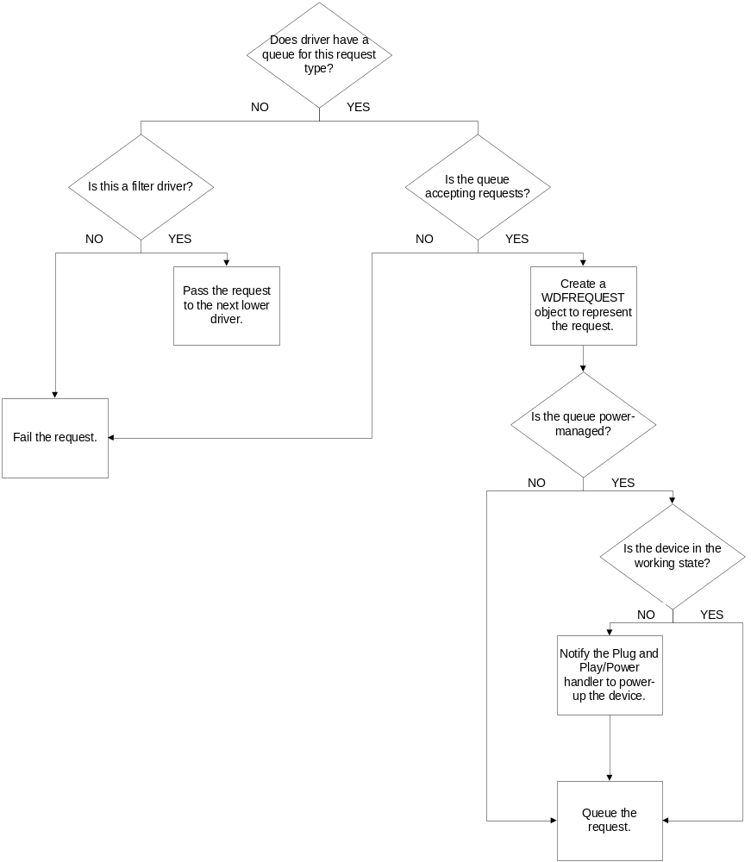
Figure 3. Flow of I/O Request through I/O Request Handler

I/O Queues
A WDFQUEUE object represents a queue that presents requests from KMDF to the driver. A WDFQUEUE is more than just a list of pending requests, however; it tracks requests that are active in the driver, supports request cancellation, manages the concurrency of requests, and can optionally synchronize calls to the driver’s I/O event callback functions.
A driver typically creates one or more queues, each of which can accept one or more types of requests. The driver configures the queues when it creates them. For each queue, the driver can specify:
- The types of requests that are placed in the queue.
- The event callback functions that are registered to handle I/O requests from the queue.
- The power management options for the queue.
- The dispatch method for the queue, which determines the number of requests that are serviced at a given time.
- Whether the queue accepts requests that have a zero-length buffer.

A driver can have any number of queues, and they can all be configured differently. For example, a driver might have a parallel queue for read requests and a sequential queue for write requests.
While a request is in a queue and has not yet been presented to the driver, the queue is considered the "owner" of the request. After the request has been dispatched to the driver, it is "owned" by the driver and is considered an in-flight request. Internally, each WDFQUEUE object keeps track of which requests it owns and which requests are pending. A driver can forward a request from one queue to another by calling a method on the request object.

Queues and Power Management
KMDF provides rich control of queues. The framework can manage the queues for the driver, or the driver can manage queues on its own. Power management is configurable on a per-queue basis. A driver can use both power-managed and non-power-managed queues and can sort requests based on the requirements for its power model.

Power-Managed Queues
By default, queues for FDOs and PDOs are power managed, which means that the state of the queue can trigger power-management activities. Such queues have several advantages:
- If an I/O request arrives while the system is in the working state (S0) but the device is not, KMDF notifies the Plug and Play/power handler so that it can restore device power.
- When a queue becomes empty, KMDF notifies the Plug and Play/power handler so that it can track device usage through its idle timer.
- If the device power state begins to change while the driver "owns" an I/O request, KMDF can notify the driver through the EvtIoStop callback. The driver must complete, cancel, or acknowledge all the I/O requests that it owns before the device can leave the working state.

For power-managed queues, KMDF pauses the delivery of requests when the device leaves the working state (D0) and resumes delivery when the device returns to the working state. Although delivery stops while the queue is paused, queuing does not. If KMDF receives a request while the queue is paused, KMDF adds the request to the queue for delivery after the queue resumes. If an I/O request arrives while the device is idle and the system is in the working state, KMDF returns the device to the working state so that it can handle the request. If an I/O request arrives while the system is transitioning to a sleep state, however, KMDF does not return the device to the working state until the system returns to the working state.
For requests to be delivered, both the driver and the device power state must allow processing. The driver can pause delivery manually by calling WdfIoQueueStop and resume delivery by calling WdfIoQueueStart.

Non-Power-Managed Queues
If a queue is not power managed, the state of the queue has no effect on power management, and conversely. KMDF delivers requests to the driver any time the system is in the working state, regardless of the power state of the device. KMDF does not start an idle timer when the queue becomes empty, and it does not power up a sleeping device when I/O arrives for the queue.
Drivers should use non-power-managed queues to hold requests that the driver can handle even while its device is not in the working state.

Dispatch Type
A queue’s dispatch type determines how and when I/O requests are delivered to the driver and, as a result, whether multiple I/O requests from a queue are active in the driver at one time. Drivers can control the concurrency of in-flight requests by configuring the dispatching method for their queues. KMDF supports three dispatch types:
- Sequential. A queue that is configured for sequential dispatching delivers I/O requests to the driver one at a time. The queue does not deliver another request to the driver until the previous request has been completed. (Sequential dispatching is similar to the start-I/O technique in WDM.)
- Parallel. A queue that is configured for parallel dispatching delivers I/O requests to the driver as soon as possible, whether or not another request is already active in the driver.
- Manual. A queue that is configured for manual dispatching does not deliver I/O requests to the driver. Instead, the driver retrieves requests at its own pace by calling a method on the queue.

Important
The dispatch type controls only the number of requests that are active within a driver at one time. It has no effect on whether the queue’s I/O event callbacks are invoked sequentially or concurrently; instead, the concurrency of callbacks is controlled by the synchronization scope of the device object. Even if the synchronization scope for a parallel queue does not allow concurrent callbacks, the queue nevertheless might have many in-flight requests. For more information about synchronization scope for queues, see "Synchronization Issues" later in this paper.
All I/O requests that a driver receives from a queue are inherently asynchronous. The driver can complete the request within the event callback or sometime later, after returning from the callback.

I/O Request Objects
The WDFREQUEST object is the KMDF representation of an IRP. When an I/O request arrives, the I/O handler creates a WDFREQUEST object, queues the object, and eventually passes the object to the driver in its I/O callback function.
The properties of the WDFREQUEST object represent the fields of an IRP. The object also contains additional information. Like all other KMDF objects, the WDFREQUEST object has a reference count and can have its own object context area. When the driver completes the I/O request that the object represents, KMDF automatically frees the object and any child resources such as associated memory buffers or memory descriptor lists (MDLs). After the driver has called WdfRequestComplete, the driver must not attempt to access the handle to the WDFREQUEST object or any of its child resources.
A driver can create its own WDFREQUEST objects to request I/O from another device or to split an I/O request into multiple, smaller requests before completing it.

Retrieving Buffers from I/O Requests
The WDFMEMORY object encapsulates the I/O buffers that are supplied for an I/O request. To enable device drivers to handle complicated requests with widely scattered buffers, any number of WDFMEMORY objects may be associated with a WDFREQUEST.
The WDFMEMORY object represents a buffer that the framework manages. The object can be used to copy memory to and from the driver and the buffer represented by the WDFMEMORY handle. In addition, the driver can use the underlying buffer pointer and its length for complex access, such as casting to a known data structure.
Like other KMDF objects, WDFMEMORY objects have reference counts and persist until all references to them have been removed. The buffer that underlies the WDFMEMORY object, however, might not be "owned" by the object itself. For example, if the issuer of the I/O request allocated the buffer or if the driver called WdfMemoryCreatePreallocated to assign an existing buffer to the object, the WDFMEMORY object does not "own" the buffer. In this case, the buffer pointer becomes invalid when the associated I/O request has been completed, even if the WDFMEMORY object still exists.
Each WDFMEMORY object contains the length of the buffer that it represents. KMDF methods that copy data to and from the buffer validate the length of every transfer to prevent buffer overruns and underruns, which can result in corrupt data or security breaches.
Depending on the type of I/O that the device and driver support, the underlying buffer might be any of the following:
- For buffered I/O, a system-allocated buffer from the nonpaged pool.
- For direct I/O, a system-allocated MDL that points to the physical pages for DMA.
- For neither buffered nor direct I/O, an unmapped and unverified user-mode memory address.

The WDFMEMORY object supports methods that return each type of buffer from the object and methods to read and write the buffers. For device I/O control requests (IOCTLs), KMDF provides methods to probe and lock user-mode buffers. The driver must be running in the context of the process that sent the I/O request to probe and lock a user-mode buffer, so KMDF also defines a callback that drivers can register to be called in the context of the sending component.
Each WDFMEMORY object also controls access to the buffer and allows the driver to write only to buffers that support I/O from the device to the buffer. A buffer that is used to receive data from the device (as in a read request) is writable. The WDFMEMORY object does not allow write access to a buffer that only supplies data (as in a write request).

Sending I/O Requests
Drivers send I/O requests by creating or reusing an I/O request object, creating an I/O target, and sending the request to the target. Drivers can send requests either synchronously or asynchronously. A driver can specify a time-out value for either type of request.

I/O Targets
An I/O target represents a device object to which an I/O request is directed. If a driver cannot complete an I/O request by itself, it typically forwards the request to an I/O target. An I/O target can be a KMDF driver, a WDM driver, or any other kernel-mode driver.
Before a driver forwards an existing I/O request or sends a new request, it must create a WDFIOTARGET object to represent either a local or remote target for the I/O request. The local I/O target is the next lower driver in the device stack and is the default target for a filter or FDO device object. A remote I/O target is any other driver that might be the target of an I/O request. A driver might use a remote I/O target if it requires data from another device to complete an I/O request. A function driver might also use a remote I/O target to send a device I/O control request to its bus driver. In this case, the I/O request originates with the function driver itself, rather than originating with some other process.
The WDFIOTARGET object formats I/O requests to send to other drivers, handles changes in device state, and defines callbacks through which a driver can request notification about target device removal. A driver can call methods on the WDFIOTARGET to:
- Open a device object or device stack by name.
- Format read, write, and device I/O control requests to send to the target. Some types of targets, such as WDFUSBDEVICE and WDFUSBPIPE, can format bus-specific requests in addition to the standard request types.
- Send read, write, and device I/O control requests synchronously or asynchronously.
- Determine the Plug and Play state of the target.

Internally, KMDF calls IoCallDriver to send the request. It takes out a reference on the WDFREQUEST object to prevent the freeing of associated resources while the request is pending for the target device object.
The WDFIOTARGET object tracks queued and sent requests and can cancel them when the state of the target device or of the issuing driver changes. From the driver’s perspective, the I/O target object behaves like a cancel-safe queue that retains forwarded requests until KMDF can deliver them. KMDF does not free the WDFIOTARGET object until all the I/O requests that have been sent to it are complete.
By default, KMDF sends a request only when the target is in the proper state to receive it. However, a driver can also request that KMDF ignore the state of the target and send the request anyway. If the target device has been stopped (but not removed), KMDF queues the request to send later after the target device resumes. If the issuing driver specifies a time-out value, the timer starts when the request is added to the queue.
If the device that is associated with a remote I/O target is removed, KMDF stops and closes the I/O target object, but does not notify the driver unless the driver has registered an EvtIoTargetXxx callback. If the driver must perform any special processing of I/O requests that it sent to the I/O target, it should register one or more such callbacks. When the removal of the target device is queried, canceled, or completed, KMDF calls the corresponding functions and then processes the target state changes on its own.
For local I/O targets, no such callbacks are defined. Because the driver and the target device are in the same device stack, the driver is notified of device removal requests through its Plug and Play and power management callbacks.

Creating Buffers for I/O Requests
Drivers that issue I/O requests must supply buffers for the results of those requests. The buffers in a synchronous request can be allocated from any type of memory, such as the nonpaged pool or an MDL, as well as a WDFMEMORY object. Asynchronous requests must use WDFMEMORY objects so that KMDF can ensure that the buffers persist until the I/O request has completed back to the issuing driver.
If the driver uses a WDFMEMORY object, the I/O target object takes out a reference on the WDFMEMORY object when it formats the object to send to the I/O target. The target object retains this reference until one of the following occurs:
- The request has been completed.
- The driver reformats the WDFREQUEST object.
- The driver calls WdfRequestReuse to send a request to another target.

A driver can retrieve a WDFMEMORY object from an incoming WDFREQUEST and reuse it later in a new request to a different target. However, if the driver has not yet completed the original request, the original I/O target still has a reference on the WDFMEMORY object. To avoid a bug check, the driver must call WdfRequestReuse in its I/O completion routine before it completes the original request.

Canceled and Suspended Requests
Windows I/O is inherently asynchronous. The system can request that a driver stop processing an I/O request at any time for many reasons, of which these are the most common:
- The thread or process that issued the request cancels it or exits.
- A system Plug and Play or power event such as hibernation occurs.
- The device is being, or has been, removed.

The actions that a driver takes to stop processing an I/O request depend on the reason for suspension or cancellation. In general, the driver can either cancel the request or complete it with an error. In some situations, the system might request that a driver suspend (temporarily pause) processing; the system notifies the driver later when to resume processing.
To provide a good user experience, drivers should provide callbacks to handle cancellation and suspension of any I/O request that might take a long time to complete or that might not complete, such as a request for asynchronous input.

Request Cancellation
How KMDF proceeds to cancel an I/O request depends on whether the request has already been delivered to the target driver.
- If the request has never been delivered—either because KMDF has not yet queued it or because it is still in a queue—KMDF cancels or suspends it automatically. If the original IRP has been canceled, KMDF completes the request with a cancellation status.
- If the request has been delivered and then requeued, KMDF notifies the driver of cancellation only if the driver has registered an EvtIoCanceledOnQueue callback for the queue.

After a request has been delivered, it cannot be canceled unless the driver that owns it explicitly marks it cancelable by calling the WdfRequestMarkCancelable method on the request and registering a cancellation callback (EvtRequestCancel) for the request.
A driver should mark a request cancelable and register an I/O cancellation callback if either of the following is true:
- The request involves a long-term operation.
- The request might never succeed; for example, the request is waiting for synchronous input.

Drivers should follow the guidelines that are described in "I/O Completion/Cancellation Guidelines," which is listed in the Resources section.
In the EvtRequestCancel callback, the driver must perform any tasks that are required to cancel the request, such as stopping any device I/O operations that are in progress and canceling any related requests that it has already forwarded to an I/O target. Eventually, the driver must complete the request with the status STATUS_CANCELLED.
Requests that are marked cancelable cannot be forwarded to another queue. Before requeuing a request, the driver must first make it noncancelable by calling WdfRequestUnmarkCancelable. After the request has been added to the new queue, KMDF once again considers it cancelable until that queue dispatches it to the driver.
If the driver does not mark a request cancelable, it can call WdfRequestIsCanceled to determine whether the I/O manager or original requester has attempted to cancel the request. A driver that processes data on a periodic basis might use this approach. For example, a driver involved in image processing might complete a transfer request in small chunks and poll for cancellation after processing each chunk. In this case, the driver supports cancellation of the I/O request, but only after each discrete chunk of processing is complete. If the driver determines that the request has been canceled, it performs any required cleanup and completes the request with the status STATUS_CANCELLED.

Request Suspension
When the system transitions to a sleep state—typically because the user has requested hibernation or closed the lid on a laptop—a driver can complete, requeue, or continue to hold any in-flight requests. KMDF notifies the driver of the impending power change by calling the EvtIoStop callback for each in-flight request. Each call includes flags that indicate the reason for stopping the queue and whether the I/O request is currently cancelable.
Depending on the value of the flags, the driver can complete the request, requeue the request, acknowledge the event but continue to hold the request, or ignore the event if the current request will complete in a timely manner. If the queue is stopping because the device is being removed (either by an orderly removal or a surprise removal), the driver must complete the request immediately.

Drivers should handle EvtIoStop events for any request that might take a long time to complete or that might not complete, such as a request for asynchronous input. Handling EvtIoStop provides a good user experience for laptops and other power-managed systems.

Completing I/O Requests
To complete an I/O request, a driver calls WdfRequestComplete. In response, KMDF completes the underlying IRP and then deletes the WDFREQUEST object and any child objects. If the driver has set an EvtCleanupCallback for the WDFREQUEST object, KMDF invokes the callback before completing the underlying IRP, so that the IRP itself is still valid when the callback runs.
After WdfRequestComplete returns, the WDFREQUEST object’s handle is invalid and its resources have been released. The driver must not attempt to access the handle or any of its resources, such as parameters and memory buffers that were passed in the request.
If the request was dispatched from a sequential queue, the driver’s call to complete the IRP might cause KMDF to deliver the next request in the queue. (If the queue is configured for parallel dispatching, KMDF can deliver another request at any time.) If the driver holds any locks while it calls WdfRequestComplete, it must ensure that its event callbacks for the queue do not use the same locks because a deadlock might occur. In practice, this is difficult to ensure, so the best practice is not to call WdfRequestComplete while holding a lock.

Self-Managed I/O
Although the I/O support that is built into KMDF is recommended for most drivers, some drivers have I/O paths that do not pass through queues or are not subject to power management. KMDF provides self-managed I/O features for this purpose. For example, the PCIDRV sample uses self-managed I/O callbacks to start and stop a watchdog timer DPC.
The self-managed I/O callbacks correspond directly to WDM Plug and Play and power management state changes. These routines are called with a handle to the device object and no other parameters. If a driver registers these callbacks, KMDF calls them at the designated times so that the driver can perform whatever actions it requires.

Accessing IRPs and WDM Structures
KMDF includes a mechanism nicknamed "the great escape" through which a driver can access the underlying WDM structures and the I/O request packet as it was delivered from the operating system. Although this mechanism exposes the driver to all the complexity of the WDM model, it can often be useful in converting a WDM driver to KMDF. In addition, some drivers require WDM features that are not available in KMDF, such as processing for some types of IRPs. Such drivers can use KMDF for most features but can rely on the "great escape" to gain access to the WDM features that they require.
To use the "great escape," a driver calls WdfDeviceInitAssignWdmIrpPreprocessCallback to register an EvtDeviceWdmIrpPreprocess event callback function for an IRP major function code. When KMDF receives an IRP with that function code, it invokes the callback. The driver must then handle the request just as a WDM driver would, by using I/O manager functions such as IoCallDriver to forward the request and IoCompleteRequest to complete it. The Serial driver sample shows how to use this feature.
In addition to the "great escape," KMDF provides methods with which a driver can access the WDM objects that the KMDF objects represent. For example, a driver can access the IRP that underlies a WDFREQUEST object, the WDM device object that underlies a WDFDEVICE object, and so forth.

Plug and Play and Power Management Request Handler
KMDF implements integrated Plug and Play and power management support as an internal state machine. An event is associated with the transition to each state, and a driver can supply callback routines that are invoked at each such state change.
If you are familiar with WDM drivers, you probably remember that any time the system power state changes, the WDM driver must determine the correct power state for its device and then issue power management requests to put the device in that state at the appropriate time. The KMDF state machine automatically handles the translation of system power events to device power events. For example, KMDF notifies the driver to:
- Transition the device to low power when the system hibernates or goes to sleep.
- Enable the device‘s wake signal so that it can be triggered while the system is running, if the device is idle.
- Enable the device’s wake signal so that it can be triggered while the system is in a sleep state.

KMDF automatically provides for the correct behavior in device parent/child relationships. If both a parent and a child device are powered down and the child must power up, KMDF automatically returns the parent to full power and then powers up the child.
To manage idle devices, the KMDF state machine notifies the driver to remove the device from the working state and put it in the designated low-power state when the device is idle and to return the device to the working state when there are requests to process.
To accomplish these power transitions, a driver includes a set of callback routines. These routines are called in a defined order, and each conforms to a "contract," so that both the device and the system are guaranteed to be in a particular state when the driver is called to perform an action. This support makes it much easier for drivers to power down idle devices. The driver simply sets an appropriate time-out value and low-power state for its device and notifies KMDF of these values; KMDF calls the driver to power down the device at the correct times.
In addition, requests received by the framework and not yet delivered to the device driver can affect the power state of the device. If the driver has configured a queue for power management, the framework can automatically restore device power before it delivers the request to the driver. It can also automatically stop and start the queue in response to Plug and Play and power events.
Finally, the driver that manages power policy for the device can specify whether a user can control both the behavior of the device while it is idle and the ability of the device to wake up the system. All the driver must do is specify the appropriate enumerator value when it initializes certain power policy settings. KMDF enables the necessary property sheet through WMI, and Device Manager displays it.

Device Enumeration and Startup
To prepare the device for operation, KMDF calls the driver’s callback routines in a fixed sequence. The sequence varies somewhat depending on the driver’s role in the device stack.

Startup Sequence for a Function or Filter Device Object
Figure 4 shows the callbacks for an FDO or filter DO that is involved in bringing a device to the fully operational state, starting from the Device Inserted state at the bottom of the figure.
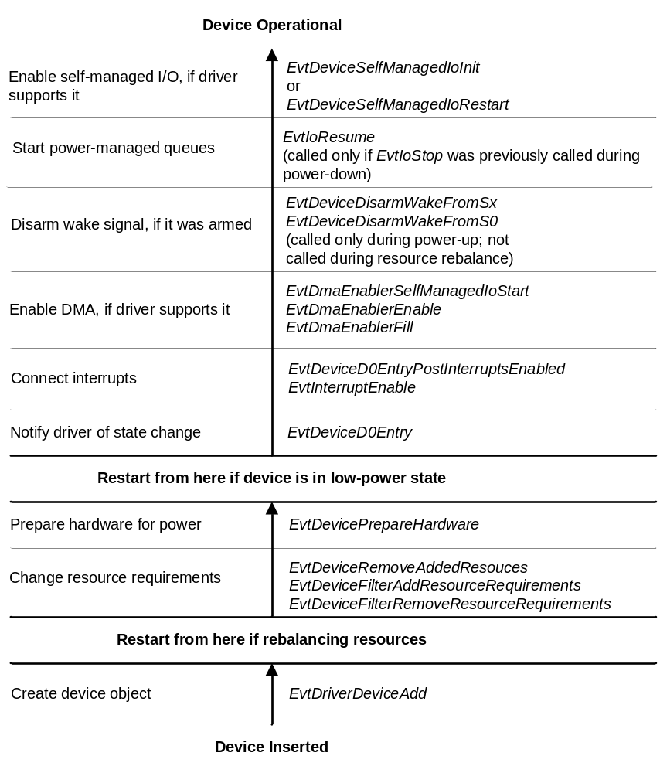Figure 4. Device Enumeration and Startup Sequence for FDO or Filter DO
The broad horizontal lines mark the steps that are involved in starting a device. The column on the left side of the figure describes the step, and the column on the right lists the event callbacks that accomplish it.
At the bottom of the figure, the device is not present on the system. When the user inserts it, KMDF begins by calling the driver’s EvtDriverDeviceAdd callback so that the driver can create a device object to represent the device. KMDF continues calling the driver’s callback routines by progressing up through the sequence until the device is operational. Remember that KMDF invokes the event callbacks in bottom-up order as shown in the figure, so EvtDeviceFilterRemoveResourceRequirements is called before EvtDeviceFilterAddResourceRequirements and so forth.
If the device was stopped to rebalance resources or was physically present but not in the working state, not all of the steps are required, as the figure shows.

Startup Sequence for a Physical Device Object
Figure 5 shows the callbacks for a bus driver (PDO) that are involved in bringing a device to the fully operational state, starting from the Device Inserted state at the bottom of the figure.
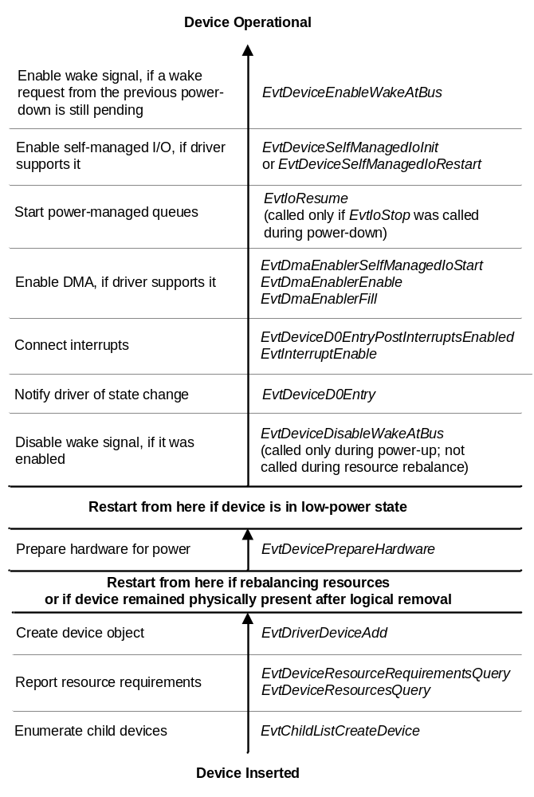
Figure 5. Device Addition/Startup Sequence for PDO
KMDF does not physically delete a PDO until the corresponding device is physically removed from the system. For example, if a user disables the device in Device Manager but does not physically remove it, KMDF retains its device object. Thus, the three steps at the bottom of the figure occur only during Plug and Play enumeration—that is, during initial boot or when the user plugs in a new device.
If the device was previously disabled but not physically removed, KMDF starts by calling the EvtDevicePrepareHardware callback.

Device Power Down and Removal
KMDF can remove a device from the operational state for several reasons:
- To put the device in a low-power state because it is idle or the system is entering a sleep state.
- To rebalance resources.
- To remove the device after the user has requested an orderly removal.
- To disable the device in response to the user’s request in Device Manager.

As in enumeration and power-up, the sequence of callbacks depends on the driver’s role in device management.

Power-Down and Removal Sequence for a Function or Filter Device Object
Figure 6 shows the sequence of callbacks that are involved in power down and removal for an FDO or filter DO. The sequence starts at the top of the figure with an operational device that is in the working power state (D0).
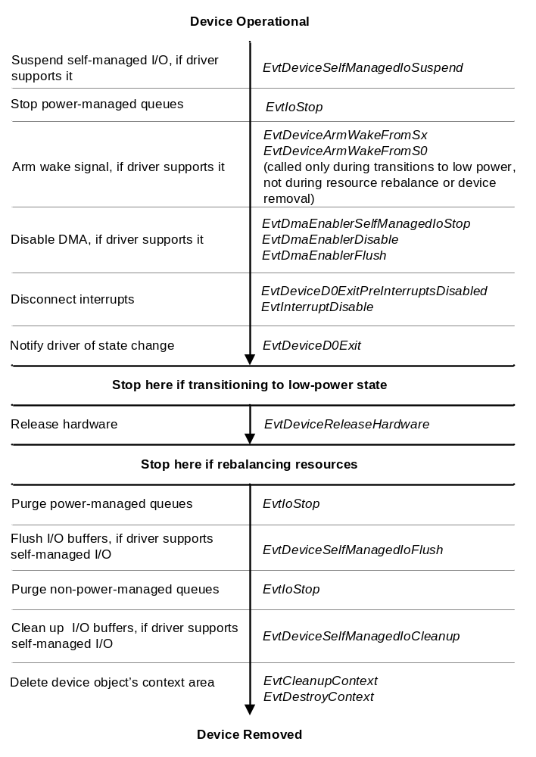
Figure 6. Device Power-Down and Orderly Removal Sequence for FDO and Filter DO
As the figure shows, the KMDF power-down and removal sequence involves calling the corresponding "undo" callbacks in the reverse order from which KMDF called the functions that are involved in making the device operational.

Power-Down and Removal Sequence for a Physical Device Object
Figure 7 shows the callbacks involved in power down and removal for a PDO.
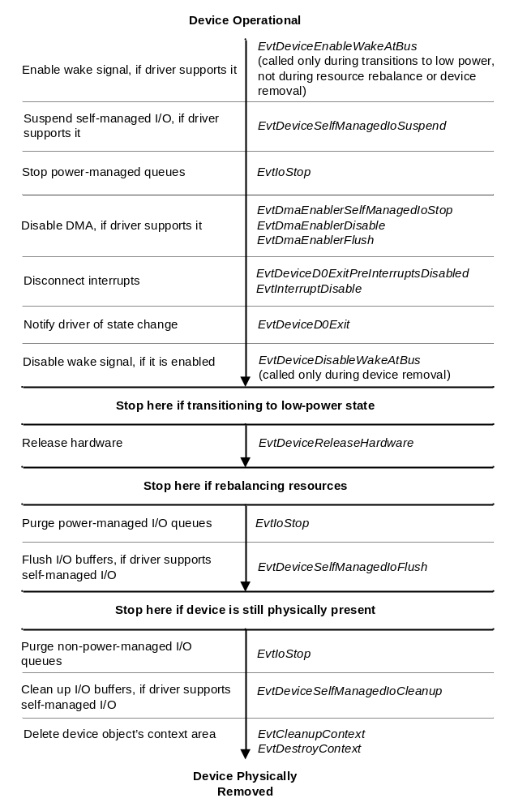Figure 7. Device Power-Down and Orderly Removal Sequence for PDO
KMDF does not physically delete the PDO until the device is physically removed from the system. For example, if a user disables the device in Device Manager or uses the Safely Remove Hardware utility to stop the device but does not physically remove it, KMDF retains the PDO. If the device is later re-enabled, KMDF uses the same PDO and begins the startup sequence by calling the EvtDevicePrepareHardware callback, as previously shown in Figure 5.

Surprise Removal Sequence
If the user removes the device without warning, by simply unplugging it without using Device Manager or the Safely Remove Hardware utility, the device is considered "surprise-removed." When this occurs, KMDF follows a slightly different removal sequence. It also follows the surprise-removal sequence if another driver calls IoInvalidateDeviceState on the device, even if the device is still physically present.
In the surprise-removal sequence, KMDF calls the EvtDeviceSurpriseRemoval callback before calling any of the other callbacks in the removal sequence. When the sequence is complete, KMDF destroys the device object.
Drivers for all removable devices must ensure that the callbacks in both the shutdown and startup paths can handle failure, particularly failures caused by the removal of the hardware. Any attempts to access the hardware should not wait indefinitely, but should be subject to time-outs or a watchdog timer.
Figure 8 shows the surprise-removal sequence.
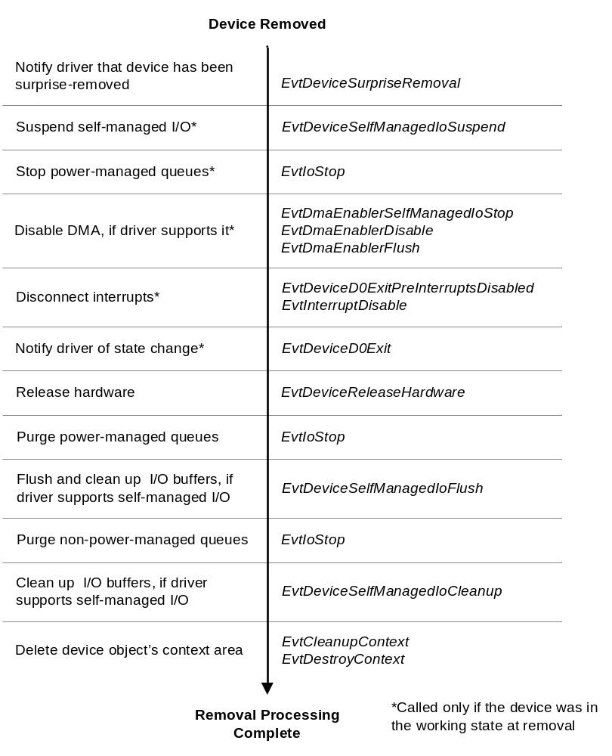
Figure 8. Surprise Removal Sequence
If the device was not in the working state when it was removed, KMDF calls the EvtDeviceReleaseHardware event callback immediately after EvtDeviceSurpriseRemoval. It omits the intervening steps, which were already performed when the device exited from the working state.

WMI Request Handler
WMI provides a way for drivers to export information to other components. Drivers typically use WMI to:
- Enable user-mode applications to query and set device-related information, such as time-out values.
- Enable an administrator with the necessary privileges to control a device by running an application on a remote system.

A driver that supports WMI registers as a provider of information and registers one or more instances of that information. Each WMI provider is associated with a particular globally unique identifier (GUID). Another component can register with the same GUID to consume the data from the instances. User-mode components request WMI instance data by calling COM functions, which the system translates into IRP_MJ_SYSTEM_CONTROL requests and sends to the target providers.
KMDF supports WMI requests through its WMI request handler, which provides the following features for drivers:
- A default WMI implementation. Drivers that do not provide WMI data are not required to register as WMI data providers; KMDF handles all IRP_MJ_SYSTEM_CONTROL requests.
- Callbacks on individual instances, rather than just at the device object level, so that different instances can behave differently.
- Validation of buffer sizes to ensure that buffers that are used in WMI queries meet the size requirements of the associated provider and instance.

The default WMI implementation includes support for the check boxes on the Power Management tab of Device Manager. These check boxes enable a user to control whether the device can wake the system and whether the system can power down the device when it is idle. WDM drivers must include code to support the WMI controls that map to these check boxes, but KMDF drivers do not require such code. If the driver enables this feature in its power policy options, KMDF handles these requests automatically.
The driver enables buffer size validation when it configures a WMI provider object (WDFWMIPROVIDER). In the WDF_WMI_PROVIDER_CONFIG structure, the driver can specify the minimum size of the buffer that is required for the provider’s EvtWmiInstanceQueryInstance and EvtWmiInstanceSetInstance callbacks. If the driver specifies such a value, KMDF validates the buffer size when the IRP_MJ_SYSTEM_CONTROL request arrives and calls the callbacks only if the supplied buffer is large enough. If the driver does not configure a buffer size—because the instance size is either dynamic or is not available when the provider is created—the driver should specify zero for this field and the callbacks themselves should validate the buffer sizes.
When KMDF receives an IRP_MJ_SYSTEM_CONTROL request that is targeted at a KMDF driver, it proceeds as follows:
- If the driver has registered as a WMI provider and registered one or more instances, the WMI handler invokes the callbacks for those instances as appropriate.
- If the driver has not registered any WMI instances, the WMI handler responds to the request by providing the requested data (if it can), passing the request to the next lower driver, or failing the request.

Like all KMDF objects, WMI instance objects (WDFWMIINSTANCE) have a context area. A driver can use the context area of a WDFWMIINSTANCE object as a source of read-only data, thus enabling easy data collection with minimal effort. A driver can delete WDFWMIINSTANCE objects any time after their creation.
WMI callbacks are not synchronized with the Plug and Play and power management state of the device. Therefore, when WMI events occur, KMDF calls a driver’s WMI callbacks even if the device is not in the working state.

Synchronization Issues
Because Windows is a pre-emptive, multitasking operating system, multiple threads can try to access shared data structures or resources concurrently and multiple driver routines can run concurrently. To ensure data integrity, all drivers must synchronize access to shared data structures. Correctly implementing such synchronization can be difficult in WDM drivers.
For KMDF drivers, ensuring proper synchronization requires attention to several areas:
- The number of concurrently active requests that are dispatched from a particular queue.
- The number of concurrently active callbacks for a particular object.
- The driver utility functions that access object-specific data.
- The IRQL at which an object’s callbacks run.

The dispatch method for an I/O queue controls the number of requests from the queue that can be concurrently active in the driver, as described previously in "Dispatch Type." Limiting concurrent requests does not, however, resolve all potential synchronization issues. Concurrently active callbacks on the same object might require access to shared object-specific data, such as the information that is stored in the object context area. Similarly, driver utility functions might share object-specific data with callbacks. Furthermore, a driver must be aware of the IRQL at which its callbacks can be invoked. At DISPATCH_LEVEL and above, drivers must not access pageable data and thread pre-emption does not occur.
KMDF simplifies synchronization for drivers by providing automatic synchronization of many callbacks. Calls to most PDO, FDO, Plug and Play, and power event callback functions are synchronized so that only one such callback function is invoked at a time for each device. These callback functions are called at IRQL PASSIVE_LEVEL. Note, however, that calls to the EvtDeviceSurpriseRemoval, EvtDeviceQueryRemove, and EvtDeviceQueryStop callbacks are not synchronized with the other callbacks and so can occur while the device is changing power state or is not in the working state.
For other types of callbacks—primarily I/O-related callbacks—the driver can specify the synchronization scope (degree of concurrency) and the maximum execution level (IRQL).
KMDF provides the following configurable synchronization features:
- Synchronization scope
- Execution level
- Locks

Although implementing synchronization is much less complicated in KMDF drivers than in WDM drivers, you should nevertheless be familiar with the basics of Windows IRQL, synchronization, and locking, as described in the papers "Scheduling, Thread Context, and IRQL" and "Locks, Deadlocks, and Synchronization," which are listed in the Resources at the end of this paper.

Synchronization Scope
KMDF provides configurable concurrency control, called synchronization scope, for the callbacks of several types of objects. An object’s synchronization scope determines whether KMDF invokes certain event callbacks on the object concurrently.
KMDF defines the following synchronization scopes:
- Device scope means that KMDF does not call certain I/O event callbacks concurrently for an individual device object or any file objects or queues that are children of the device object. Specifically, device scope applies to the following event callbacks: EvtDeviceFileCreate, EvtFileCleanup, EvtFileClose, EvtIoDefault, EvtIoRead, EvtIoWrite, EvtIoDeviceControl, EvtIoInternalDeviceControl, EvtIoStop, EvtIoResume, EvtIoQueueState, EvtIoCanceledOnQueue, and EvtRequestCancel.
However, callbacks for different device objects that were created by the same driver object can be called concurrently. Internally, KMDF creates a synchronization lock for each device object. To implement device synchronization scope, KMDF acquires this lock before invoking any of the device object’s callbacks.
- Queue scope means that KMDF does not call certain I/O callbacks concurrently on a per-queue basis. If a kernel-mode driver specifies queue scope for a device object, some callbacks for the device object and its queues can run concurrently. However, the following callbacks for an individual queue object are not called concurrently: EvtIoDefault, EvtIoRead, EvtIoWrite, EvtIoDeviceControl, EvtIoInternalDeviceControl, EvtIoStop, EvtIoResume, EvtIoQueueState, EvtIoCanceledOnQueue, and EvtRequestCancel. If the driver specifies queue scope, KMDF creates a synchronization lock for each queue object and acquires this lock before invoking any of the listed callbacks.
- No scope means that KMDF does not acquire any locks and can call any event callback concurrently with any other event callback. The driver must create and acquire all its own locks. By default, KMDF uses no scope. A driver must "opt in" to synchronization for its objects by setting device scope explicitly.

Each KMDF object inherits its scope from its parent object (WdfSynchronizationScopeInheritFromParent). The parent of each WDFDEVICE object is the WDFDRIVER object, and the default value of the synchronization scope for the WDFDRIVER object is WdfSynchronizationScopeNone. Thus, a driver must explicitly set the synchronization scope on its objects to use frameworks synchronization.
A driver can change the scope by setting a value in the WDF_OBJECT_ATTRIBUTES structure when it creates the object. Because scope is inherited, a driver can easily set synchronization for most of its objects by setting the scope for the device object, which is the parent to most KMDF objects. (For the complete hierarchy, see Figure 1.)
For example, to set the concurrency for its I/O callback functions, a driver sets the SynchronizationScope in the WDF_OBJECT_ATTRIBUTES for the device object that is the parent to the I/O queues. If the driver sets device scope (WdfSynchronizationScopeDevice), KMDF calls only one I/O callback function at a time across all the queues. To use queue scope, the driver sets WdfSynchronizationScopeQueue for the device object and WdfSynchronizationScopeInheritFromParent for the queue object. Queue scope means that only one of the listed callback functions can be active for the queue at any time. A driver cannot set concurrency separately for each queue. Restricting the concurrency of I/O callbacks can help to manage access to shared data in the WDFQUEUE context memory.
By default, a file object inherits its scope from its parent device object. Attempting to set queue scope for a file object causes an error. Therefore, drivers that set queue scope for a device object must manually set the synchronization scope for any file objects that are its children. The best practice for file objects is to use no scope and to acquire locks in the event callback functions when they are required to synchronize access.
If a driver sets device scope for a file object, it must also set the passive execution level for the object, as described in "Execution Level" later in this paper. The reason is that the framework uses spin locks (which raise IRQL to DISPATCH_LEVEL) to synchronize access to objects with device scope. However, the EvtDeviceFileCreate, EvtFileClose, and EvtFileCleanup callbacks run in the caller’s thread context and use pageable data, so they must be called at PASSIVE_LEVEL. At PASSIVE_LEVEL, the framework uses a FAST_MUTEX instead of a spin lock for synchronization.
Interrupt objects are the children of device objects. KMDF acquires the interrupt object’s spin lock at device interrupt request level (DIRQL) to synchronize calls to the EvtInterruptEnable, EvtInterruptDisable, and EvtInterruptIsr callbacks. A driver can also ensure that calls to its interrupt object’s EvtInterruptDpc callback are serialized with other callbacks on the parent device object.
DPC, timer, and work item objects can be the children of device objects or of queue objects. To simplify a driver’s implementation of callbacks for DPCs, timers, and work items, KMDF enables the driver to synchronize their callbacks with those of either the associated queue object or the device object (which might be the parent or the grandparent of the DPC, timer, or work item).
A driver sets callback synchronization on interrupt, DPC, timer, and work item objects by setting AutomaticSerialization in the object’s configuration structure during object creation.

Execution Level
KMDF drivers can specify the maximum IRQL at which the callbacks for driver, device, file, and general objects are invoked. Like synchronization scope, execution level is an attribute that the driver can configure when it creates the object. KMDF supports the following execution levels:
- Default execution level indicates that the driver has placed no particular constraints on the IRQL at which the callbacks for the object can be invoked. For most objects, this is the default.
- Passive execution level (WdfExecutionLevelPassive) means that all event callbacks for the object occur at PASSIVE_LEVEL. If necessary, KMDF invokes the callback from a system worker thread. Drivers can set this level only for device and file objects. Typically, a driver should set passive execution level only if the callbacks access pageable code or data or call other functions that must be called at PASSIVE_LEVEL.
Callbacks for events on file objects (WDFFILEOBJECT type) are always called at PASSIVE_LEVEL because these functions must be able to access pageable code and data.
- Dispatch execution level (WdfExecutionLevelDispatch) means that KMDF can invoke the callbacks from any IRQL up to and including DISPATCH_LEVEL. This setting does not force all callbacks to occur at DISPATCH_LEVEL. However, if a callback requires synchronization, KMDF uses a spin lock, which raises IRQL to DISPATCH_LEVEL. Drivers can set dispatch execution level but nevertheless ensure that some tasks are performed at PASSIVE_LEVEL by using work items (WDFWORKITEM objects). Work item callbacks are always invoked at PASSIVE_LEVEL in the context of a system thread.

By default, an object inherits its execution level from its parent object. The default execution level for the WDFDRIVER object is WdfExecutionLevelDispatch.

Locks
In addition to internal synchronization, synchronization scope, and execution level, KMDF provides the following additional ways for a driver to synchronize operations:
- Acquire the lock that is associated with a device or queue object.
- Create and use additional, KMDF-defined, driver-created lock objects.

Driver code that runs outside an event callback sometimes must synchronize with code that runs inside an event callback. To accomplish this synchronization, KMDF provides methods (WdfObjectAcquireLock and WdfObjectReleaseLock) through which the driver can acquire and release the internal framework lock that is associated with a particular device or queue object.
Given the handle to a device or queue object, WdfObjectAcquireLock acquires the lock that protects that object. After acquiring the lock, the driver can safely access the object context data or properties and can perform other actions that affect the object. If the driver has set WdfExecutionLevelPassive for the object (or if the object has inherited this value from its parent), KMDF uses a PASSIVE_LEVEL synchronization primitive (a fast mutex) for the lock. If the object does not have this constraint, use of the lock raises IRQL to DISPATCH_LEVEL and, while the driver holds the lock, it must not touch pageable code or data or call functions that must run at PASSIVE_LEVEL.
KMDF also defines two types of lock objects:
- Wait locks (WDFWAITLOCK) synchronize access from code that runs at IRQL PASSIVE_LEVEL or APC_LEVEL. Such locks prevent thread suspension. Internally, KMDF implements wait locks by using kernel dispatcher events, so each wait lock is associated with an optional time-out value (as are the kernel dispatcher events). If the time-out value is zero, the driver can acquire the lock at DISPATCH_LEVEL.
- Spin locks (WDFSPINLOCK) synchronize access from code that runs at any IRQL up to DISPATCH_LEVEL. Because code that holds a spin lock runs at DISPATCH_LEVEL, it cannot take a page fault and therefore must not access any pageable data. The WDFSPINLOCK object keeps track of its acquisition history and ensures that deadlocks cannot occur. Internally, KMDF uses the system’s spin lock mechanisms to implement spin lock objects.

As with all other KMDF objects, each instance of a lock object can have its own context area that holds lock-specific information.
Drivers that do not use the built-in frameworks locking (synchronization scope, execution level, and AutomaticSerialization) can implement their own locking schemes by using KMDF wait locks and spin locks. Drivers that use frameworks locking can use KMDF wait locks and spin locks to synchronize access to data that is not associated with a particular device or queue object. In general, drivers can rely on frameworks locking while communicating with their own hardware and calling within their own code. Drivers that communicate with other drivers generally must implement their own locking schemes.

Interaction of Synchronization Mechanisms
Synchronization scope and execution level interact because of the way in which KMDF implements synchronization. By default, KMDF uses spin locks, which raise IRQL to DISPATCH_LEVEL, to synchronize callbacks. Therefore, if the driver specifies device or queue synchronization scope, its device and queue callbacks must be able to run at DISPATCH_LEVEL.
If the driver sets the WdfExecutionLevelPassive constraint for a parent device or queue object, KMDF uses a fast mutex instead of a spin lock. In this case, however, KMDF cannot automatically synchronize callbacks for timer and DPC child objects (including the DPC object that is associated with the interrupt object) because DPC and timer callbacks, by definition, always run at DISPATCH_LEVEL. Trying to create any of these objects with AutomaticSerialization fails if the WdfExecutionLevelPassive constraint is set for the parent object.
Instead, the driver can synchronize the event callbacks for these objects by using a WDFSPINLOCK object. The driver acquires and releases the lock manually by the KMDF locking methods WdfSpinLockAcquire and WdfSpinLockRelease. Alternatively, the driver can perform whatever processing is required within the DPC or timer callback and then queue a work item that is synchronized with the callbacks at PASSIVE_LEVEL to perform further detailed processing.

Security
KMDF is designed to enhance the creation of secure drivers by providing:
- Safe defaults
- Parameter validation
- Counted Unicode strings
- Safe device naming techniques

Safe Defaults
Unless the driver specifies otherwise, KMDF provides access control lists (ACLs) that require Administrator privileges for access to any exposed driver constructs, such as names, device IDs, WMI management interfaces, and so forth. In addition, KMDF automatically handles I/O requests for which a driver has not registered by completing them with STATUS_INVALID_DEVICE_REQUEST.

Parameter Validation
One of the most common driver security problems involves improper handling of buffers in IOCTL requests, particularly requests that specify neither buffered nor direct I/O (METHOD_NEITHER). By default, KMDF does not grant drivers direct access to user-mode buffer pointers, which is inherently unsafe. Instead, it provides methods for accessing the user-mode buffer pointer that require probing and locking, and it provides methods to probe and lock the buffer for reading and writing.
All KMDF DDIs that require a buffer take a length parameter that specifies a required minimum buffer size. I/O buffers use the WDFMEMORY object, which provides data access methods that automatically validate length and determine whether the buffer permissions allow write access to the underlying memory.

Counted UNICODE Strings
To help prevent string handling errors, KMDF DDIs use only counted PUNICODE_STRING values. To aid drivers in using and formatting UNICODE_STRING values, the safe string routines in ntstrsafe.h have been updated to take PUNICODE_STRING parameters.

Device Naming Techniques
KMDF device objects do not have fixed names. KMDF sets FILE_AUTOGENERATED_DEVICE_NAME in the device’s characteristics for PDOs, according to the WDM requirements.
KMDF also supports the creation and registration of device interfaces on all Plug and Play devices and manages device interfaces for its drivers. Whenever possible, you should use device interfaces instead of the older fixed name/symbolic link techniques.
However, if legacy applications require that a device has a name, KMDF enables you to name a device and to specify its security descriptor definition language (SDDL). The SDDL controls which users can open the device.
By convention, a fixed device name is associated with a fixed symbolic link name (such as \DosDevices\MyDeviceName). KMDF supports the creation and management of a symbolic link and automatically deletes the link when the device is destroyed. KMDF also enables the creation of a symbolic link name for an unnamed Plug and Play device.

Build and Debug Environment
KMDF drivers, like WDM drivers, are built in the WDK build environment. KMDF drivers include the header files Wdf.h (shipped with KMDF) and ntddk.h.
To build a KMDF driver, you must set the /GS flag on the compiler and the KMDF_VERSION environment variable in the Sources file. Setting KMDF_VERSION=1 indicates that the driver should be built with the first version of KMDF.
KMDF is distributed with the following libraries:
- WdfDriverEntry.lib defines the framework’s FxDriverEntry function, which intercepts calls to the driver’s DriverEntry function and calls the driver’s own DriverEntry function. Drivers bind statically with this library at build time.
- WdfMM000.sys supports the KMDF DDIs. The name includes the KMDF major version; thus, Wdf01000.sys is a version 1 library, Wdf02000.sys is a version 2 library, and so forth. The co-installer installs this run-time library at driver installation, and drivers bind dynamically with it at load time.
- Wdfldr.sys is the KMDF loader, which loads the appropriate version of WdfMM000.sys and binds the client driver to it. The co-installer installs this library at driver installation.

KMDF is also distributed with a set of debugger extensions and a symbol file to aid in debugging.

Installation
KMDF drivers are installed by using an INF file and the redistributable KMDF co-installer. A hardware vendor’s installation package thus includes:
- An INF file for the driver.
- The redistributable co-installer WdfCoinstallerMMmmm.dll (where MM is the major KMDF version number and mmm is the minor version number).
- A driver binary.
- An optional custom installation application.

The INF file includes a [wdf] section and references the co-installer. The co-installer includes the redistributable installation package (a .cab file) as a resource. The .cab file, in turn, includes the KMDF run-time library (WdfMM000.sys) and the KMDF loader (WdfLdr.sys). The co-installer is available to hardware vendors in the WDK and in general distribution releases (GDRs).
The WdfCoInstallerMMmmm.dll, the extracted .cab file, and the contents of the cabinet file are all signed components. Driver installation fails if the certificate with which the co-installer was signed is not available on the target system.
The Components variable in the Wdf section of the driver’s INF file specifies the driver service name and the version of KMDF with which the driver was built.

Versioning and Dynamic Binding
When Windows loads a KMDF driver, the driver is dynamically bound to the KMDF run-time library (WdfMM000.sys). Multiple drivers can share the same run-time library (DLL) image, and the run-time libraries for two major versions can co-exist side by side.
When you build a KMDF driver, you link it with WdfDriverEntry.lib. This library contains information about the KMDF version in a static data structure that becomes part of the driver binary. The internal FxDriverEntry function in WdfDriverEntry.lib wraps the driver’s DriverEntry routine, so that when the driver is loaded, FxDriverEntry becomes the driver’s entry point. At load time, the following occurs:
1. FxDriverEntry calls the internal function WdfVersionBind (defined in wdfldr.sys) and passes the version number of the KMDF run-time library with which to bind.
2. The loader determines whether the specified major version of the framework library is already loaded. If not, it starts the service that represents the framework library and loads the library and the driver. If so, it adds the driver as a client of the service and returns the relevant information to the FxDriverEntry function. If the driver requires a newer version of the run-time library than the one already loaded, the loader fails and logs the failed attempt in the system event log.
3. FxDriverEntry calls the driver’s DriverEntry function, which in turn calls back to KMDF to create the KMDF driver object.

Although two major versions of KMDF can run side-by-side simultaneously, two minor versions of the same major version cannot. At installation, a more recent minor version of the KMDF run-time library overwrites an existing, older minor version. If the older version is already loaded when a user attempts to install a driver with a newer version, the user must reboot the system.
For a boot driver, the loading scenario is different because the KMDF run-time library must be loaded before the driver. At installation, the co-installer reads the INF (or the registry) to determine whether the driver is a boot driver. If so, the co-installer both changes the start type of the KMDF service so that the Windows loader starts it at boot time and sets its load order so that it is loaded before the client driver.

Resources
Windows Driver Foundation on the WHDC Web site
http://www.microsoft.com/whdc/driver/wdf/default.mspx

Current White Papers
Architecture of the Windows Driver Foundation
http://www.microsoft.com/whdc/driver/wdf/wdf-arch.mspx
Introduction to the WDF User-Mode Driver Framework
http://www.microsoft.com/whdc/driver/wdf/UMDF_intro.mspx
Introduction to the Windows Driver Foundation
http://www.microsoft.com/whdc/driver/wdf/wdf-intro.mspx
Introduction to Plug and Play and Power Management in the Windows Driver Foundation
http://www.microsoft.com/whdc/driver/wdf/WDF_pnpPower.mspx
DMA Support in Windows Drivers
http://www.microsoft.com/whdc/driver/kernel/dma.mspx
I/O Request Flow in WDF Kernel Mode Drivers
http://www.microsoft.com/whdc/driver/wdf/ioreq_flow.mspx
Sample Drivers for the Kernel Mode Driver Framework
http://www.microsoft.com/whdc/driver/wdf/KMDF-samp.mspx
I/O Completion/Cancellation Guidelines
http://www.microsoft.com/whdc/driver/kernel/Iocancel.mspx
Scheduling, Thread Context, and IRQL
http://www.microsoft.com/whdc/driver/kernel/IRQL.mspx
Locks, Deadlocks, and Synchronization
http://www.microsoft.com/whdc/driver/kernel/locks.mspx

Windows Driver Kit
http://www.microsoft.com/whdc/driver/WDK/default.mspx
WDK Documentation
Windows Driver Foundation
Kernel-Mode Driver Framework
Kernel-Mode Driver Architecture
Design Guide ("Windows Management Instrumentation")
Reference (In "Driver Support Routines," see "WMI Library Support Routines")
Driver Development Tools
Tools for Software Tracing ("WPP Software Tracing" and "Software Tracing FAQ")

