Architecture of the Windows Driver Foundation
May 10, 2006
Abstract
This paper provides information about the Windows Driver Foundation (WDF), the next-generation driver model for the Microsoft® Windows® family of operating systems. It describes the overall architecture of the model and explains how WDF can help to reduce driver development time, contribute to greater system stability, and improve driver diagnosability and serviceability. This material is intended for technical managers, architects, and driver designers who are unfamiliar with WDF.
This information applies for the following operating systems:
Microsoft Windows Vista™
Microsoft Windows Server™ 2003
Microsoft Windows XP
Microsoft Windows 2000
The current version of this paper is maintained on the Web at
http://www.microsoft.com/whdc/driver/wdf/wdf-arch.mspx.
References and resources discussed here are listed at the end of this paper.
Contents
Introduction 3
Design Goals for WDF 4
Device and Driver Support in WDF 5
WDF Driver Model 6
WDF Object Model 6
Kernel-Mode Objects 7
User-Mode Objects 7
Plug and Play and Power Management Support 8
Plug and Play/Power Management State Machine 9
Integrated I/O Queuing and Cancellation 9
Concurrency 9
I/O Model 10
I/O Request Flow 11
Device I/O Requests 11
Plug and Play and Power Management Requests 12
WMI Requests (Kernel-Mode Drivers Only) 12
Sample Scenario 13
Driver Frameworks 13
Kernel-Mode Framework 14
User-Mode Framework 15
Tools for Development and Testing 17
Frameworks Verifier 18
Trace Logging 18
Debugger Extensions 18
Serviceability and Versioning 19
Next Steps 19
Resources 19

Disclaimer
This is a preliminary document and may be changed substantially prior to final commercial release of the software described herein.

The information contained in this document represents the current view of Microsoft Corporation on the issues discussed as of the date of publication. Because Microsoft must respond to changing market conditions, it should not be interpreted to be a commitment on the part of Microsoft, and Microsoft cannot guarantee the accuracy of any information presented after the date of publication.

This White Paper is for informational purposes only. MICROSOFT MAKES NO WARRANTIES, EXPRESS, IMPLIED OR STATUTORY, AS TO THE INFORMATION IN THIS DOCUMENT.

Complying with all applicable copyright laws is the responsibility of the user. Without limiting the rights under copyright, no part of this document may be reproduced, stored in or introduced into a retrieval system, or transmitted in any form or by any means (electronic, mechanical, photocopying, recording, or otherwise), or for any purpose, without the express written permission of Microsoft Corporation.

Microsoft may have patents, patent applications, trademarks, copyrights, or other intellectual property rights covering subject matter in this document. Except as expressly provided in any written license agreement from Microsoft, the furnishing of this document does not give you any license to these patents, trademarks, copyrights, or other intellectual property.

Unless otherwise noted, the example companies, organizations, products, domain names, e-mail addresses, logos, people, places and events depicted herein are fictitious, and no association with any real company, organization, product, domain name, email address, logo, person, place or event is intended or should be inferred.

© 2005 Microsoft Corporation. All rights reserved.

Microsoft, Win32, Windows, Windows Server, and Windows Vista are either registered trademarks or trademarks of Microsoft Corporation in the United States and/or other countries.

The names of actual companies and products mentioned herein may be the trademarks of their respective owners.

Introduction
The Microsoft® Windows® Driver Foundation (WDF) is Microsoft’s next-generation driver-development model. WDF includes a suite of components that support the development, deployment, and maintenance of both kernel-mode and user-mode drivers. As Figure 1 shows, WDF components work with existing driver development tools to address the entire driver life cycle:
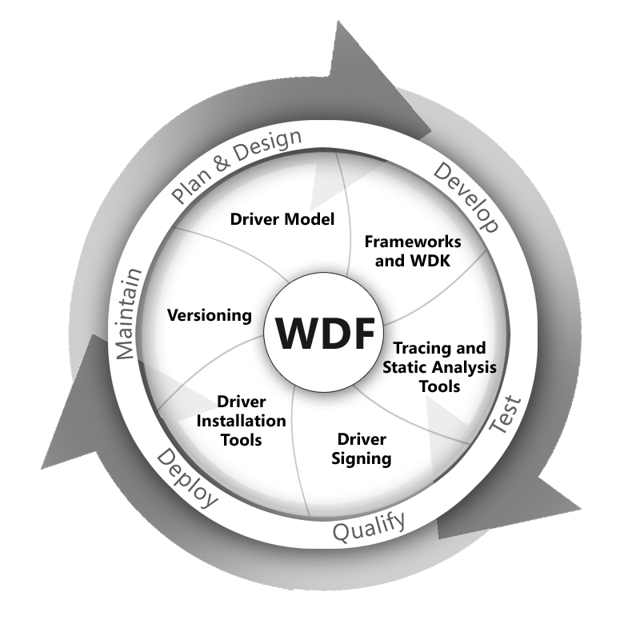
Figure 1. Windows Driver Foundation and the Driver Life Cycle
- Driver model. The WDF driver model supports the creation of object-oriented, event-driven drivers. By using WDF, driver writers can focus on their device hardware, rather than on the operating system. WDF drivers can be written for either kernel mode or user mode.
- Frameworks and the Windows Driver Kit (WDK). WDF defines a single driver model and includes frameworks for both kernel-mode and user-mode driver development. The frameworks provide the basic infrastructure to support the WDF model. They implement common features, provide intelligent defaults, and manage most interactions with the operating system.
The kernel-mode driver framework (KMDF) implements basic kernel-mode driver support features that are required by Windows and are common to all kernel-mode drivers.
The user-mode driver framework (UMDF) provides functional support similar to that in the KMDF, but enables drivers for some types of devices to run in user mode instead of in kernel mode.
All WDF drivers are built by using the WDK build environment.
- Tracing and static analysis tools. Both the KMDF and the UMDF have built-in verification code and support integrated tracing through Event Tracing for Windows (ETW). The generated traces can help in debugging drivers during development and in diagnosing problems in released drivers. WDF drivers also work with the existing driver verifier. In addition, compile-time driver verification tools, such as PREfast and Static Driver Verifier (SDV), are also part of the WDF effort.
- Driver signing. WDF drivers are signed in the same way as Windows Driver Model (WDM) drivers.
- Driver installation tools. WDF drivers are installed by using INF files and work with existing driver installation tools, including the Driver Install Frameworks (DIFx) tools.
- Versioning. WDF supports versioning so that a single driver binary can run on any version of the operating system and use the same version of the framework with which it was built and tested.

“Designed for Windows” Logo Program requirements for WDF drivers are currently under development.
This paper describes the design goals for WDF as a whole and addresses how the WDF architecture and components help to achieve these goals. Although the implementations differ, most features are common to both kernel-mode and user-mode frameworks. Some features and components differ, however; the paper identifies these as they apply specifically to kernel-mode drivers (or the KMDF) or user-mode drivers (or the UMDF).

Design Goals for WDF
Writing a Windows driver is not easy. The current kernel-mode driver development model—WDM—is complex and has serious limitations.
WDM requires that drivers be designed to manage interactions with the operating system, not just the device hardware. A simple WDM driver has thousands of lines of code, much of which implements common features that every driver must support. WDM drivers must use device-driver interfaces (DDIs) that are exported directly from the operating system kernel. These interfaces were designed for performance, not for ease of use. In many cases, the DDIs expose essential operating system data structures directly to drivers, thus increasing the chance that a driver error might crash or corrupt the system.
For some device types, port/miniport models implement much of the WDM code. However, Windows supports more than ten such models and each is different, so the knowledge gained from writing a miniport driver for one type of device does not necessarily apply to writing a miniport driver for a different type of device.
Unlike kernel-mode drivers, user-mode drivers have no common infrastructure that is comparable to WDM. The various user-mode driver models are different and incompatible. None of the user-mode driver models provides integrated support for Plug and Play and power management, and none works closely with the Windows I/O manager, which leads to an inconsistent and unsatisfactory user experience.
WDF was designed to simplify driver development and improve driver quality without sacrificing performance. It provides a single model that has infrastructures for both kernel-mode and user-mode drivers. The model is flexible, extensible, and scalable, and enables incremental development, decreases the learning curve, and enables driver writers to focus on their device hardware, rather than on the operating system.
The following are the primary design principles underlying the WDF model:
- Separate the driver model from the core operating system components.
- Provide a user-mode option for some device types.
- Implement common and default driver features so that driver developers can focus on their hardware.
- Make drivers event driven and define the events at a detailed level so that driver tasks are straightforward.
- Simplify Plug and Play and power management implementation for all drivers.
- Support a consistent installation process for both user-mode and kernel-mode drivers.
- Provide integrated tools, including built-in tracing and verification support, to help find and diagnose problems both during debugging and after release.
- Enable a single driver binary to work with several versions of the framework and the operating system.

Device and Driver Support in WDF
Table 1 lists the WDF support planned for various device classes and driver models in Windows Vista.
Table 1. WDF Device Support Planned for Windows Vista
Device class / Driver model | KMDF | UMDF | SDV | PREfast
Antivirus filters | No | No | Yes | Yes
CD-ROM devices | Yes | No | Yes | Yes
Cell phones | No | Yes | No | Yes
Digital cameras | No | Yes | No | Yes
Display adapters | No | No | No | Yes
DSL / Cable modems | Yes | No | No | Yes
Ethernet devices | No | No | No | Yes
Keyboards and mouse devices | Yes | No | Yes | Yes
Modems | Yes | No | Yes | Yes
Other devices (not listed here) that connect to a protocol bus such as USB or IEEE 1394 | No | Yes | No | Yes
PDAs | No | Yes | No | Yes
Portable media players | No | Yes | No | Yes
Printers | No | No | No | Yes
Scanners | No | No | No | Yes
SCSI / StorPort | No | No | No | Yes
Video capture devices (Webcams) | No | No | No | Yes

For the release of Windows Vista, in-box drivers for several device types, including cell phones, media players, and network-connected devices, are currently planned as UMDF drivers. Drivers for WinUSB, ultrawide band, HD Audio, and several other device types are planned as KMDF drivers. In addition, Microsoft plans to use KMDF for most of the drivers that are involved in future virtualization technologies.
Support for additional device classes will be added over time.

WDF Driver Model
The WDF driver model defines an object-oriented, event-driven environment in which driver code manages device-specific features and a Microsoft-supplied framework calls the driver to respond to events that affect the operation of its device. The driver model includes:
- An object model that is implemented by both frameworks.
- A Plug and Play and power management implementation that both frameworks use.
- An I/O model in which the frameworks handle interactions with the operating system and manage the flow of I/O, Plug and Play, and power management requests.
- A versioning strategy that applies to both kernel-mode and user-mode drivers.
- Consistent installation techniques for both kernel-mode and user-mode drivers.

This design has several important advantages:
- The frameworks implement common driver features and default behavior, thus making vendor-written drivers smaller and faster to develop and debug.
- Microsoft can change the operating system’s internal data structures without introducing driver incompatibilities.
- Driver developers and hardware vendors are better isolated from incremental changes in each new version or update of the operating system.
- Each framework can track the state of the driver, operating system, and device, thus eliminating much of the complex logic often required in drivers, particularly in respect to Plug and Play and power management.

The WDF model provides a consistent but extensible driver development interface. Both frameworks conform to conventions for naming, parameter types and usage, object hierarchy, and defaults. Features that are required by or common to all device types are part of each overall framework, so driver writers can apply knowledge gained from writing a driver for one device type to writing a driver for another device type.

WDF Object Model
In the WDF object model:
- Objects work as building blocks for the driver. A driver modifies these objects through well-defined interfaces. The objects themselves have well-defined life cycles.
- A set of events can affect each type of object. The framework defines default behavior for each event. To support device-specific behavior, the driver includes callback routines that override the defaults.

The model defines a set of objects that represent common driver constructs, such as devices, queues, I/O requests, and the driver itself. The objects have properties, methods, and events.
- Properties describe characteristics of the object. Each property is associated with methods that get and (if relevant) set the value of the property.
- Methods perform actions on the objects.
- Events are conditions for which a driver might need to take action. WDF identifies possible events for each object and defines default actions for most of them. The driver includes code to handle only the events for which the default actions are inappropriate or inadequate for its device. When the event occurs, WDF invokes the related callback.

A WDF driver creates instances of the objects that it requires to service its device and customizes those instances to suit its requirements. For each instance, the driver provides callbacks for the events that require actions other than the WDF defaults. The callbacks call methods on the object to perform any additional actions.
Objects are organized hierarchically. The WDF driver object is the root object; all other objects are subordinate to it. For most object types, a driver can specify the parent when it creates the object. If the driver does not specify a parent at object creation, the framework sets the parent to the WDF driver object by default. Some object types, however, have predefined parents that cannot be changed at creation. For example, I/O queue objects are children of the device object. Each child object is deleted when its parent object is deleted.
Although the object model applies to both the KMDF and UMDF, WDF objects themselves are implemented differently in the two frameworks.

Kernel-Mode Objects
KMDF objects are structures that are opaque to the driver. Drivers never directly access instances of KMDF objects. Instead, they reference object instances by handles. To read, write, or perform an action on an object, a driver calls a method on the object and passes the handle.
The KMDF defines more than 20 types of objects. Table 2 lists some of the most commonly used.
Table 2. Commonly Used KMDF Object Types
Object type name | Usage
WDFDRIVER | Represents the driver object
WDFDEVICE | Represents a device object
WDFQUEUE | Represents a queue of I/O requests
WDFINTERRUPT | Represents an interrupt resource
WDFREQUEST | Describes an I/O request
WDFMEMORY | Describes a buffer for an I/O request
WDFDMAENABLER | Describes the characteristics of all DMA transfers for a device
WDFDMATRANSACTION | Manages operations for an individual DMA request
WDFIOTARGET | Represents the driver that is the target of an I/O request

KMDF objects are unique to the framework. They are not managed by the Windows object manager and therefore cannot be manipulated by using the system’s ObXxx functions. Only the framework and WDF drivers can create and manipulate them.
Similarly, KMDF events are not related to the kernel-dispatcher events that Windows uses as synchronization mechanisms. A driver cannot create, manipulate, or wait on a WDF event. Instead, the driver registers a callback for the event and WDF calls the driver when the event occurs.

User-Mode Objects
UMDF objects are based on the component object model (COM). The UMDF uses a small subset of COM for query-interface and reference counting features. In user-mode drivers, both the driver and the framework implement and expose COM-style interfaces. Handles are not required because the interfaces are abstract base classes and thus identify the object.
The UMDF defines fewer objects than the KMDF because user-mode drivers cannot directly access hardware and therefore do not perform direct memory access (DMA) or handle interrupts. Table 3 lists the interfaces that expose the UMDF object types.
Table 3. Interfaces for UMDF Object Types
Object interface name | Usage
IWDFObject | Defines the base WDF object type
IWDFDriver | Represents the driver object
IWDFDevice | Represents a device object
IWDFFile | Represents a file object
IWDFIoQueue | Represents a queue of I/O requests
IWDFIoRequest | Describes an I/O request
IWDFIoTarget | Represents the driver that is the target of an I/O request
IWDFMemory | Provides access to an area of memory

Plug and Play and Power Management Support
Simplifying driver support for Plug and Play and power management and making it available in both kernel mode and user mode were primary design goals for WDF. Seamless handling of Plug and Play and power events is critically important to system reliability and a good user experience, but is exceedingly complex to implement correctly.
Much of this complexity occurs because drivers must determine the correct way to handle each Plug and Play or power management request. Proper handling depends on the driver’s position in the device stack, the current state of its device, the current state of the operating system, and sometimes the nature of an impending state change for the device or system. Such support typically requires thousands of lines of code to handle tricky, state-dependent situations. Most drivers require code to handle requests that they don’t even support.
WDF concentrates the state-tracking and decision-making logic in the frameworks, instead of requiring it in each driver. WDF support for Plug and Play and power management is based on the following principles:
- The driver should not be required to interpret or respond to every uninteresting request. Instead, the driver should be able to “opt in” and handle only the requests that are relevant to its device.
- The frameworks should provide default behavior for a rich set of Plug and Play and power features, including device stop, device removal, device ejection, fast resume, low run-time power usage, and device wake-up by external events.
- WDF actions at each point must be well-defined and predictable; in effect, a “contract” applies to each driver callback.
- Plug and Play and power management should be thoroughly integrated with other parts of the frameworks, such as queue management.
- The frameworks must support both simple and complex hardware and driver designs.
- A driver should be able to override any framework-supplied defaults.

Plug and Play/Power Management State Machine
Internally, WDF implements Plug and Play and power management as a state machine. Both the KMDF and the UMDF use the same state machine. A driver includes callbacks so that it can perform device-specific actions at individual states in the machine. For example, a driver can provide a callback that is called immediately after its device enters the working state.
At each state transition, a predetermined set of events is valid for each type of object, and the framework invokes the driver’s callbacks for these events in a defined order. Thus, a driver can assume that both the system and its device are in a particular state whenever it is asked to perform a Plug and Play or power management action.
The complicated logic that tracks system and device state is incorporated into the framework, not into the driver. This approach vastly reduces the amount of required decision-making in the driver—especially during power transitions—and eliminates much redundant code. Instead, the framework defines a state-related event and the driver optionally supplies a corresponding callback. As a result, a WDF driver includes code to handle only those events for which it requires device-specific support. All other events can be handled by WDF defaults.
Furthermore, Plug and Play and power management support are integrated throughout the framework so that other aspects of the driver operate properly when state transitions occur. For example, a driver can configure its I/O queues so that the framework stops dispatching requests while the device is in a low-power state.

Integrated I/O Queuing and Cancellation
WDF integrates Plug and Play and power management support with the queuing of I/O requests and, in turn, integrates queuing with request cancellation.
Both the KMDF and the UMDF provide configurable I/O queues. The driver creates the queues and configures them for specific I/O requests, power management characteristics, and dispatching requirements. The framework queues and dispatches requests according to the driver’s specifications: sequentially (one at a time), in parallel (as soon as they arrive), or manually (at the driver’s explicit request). When Plug and Play or power management events affect queuing, WDF can start, stop, or resume queuing as appropriate, depending on how the driver configured the queue.
Because Windows I/O is inherently asynchronous, handling the cancellation of an I/O request is often complex. The driver must cope with several potential race conditions and one or more locks, and the required code is typically scattered among several driver routines.
WDF relieves drivers of much of this burden by managing the locks for the I/O queues and by canceling queued requests without driver intervention. (A driver can, however, register for notification when a request is canceled.) By default, requests that are in a queue can be canceled. Requests that have been removed from a queue and dispatched to a driver cannot be canceled unless the driver specifically marks them so. WDF drivers that use these defaults typically require little if any cancellation code.

Concurrency
Managing concurrent operations is another challenge in writing a Windows driver. Because Windows is a pre-emptive, multitasking operating system, multiple threads can concurrently try to access shared data structures or resources, and multiple driver routines can run concurrently. To ensure data integrity, drivers must synchronize access to shared data structures.
WDF simplifies synchronization by implementing several internal synchronization mechanisms and by holding any required locks when it invokes a driver’s callbacks. In addition, WDF supports synchronization scope, a configurable object-based mechanism for specifying the degree of concurrency. (Synchronization scope is called the locking constraint in the UMDF.) An object’s synchronization scope determines whether WDF invokes multiple event callbacks on the object concurrently. Drivers that use the KMDF can specify synchronization scope for driver, device, and file objects. In the UMDF, synchronization scope applies only to device objects.
WDF defines the following synchronization scopes:
- Device scope
- Queue scope
- No scope

Device scope means that WDF does not call certain I/O event callbacks concurrently for an individual device object or any file objects or queue objects that are its children.
Queue scope means that these I/O callbacks are not called concurrently on a per-queue basis. If a kernel-mode driver specifies queue scope for a device object, these callbacks can run concurrently for multiple queues. However, multiple callbacks for an individual queue object will not be called concurrently. The initial UMDF release does not support queue scope.
No scope means that WDF does not acquire any locks and can call any event callback concurrently with any other event callback.
By default, the KMDF uses no scope. A kernel-mode driver must “opt in” to synchronization for its objects by setting device scope or queue scope when it creates the object. The UMDF uses device scope by default.
For kernel-mode drivers, the KMDF also enables driver writers to constrain the interrupt request level (IRQL) at which the callbacks can be invoked.

I/O Model
In Windows, the I/O request packet (IRP) does more than just present traditional I/O requests (read, write, create, and so forth) to drivers. It works as a general packet-based communication mechanism between the operating system and drivers, and between drivers themselves. The Windows I/O manager sends IRPs to notify drivers of Plug and Play requests, power management requests, changes in device status, and queries about device and driver resources (among other purposes) in addition to passing I/O requests. Therefore, the WDF I/O model encompasses more than just data transfers to and from a device.
For WDF drivers, the framework manages the mechanics of dispatching, queuing, completing, and canceling IRPs on behalf of its drivers. The framework calls the driver’s event callback routines to notify it of significant events such as requests that the driver must handle.
After receiving a request, the framework records information about the request, creates a WDF object to represent the request (if necessary), and calls one or more of the driver’s event callbacks to handle the request as appropriate. WDF queue objects help drivers to manage the arrival of I/O requests. A driver can create one or more such queues and configure each to receive specific types of requests. Depending on the dispatch mechanism that the driver has designated for each queue, the framework either delivers the request to the driver immediately or queues it for later delivery.
The framework keeps track of every I/O request while the driver "owns" the request—that is, until the request has been canceled, completed, or passed to another target. Because the framework is aware of all the active requests, it can call the appropriate driver callbacks in case of IRP cancellation, power state changes, hardware removal, and so forth.

I/O Request Flow
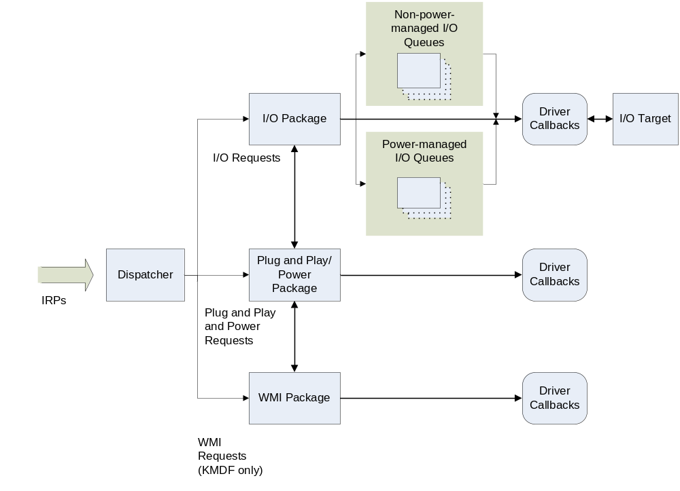
Both the KMDF and the UMDF use the same I/O model, although it is implemented by different components. Within this model, I/O requests flow as shown in Figure 2.
Figure 2. I/O Request Flow
As Figure 2 shows, WDF dispatcher code directs I/O request packets within the framework. WDF dispatches I/O requests according to their major I/O function code. The major function code is a field within the IRP that identifies the type of request. Based on the major I/O function code, the dispatcher determines which package within the framework should initially handle the request.
The following sections describe how WDF processes requests.

Device I/O Requests
When an IRP arrives that requests device I/O, the dispatcher passes it to the I/O package.
If the driver has not configured a queue or exposed a callback for the request type, the framework takes a default action that depends on the type of driver. For a user-mode driver, or for a kernel-mode function driver or bus driver, the framework fails the request. For a kernel-mode filter driver, the framework forwards the request to the next lower driver in the stack.
If the driver has configured a queue or exposed a callback for the request type, the framework creates a WDF request object, which contains the information in the original IRP structure along with additional information about the driver state. The framework then places the request object in the corresponding queue.
If the queue is configured for automatic power management, the framework then determines whether the device is in the correct power state. If not, the Plug and Play and power package puts the device in the working state. If the driver has registered callbacks for power events, the framework calls them; otherwise, it takes whatever default steps are required.
After the device has entered the working state, the framework dispatches the I/O request according to the driver’s specifications by invoking the callbacks registered for the I/O request. (A driver can also request manual dispatching, which means that it must call the framework to get a request.) The framework passes the WDF request object when it invokes the callbacks. The driver’s callbacks might set or get properties for the request, call methods on the request object or other WDF objects, perform device I/O, and take other actions as necessary to handle the request.
When the driver has finished processing the request, the driver can complete it or pass it on to an I/O target. An I/O target is an external destination for the I/O request. The next lower driver in the device stack is considered the local I/O target; any other driver is considered a remote I/O target.
If a driver does not complete an I/O request, it typically sends the request to its local I/O target. Occasionally, however, a driver might require information from a different driver before it can complete a request. To obtain this information, the driver creates an object to represent the remote I/O target, creates a WDF request object, and then calls methods on the I/O target to send the request.

Plug and Play and Power Management Requests
When a Plug and Play or power request arrives, the framework determines whether any Plug and Play or power management state changes are required to satisfy the request. If so, the framework takes the necessary actions to change the state and either calls the driver’s registered event callbacks or performs default actions if the driver has not registered any callbacks for those events.
After the relevant callbacks have returned, the framework completes or forwards the request, as appropriate, on the driver’s behalf.

WMI Requests (Kernel-Mode Drivers Only)
A Windows Management Instrumentation (WMI) request triggers callbacks that the driver registered for any current WMI events. In its WMI callbacks, the driver might call WMI methods on the device object to create and manipulate WMI instances or to change its status as a WMI provider. After the WMI callbacks have returned, the framework completes or forwards the request, as appropriate, on the driver’s behalf.
Only the KMDF supports WMI.

Sample Scenario
To understand how an I/O request flows through a WDF driver, consider the following scenario:
- A user-mode process requests a read from a device.
- At the time of the request, the device is in a low-power state.
- The driver has configured a power-managed queue to accept read requests.

The request is processed by the WDF function driver as follows:
1. The IRP dispatcher inspects the IRP and directs it to the I/O package. The I/O package creates a WDF request object to represent the IRP, adds the WDF request object to the queue, and checks the current device power state. Because the device is in a low-power state, the I/O package calls the Plug and Play/power management package to put the device in the fully powered working state so that it can perform the read operation.
2. The Plug and Play/power management package returns the device to the working state by taking default actions and calling the appropriate power management callbacks implemented by the driver.
3. When the device has successfully re-entered the working state, the framework dispatches the read request to the driver. If the driver has configured manual dispatching, the driver calls a method on the queue to get a request. Otherwise, the framework dispatches the request either immediately or when the driver has completed the previous request, depending on the queue’s configuration.
4. If the driver can satisfy the request, it does; if it cannot, it sends the request to an I/O target.

Driver Frameworks
The WDF driver model is implemented through the KMDF, which supports kernel-mode driver development, and the UMDF, which supports user-mode driver development. The frameworks provide the basic driver infrastructure and perform the following services for WDF drivers:
- Define WDF objects that drivers can instantiate.
- Manage object lifetimes.
- Expose a basic set of DDIs that drivers call to manipulate the objects.
- Provide a common implementation of features that drivers typically require, such as Plug and Play, power management, synchronization, I/O queues, and access to the registry.
- Manage the flow of I/O requests and Plug and Play and power notifications from the operating system to the driver.

Instead of calling the operating system directly, drivers interact with the appropriate framework for most services. The frameworks manage most of the interactions with the operating system on behalf of the driver. In effect, the frameworks shield driver developers from the details of the operating system.
The frameworks implement the WDF I/O model, object model, and Plug and Play and power management support. Each framework receives I/O requests, calls the driver to handle events according to the driver’s configuration, and applies defaults otherwise. Both frameworks provide intelligent defaults for common operations so that drivers do not require large amounts of potentially buggy “boilerplate” code.
The frameworks support common features required for all device classes. Device-class–specific extensions can also be added. For example, the initial release of the KMDF supports extensions specifically for USB devices. As new features are added to the operating system, and as new device classes are supported, features that are common to all device classes will be added to the base set of DDIs in the frameworks. Extensions will provide features that are required by one or more specific device classes, but not by every device class. The extensions are intended to replace the miniport models common with WDM.

Kernel-Mode Framework
For kernel-mode drivers, the KMDF does not replace WDM; instead, it provides a skeletal WDM implementation. In effect, the driver developer configures the skeletal driver to work with a particular device by creating objects and providing event-based callback routines.
The KMDF is a reentrant library that can be shared by multiple drivers. Drivers are dynamically bound with the library at load time, and multiple versions of the library can be used by multiple drivers simultaneously.
The KMDF currently supports creation of the following types of kernel-mode drivers:
- Function drivers for Plug and Play devices.
- Filter drivers for Plug and Play devices.
- Bus drivers for Plug and Play device stacks.
- Control device drivers for legacy (“NT 4.0-style”) devices that are not part of a Plug and Play stack.

Currently, the KMDF does not support bus filter drivers.
WDF provides certain methods and callbacks specifically for bus drivers, others specifically for function and filter drivers, and still others for control device drivers.
The KMDF identifies a function driver, control device driver, or a bus driver based on the methods that the driver calls and the callbacks that the driver supports. For example, the bus driver for a device typically supports callbacks to enumerate the children of the device and to supply a list of the hardware resources that the device requires. A function driver for a device typically supports callbacks to manage power to its device.
A filter driver explicitly identifies itself as such before creating its device object. The KMDF uses this information when passing I/O requests to the driver. A filter driver registers for only the I/O requests it chooses to filter; the KMDF passes all other requests to the next lower driver. (For a function or bus driver, WDF fails other requests.) By contrast, a WDM filter driver must accept all I/O requests that could be targeted to its device, pass those it does not filter to a lower driver, and act on the remaining subset. A WDM filter driver requires logic to inspect and forward many types of requests; a WDF filter driver has no such code because it receives only the requests it is interested in.
When an application sends an I/O request to a kernel-mode WDF driver, the request travels through the components shown in Figure 3.
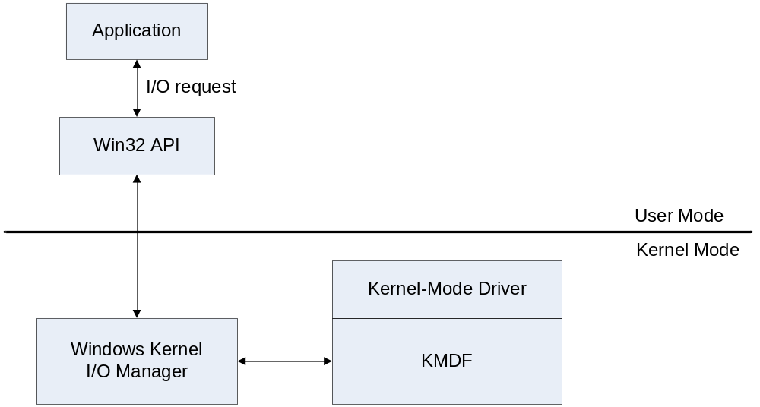
Figure 3. I/O Flow to Kernel-Mode WDF Driver
As the figure shows, the following components are involved in handling an I/O request to a kernel-mode WDF driver:
- Application. The application is a user-mode process that issues I/O requests through the Microsoft Win32® API.
- Win32 API. In response to the application’s I/O request, the Win32 API calls I/O routines in the Windows kernel.
- Windows kernel. The I/O manager in the Windows kernel creates an IRP to represent the request and presents it to the target driver by calling the driver at a designated entry point. For kernel-mode WDF drivers, the KMDF registers the entry points, in effect intercepting the request on behalf of the driver.
- KMDF. The KMDF processes the request as previously described in “I/O Request Flow,” creating a WDF request object and calling the driver’s event callback routines as required.

User-Mode Framework
The UMDF implements a subset of the KMDF functionality, including support for Plug and Play, power management, and asynchronous I/O. Drivers that run in user mode have access only to the user address space and therefore pose low risk to system stability. User-mode drivers cannot handle interrupts, perform DMA, or use kernel-mode resources such as nonpaged pool.
Using the UMDF, developers can create drivers for any protocol- or serial-bus–based device. Although these drivers run in user mode, they use the standard Plug and Play installation mechanism and the same I/O model as kernel-mode WDF drivers. To determine whether a user-mode driver is suitable for your device, see “Introduction to the WDF User-Mode Driver Framework,” which is listed in the Resources section.
Figure 4 shows the components involved in transmitting an I/O request from an application to a user-mode WDF driver.
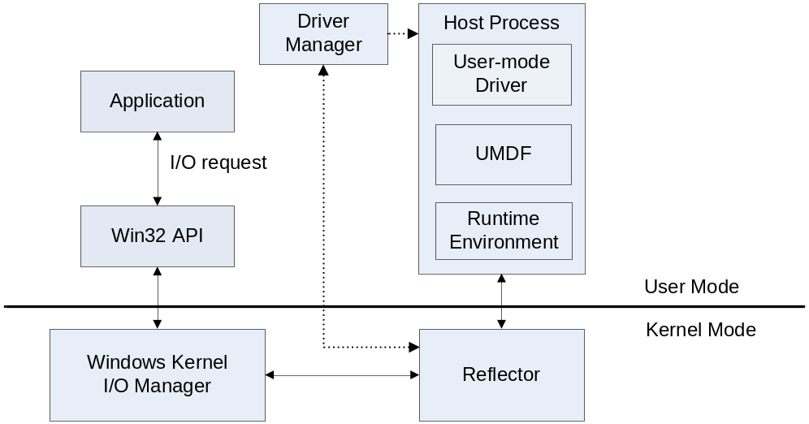
Figure 4. I/O Flow to User-Mode WDF Driver
Figure 4 includes the following components, described according to the typical flow of an I/O request.
Application. The application is a user-mode process that issues I/O requests through the Win32 API.
Win32 API. In response to the application’s I/O request, the Win32 API calls I/O routines in the Windows kernel.
Windows Kernel. The I/O manager in the Windows kernel creates IRPs to represent the requests and presents them to the target driver by calling the driver at a designated entry point. If the target of the request is a user-mode WDF driver, however, the I/O manager cannot call the driver or the UMDF directly because these components run in a user mode process and kernel-mode components cannot call back to user mode. Therefore, the I/O manager does not present the request directly to the user-mode driver. Instead, the I/O manager presents the request to a kernel-mode component called the reflector.
Reflector. The reflector is a kernel-mode WDM filter driver that represents the user-mode driver in the kernel-mode driver stack. The reflector passes the I/O request to the user-mode driver host process.
The reflector manages communication between the kernel-mode components and the user-mode driver host process. It monitors the driver host process to ensure that it responds properly to messages and completes critical operations in a timely manner, thus helping to prevent driver and application hangs. The reflector also sends messages to the driver manager as required.
The reflector is supplied by Microsoft and is added as the top driver in the kernel-mode driver stack during installation of the user-mode driver.
Driver Host Process. The driver host process is the user-mode process in which the user-mode driver runs. It includes the following components:
- The user-mode WDF driver is an in-process COM component that controls the hardware from user mode. An independent hardware vendor (IHV) supplies the user-mode WDF driver.
- The UMDF exposes the user-mode DDI. The UMDF is a dynamic-link library (DLL) of COM-style objects that support the presentation, flow, and management of I/O, Plug and Play, and power management requests to the driver.
- The run-time environment dispatches I/O requests, loads the driver, constructs and destroys the user-mode device stack, manages a user-mode thread pool, and handles messages from the reflector and the driver manager.

The driver host process is separate from the application process and the driver manager. It runs in the security credentials of a LocalService account, although it is not a Windows service. The driver host process contains the user-mode device stack for the device. The device stack is visible to all applications across the system. Each instance of a device has its own device stack. Currently, each instance has a separate driver host process, too. The driver host process is a child process of the driver manager.
Driver Manager. The driver manager creates and shuts down the driver host process and maintains status information about it. It also responds to messages from the reflector. The driver manager runs as a Windows service and is started during installation of the first device that is managed by a user-mode WDF driver. The driver manager must be running all the time that any device controlled by a user-mode WDF driver is installed on the system. Microsoft provides the driver manager.

Tools for Development and Testing
Thoroughly testing a driver is nearly as complex as writing one for two main reasons:
- Observing the point of error can be difficult. In many cases, a driver error is not apparent until long after it has actually occurred. If a kernel-mode driver uses a DDI incorrectly, the system might not crash until another driver attempts to perform an action based on the first driver’s error.
- Subtle, condition-dependent errors and related code paths are difficult to exercise. Drivers that work correctly under normal circumstances can have subtle errors that occur only under exceptional situations, such as when another driver, lower in the stack, fails an I/O request.

Too often, testing becomes a hit-or-miss, trial-and-error affair. To help remedy this situation, WDF has several testing and tracing features that make it easier for driver writers to find problems early in the development cycle. These features include the following:
- Built-in verification with the frameworks verifier
- Built-in trace logging
- Debugger extensions

In addition, WDF includes PREfast and Static Driver Verifier (SDV). PREfast and SDV are both compile-time code verification tools that are provided with the WDK. PREfast analyzes code on a function-by-function basis, looking for a wide variety of common logic and usage errors. SDV applies knowledge about system internals to kernel-mode driver verification. For more information about PREfast and SDV, see the paper “PREfast Step-by-Step” and the WHDC Web site, which are listed in the Resources section.

Frameworks Verifier
WDF includes an internal driver verifier that provides framework-specific features that are not currently available in the driver verifier (Verifier.exe). The frameworks verifier provides extensive tracing messages that supply detailed information about activities within the framework. It tracks references to each WDF object and builds a trace that can be sent to the debugger.
In kernel mode, the frameworks verifier checks lock acquisition and hierarchies, ensures that calls to the framework occur at the correct IRQL, and verifies correct I/O cancellation and queue usage. It can also simulate low-memory and out-of-memory conditions and test a driver’s response to these situations to determine whether the driver responds properly without crashing, hanging, or failing to unload.
In user mode, the frameworks verifier checks for correct use of parameters, valid configurations, and correct responses to events.

Trace Logging
Both the KMDF and the UMDF support integrated internal trace logging.
The KMDF includes an internal trace logger called the in-flight recorder (IFR), which is based on the Windows software trace preprocessor (WPP). The IFR provides a recent history of events (currently, about the last 100 trace events) on a per-driver-instance basis. The trace logs track the progress of IRPs through the framework and the corresponding requests through a driver. Each WDF driver has its own log.
Kernel-mode drivers can use ETW and WPP software tracing to generate a trace log that contains information about both the driver and the KMDF. Driver-level tracing provides information about events in the driver code. Internal WDF tracing provides information about events internal to WDF that might affect driver activities. A driver developer can choose whether to implement driver-level tracing, but internal WDF tracing is always available.
Driver writers can use the software tracing tools provided with the WDK to view the IFR logs during interactive debugging. These logs can also be made available as part of a minidump for inspection after a crash. The typical saved IFR log file is small (10 to 20 K bytes) and written in a binary form that humans cannot read.
The user-mode driver components supplied by Microsoft start trace sessions that record their activities and note such events as driver hangs, time-outs, and failures. The log files from these sessions can be sent as input to Windows Error Reporting (WER). Vendor-supplied user-mode WDF drivers can use ETW to generate a trace log of driver events.

Debugger Extensions
WDF also includes several debugger extensions that can dump internal trace records. This information can help locate the exact point in I/O processing at which an error occurred and can often give a clue to faulty assumptions or unexpected behavior.
Two sets of debugger extensions are provided for WDF. One set supports user-mode debuggers, and the other supports kernel-mode debuggers. The extensions have different names, but provide similar functionality and display similar output.

Serviceability and Versioning
To improve driver serviceability, WDF includes versioning and side-by-side support. Versioning allows a driver binary to run with the same major version of WDF with which it was built. Side-by-side support enables the simultaneous use of two or more major versions of WDF by two or more drivers.
Serviceability is a common problem for drivers. When Microsoft releases a new version of Windows, driver vendors must test their drivers to ensure that they operate properly on the new release. Any driver that uses undocumented features, or that uses documented features in a nonstandard way, is likely to encounter compatibility problems from one release to the next. Even drivers that follow the rules might be affected by subtle changes between versions of Windows.
Drivers that use the frameworks, however, are less susceptible to such problems. Microsoft is responsible for testing the frameworks on each new version of the operating system and ensuring that drivers built with older versions maintain consistent behavior from one release to the next.
In addition, the versioning support in WDF helps to prevent compatibility problems. The frameworks have major and minor version numbers, which are recorded in the driver binaries. In general, a WDF driver runs against the latest available minor version of the major version against which it was compiled, so that it can benefit from bug fixes in the newer version.
A WDF driver can use a newer minor version, but not an older minor version, than the one against which it was built. Multiple WDF drivers can use a single WDF library. They can also run side by side using different major versions of the framework.

Next Steps
WDF is the next-generation model for Windows drivers. It provides frameworks for creating both kernel-mode and user-mode drivers and works with a set of integrated development and testing tools.
Microsoft strongly encourages device and driver vendors to use the WDF model. It provides the following benefits:
- Shorter learning curve for driver developers.
- Focus on device hardware, not on the details of the operating system.
- Faster and easier driver development and debugging.
- Improved serviceability and reduced maintenance costs.

What should you do?
- Learn about WDF by exploring the resources in the next section.
- Sign up for the WDF beta program and begin using WDF now.
- Use WDF to develop new drivers whenever possible.

Resources
Windows Driver Foundation:
Windows Driver Foundation
http://www.microsoft.com/whdc/driver/wdf/default.mspx
Introduction to the Windows Driver Foundation
http://www.microsoft.com/whdc/driver/wdf/wdf-intro.mspx

Windows Driver Foundation Beta:
Windows Driver Foundation Beta Program Invitation
http://www.microsoft.com/whdc/driver/wdf/beta.mspx
Information about future beta releases will also be provided on the WDF page on the WHDC Web site and on the DDK Web page.

Windows Driver Development Kit: Overview:
http://www.microsoft.com/whdc/DevTools/ddk/default.mspx

White Papers:
Introduction to the WDF User-Mode Driver Framework
http://www.microsoft.com/whdc/driver/wdf/UMDF_intro.mspx
Architecture of the Kernel-Mode Driver Framework
http://www.microsoft.com/whdc/driver/wdf/kmdf-arch.mspx
Introduction to Plug and Play and Power Management in the Windows Driver Foundation
http://www.microsoft.com/whdc/driver/wdf/WDF_pnpPower.mspx
PREfast Step-by-Step
http://www.microsoft.com/whdc/DevTools/tools/PREfast_steps.mspx

PREfast
PREFast
http://www.microsoft.com/whdc/devtools/tools/prefast.mspx

Static Driver Verifier:
Static Driver Verifier - Finding Driver Bugs at Compile-Time
http://www.microsoft.com/whdc/devtools/tools/sdv.mspx

