



Digital Resume here
Rakesh Nagarajan
DevOps|Cloud|Platform
8 Years of Experience
rakesh-nagarajan
RakeshNagarajan
narakeshece12@gmail.com
+91-9698490903

Coimbatore, TN, India

About Me
Currently working in Advanced Micro Devices[AMD] as MTS Software development engineer with nearly 8 years of total experience in IT. I am a team player with team managing capability and have good debugging skills. Having interest in learning hot technology in short span of time. Sharing knowledge to the team with proper documentation. Providing on the go solution to the customers. Follow sprint properly on-time and providing on-time product delivery. Adhere to all security norms of organization. Also, I am interested in hosting training sessions and tech-talks inside team.

Career Objective
To implement innovative ideas in an efficient way and to reduce manual effort.



S

My Timeline
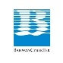




SSSS
2025
2012
2024
2018
2020
2016
2019
2022
2017
2023
2021
May-2018 to June-2021 (3yrs)
Robert Bosch
Role : Devops/Cloud
Projects: JMaaS, XaaS, BIaaS
Team : 5 [24*5]
Location: Coimbatore, TN

What next?
June-2016 to May-2018 (2yrs)
Bahwancybertek
Role : DBA/Devops
Clients : American towers
Team size: 4 [24*7]
Location: Chennai, TN

June-2021 to till date (3yrs)
Advanced Micro Devices (AMD)
Role : Devops /Cloud/SRE
Projects: DevCloud, Infra
Team : 7 [24*5]
Location: Bengaluru, KA (WFH)
June-2012 to May-2016
B.E [E.C.E] with 79 %

Individual contribution
- Designed and developed a Self-service portal for project – Saves 4 hours of manual work per day
- Designed and developed an internal application with Django Rest API, VueJs and Kubernetes on premise for deploying any Docker application container (XaaS - Anything as a Service)
- Implemented efficient monitoring solution of servers and Docker logs using Grafana/promtail/loki – saves debugging time
- Automated Docker build with dynamic Dockerfile using Jenkins pipeline
- Automated oracle 12c Database installation using Ansible – Saves 7 hours of manual work
- Impmemented health Check Automation for SQL server using PowerShell and CSS – Reduced manual work 3 hours per day
- Upgraded on-premise Kubernetes from 1.17 to 1.18 to 1.19
- Migrated applications from on-premise to azure cloud
- Migration of on-premise kubernetes cluster to AKS with minimal downtime
- Gitlab to github migration including workflows
- Openstack deployment
- Architected and Developed a new application for infrastructure provisioning the internal project
- Managed Aruba switch for Openstack ironic

 Awards
- RSU grant for helping other teams projects
- Best employee of the month
- Spot award for creating an internal application from the scratch
- Bronze award for Automating Jenkins version update for 250+ instance
- Travelled to Germany for short term

Core Skills
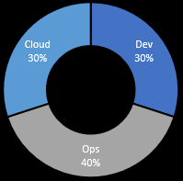

Everyday Schedule
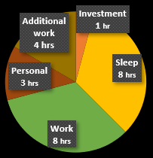



Interest
- Technology
- Macro-economics

Personal info
Date of Birth : 03-11-1994
Nationality : Indian
Gender : Male
Marital status : Single
Zodiac : Libra
Wakeup @ : 6 AM

Hobbies
- Technology
- Youtube
- Listening Music
- Investment

Languages
- Tamil
- English

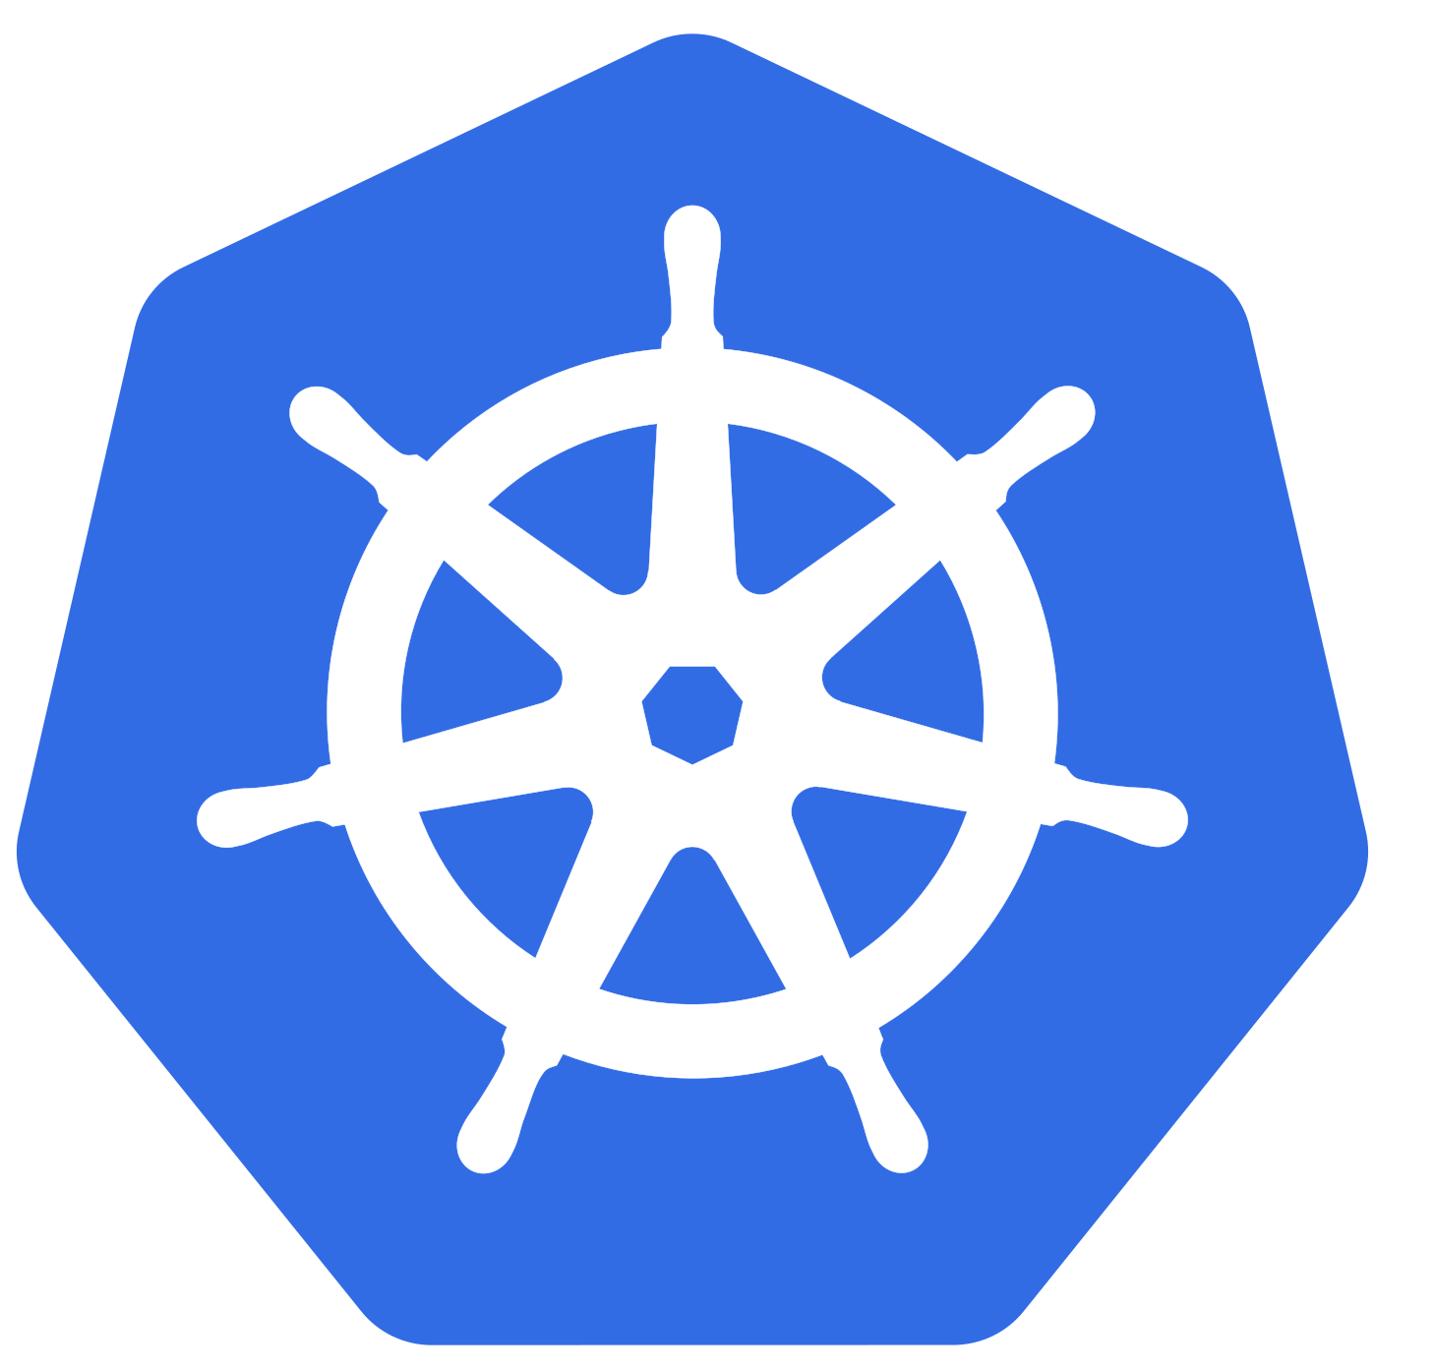









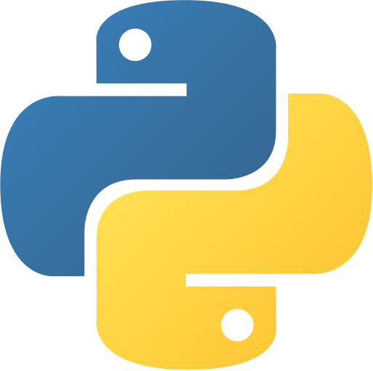


























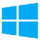



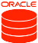











Tools
VScode
Draw.io
Mermaid chart
Apache directory studio

Cloud

Deployed openstack zed version from scratch using Openstack-ansible
Customization of images using disk image builder
Developed openstack DIB custom elements
Extending openstack ironic inspection
Enrollment of Openstack ironic metal nodes
Deploying virtual machine and VM scale set with auto scale up and scale down based on resource
Designing Network security groups to handle inbound and outbound access to network interface
Creating resource group and virtual network along with subnet
Working with storage accounts – Blobs, disks
Experience in app service/container service and hosted web application public
Experience in azure container registry
Experience in tags, locks, security, logs, activity logs, monitoring and other components of service
Working with cloud shell and Azure CLI
Disk image builder for creating custom images for Openstack.
Creating a new DNS for custom application
Experience in handling Nova, Neutron, Zun, Glance, keystone, placement, Horizon services in Openstack
VBMC for simulating vm as metals
Galera cluster backup
Ceilometer

Devops

- Experience configuring and maintaining kubernetes cluster and working with PV, PVC, secrets, services, statefulset, namespace, deployment, ingress and other K8s components
- Implemented Velero and minIO for Kubernetes cluster backup
- Continuous monitoring of the entire 400+ containers and 100+ servers using Splunk and Grafana loki
- Having experience in working with Docker swarm cluster of 80+ production servers
- Experience in kind kubernetes cluster for local testing
- Developed custom resource definition
- Mermaid chart for flowchart
- Written custom helm charts for 18 applications
- Integrated Grafana API, Jenkins API , Splunk API with Django API
- Creating and maintaining Docker swarm, Docker volume/Network/Plugin
- Having real-time experience in configuring splunk forwarder/alerts/dashboards/SPL
- Creating and maintaining GIT/SOCO/TFS repository
- self hosted Github and gitlab runners
- Github enterprise administration
- Migrated gitlab pipeline to github actions
- Adapted pre-commit hook for code formatting automatically
- Secrets abstraction using vault - Dynamic credentials update
- Injecting secrets into k8s pods
- Having knowledge on LXC/LXD containers
- Configuring Jenkins slave and writing pipeline jobs for CI/CD
- Implemented django channels for WebSocket
- Implemented django channels for pushing live notifications
- Adaption of hugo and sphinx for documentation
- Implemented opentelemetry for distributed tasks
- Deployed multiple kubernetes cluster using kubespray
- Automated functional test using robot framework
- Metallb for load balancer in on-premise kubernetes cluster
- AWX for ansible

System administration

- Installation and configuration of operating systems (Windows/ RHEL/ CentOS/Ubuntu)
- Sharing/configuring mount points Between Windows-Linux
- yum repository configuration (Local, Satellite, remote)
- Pushing Security patches in linux server’s
- Configuring NFS Storage/datastore for sharing the data
- Having Knowledge on KVM and QEMU for IaaS
- Monitoring server health and logs using Grafana Loki
- Experience with V-center and handling VMDK volume
- Ansible play-books for server management and Managing the Cluster configuration
- Ansible playbook for identifying wrongly attached VMDK volumes.
- Automated yum configuration/RMP installation using Ansible – Reduces 3 hours of manual work
- IPMI accessing servers
- SSSD for ldap connectivity to linux servers
- KVM for virtual machines creation
- Openldap and keycloak for local user creation and testing
- Rotation of SSL certificate
- Handling RHEL subscriptions




Artificial Intelligence

Having experience in using local models llama2/3 and phi3 via ollama
Experience in designing multi-agent workflow using langgraph
Developed a RAG application for faster searching of documentation
Having experience in vector database and embeddings.

Signature
(RAKESH N)






☐All above given information were true. You can trust me.
☐Ready to relocate based on project demand.
☐Open to work in shift based on project demand.
Place : Coimbatore
Date :

Find me on

