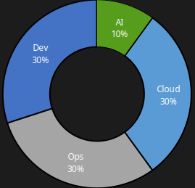
Rakesh Nagarajan
DevOps|Cloud|AI
8+ Years of experience




+91-9698490903
narakeshece12@gmail.com
rakesh-nagarajan
$whoami

I am currently working as an MTS Software Development Engineer at Advanced Micro Devices (AMD) with nearly 8 years of IT experience. I am a collaborative team player with strong team management skills and excellent debugging abilities. I am highly motivated to learn emerging technologies quickly and enjoy sharing my knowledge with the team through thorough documentation. I provide real-time solutions to customers, follow sprint schedules diligently to ensure on-time product delivery, and strictly adhere to organizational security standards. Additionally, I am passionate about hosting training sessions and tech talks within the team.


$history




2016
2018
2021
2025

June-2021 to till date (3 years)

Role:Devops/Cloud
Projects:DevCloud
Team Size:7[24*5]
Location:Bengaluru, KA
(WFH)
May-2018 to June-2021 (3 years)

Role:Devops
Projects:JMaaS/XaaS
Team Size:4[24*7]
Location:Coimbatore, TN
June-2016 to May-2018 (2 years)

Role:DBA/Devops
Project:Internal
Team Size:4[24*7]
Location:Chennai, TN

Individual contribution
Deployed multi-node Openstack production from scratch
Designed and developed a self service platform for instance provisioning
Migrated from on-premise kubernetes to Azure kubernetes services
Migrated from Gitlab to Github including workflows
Upgraded on-premise kubernetes from 1.17 to 1.18 to 1.19
Designed a micro-service template repository

Personal info
Education:B.E [E.C.E]
Date of Birth:03-11-1994
Nationality:Indian
Gender:Male
Marital status:Single
Zodiac:Libra
Wakeup@:6AM
Languages:English,Tamil
My Routine
Languages
Tamil
English
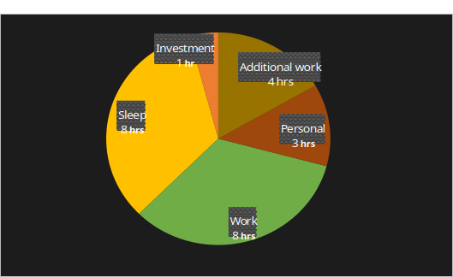

Interest
Technology
Macro-economics
Content creation

Technology  My skills  Knowledge  Openstack cloud  Nova  Glance  Neutron  Keystone  Cinder  Swift  Ironic  Horizon  Placement  Galera  Openstack API  Openstack python SDK  Scripting  Dockerfile  Ansible-playbooks  Kubernetes Manifest  Helm chart  Kustomize file  Python scripting  Powershell  Shell scripting  Github workflow  Jenkinsfile  Foreman template  System Administration  Linux administration  Virtualization  Containerization  Orchestration  Networking  Server monitoring  Storage management  IPMI/BMC  Operating systems  RHEL/RockyLinux  Ubuntu/Debian | Knowledge
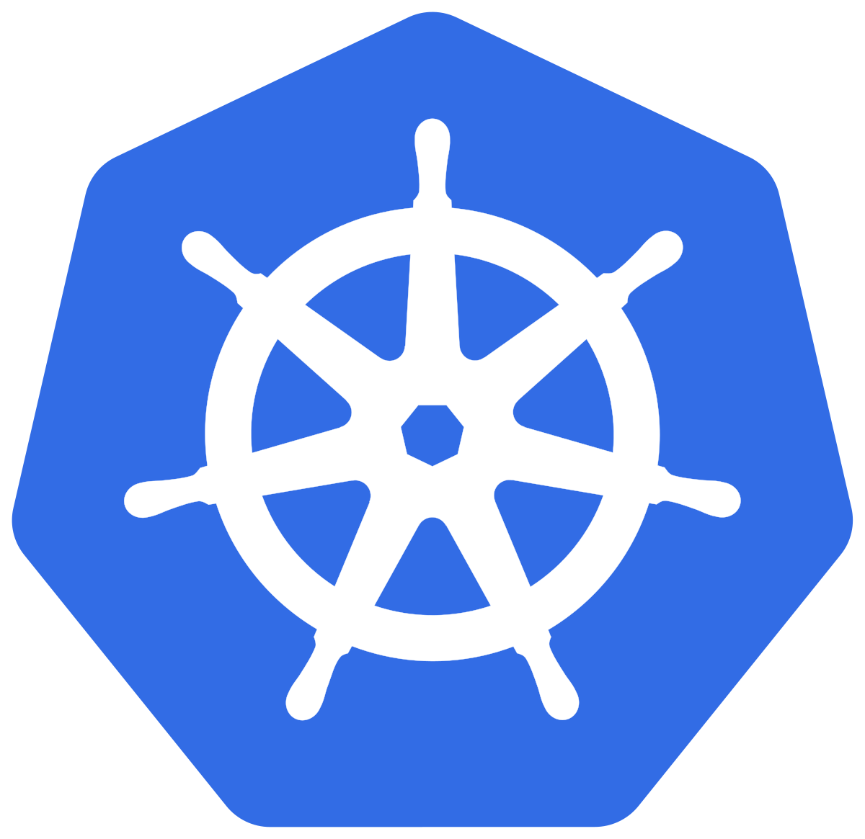
Kubernetes

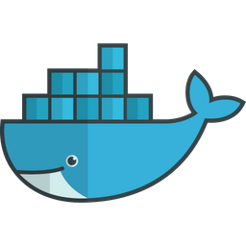
Docker
Containerd

Openstack

Azure

Harbor

Ceph
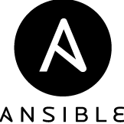
Ansible

AWX - Tower

Python

Django/channels

Fastapi


Github/workflow

Hahicorp Vault
Jenkins

Sonarqube

Grafana

Prometheus

Loki

Hugo

Sphinx

Rabbitmq

Minio


Opentelemetry
Jaeger

Robot framework

Kubespray

Vuejs/Vuetify

Postgresql

Mongodb

Keycloak

Argocd

Langchain/Langgraph
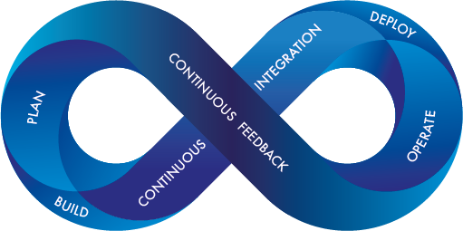
Devops
Implemented a complete monitoring stack with grafana/prometheus for infrastructure
Implemented log aggregation monitoring solution using loki
Implemented opentelemetry for all microservices helps in improving tracing
Implemented self-hosted github runners in kubernetes for running workflows
Written github workflows for configuring CI pipeline in github.
Adapted pre-commit hook in the project for reducing formating issues while review
Auto injection of secrets from hashicorp vault into the pod.
Having knowledge on LXC/LXD containers
Implemented Django websockets for pushing live notification
Adapted hugo and sphinx documentation
Having experience in kubespray
Implemented argocd for gitops, which reduces unwanted accidental changes in the cluster
Having experience in Robot framework, which helped to perform functional testing
Implemented Keda in kubernetes to autoscale pods based on application traffic
Implemented centralized authentication system for microservices using keycloak
Writtern ansible-playbook for automated system configuration and used AWX hook for configuring.
Having experience in writing helm chart and kustomize files for internal micro-service applications.
Deployed multiple kubernetes cluster using kubespray.

Cloud
Managed 100+ baremetal servers via openstack
Customized images using disk image builder
Developed openstack DIB custom elements
Having experience in VBMC for simulating virtual machines as baremetal nodes
Having real-time experience in openstack-ansible deployment method
Having knowledge on Foreman and MaaS
Experience in running dnsmasq for local DHCP configuration
Handled multi-node Ceph storage cluster
Having experience in Azure cloud as a regular user with having working experence in Azure virtual machines, Kubernetes services, Storage classes, Azure container registry
Experience in migration of openstack servers from one lab to another.
Handling RHEL subscriptions



Artificial Intelligence
Developed a chatbot for internal application using langchain
Experience in Ollama for running models locally
Experience in using continue project for setting up local modes in code editor

All above given information were all true. You can trust me. Ready to relocate based on project demand.
Place: Coimbatore, TN
Date:
Signature
(Rakesh Nagarajan)

