**Monkeypox Disease Detection Using Deep Learning**

Rakesh Kumar Jaiswal

*Abstract*—This electronic document is a “live” template and already defines the components of your paper [title, text, heads, etc.] in its style sheet. *\*CRITICAL: Do Not Use Symbols, Special Characters, Footnotes, or Math in Paper Title or Abstract*. (*Abstract*)

Keywords—component, formatting, style, styling, insert (key words)

# Introduction

Monkeypox is an emerging infectious disease caused by a virus transmitted to humans from infected animals, most commonly rodents. The most common symptoms of monkeypox include fever, headache, muscle aches, back pain, low energy, and swollen lymph nodes

In the Democratic Republic of the Congo, where smallpox had been eradicated in 1968, a 9-month-old boy was the first person to contract monkeypox [2] in 1970. Since then, human cases have progressively been recorded from central and west Africa, with the majority of cases coming from the rural, rain forest parts of the Congo Basin, mainly in the Democratic Republic of the Congo. Monkeypox is a zoonotic virus disease similar to smallpox which belongs to orthopoxvirus family.

Diagnosis of Monkeypox from an image is difficult problem as there exist many similar skin diseases like monkeypox like chickenpox, smallpox, measles. If monkeypox disease is detected early of an infected person then it can be treated well for that purpose an expert or a doctor is required. Manual diagnosis of skin diseases by visiting and consulting dermatologists is time consuming. Most rural areas do not have this option. These rural people need to travel to a nearby city for advice and diagnosis. This takes a lot of human effort. Although for a common person the payable fees for doctors and specialists are not affordable. The precise identification of monkeypox from the image will enhance the diagnosis, shorten the diagnostic process, and result in better and more affordable patient care. The results of skin biopsies and the expertise of medical professionals play a crucial role in the lengthy process of diagnosing monkeypox.

Deep learning is a type of machine learning technique that takes inspiration from the structure and operation of human neural networks. Convolution Neural Networks (CNNs) are a subclass of deep learning algorithms that are typically employed for the analysis of visual content, such as images and videos. Numerous classification-based issues in medical image analysis have dramatically improved with the development of CNN.

A model is trained and developed for one task using the machine learning process and it is then applied to a second, related task known as transfer learning.  It describes the situation in which what has been discovered in one context is used to enhance optimization in another context. When a fresh dataset that was used to train the pre-trained model is smaller than the original dataset, transfer learning is typically used.

**5.Literature (paper Download)**

**6.Research Gap**

1) There is not sufficient work done on classification of monkeypox with other skin diseases in the research field.

2) monkeypox disease is similar to smallpox, chickenpox, Measle which comes under orthopoxvirus family and they have nearly same features and symptoms so classification of these diseases become tedious task from images.

3) the main objective of this research is to focus monkeypox detection.

**7.Main Contribution (design, Challenges, proposed, Results)**

A deep study has been done on traditional machine learning and deep learning techniques for the classification purpose of monkeypox from the other skin disease images like chickenpox, measles and normal. A deep learning-based model, EfficientBetB3 with fine tuning has been proposed for classification of monkeypox images from the others skin disease images like chickenpox, measles and normal. the proposed model consisting of three main modules, including data pre-processing, model learning, and model prediction, to perform the monkeypox disease classification based on the skin images.

**Data Pre-Processing: -**

**Noise filtering:** in this process, the repeated images are manually filter out in the same class and across the classes. The irrelevant images are also removed. Finally, the selected four classes are selected (monkeypox, chickenpox, measles, normal) with 279, 107, 91 and 293 images respectively.

**Image Resizing: -**

**Image Augmentation: -** in order to improve the model performance and reduce the risk of model overfitting, images are augmented.

**Model Learning: -** Different- Different pretrained model and proposed model are applied on Augmented images**.**

# LITERATURE review

# . METHODOLOGY

## Dataset

In the proposed work, a 4-class Dermoscopy image dataset is used, which contains skin images. dataset consists of four classes: Monkeypox, Chickenpox [1], Measles, and Normal. All the image classes are collected from internet-based sources by a research team of Department of Computer Science and Engineering, Islamic University, Kushtia-7003, Bangladesh. The number of images in Monkeypox, Chickenpox, Measles, and Normal are 279, 107, 91 and 293 respectively. However, in dataset, the number of images are less so to increase the number of images data augmentation has been performed. After augmentation the number of images has increased. The dataset is divided in three-part name train, test and validation.

**Sample images: -**

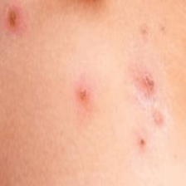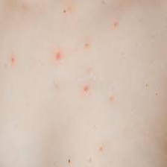

**Monkeypox Chickenpox**

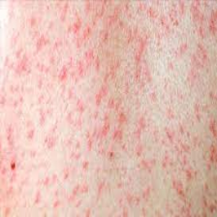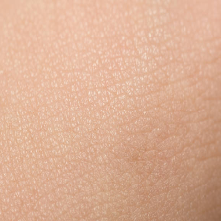

**Measles Normal**

**Before Augmentation:** -  **After Augmentation: -**

| Class Name | Number of images | | |
| --- | --- | --- | --- |
| Train | Test | Validation |
| monkeypox | 223 | 28 | 27 |
| measles | 72 | 10 | 9 |
| chickenpox | 85 | 11 | 10 |
| normal | 234 | 30 | 29 |

| Class Name | Number of images | | |
| --- | --- | --- | --- |
| Train | Test | Validation |
| monkeypox | 640 | 28 | 161 |
| measles | 556 | 10 | 139 |
| chickenpox | 652 | 11 | 164 |
| normal | 631 | 30 | 158 |

## Steps

1) Image-Acquisition

2) Preprocessing of images(resizing)

2) Divide Dataset in Two Part (.9, .1)

3) Augmentation of Dataset (.9) after that Divide further in Train and Val (.8, .2)

4) Create Train, Test and Validation generators

5) Create a function to show Training image sample

6) Create Model and train the Model

7) Make prediction on test set, create Confusion Matrix and Classification Report

## Model and Methodology

One of the most effective models that achieves State-of-the-Art accuracy on both imagenet and typical image classification transfer learning tasks is EfficientNet, which was initially shown in Tan and Le in 2019.

EfficientNet is a convolutional neural network design and scaling technique

that uses a compound coefficient to consistently scale all depth, breadth, and resolution parameters. The EfficientNet scaling approach evenly scales

network breadth, depth, and resolution using a set of preset scaling coefficients, in contrast to standard practice, which scales these variables arbitrarily.

**EfficientNetB3**

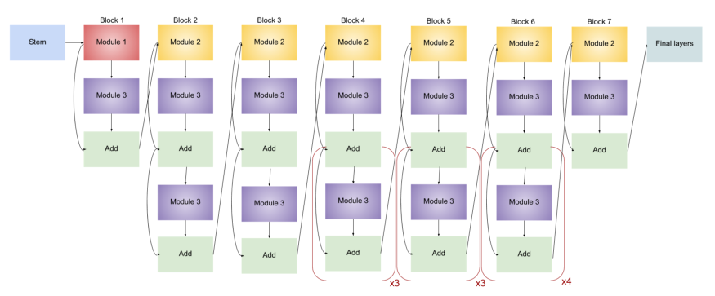

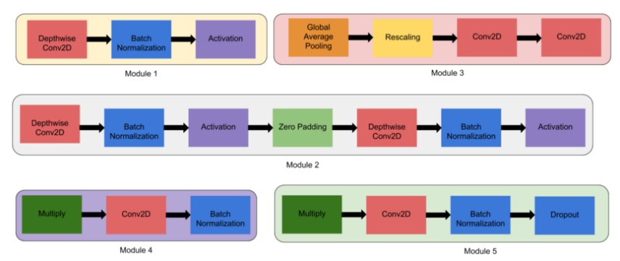

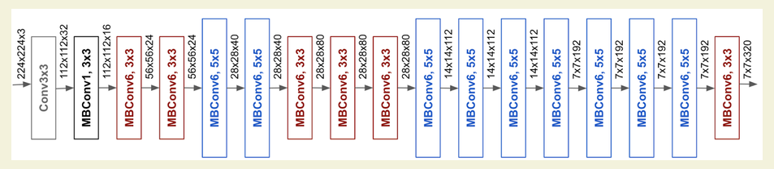

**System Architecture**

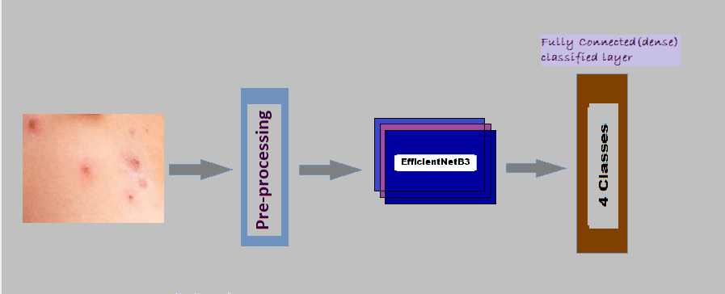

# Experimental results

## Configuration of system

## models applied (Pretrained and fine-tuned) in this work were tested on a computer with Nvidia K80/T4 GPU, 16 GB GPU memory, .82GHz / 1.59GHz GPU Memory Clock and 4.1 TELOPS / 8.1 TELOPS. The batch size and epochs have been chosen as 32 and 40 respectively.

## Parameters

1. **Confusion Matrix: -**

The confusion matrix was used to determine how well the procedures utilized after the classification performed. The confusion matrix represents the correctly classified TP values, FP values in the relevant class while it should be in another class, and FN values in another class while it should be in the relevant class and the correctly classified TN values in the other class. The most frequently used performance metrics for classification according to these values are accuracy (*ACC*), precision (*P*), sensitivity (*Sn*), specificity (*Sp*), and *F*-score values.

|  |  |
| --- | --- |
|  |  |
|  |  |

1. **Precision: -**The percentage of positive values out of all projected positive cases is known as precision or the positive predictive value. In other terms, precision is the percentage of correctly identified positive values:

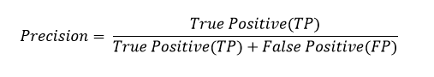

1. **Recall: -**

The proportion of correctly identified positive inputs is used to calculate the recall.

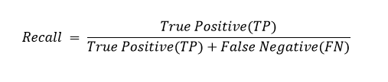

1. **F1-score: -**

The weighted average of recall and precision is the F1 score. Therefore, both false positives and false negatives are considered while calculating this score. Although F1 is generally more beneficial than accuracy, especially if you have an uneven class distribution, it is not intuitively as simple to understand as accuracy. When false positives and false negatives cost about the same, accuracy performs best. It is preferable to include both Precision and Recall if the values of false positives and false negatives are significantly varied.

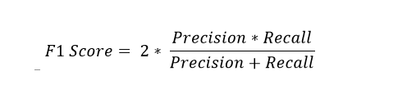

## Hyperparameters

1. Learning Rate: - 0.001
2. Image size: -
3. Activation Function: - SoftMax, ReLU
4. Loss function: -Categorical Cross entropy
5. Number of epochs: -40
6. Batch size:32

**ReLU Function: -**

Another non-linear activation function that has grown in prominence in the deep learning field is the ReLU function. Rectified Linear Unit is referred to as ReLU. The primary advantage of ReLU function over other activation functions is that it does not simultaneously fire all of the neurons.

This signifies that the neurons will not stop firing unless the result of linear transformation is less than 0. This will be easier to grasp if you look at the plot below:

**f(x)=max (0, x)**

**SoftMax Function: -**

The SoftMax function normalizes a vector z of K real numbers into a probability distribution with K probabilities proportional to the exponentials of the input values. It accepts this vector as an input. This means that some vector components before applying SoftMax might be negative or greater than one, and they might not add up to 1, but after applying SoftMax, each component will be in the range display style (0,1)(0,1), and the components will add up to 1, so they can be interpreted as probabilities. Additionally, higher probabilities will follow from greater input components**.**

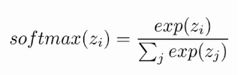

**Categorical Cross entropy: -**

Categorical cross entropy is a loss function that is used in multi-class classification tasks.

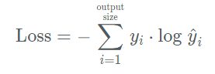

**EfficientNetB3 with fine Tuning (Proposed Model): -**

1. **Confusion matrix of proposed model**

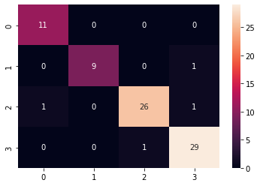

1. **Classification Report: -**

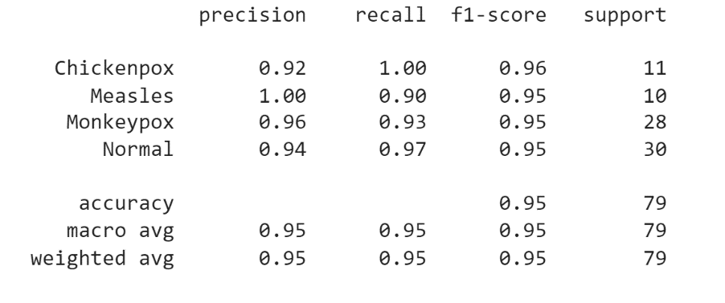

1. **Accuracy Curve and Loss Curve: -**

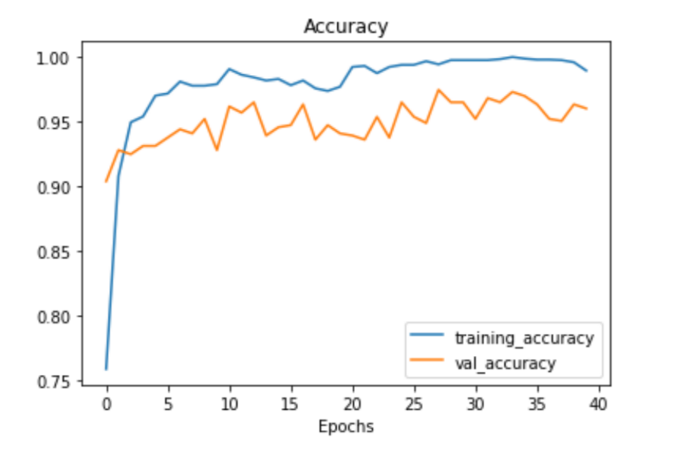 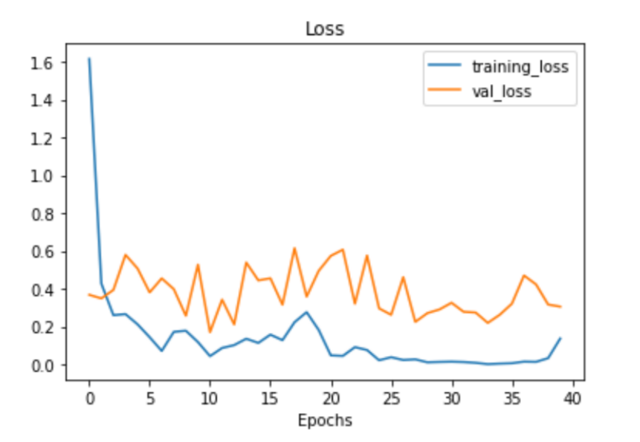

## Proposed Method

**Before Augmentation: -**

| Model | Accuracy | | |
| --- | --- | --- | --- |
| Train | Test | Validation |
| InceptionV3 | 99.25 | 70 | 73.33 |
| Mobilenet | 99.84 | 75 | 78.67 |
| VGG16 | 100 | 79 | 85.33 |
| Resnet50 | 100 | 86 | 85.33 |
| EfficientNetB3 | 99.84 | 85 | 86.67 |

**After Augmentation: -**

| Model Name | Accuracy | | |
| --- | --- | --- | --- |
| Train | Test | Validation |
| EfficieentNetB0 | 99.48 | 92.41 | 97.43 |
| EfficientNetB1 | 99.03 | 83.54 | 95.66 |
| EfficientNetB3 | 99.56 | 95 | 96.30 |
| EfficientNetB4 | 99.52 | 88.61 | 96.30 |
| EfficientNetB5 | 98.43 | 84.81 | 94.86 |
| EfficientNetB6 | 99.03 | 86.08 | 94.53 |
| EfficientNetB7 |  |  |  |

| Model | Accuracy | | |
| --- | --- | --- | --- |
| Train | Test | Validation |
| InceptionV3 | 94.88 | 59 | 74.60 |
| Mobilenet | 100 | 80 | 77.49 |
| VGG16 | 100 | 82 | 92.77 |
| Resnet50 | 100 | 91 | 92.77 |
| **EfficientNetB3** | **99.56** | **95** | **96.14** |

**Precision, Recall, F1-Score**

| Class Name | Accuracy | | |
| --- | --- | --- | --- |
| Precision | Recall | F1 Score |
| Monkeypox | 0.96 | 0.93 | 0.955 |
| Measles | 1.00 | 0.90 | 0.95 |
| Chickenpox | 0.92 | 1.00 | 0.96 |
| Normal | 0.94 | 0.97 | 0.95 |

**Result For MobileNet (after Augmentation): -**

1. **Confusion Matrix: -**

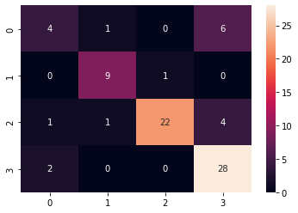

1. **Classification Report: -**

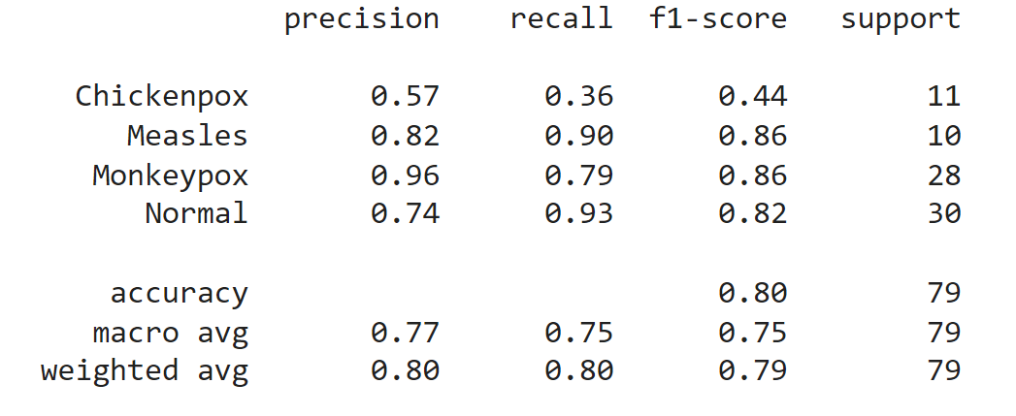

1. **Accuracy Curve and Loss Curve: -**

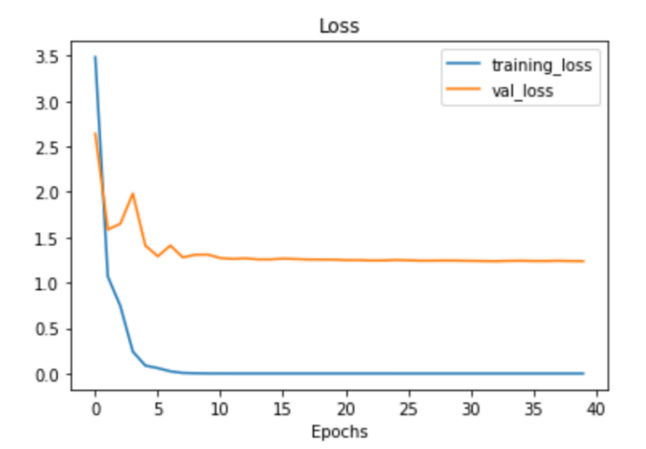

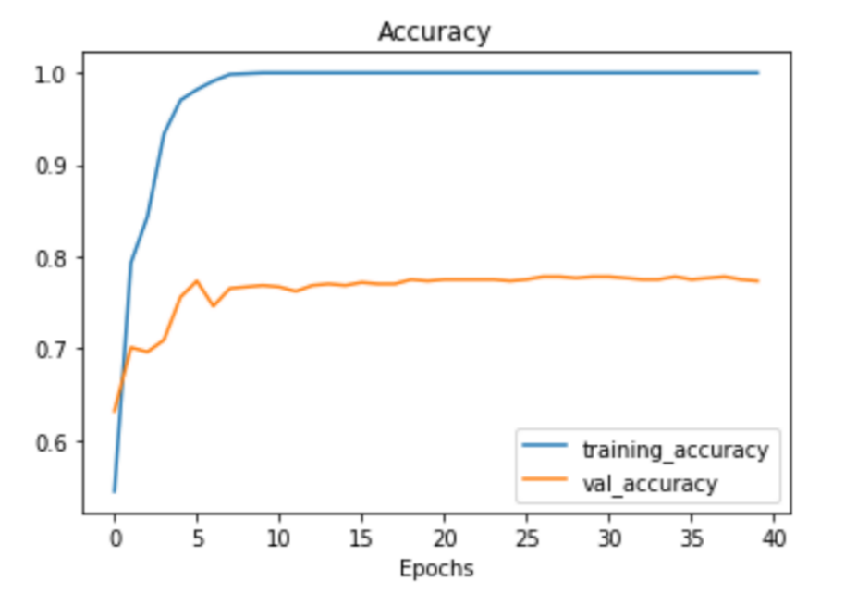

**Result For VGG16 (after Augmentation): -**

1. **Confusion Matrix: -**

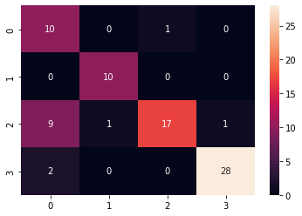

1. **Classification Report: -**

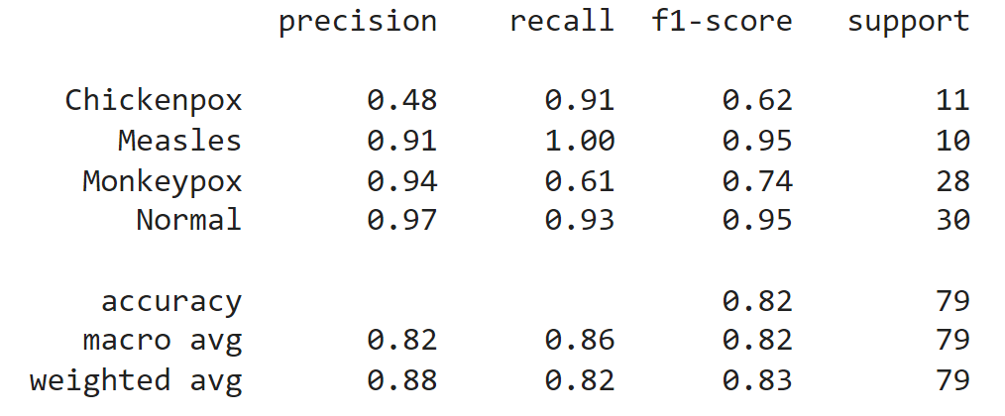

1. **Accuracy Curve and Loss Curve: -**

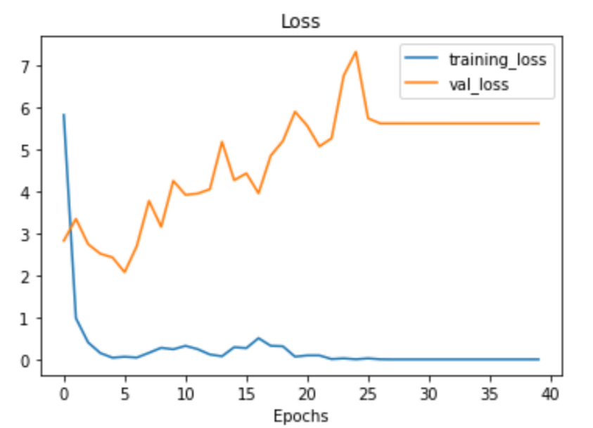

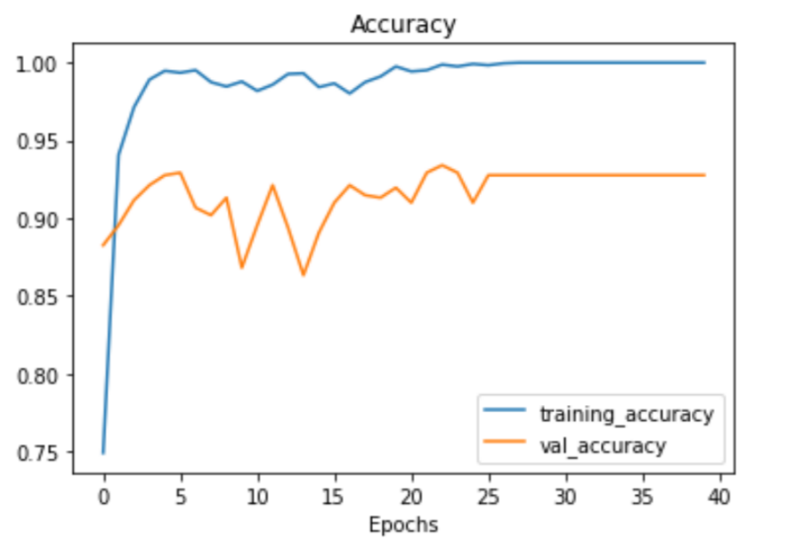

**Result For ResNet50 (after Augmentation): -**

1. **Confusion Matrix: -**

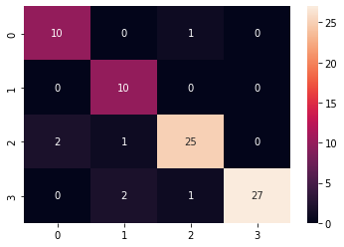

1. **Classification Report:-**

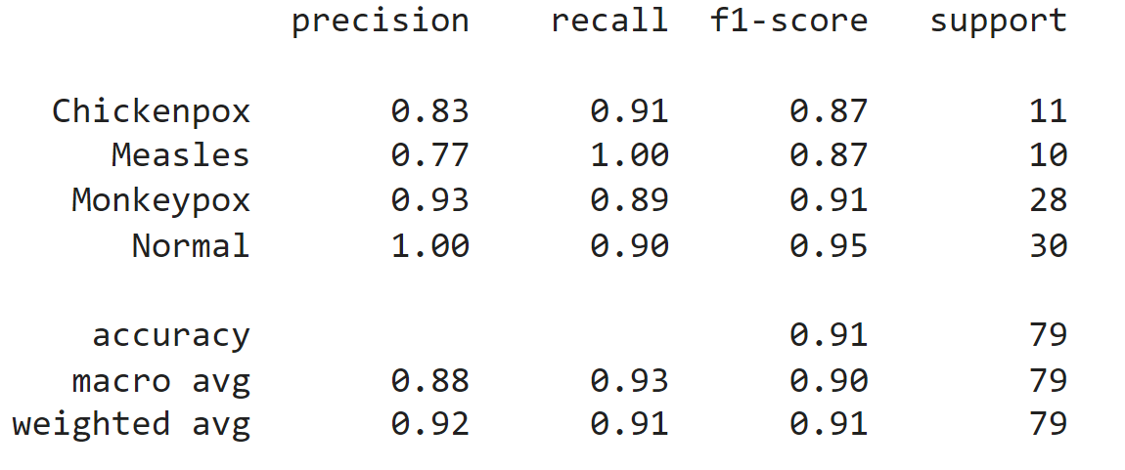

1. **Accuracy Curve and Loss Curve: -**

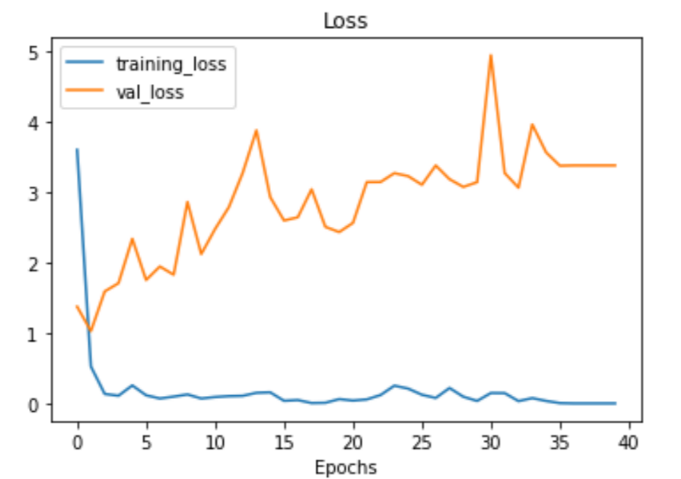

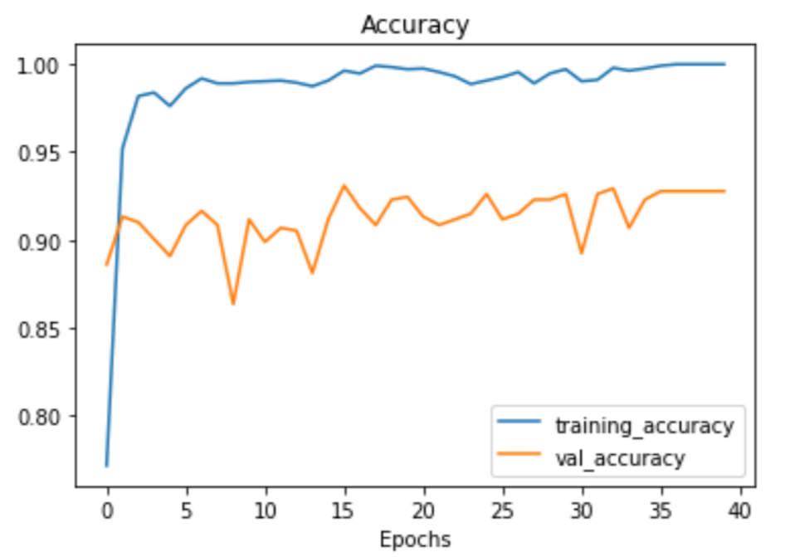

**Different Optimizers**

| Optimizers | Accuracy | | |
| --- | --- | --- | --- |
| Train | Test | Validation |
| AdaDelta | 98.31 | 90 | 93.89 |
| RMSProp | 99.60 | 91 | 97.59 |
| Adagrad | 99.96 | 94 | 97.43 |
| **Adam** | **99.56** | **95** | **96.14** |

**Conclusion**

* The propose model is for Monkeypox disease detection from the images. An extensive experiment on five deep learning methods has been conducted. The experimental results, in general, proved the validity of the datasets and classification algorithms.
* The best results are obtained from the EfficientnetB3 with fine tuning, with an accurate test accuracy of 95%. It is believed that the proposed model can classify the Monkeypox with other skin disease classes like Chickenpox, Measles and Normal. In the future, we plan to improve the performance by integrating more datasets. Also, we plan to experiment with transfer learning or few-shot learning models**.**

##### References

1. Sandeep, R., Vishal, K.P., Shamanth, M.S., Chethan, K. (2022). Diagnosis of Visible Diseases Using CNNs. In: Goyal, V., Gupta, M., Mirjalili, S., Trivedi, A. (eds) Proceedings of International Conference on Communication and Artificial Intelligence. Lecture Notes in Networks and Systems, vol 435. Springer, Singapore. <https://doi.org/10.1007/978-981-19-0976-4_38>.
2. Sklenovská N, Van Ranst M. Emergence of Monkeypox as the Most Important Orthopoxvirus Infection in Humans. Front Public Health. 2018 Sep 4;6:241. doi: 10.3389/fpubh.2018.00241. PMID: 30234087; PMCID: PMC6131633.