SAI VIDYA INSTITUTE OF TECHNOLOGY
(Affiliated to Visvesvaraya Technological University, Belagavi | Recognized by Govt. of Karnataka | Approved by AICTE, New Delhi)
Rajanukunte, Bengaluru- 560 064

DEPARTMENT OF COMPUTER SCIENCE AND ENGINEERING
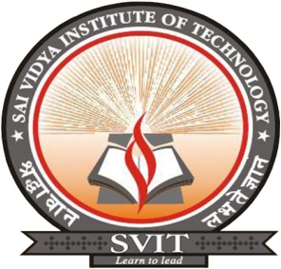

CERTIFICATE

Certified that the Project Phase -1 (17CSP78) work entitled “TRAFFIC RULE VIOLATION DETECTION AND REPORTING SYSTEM” carried out by Mr. Rakesh M R (1VA17CS040), Mr. B G Vinayak (1VA17CS010), a bonafide students of SAI VIDYA INSTITUTE OF TECHNOLOGY, Bengaluru, in partial fulfillment for the award of Bachelor of Engineering in Computer Science and Engineering of VISVESVARAYA TECHNOLOGICAL UNIVERSITY, Belagavi during the year 2020-21. It is certified that all corrections/suggestions indicated for Internal Assessment have been incorporated in the Report deposited in the departmental library. The Project Phase – 1 report has been approved as it satisfies the academic requirements in respect of Project Phase – 1 work prescribed for the said Degree.

Prof Santhosh Reddy P Assistant Professor,  Dept. of CS&E, SVIT | Dr. Archana R A  Associate Professor & Head  Dept. of CS&E, SVIT | Dr. H S Ramesh Babu  Principal

Project Phase – 1 Marks Allotment
Introductory (20) | Intermediate (20) | Final (60) | Total (100) | Signature of Guide

