**CD-**  This command is used to change the directory. It can be used in following ways-

1. **cd..** It can be used to go to the immediate parent directory of the present directory as shown below-

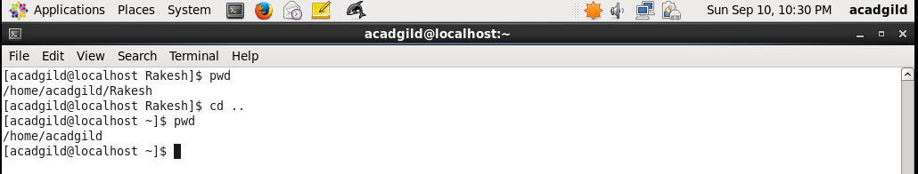

1. **cd <dir name>-** It can be used to jump into library directly by specifying its name as shown below-

