**DATE-** This command is used to display current system date and time.

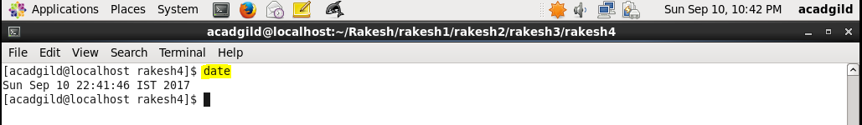

We can also set the date to whatever value we want.

Syntax- **date –s ‘timestamp value’**

