**mv-** This command is used to move the contents of one file/directory to another file/directory. We can also think of it as renaming of file/directory.

As shown below contents of file1.txt are moved to file2.txt and we don’t have file2.txt present after moving-

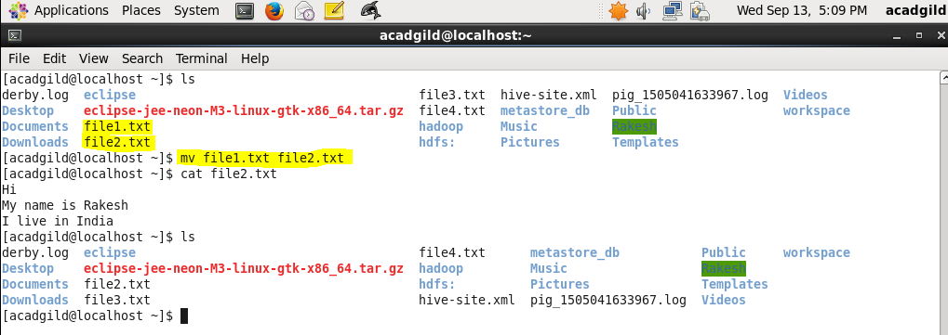

If the target file is not present then it will get created as shown in below example-

