**vi-** It is screen oriented text editor(Visual Editor) in Unix used to view/create/edit a file.

**e.**g- **vi File1.txt**🡪 If the file is existing it will open the file and if it is non-existent then it will create the file and open it. See below for screenshot-

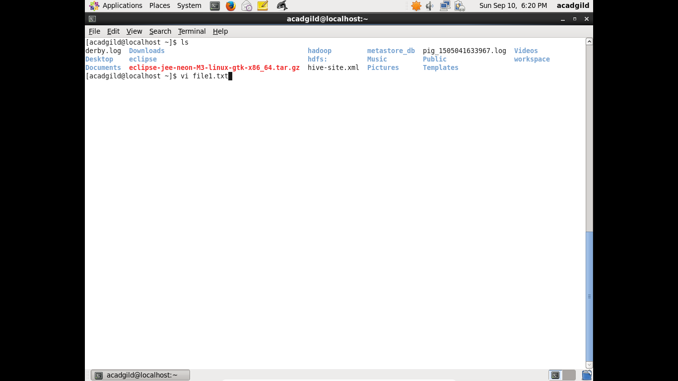

In the above screenshot the file is non-existent and we have typed vi command with file1.txt. It will create a new file **file1.txt** at **/home/adagild** as shown in below screenshot-

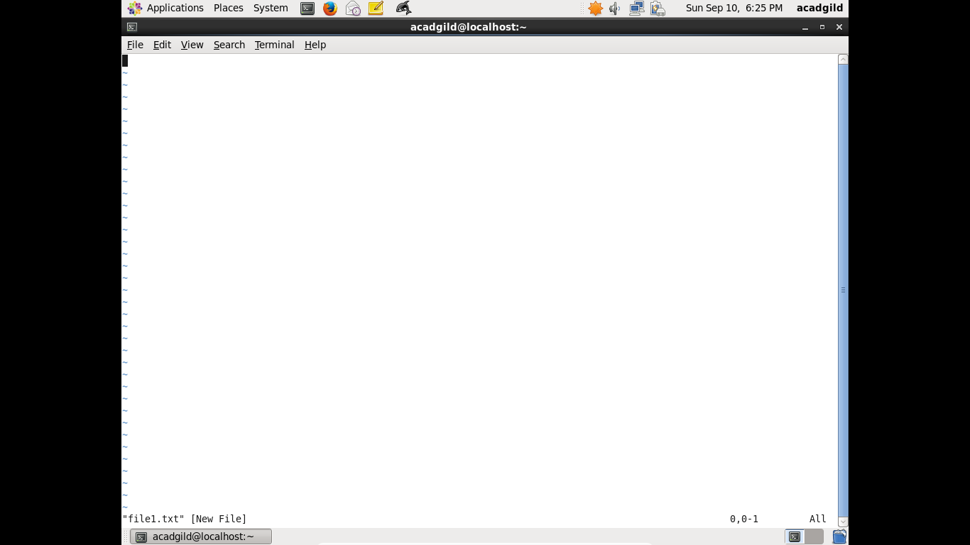

As we can see it is creating a new file.

To work in vi editor we have 2 modes of operation-

1. **Command mode-** This mode allows us to do any administrative action on file.

For example we can save above file- file1.txt in command mode so that it gets created.

The command used to save it is **:wq.**

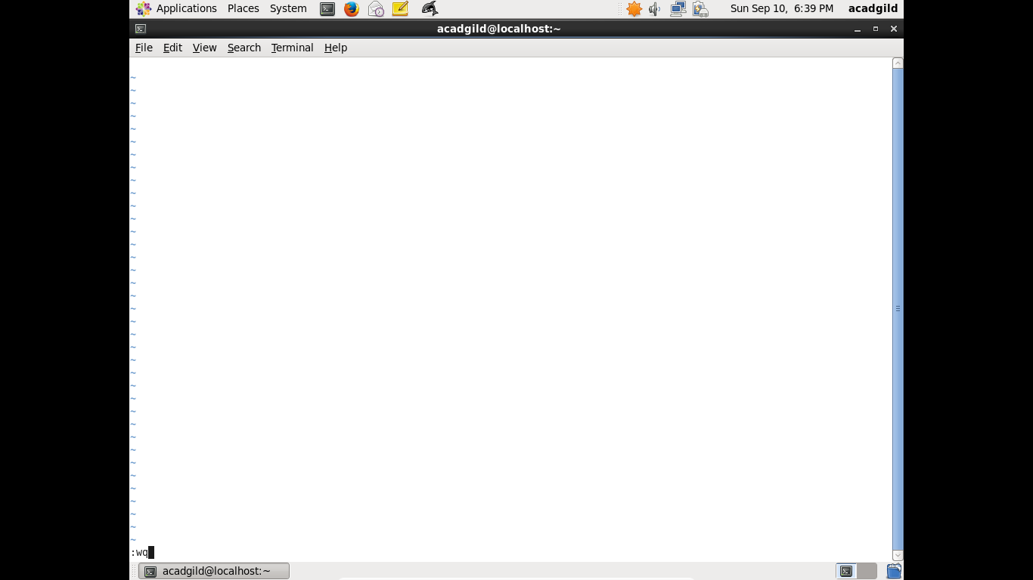

As shown in below screenshot the file1.txt gets created.

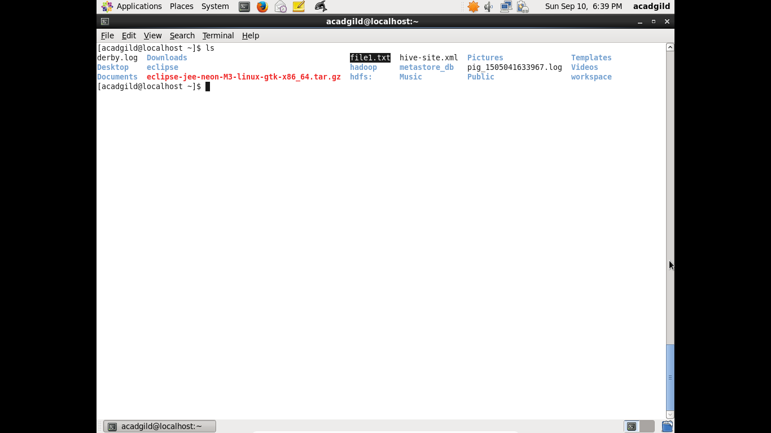

1. **Insert Mode-** We need to press INSERT key to go in this mode. After that we can go inside the file and insert the text that we want to be in the file as shown below.

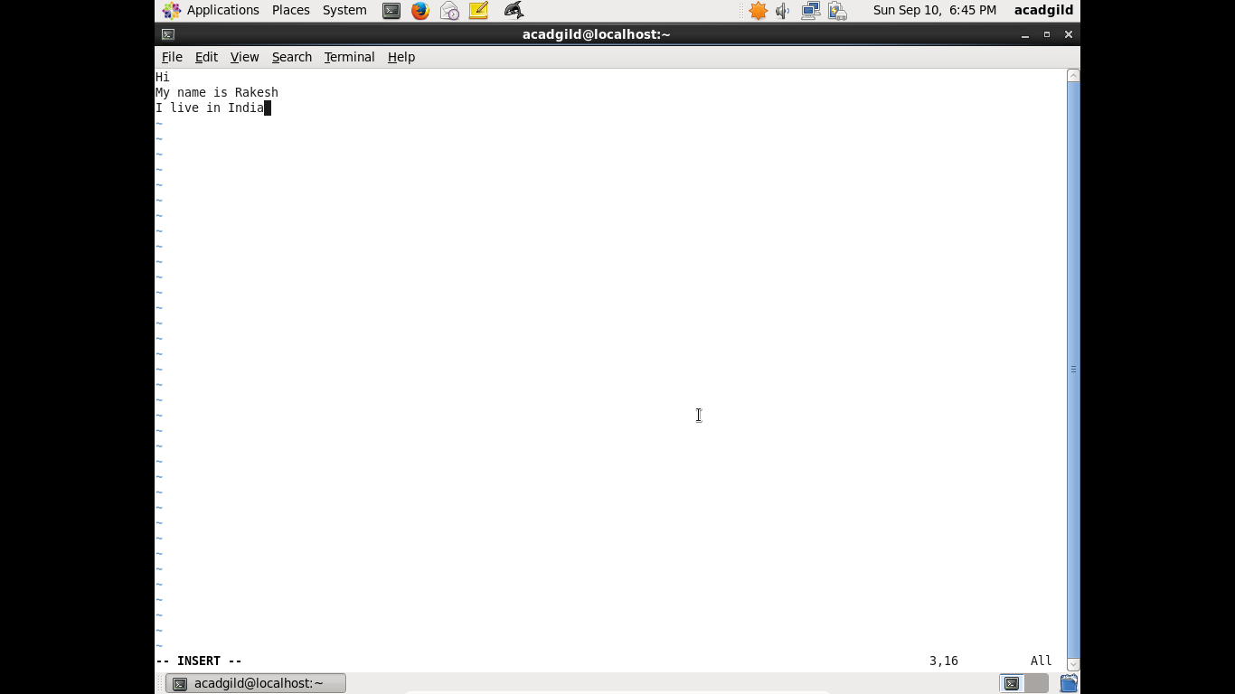

To go back into control mode from Insert mode we need to press “ESC” key and we can use any command  **:q- to quit**

**:wq- to save and quit**

**:q!- to save without quitting**