**Touch-** This command is used to update the access date or modification date information of a file or directory. Its syntax is- **touch <option> <file name>.**

If we give the file name which does not exist then a blank file will be created.

For ex- **touch file2.txt**

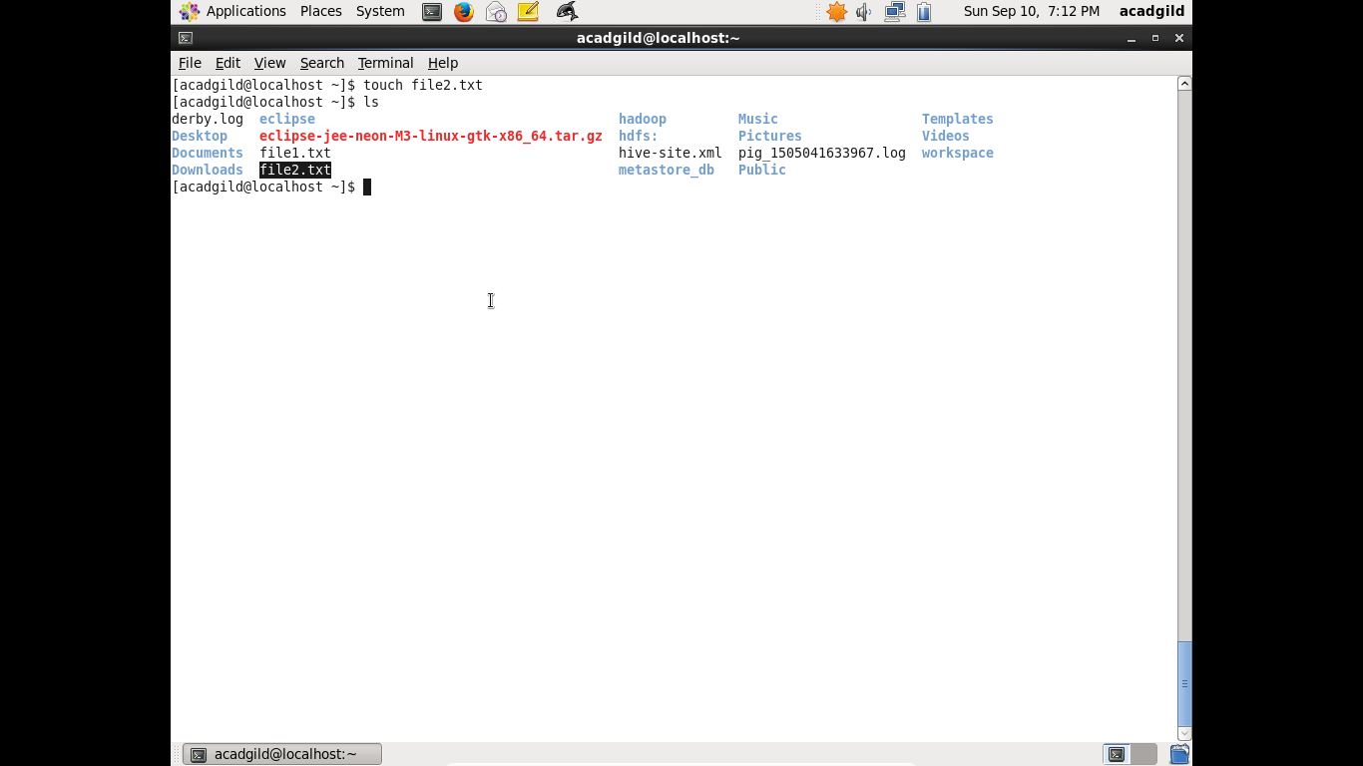

The options that are mostly used with **touch** command are-

1. **Touch –a <file name>-** This command changes the access time to current time on a file.

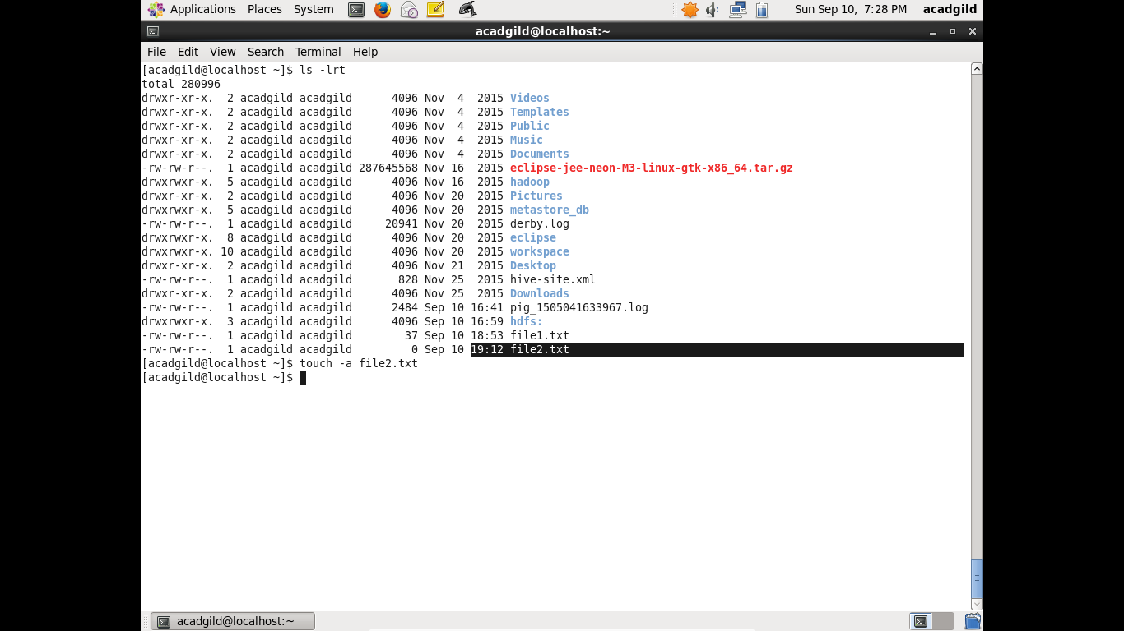

The access time changes as shown in below screenshot for **file2.txt**

