**mkdir-** This command is used to make any directory in UNIX. It can also set permissions while creating the dircetories.

**Ex-** mkdir <option> <directory name>

In the below example we are creating a directory Rakesh in the path /home/acadgild/Rakesh

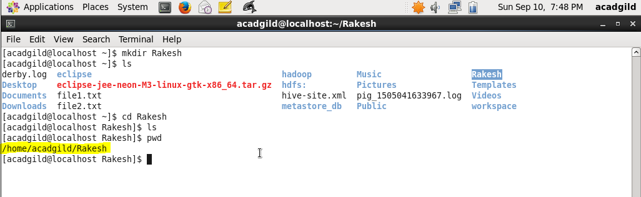

It can also be used to create multiple subdirectories at a time.

For ex- mkdir –p /Rakesh/rakesh1/rakesh2/rakesh3/rakesh4.

