**ls-** This is used to list the contents of directories and files.

In below screenshot it is simply listing all files and directories -

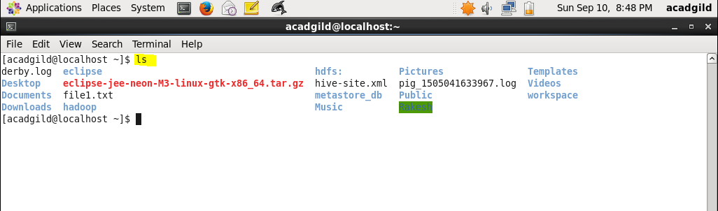

When used with some other options it can be used to extract other information too about files or directories.

For example **ls – R <file name/dir name>** gives directory tree in a recursive manner.



**ls –ltr** gives long listing format sorted by date/time in reverse order as shown in below screen shot

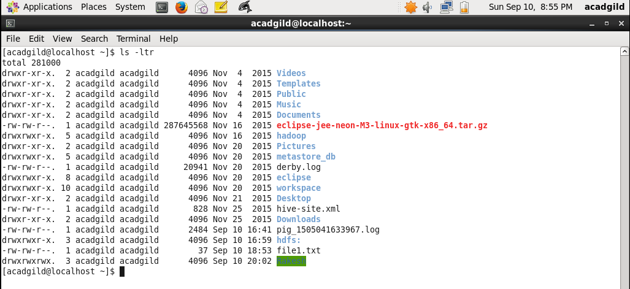

**ls- lt** - It can be used to list libraries with the most recent one on the upside as shown in below screenshot-

