**ECHO-** This command is used to print any message/string/value of variable etc on the console.

Syntax- **echo <option> <string>**

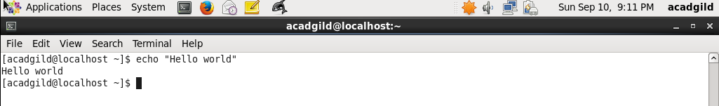

It can also be used to display the value of system defined variables as shown in below screenshot-

