**CAT-** This command is used to create file/s. One can also view the file, concatenate them and redirect the output in terminal or files.

**Syntax-** cat <option> <file>

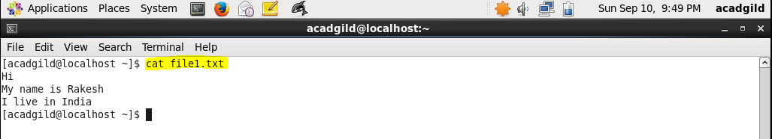

The above screenshot shows use of cat command to display contents of file file1.txt.

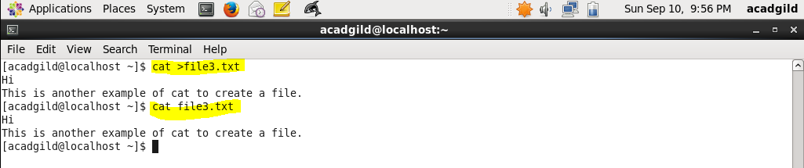

The above screenshot shows how to use cat to create a new file.

After using command **cat >file3.txt** we can input our text and press CTRL+D to save and exit.

The file will be created

It can also be used to show multiple files at once using below syntax-

**cat file1; cat file2; cat file3**

Below is the example for same-

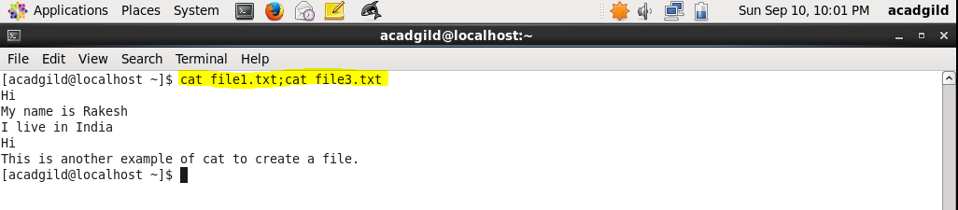

One can also redirect or copy the contents of a file into a new file or existing file using below command-

**Cat file1 > file2-** Here file2 will be overridden by file1.

Below example depicts the same-

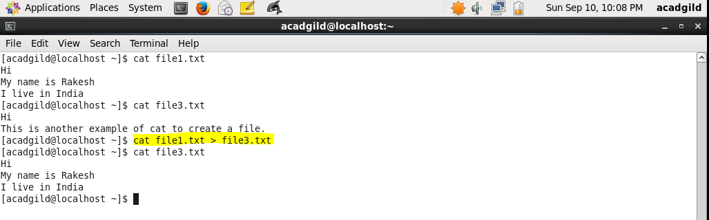

It can also be used to append the records of one file into another

Syntax- **cat file1 >> file2**

Below example shows the same. Contents of file1.txt are being appended to contents of file3.txt.

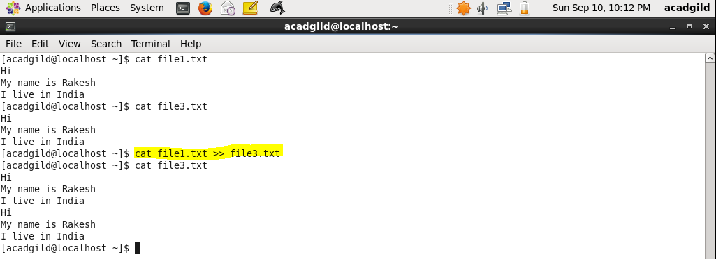

We can also redirect the contents of multiple files into a single one using below syntax-

**cat file1 file2 file3 > file4. –** Here file4 will be created with contents of file1, file2, file3.

In below example we are concatenating file1.txt and file3.txt to file4.txt.

