**TASK 1**

1. The directory user/acadgild exists on hdfs as shown below

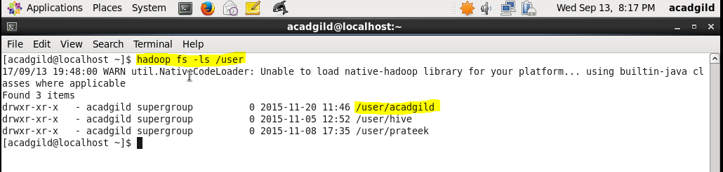

1. Creating directory user/acadgild/hadoop with below highlighted command-

