TASK2

Creating a file word-count.txt under directory /user/acadgild/hadoop/word-count.txt

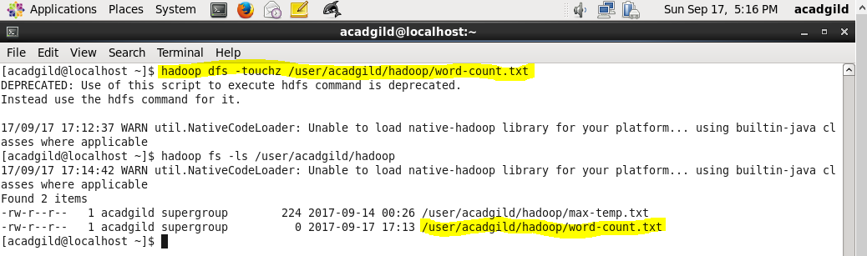

Appending content from screen to file using below command-

hadoop dfs –appendToFile - /user/acadgild/hadoop/word-count.txt

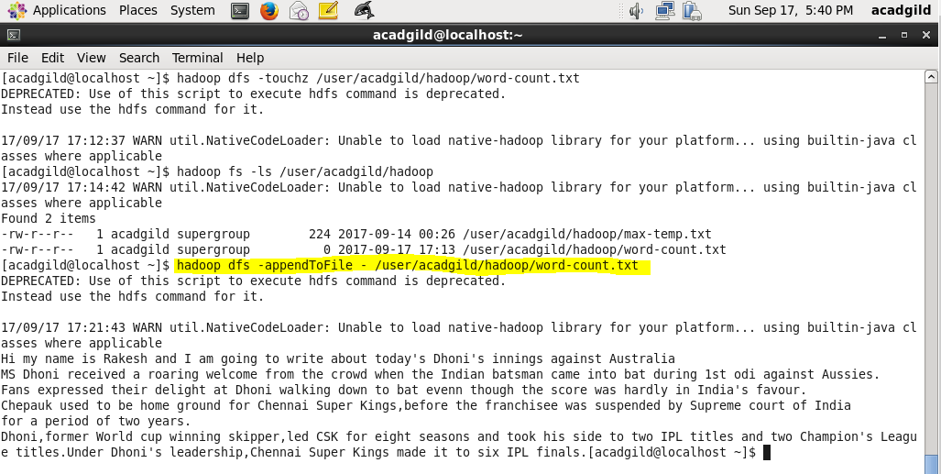

Output displayed is shown below using cat command-

