**Task-3-**

Creating a file max-temp.txt in local File System-

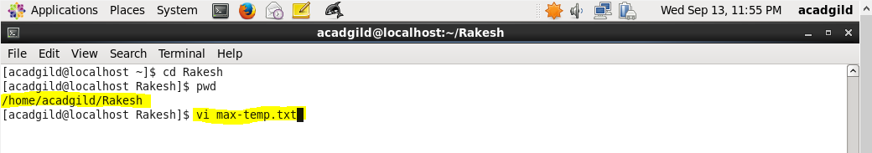

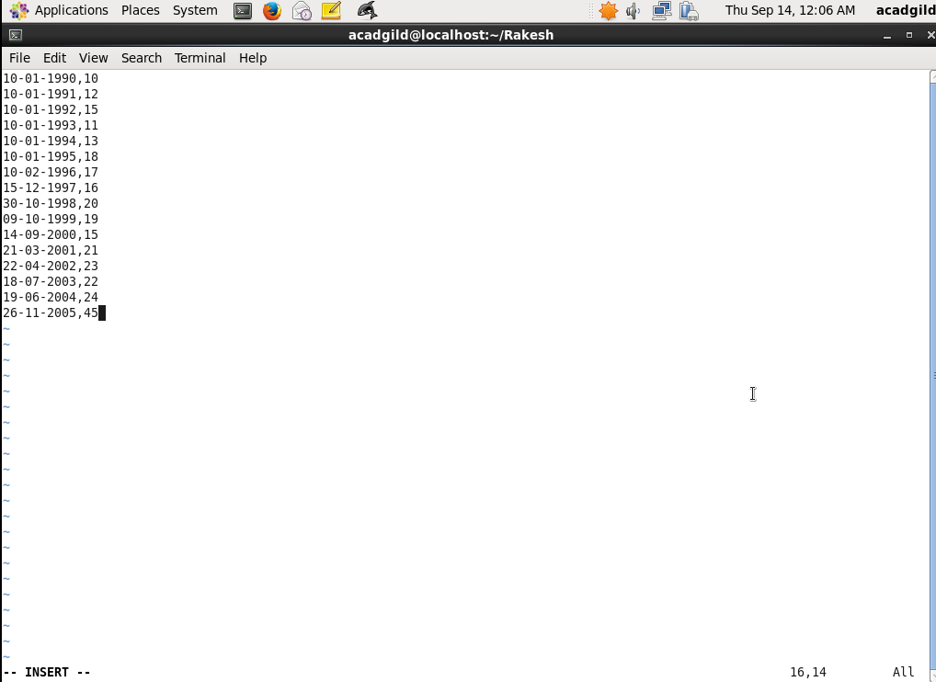

Inserted records for year and date as shown in above and below screenshots-

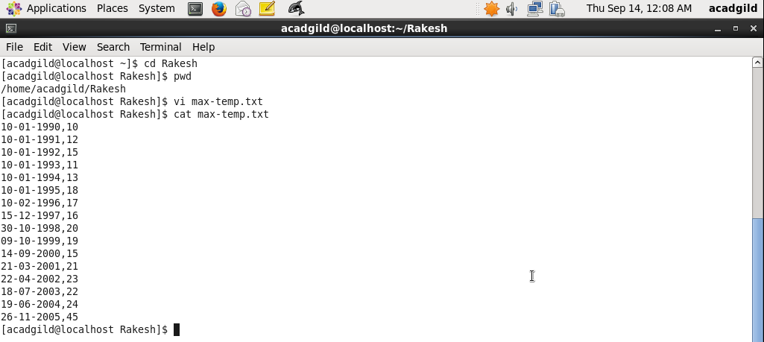

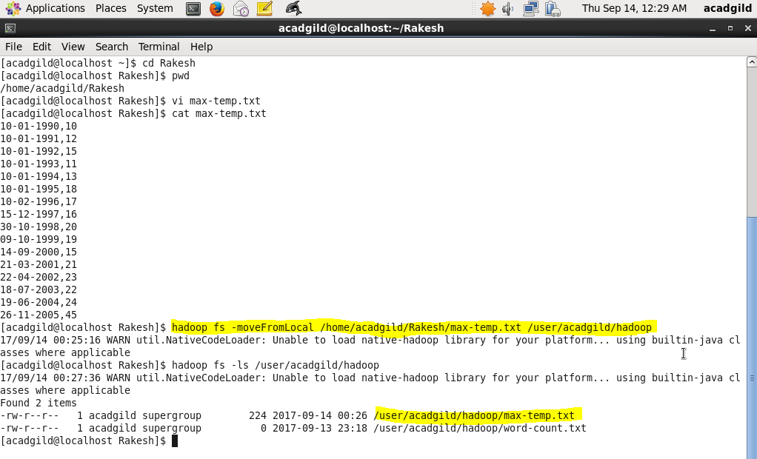

Used command moveFromLocal to move file from local file system to HDFS.

However this command deletes the file from local file system.