Below Screenshot shows the location of JAR file and then we are running map reduce job using below command-

**hadoop jar invalidfilter-assignmnet-3.2.jar filterinvalid.FilterInvalidRec /user/acadgild/hadoop/television.txt /user/acadgild/hadoop/invalidfilter**

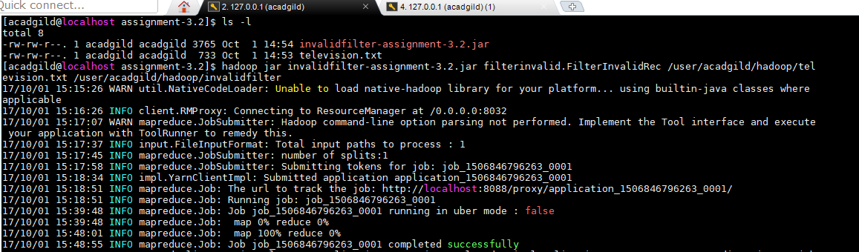

**Below is the output that we are getting at the same location without having rows with record- “NA”**

**/user/acadgild/hadoop/invalidfilter**

