2. Below screenshots show execution of mapreduce program to calculate total units sold for each company-

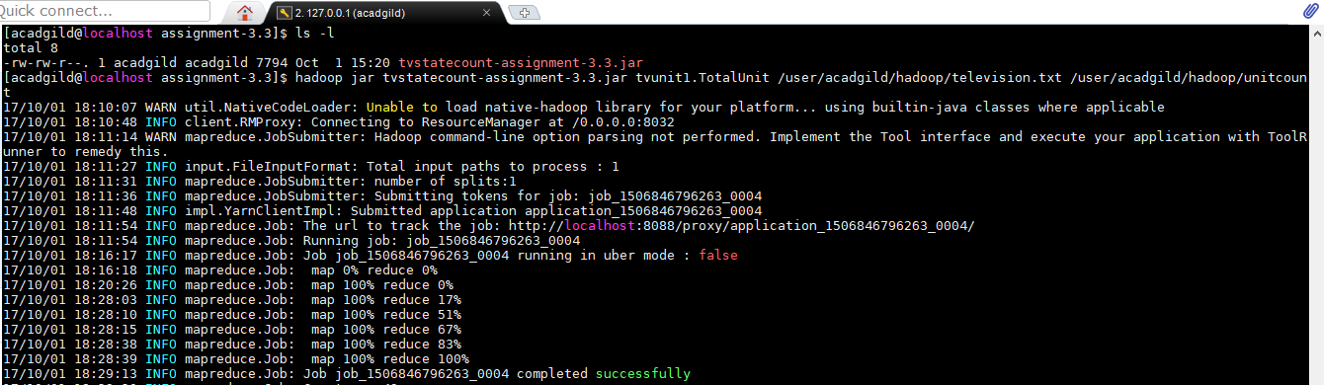

**Output-**

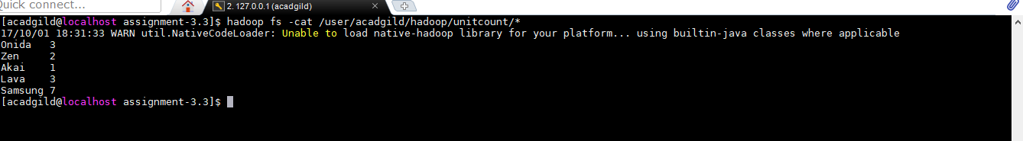

3. Below screenshots show execution of mapreduce program to calculate total units sold for Onida company per state-

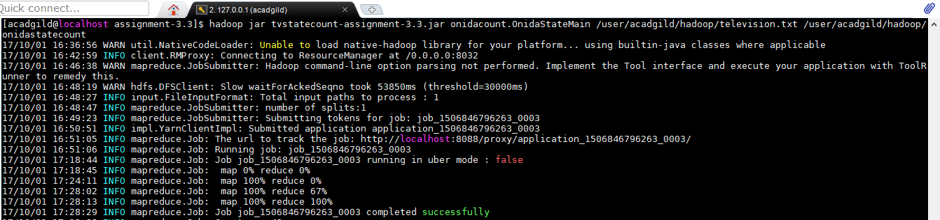

**Output-**

