We can overload a method with same return type. For a method to be overloaded it is the overall signature which decides as to which method to call i.e the number of arguments that we are passing.

The return type of a method is not explicitly a part of signature of method.

It has been shown using below example-

Below is a class with method as sum(). As we can see there are 3 methods defined with same name sum() but the number of arguments are different for them.

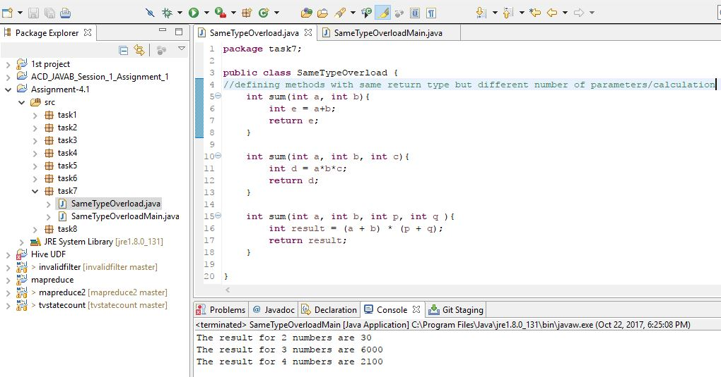

The same can be seen getting reflected in below screenshot-

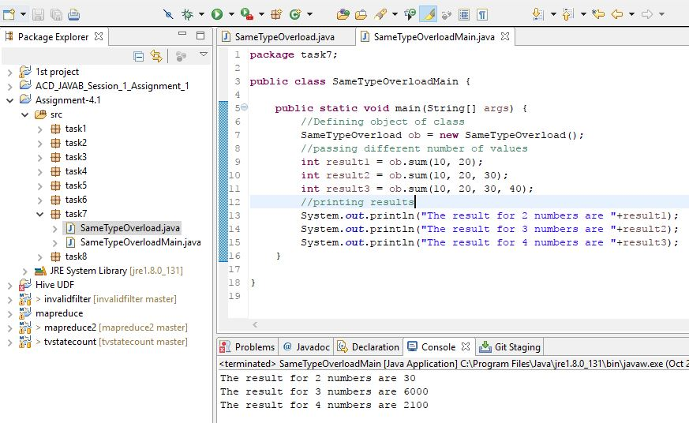

Above screenshot shows we are calling sum() method 3 times but with different number of arguments. As defined in **SameTypeOverload**  class, these 3 callings are doing different operations but their return type is same-**int.**