1. **CONCAT-** This command is used to concatenate two fields(columns) or any hardcoded string to produce desired results.

First load the file and dump it using below commands-

Raw= load '/home/acadgild/hadoop/employee_details.txt' USING PigStorage(',') AS (emp_id:int, name:chararray, salary:int, rank:int);

Dump Raw;

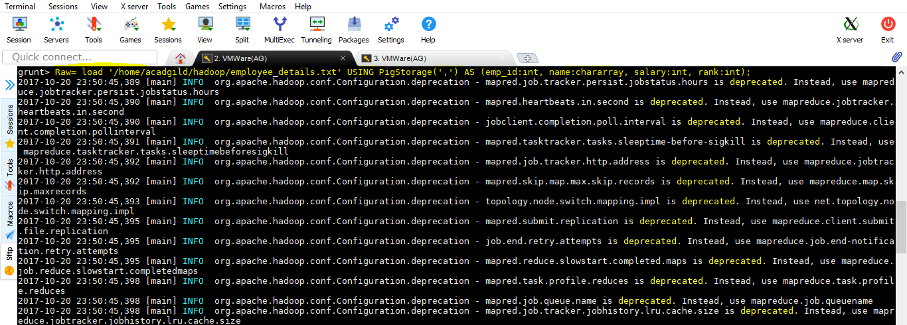

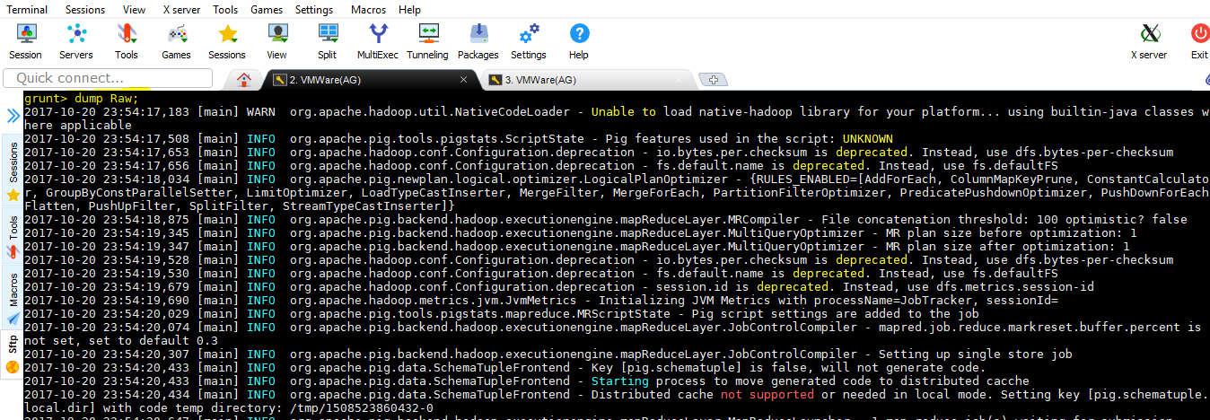

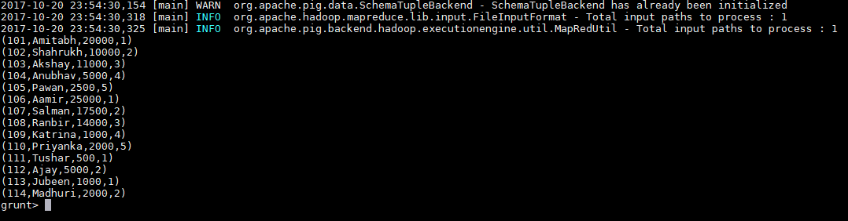

The input file basically contains emp_id, name, salary, rank.

Concatenate “@gmail.com” to Name field to generate employee email id.

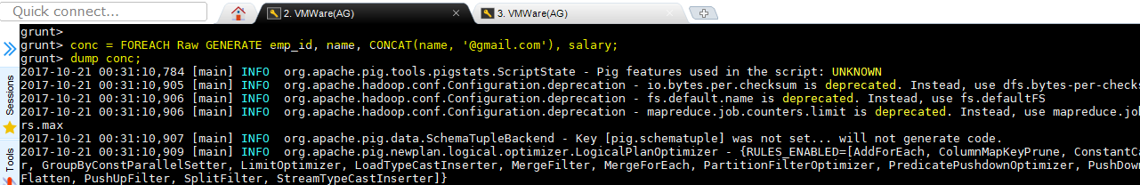

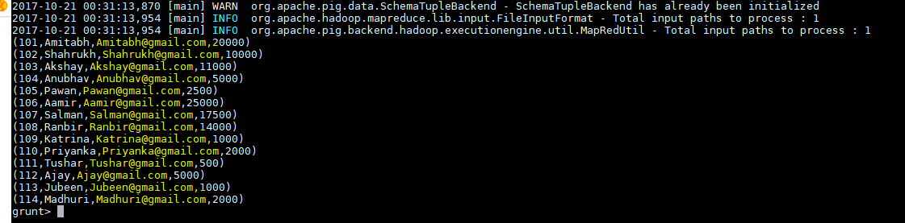

The above output contains additional field referring to email-id of employee.