**IsEmpty -**The isEmpty() function of Pig Latin is used to check if a bag or map is empty.

We are taking two input files- a. emp_details.txt

b. emp_expense.txt

Loading it using PigStorage

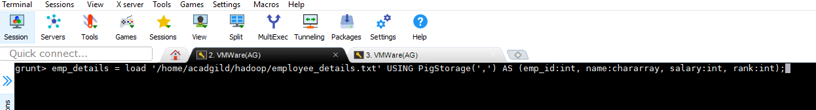

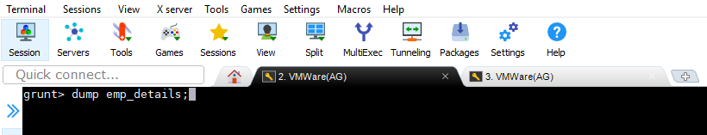

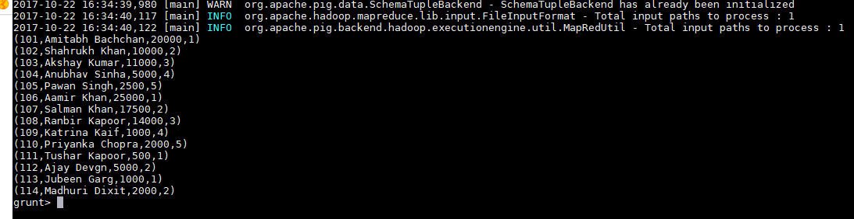

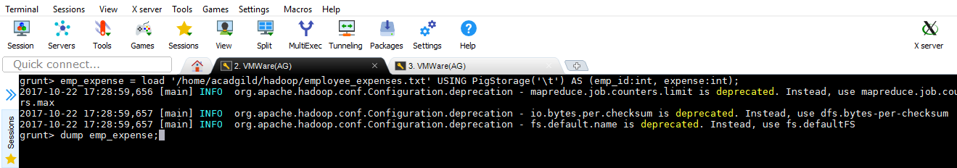

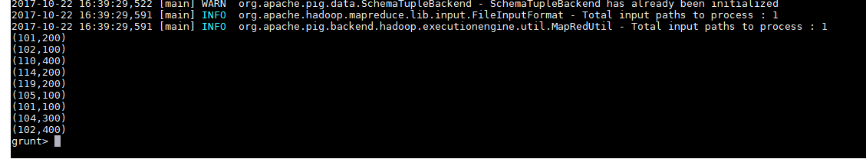

Using cogroup to group both datasets together-

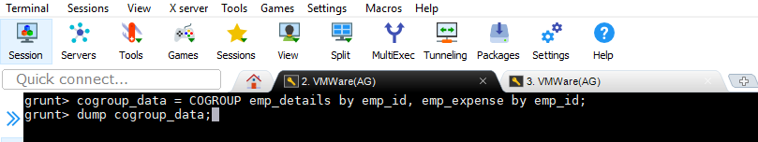

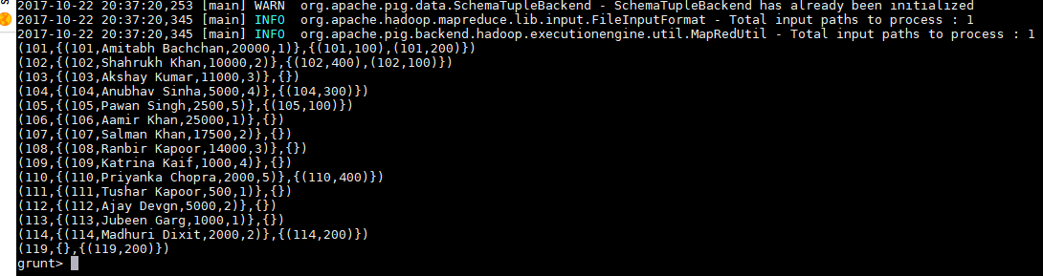

Using IsEmpty on emp_details to check which of the values from emp_expense with emp_id are not present(empty) in emp_details-

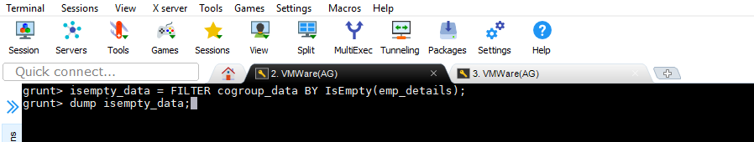

O/P-

