**MIN-**This is used to calculate the minimum of fields having same value. Usually it always works with grouped columns.

Here we have taken below sample_temperature_dataset.csv as input file.

Define relation to load and dump

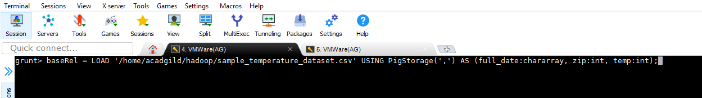

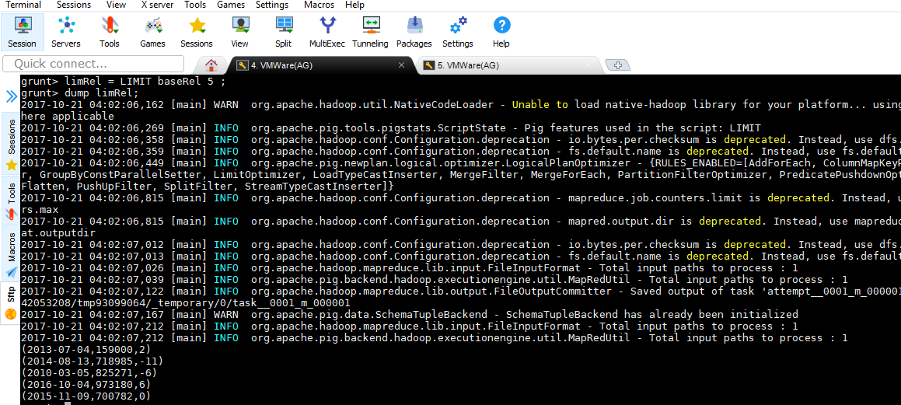

Below relation resRel shows how to implement MIN.

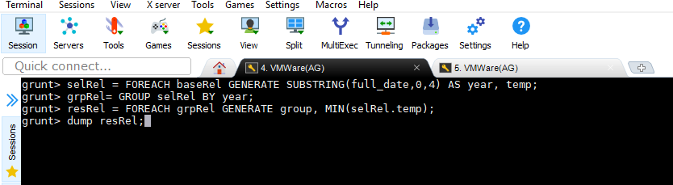

O/P-

