**LIMIT-** The **LIMIT** operator is used to get a limited number of results from a relation.

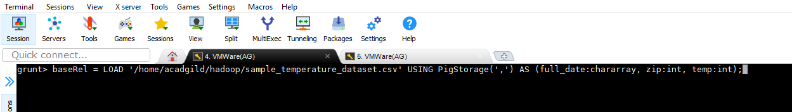

Limiting baseRel to display only 5 records-

limRel = LIMIT baseRel 5;

