**STORE-** It is used to STORE the result of PIG output to HDFS. The output directory specified in HDFS should not exist.

Below are the steps of an operation and finally storing it iin HDFS-

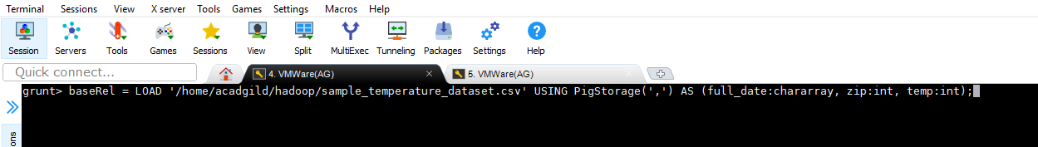

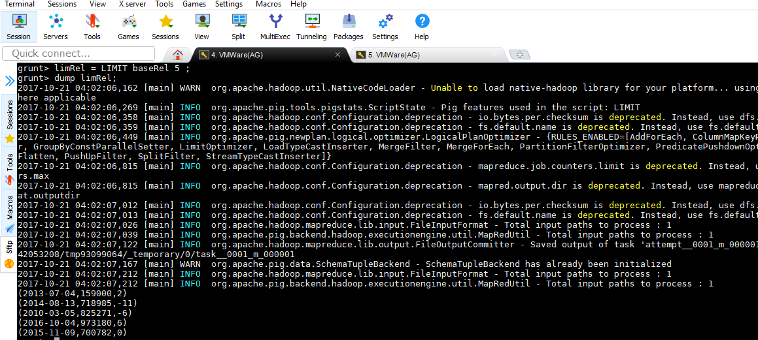

Calculating MAX for the temperature of every Year-

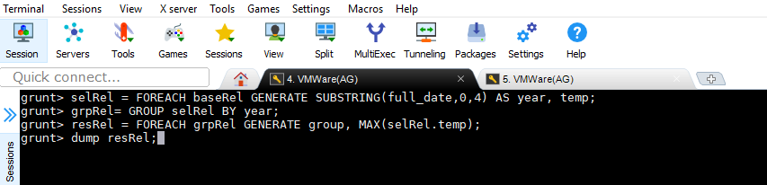

Storing result in **/home/acadgild/hadoop/storerel**

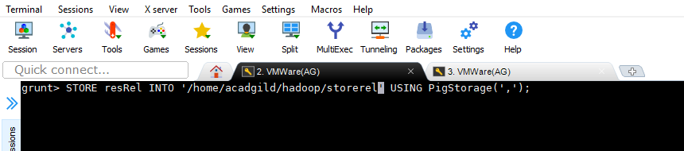

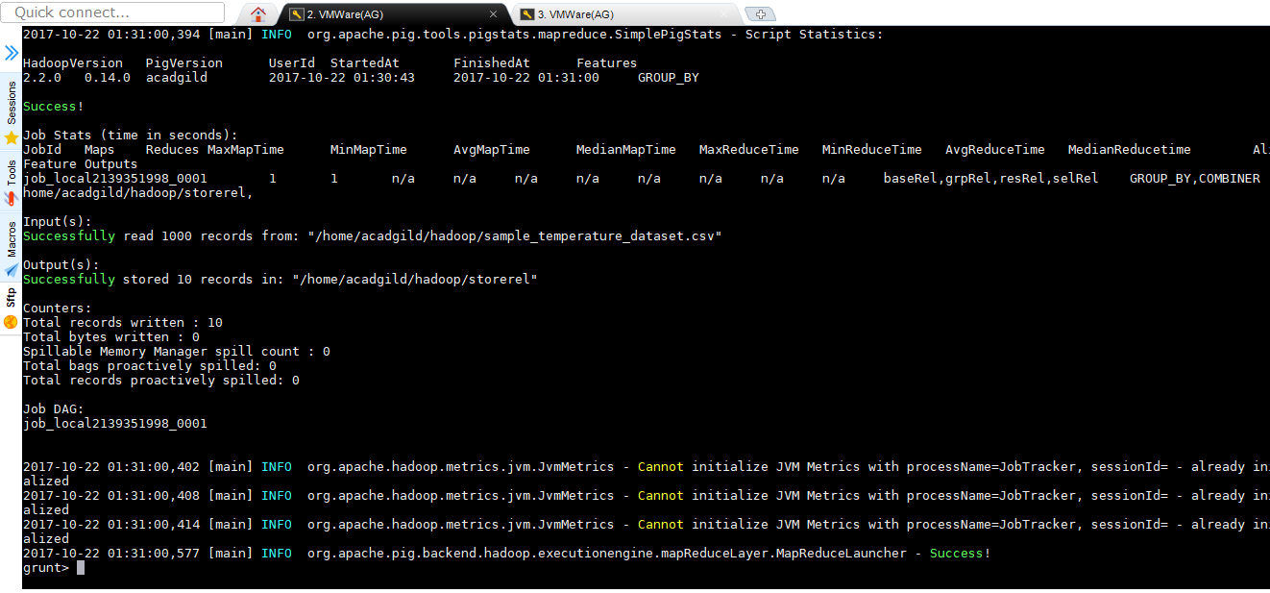

**O/P**

