**DISTINCT-** The **DISTINCT** operator is used to remove redundant (duplicate) tuples from a relation.

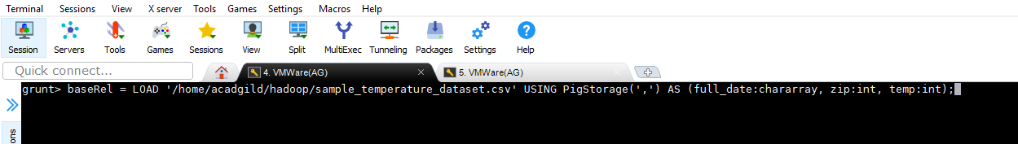

Extracting only years from input dataset, and using DISTINCT command finding all the unique values of the year-

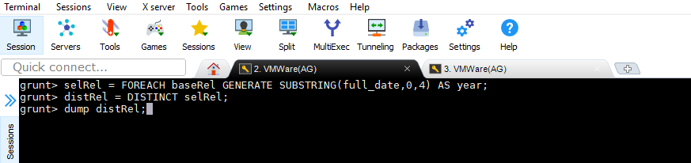

O/P-

