**FLATTEN-** It is used to un-nest data from tuples or bags.

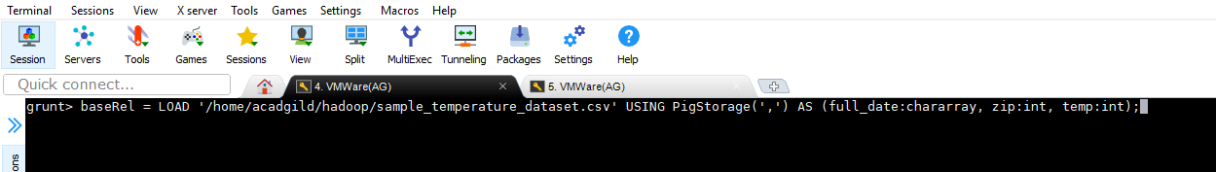

Using below command we are extracting years from the input dataset and grouping it by the year only-

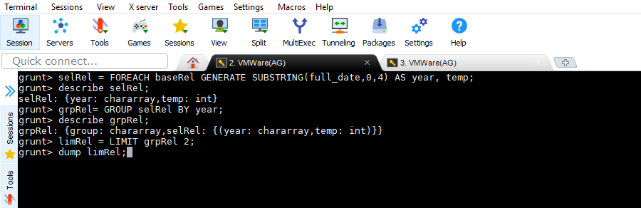

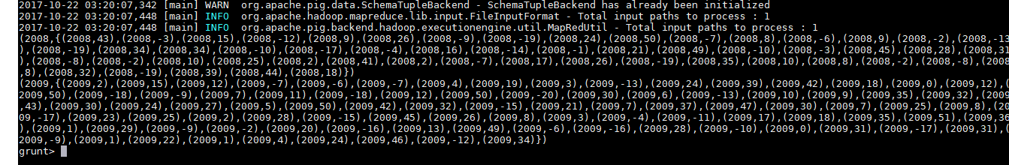

Using FLATTEN to un-nest the grouped data defined above-

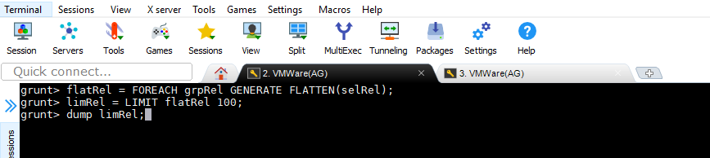

O/P-

