**Creating the database- “custom” in hive-**

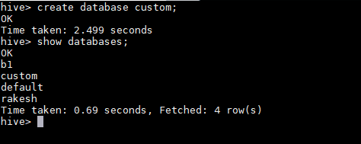

**Creating table “temperature_data” inside database custom and loading the dataset inside that table-**

