**Creating the database- “custom” in hive-**

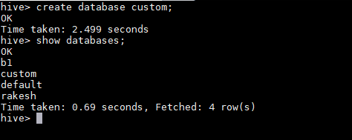

**Creating table inside database custom and loading the dataset inside that table-**

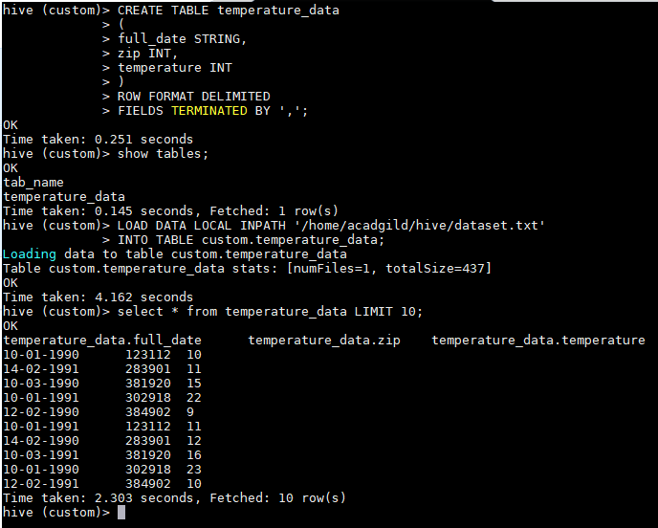

**Next page contains output**

**Below querry gives the desired result-**

