**Creating the VIEW-**

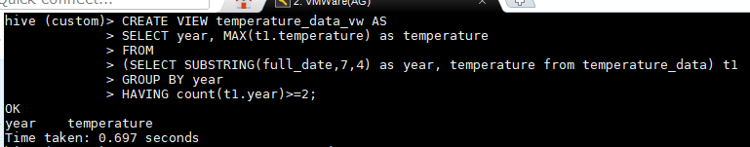

**Selecting Contents of VIEW-**

