Below are the steps followed to get the required result-

1. **CREATE a database in HIVE named as DEMO-**



1. **CREATE a TABLE inside DATABASE Demo as employee with below structure-**

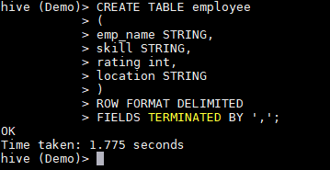

1. **File contents in Local File System-**

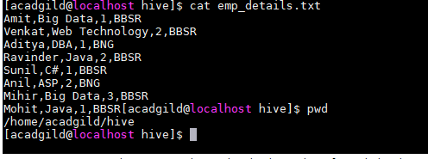

1. **Load data from Local File to the table EMPLOYEE using below LOAD statement-**

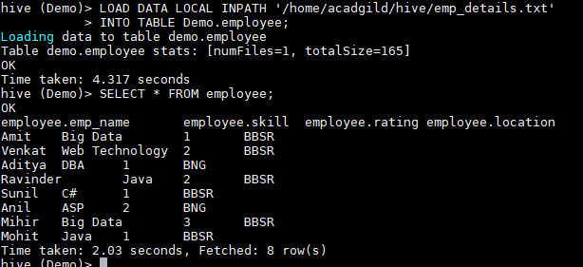

1. **Below query gives the desired output of count of employees for each skill-**

**SELECT skill,count(*) FROM employee GROUP BY skill;**

