**Below is the query to find the number of medals India won year wise-**

>SELECT year,

> SUM(gold_medal) as TOTAL_GOLD,

> SUM(silver_medal) as TOTAL_SILVER,

> SUM(bronze_medal) as TOTAL_BRONZE,

> SUM(total_medal) as TOTAL_MEDALS

> FROM OLYMPIC WHERE country='India'

> GROUP BY year;

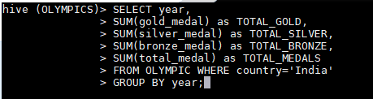

Below is the output of above query-

