**PIZZA SQL_QUERIES**

**A.KPI’s**

**1.Total Revenue:**

select sum(total_price) as Total_Revenue from pizza_sales;

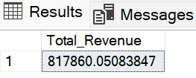

**2. Average order value:**

select sum(total_price)/ count(distinct order_id) as Avg_order_value

from pizza_sales;

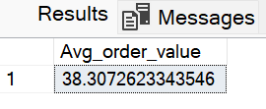

**3. Total Pizza Sold:**

select sum(quantity) as Total_Pizza_Sold from pizza_sales;

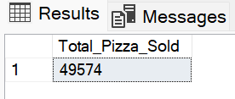

**4. Total Orders:**

select count(distinct order_id) as Total_orders from pizza_sales;

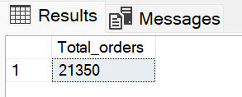

**5. Average Pizzas per Orders:**

select cast (cast(sum(quantity) as decimal(10,2)) /

cast(count( distinct order_id) as decimal(10,2))as decimal(10,2))

as Avg_Pizzas_Per_Order from pizza_sales

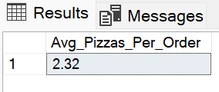

**B.Problem Statements:**

**1. Daily Trends for Total_Orders:**

select DATENAME(DW, order_date) as Order_day,

count( distinct order_id) as Total_orders from pizza_sales

group by DATENAME(DW, order_date)

order by Total_orders desc;

**Output:**

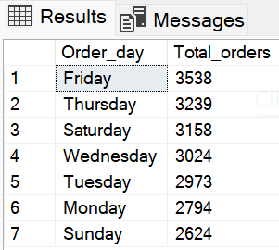

**2. Monthly Trends for Total Orders:**

select DATENAME(Month, order_date) as Month_name,

Count( Distinct Order_id) as Total_Orders from pizza_sales

group by DATENAME(Month, order_date)

order by Total_Orders desc;

**Output:**

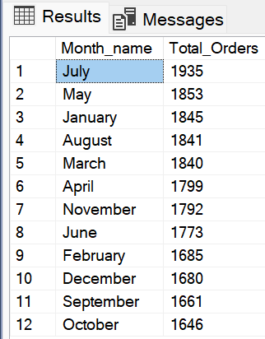

**3. Percentage of Sales by Pizza Category**

SELECT pizza_category, cast (sum(total_price) as decimal(10,2)) as Total_Sales,

cast( sum(total_price) * 100 / (SELECT sum(total_price) FROM pizza_sales) as decimal(10,2)) AS Sale_PCT

FROM pizza_sales

GROUP BY pizza_category;

**Output:**

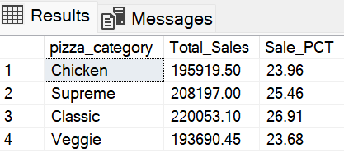

**4. Percentage of Sales by Pizza Size**

SELECT pizza_size, cast (sum(total_price) as decimal(10,2)) as Total_Sales,

cast( sum(total_price) * 100 / (SELECT sum(total_price) FROM pizza_sales where DATEPART(Quarter, order_date) = 1) as decimal(10,2)) AS Sale_PCT

FROM pizza_sales

where DATEPART(Quarter, order_date) = 1

GROUP BY pizza_size

order by Sale_PCT desc;

**Output:**

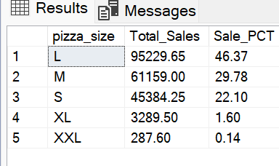

**5. Top 5 Pizzas by Revenue:**

select Top 5 pizza_name, sum(total_price) as Total_Revenue from pizza_sales

group by pizza_name

order by Total_revenue desc;

**Output:**

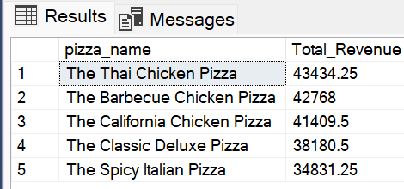

**6. Bottom 5 Pizzas by Revenue:**

select Top 5 pizza_name, sum(total_price) as Total_Revenue from pizza_sales

group by pizza_name

order by Total_revenue asc;

**Output:**

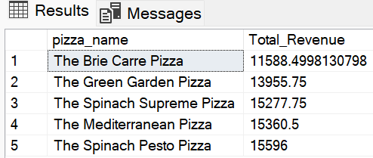

**7. Top 5 Pizzas by Quantity**

select Top 5 pizza_name, sum(quantity) as Total_Quantity from pizza_sales

group by pizza_name

order by Total_Quantity desc;

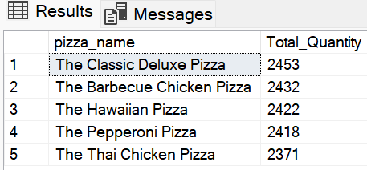

**8. Bottom 5 Pizzas by Quantity**

select Top 5 pizza_name, sum(quantity) as Total_Quantity from pizza_sales

group by pizza_name

order by Total_Quantity asc;

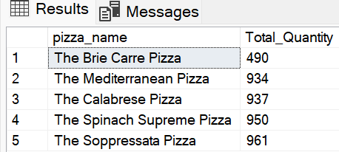

**9. Top 5 Pizzas by orders:**

select Top 5 pizza_name, count(distinct order_id) as Total_Orders from pizza_sales

group by pizza_name

order by Total_Orders desc;

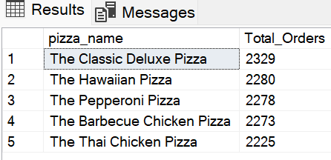

**10. Bottom 5 Pizzas by Orders:**

select Top 5 pizza_name, count(distinct order_id) as Total_Orders from pizza_sales

group by pizza_name

order by Total_Orders asc;

