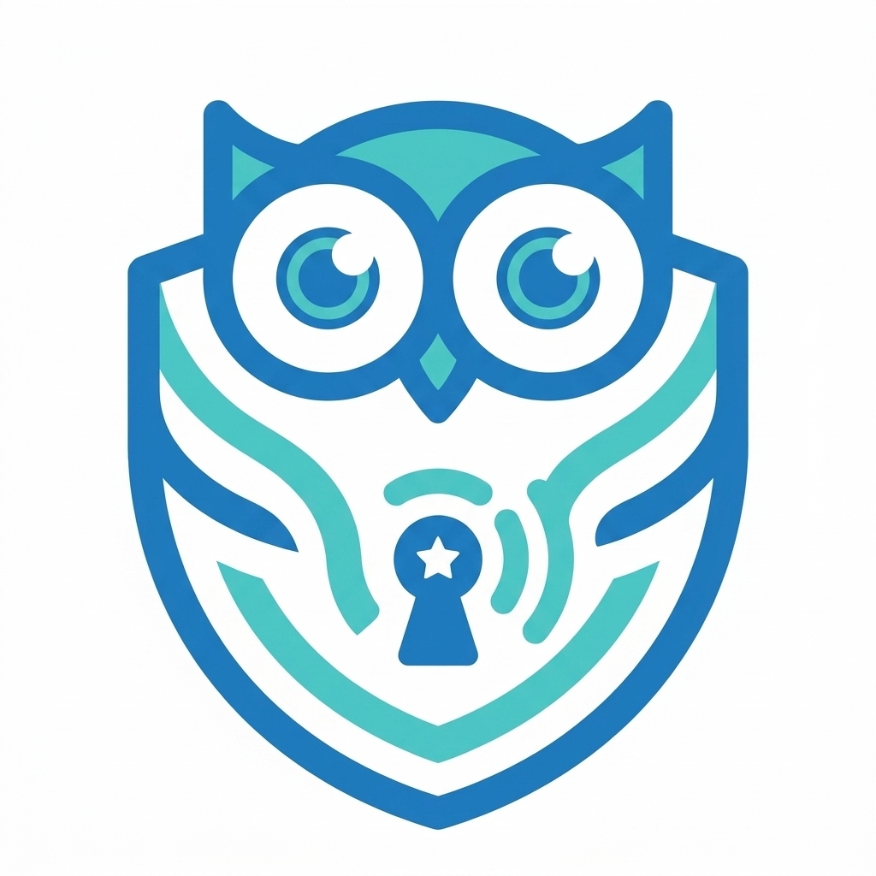

PROPOSAL FOR INTERACTIVE CYBER SAFETY WORKSHOP
Empowering Students for a Safer Digital Future

1. Overview & Objective
In today's highly connected world, students are spending more time online than ever before. While the internet is an incredible resource for learning and entertainment, it also exposes them to sophisticated risks such as phishing attacks, deepfakes, and online scams. The objective of this free, 1-hour interactive workshop is to equip students with the practical skills needed to identify and defend against these modern digital threats.

2. The Cyber Awareness Lab
Instead of boring lectures, this workshop uses the Cyber Awareness Lab — a custom-built, gamified simulation tool. Students will safely experience simulated cyber threats in real-time. By interacting with these harmless simulations, they learn to spot red flags in a risk-free environment.

Key Modules Covered:
- Phishing & Fake Logins: Spotting deceptive links and fraudulent websites.
- Social Engineering: Understanding how attackers manipulate emotions.
- AI & Deepfakes: Recognizing AI-generated voice clones and manipulated media.
- Public Wi-Fi Risks: The dangers of open networks and the importance of encryption/VPNs.

3. Benefits to the School & Students
- Zero Cost: This workshop is provided entirely free of charge as a community initiative.
- Interactive Learning: Gamified simulations ensure high student engagement and retention.
- Future-Ready Skills: Equips students with critical thinking skills for the digital age.

4. Requirements
The workshop requires a projector/smartboard for the presentation. If available, it can also be conducted in a computer lab where students can interact with the tool directly via their web browsers. No software installation is required.

5. About the Instructor
This initiative is led by a B.Tech graduate and local Cybersecurity Professional based in Poranki. Passionate about digital literacy, the instructor has developed this platform specifically to make enterprise-grade security awareness accessible to students.

6. Next Steps & Acknowledgment
A 5-minute live demo of the tool can be arranged at your convenience. If the school finds value in the workshop upon completion, the only request is a brief official letter of acknowledgment on the school's letterhead to support future community initiatives.
Contact Information:
Name: [Your Name]
Location: Poranki, Vijayawada
Phone: [Your Phone Number]
Email: [Your Email]

