Test Report: Tests_CMS_create_request_post-pre_test

Base Page

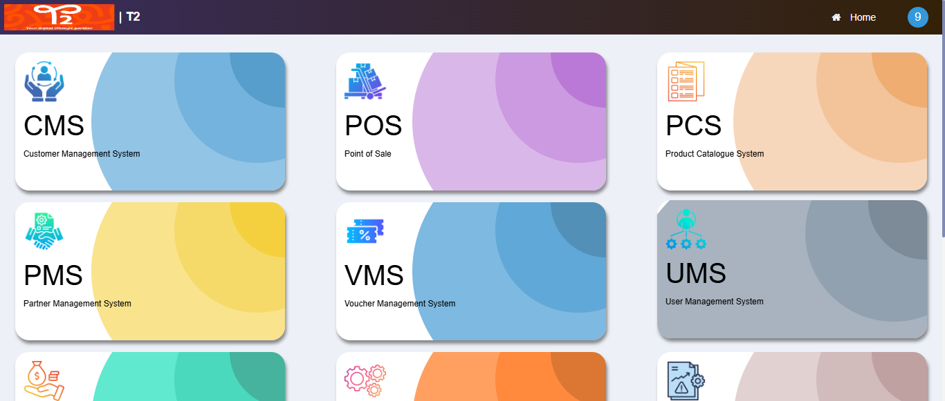

CMS Base Page

