Step 1: Install Java and set add to path

<https://docs.oracle.com/cd/E19182-01/820-7851/inst_cli_jdk_javahome_t/>  
  
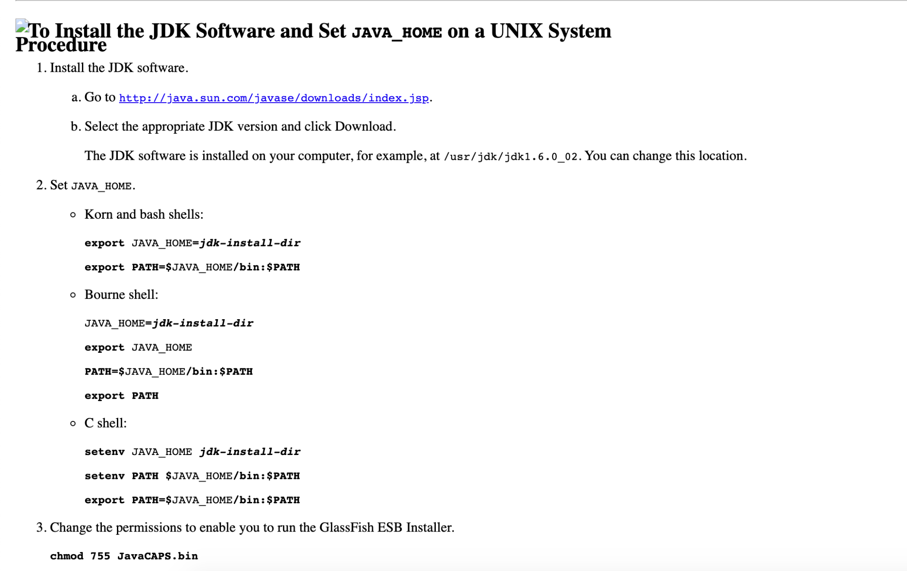  
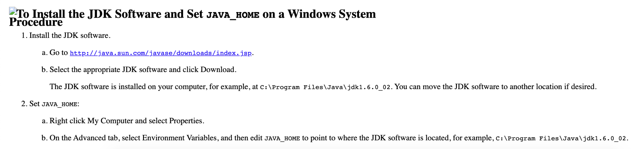  
  
Step 2: Install maven and add to path

<https://maven.apache.org/install.html>  
  
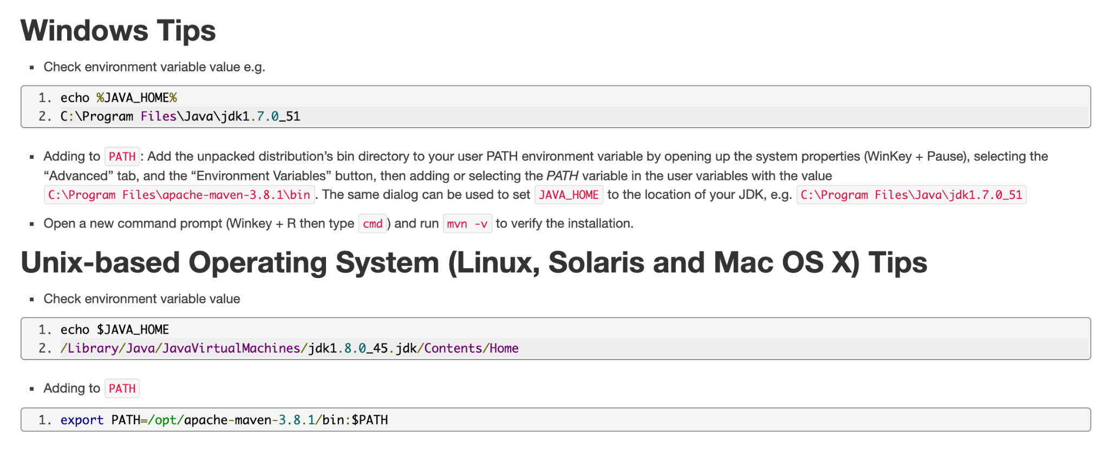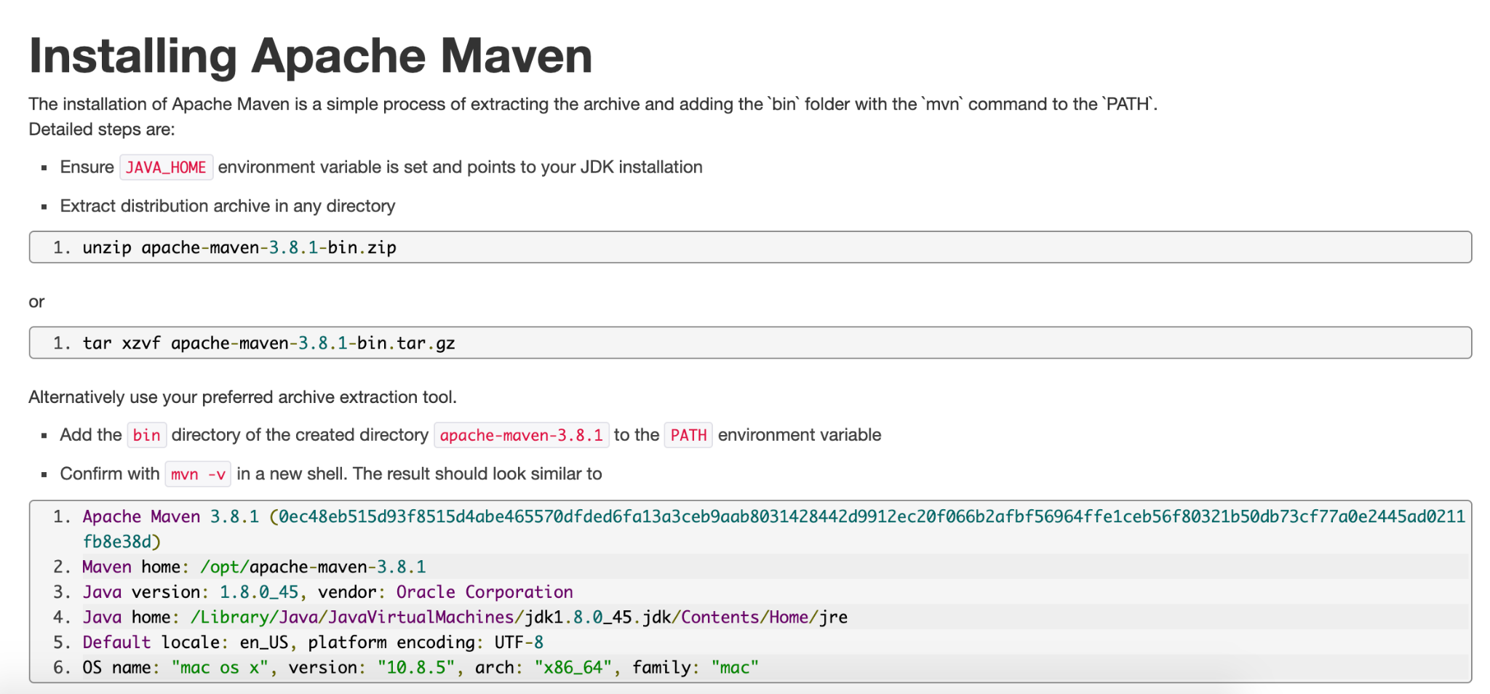

Steps for running:

1. Clone or download the project from here -

- <https://github.com/rakesh-tv/AutomateFileUpload>

1. Navigate to the project folder from command prompt or Terminal
2. Run command - “mvn clean test -DfolderPath={path from where files should be uploaded}”