Task 1:

Check whether /user/acadgild directory exists or not in the HDFS.

Ans: folder is existing. Please find the below screenshot

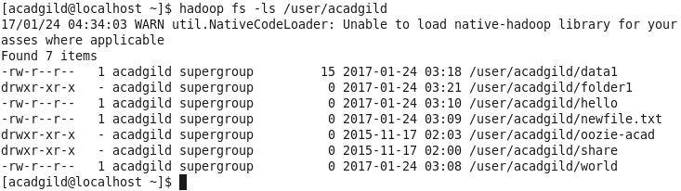

Create a directory /user/acadgild/hadoop.

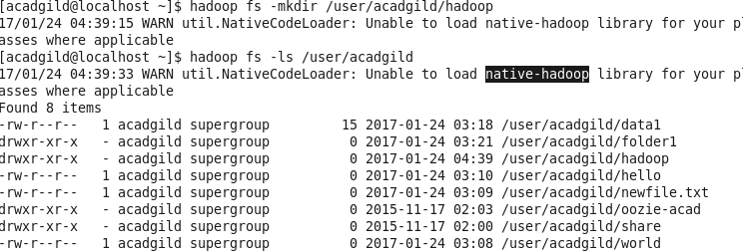

Task 2:

Create a file in HDFS under directory /user/acadgild/hadoop, with name word-count.txt.

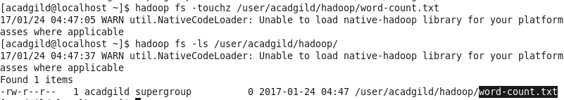

Whatever we type on screen should get appended to the file.

