PRJ_111
Development of a Software Application for Analysis and Processing of DVB-S2 Receiver Output Stream
B.Tech CSE Mini Project — Review-1 Documentation
Team
Name | Role | Primary Responsibilities
Rakeshwar | Core Development & Technical Lead | Backend, Frontend, AI/ML, data processing, stream processing, feature extraction, system integration, technical implementation
Samad | Testing, Validation & Development | Testing, validation, literature review, documentation, report preparation and supporting development activities.
Vengal Rao | Frontend, Visualization & Development | Frontend development, visualization, dashboard components, presentation and supporting development activities.

Review-1: 29 August | 11:00 AM – 2:00 PM | Total Marks: 20
Document prepared by: Samad (Documentation Lead)

Table of Contents
1. Introduction 4
2. Background / DVB-S2 4
2.1 Baseband (BB) Frames 4
2.2 Generic Stream Encapsulation (GSE) 4
2.3 MPEG Transport Stream (TS) 4
3. Problem Statement 5
4. Objectives 5
5. Existing System 5
6. Literature Review 5
7. Research / Engineering Gap 6
8. Proposed System 6
9. Scope 7
9.1 In Scope 7
9.2 Out of Scope (current phase) 7
10. Architecture 7
11. Modules 8
12. Dataset and Data Strategy 8
12.1 Finalized Folder Structure 8
12.2 Dataset Sources and Purpose 9
12.3 Interpretation and Constraints 9
13. Data Processing 9
14. Seven Proposed Features 10
15. AI/ML Strategy 11
16. Expected Output 11
17. Project Planning 12
18. Gantt Chart Description 13
19. Testing Strategy 13
20. Current Progress 13
20.1 Established / Completed 13
20.2 Ongoing 14
20.3 Planned 14
21. Limitations 14
22. Future Work 15
23. Expected Final Outcome 15
24. Conclusion 15
25. References 15
25.1 Standards 15
25.2 Tools 15
25.3 Datasets 15
25.4 Research Papers 16
26. Appendices 16

1. Introduction
Satellite broadcasting systems built on the DVB-S2 (Digital Video Broadcasting – Satellite – Second Generation) standard produce receiver output in multiple encapsulated forms, including Baseband (BB) Frames, Generic Stream Encapsulation (GSE) frames, and MPEG Transport Stream (TS) packets. Analyzing this output is important for verifying stream health, detecting anomalies, and understanding transmission behaviour.
This project proposes a software application that accepts DVB-S2 receiver output — in any of the three formats above — and analyzes it to produce stream health information, anomaly and pattern detection, visualizations, comparisons, and automated reports. The three formats are treated as alternative input types the application can work with, not as a mandatory sequential conversion chain.
Document status: this report reflects the project as of Review-1 preparation. [ONGOING]
Rubric mapping: Literature Review — Section 6; Architecture Diagram — Section 10; Project Planning with Gantt Chart — Sections 17–18; Understanding of Expected Output — Section 16.

2. Background / DVB-S2
DVB-S2 is a widely adopted satellite transmission standard defined by ETSI (EN 302 307-1/-2) that supersedes DVB-S. It supports higher spectral efficiency and flexible modulation/coding, and is used for satellite television, data broadcasting, and other satellite communication services.

2.1 Baseband (BB) Frames
BB Frames are the framing structure at the physical/link boundary of a DVB-S2 signal, carrying the encapsulated payload prior to or immediately after channel coding/modulation processing at the receiver side. They represent one of the lower-level forms of receiver output this project analyzes.

2.2 Generic Stream Encapsulation (GSE)
GSE (ETSI TS 102 606-1) is an encapsulation method that allows IP and other network-layer packets to be carried efficiently over DVB-S2 baseband frames, particularly for data services. GSE frames are one of the three input formats supported by the proposed application.

2.3 MPEG Transport Stream (TS)
MPEG-TS (ISO/IEC 13818-1) is a standard container format for transmitting and storing audio, video, and data, and is commonly used to carry DVB broadcast content, including over DVB-S2 links. TS is the third input format supported by this project.
Important clarification: BB Frames, GSE, and TS are treated in this project as alternative receiver-output/input formats the application can accept, not as a fixed sequential pipeline (i.e., the architecture is not "BBFrame → GSE → TS").

3. Problem Statement
DVB-S2 receiver output is available in multiple formats (BB Frames, GSE, TS), and there is a need for a unified software application capable of analyzing and processing this output to determine stream health, detect anomalies and patterns, and present the results in an interpretable form. Existing tools tend to focus on individual, narrow aspects (protocol inspection, signal-level analysis, or isolated AI tasks) rather than an integrated analysis workflow across these three formats.

4. Objectives
- Analyze DVB-S2 receiver output streams across BB Frame, GSE, and TS input formats.
- Process and parse the three input formats to extract structural and content information.
- Extract meaningful stream-level information relevant to health and behaviour analysis.
- Identify stream health characteristics and support anomaly/pattern detection (Features 1–3).
- Present analysis results — including timelines, explanations, comparisons, and automatic reports — through an understandable application interface (Features 4–7).
These objectives map directly to the seven finalized target features described in Section 14.

5. Existing System
Currently reviewed existing approaches fall broadly into three categories:
- Protocol/packet inspection tools (e.g., Wireshark and its DVB-S2/GSE dissectors) — useful for manual inspection of BBFrame/GSE/TS structures but not designed for automated health analysis, anomaly detection, or reporting.
- Signal-level research on satellite RF interference (RFI) and modulation recognition — typically applies AI/ML at the physical/signal layer rather than at the parsed stream-content layer.
- General network/stream anomaly detection research — often generic to IP/network traffic rather than specific to DVB-S2 receiver-output structures.
Limitation identified: none of the reviewed categories alone provide an integrated workflow spanning multi-format DVB-S2 stream parsing, feature extraction, AI-based anomaly/pattern detection, explanation, comparison, and automatic reporting in one application. [ONGOING — literature review in progress]

6. Literature Review
The literature review is organized into four categories — standards, tools, datasets, and research papers — to give a clear picture of what has been reviewed and what still needs verification.

A. Standards
- ETSI EN 302 307-1 / -2 — defines the DVB-S2 framing structure, including BB Frames.
- ISO/IEC 13818-1 — defines the MPEG Transport Stream (TS) packet structure used as one input format.
- ETSI TS 102 606-1 — defines the Generic Stream Encapsulation (GSE) structure used as one input format.

B. Tools
- Wireshark — DVB-S2 BBFrame/GSE protocol dissector and example capture; reference for structure and for parser validation.

C. Datasets
- daniestevez/grcon22-ctf (GRCon22 Blockstream Satellite capture) — real-world DVB-S2 data for structure reference and validation.
- ssloxford/gsextract sample.ts — small sample used for GSE parser cross-validation, not a training dataset.
- Astra 19.2E TS captures (France, Spain) — used for TS processing and validation.
- RFI classification / Modulation Recognition datasets — supporting sources for AI/ML feature exploration at the signal level, not directly equivalent to DVB-S2 stream datasets.

D. Research Papers

E. Arbon, P. Smet, L. Gunn, and M. McDonnell, “Anomaly Detection in Satellite Communications Systems using LSTM Networks,” 2018 Military Communications and Information Systems Conference (MilCIS), IEEE, 2018, Art. no. 8574109, doi: 10.1109/MilCIS.2018.8574109.

D. Pan, Z. Song, L. Nie, B. Wang, et al., “Satellite Telemetry Data Anomaly Detection Using Bi-LSTM Prediction Based Model,” 2020 IEEE International Instrumentation and Measurement Technology Conference (I2MTC), IEEE, 2020, pp. 1–6, doi: 10.1109/I2MTC43012.2020.9129010.

7. Research / Engineering Gap
Existing standards (DVB-S2, TS, GSE) define protocol structures but do not prescribe analysis tooling. Existing tools support manual inspection/troubleshooting rather than automated, intelligent analysis. Existing AI/ML research in this space tends to target individual tasks (e.g., modulation recognition, RFI classification) in isolation.
The identified engineering gap that this project addresses is an integrated software workflow combining:
- DVB-S2 receiver-output processing across BBFrame / GSE / TS formats
- Feature extraction from parsed stream data
- AI-based anomaly and pattern detection
- Visualization, explanation, comparison, and automatic reporting of results
This gap defines the project's proposed engineering contribution; it has not yet been experimentally demonstrated. [PLANNED — to be demonstrated through implementation]

8. Proposed System
The proposed system is a software application that accepts DVB-S2 receiver output in any of the three supported formats (BB Frames, GSE, or TS) as input, parses and validates it, extracts relevant features, applies AI/ML-based analysis for anomaly and pattern detection, and presents the results — stream health, timelines, explanations, comparisons, and automatic reports — through an application interface.
Cloud deployment is an optional/future consideration and is not part of the current implementation. [PLANNED — future work]

9. Scope

9.1 In Scope
- Analysis of DVB-S2 receiver output in BB Frame, GSE, and TS formats (as alternative inputs).
- The seven finalized target features (Section 14).
- Use of multiple complementary datasets for development and validation, as organized in the current folder structure.

9.2 Out of Scope (current phase)
- Live/real-time satellite receiver hardware integration (not currently planned as part of this phase).
- Cloud deployment (optional/future work only).
- Any capability not listed among the seven finalized features.

10. Architecture
The architecture concept has been established and the graphical architecture has been finalized for Review-1. Detailed refinement and implementation will continue during the development phase.BB Frames, GSE, and TS are alternative receiver-output input formats accepted by the Input/Stream Handler — the application works with whichever format is provided, not a fixed BBFrame → GSE → TS conversion sequence.
DVB-S2 Receiver Output
├── BB Frames
├── GSE
└── TS
(alternative input formats — not a sequential chain)
|
v
Input / Stream Handler
|
v
Stream Parsing
|
v
Data Processing / Validation
|
v
Feature Extraction
|
v
AI / ML Analysis
├── Anomaly Detection
└── Pattern Detection
|
v
Analysis Engine
|
v
Application Layer
|
v
Dashboard / Visualization
├── Health
├── Timeline / Activity
├── Explanation
├── Comparison
└── Automatic Report

11. Modules
Module | Description | Status
Input / Stream Handler | Accepts DVB-S2 receiver output in BBFrame, GSE, or TS format | PLANNED
Stream Parser | Parses the accepted format into structured data | ONGOING (design)
Preprocessing / Validation | Validates and cleans parsed data before feature extraction | PLANNED
Feature Extractor | Derives stream-level features/metrics from processed data | PLANNED
AI/ML Module | Performs anomaly detection and pattern detection on extracted features | PLANNED
Analysis Engine | Aggregates parsing, feature, and AI/ML outputs into analysis results | PLANNED
Comparison Engine | Supports stream-to-stream comparison | PLANNED
Visualization / Dashboard | Presents health, timeline, explanation, comparison, and report views | PLANNED
Report Generator | Produces the automatic analysis report | PLANNED

12. Dataset and Data Strategy
A single public dataset does not cover all requirements of this project (BBFrame/GSE parsing validation, real DVB-S2 structure reference, TS processing, and AI/ML feature exploration). The project therefore uses multiple complementary datasets rather than depending on one source.

12.1 Finalized Folder Structure
PRJ_111_DVB_S2_AI_PROJECT
├── 01_RAW_DATA
│ ├── 01_BBFRAME_GSE
│ │ └── dvb-s2_bb_example.pcap
│ ├── 02_GSE
│ │ └── GSExtract
│ │ └── sample.ts
│ ├── 03_TS
│ │ ├── Astra_19.2E_France
│ │ │ ├── astra192E-ts1080-2018-05-11.ts
│ │ │ └── astra192E-ts1120-2018-05-11.ts
│ │ ├── Astra_19.2E_Spain
│ │ │ └── astra-10847V-2020-08-24.ts
│ │ └── DVBS2_toolkit
│ │ └── sample.ts
│ ├── 04_RFI_AI
│ │ ├── Modulation Recognition.zip
│ │ └── RFI classification.zip
│ └── 05_REAL_DVB_S2
│ └── GRCon22_Blockstream
├── 02_PROCESSED_DATA
├── 03_FEATURE_DATA
├── 04_AI_MODELS
├── 05_CODE
├── 06_RESULTS
└── 07_DOCUMENTATION

12.2 Dataset Sources and Purpose
Source | Purpose | Note
Wireshark DVB-S2 BBFrame/GSE example capture | BBFrame/GSE parsing and validation; real DVB-S2 structure reference | —
daniestevez/grcon22-ctf (GRCon22 Blockstream Satellite capture) | Real DVB-S2 data for real-world validation; TS/GSE/IP processing reference | —
ssloxford/gsextract sample.ts | GSE parser cross-validation | Small parser/testing sample — not a large training dataset
Astra 19.2E TS captures (France, Spain) | TS processing and validation | —
RFI classification / Modulation Recognition datasets | Supporting AI/ML feature exploration | Not directly equivalent to DVB-S2 stream datasets

12.3 Interpretation and Constraints
- Dataset compatibility must be evaluated before any AI training is undertaken.
- Small parser samples (e.g., gsextract sample.ts) are used for validation, not described as training datasets.
- RFI/modulation datasets are supporting sources for feature exploration, not treated as DVB-S2-equivalent training data.
- If training data proves insufficient for a generalizable model, controlled/additional data generation may be considered later (future work).
Current status: dataset strategy — ESTABLISHED; folder structure — ESTABLISHED; dataset collection and organization — ONGOING (not all datasets are yet fully collected/organized).

13. Data Processing
The intended data-processing pipeline, described here conceptually, is: input acceptance (BBFrame/GSE/TS) → stream parsing → preprocessing/validation → feature extraction → storage in processed/feature data directories for downstream AI/ML analysis.
This pipeline has not yet been implemented; parser development, preprocessing, and feature extraction are ongoing/planned work. [PLANNED / ONGOING]

14. Seven Proposed Features
The following are the seven finalized TARGET FEATURES of this project. Their definitions and scope are established; implementation and validation remain part of the ongoing/planned development lifecycle and are not yet complete.

1. Stream Health Analysis
- Purpose: Assess overall condition/quality indicators of a parsed DVB-S2 stream.
- Input: Parsed stream data (BBFrame/GSE/TS)
- Processing concept: Extract health-related metrics from parsed structure
- Expected output: Health status summary for the input stream
Status: definition — ESTABLISHED; implementation and validation — PLANNED.

2. AI-based Anomaly Detection
- Purpose: Identify unusual/abnormal patterns in stream data using AI/ML.
- Input: Extracted stream features
- Processing concept: Apply an AI/ML model to flag anomalies
- Expected output: List/markers of detected anomalies
Status: definition — ESTABLISHED; implementation and validation — PLANNED.

3. Pattern Detection
- Purpose: Identify recurring or notable patterns in stream behaviour.
- Input: Extracted stream features
- Processing concept: Apply pattern-detection logic/model
- Expected output: Identified pattern(s) in the stream
Status: definition — ESTABLISHED; implementation and validation — PLANNED.

4. Timeline / Activity Visualization
- Purpose: Visualize stream activity/events over time.
- Input: Extracted features, detected anomalies/patterns
- Processing concept: Aggregate events on a time axis
- Expected output: Timeline visualization of activity
Status: definition — ESTABLISHED; implementation and validation — PLANNED.

5. Anomaly Explanation
- Purpose: Provide an interpretable explanation for detected anomalies.
- Input: Detected anomalies + underlying features
- Processing concept: Map anomaly to contributing factors
- Expected output: Human-readable explanation of anomaly cause
Status: definition — ESTABLISHED; implementation and validation — PLANNED.

6. Stream Comparison
- Purpose: Compare two or more streams/analysis results.
- Input: Analysis results of multiple streams
- Processing concept: Compute differences/similarities
- Expected output: Comparison summary between streams
Status: definition — ESTABLISHED; implementation and validation — PLANNED.

7. Automatic Analysis Report
- Purpose: Generate a consolidated report of the analysis.
- Input: All prior analysis outputs
- Processing concept: Compile results into a structured report
- Expected output: Generated analysis report (e.g., document/PDF)
Status: definition — ESTABLISHED; implementation and validation — PLANNED.

15. AI/ML Strategy
The AI/ML strategy is currently at the planning stage. The intended direction is to apply machine learning to extracted stream features to support anomaly detection (Feature 2) and pattern detection (Feature 3), drawing on the multi-dataset strategy described in Section 12. The planned sequence is as follows:
- Dataset inspection must be completed first.
- Dataset compatibility must then be evaluated across the identified sources.
- Features will be extracted before any model development begins.
- Model selection (type/architecture) has not yet been finalized.
- Training has not yet been undertaken.
No model has been trained and no accuracy or performance figures currently exist. [PLANNED]

16. Expected Output
EXPECTED / TARGET OUTPUTS — the items below describe what the finished application is intended to produce. They are not current experimental results, and no screenshots or figures are attached at this stage.
Output | What it represents | Why it is useful
Input stream identification | Confirms which format (BBFrame/GSE/TS) was provided and its basic identification | Confirms correct input handling
Stream health/status | Summary indicator of stream condition | Quick assessment of stream quality
Extracted parameters | Key structural/content parameters from the stream | Basis for further analysis
Feature/metric values | Quantitative features derived from the stream | Input to AI/ML analysis
Detected anomalies | Flagged unusual occurrences in the stream | Highlights potential issues
Detected patterns | Identified recurring behaviours | Aids understanding of stream behaviour
Timeline/activity visualization | Time-based view of stream events | Visual understanding of activity over time
Anomaly explanation | Reasoning behind a flagged anomaly | Improves interpretability/trust
Stream comparison | Side-by-side comparison of streams | Supports relative analysis
Automatic analysis report | Consolidated document of findings | Single reference output for the user

These outputs represent the target end-state of the application and are not yet produced by a working implementation. [PLANNED]

17. Project Planning

The project roadmap is organized into five phases, consistent with the Review-1 presentation. The finalized Gantt chart maps the project phases and tasks to the planned timeline, including the Review-1 checkpoint on 29 August.

Phase 1 — Foundation
- Problem understanding & scope [COMPLETED]
- Literature review [ONGOING]
- Dataset collection & organization [ONGOING]

Phase 2 — Data & Core Processing
- Dataset inspection & validation [ONGOING]
- Data preprocessing [PLANNED]
- BBFrame/GSE/TS parser development [ONGOING (design)]
- Feature extraction [PLANNED]

Phase 3 — Intelligent Analysis
- AI/ML model development [PLANNED]
- Anomaly detection [PLANNED]
- Pattern detection [PLANNED]
- Anomaly explanation [PLANNED]

Phase 4 — Application
- Backend development [PLANNED]
- Frontend / dashboard [PLANNED]
- Stream comparison & visualization [PLANNED]
- Automatic reporting [PLANNED]
- System integration [PLANNED]

Phase 5 — Validation & Delivery
- Testing & validation [PLANNED]
- Documentation [ONGOING]
- Final presentation [PLANNED]
Review-1 is a checkpoint covering Phase 1 and the early parts of Phase 2 (dataset inspection, parser design) and does not represent completion of the entire project.

18. Gantt Chart Description
The finalized Gantt chart maps the five project phases to specific weeks and dates and marks the Review1 checkpoint on 29 August. It should visually indicate:
- Completed and ongoing items within Phase 1 and the early part of Phase 2
- Planned items across Phases 2–5 with target date ranges
- The Review-1 checkpoint date (29 August) marked against the timeline

19. Testing Strategy
Testing is planned for the Validation & Delivery phase and will include the following categories. No test execution or results currently exist.
- BBFrame parser testing [PLANNED]
- GSE parser testing [PLANNED]
- TS parser testing [PLANNED]
- Input validation [PLANNED]
- Invalid/corrupted input handling [PLANNED]
- Feature extraction validation [PLANNED]
- Stream health validation [PLANNED]
- AI/ML validation [PLANNED]
- Anomaly detection validation [PLANNED]
- Pattern detection validation [PLANNED]
- UI/output validation [PLANNED]
- Stream comparison validation [PLANNED]
- Report generation validation [PLANNED]
- Performance testing [PLANNED]
- Unseen-data / generalization testing [PLANNED]

20. Current Progress

20.1 Established / Completed
- Problem understanding
- Project scope definition
- Core application concept
- Seven target features finalized
- Dataset strategy finalized
- Dataset folder structure established
- Literature review direction established
- Initial architecture concept established
- Expected application output concept defined
- Review-1 preparation

20.2 Ongoing
- Dataset collection and organization
- Dataset inspection
- Dataset compatibility validation
- Literature review
- Architecture refinement
- Parser design/development
- Documentation
- Review-1 preparation

20.3 Planned
- Full parsing implementation
- Preprocessing
- Feature extraction implementation
- AI/ML development
- Anomaly detection
- Pattern detection
- Anomaly explanation
- Stream comparison
- Backend/frontend/dashboard
- Visualization
- Automatic reporting
- Integration
- Testing and validation
- Final documentation

21. Limitations
- Limited availability of public, comprehensive DVB-S2 stream datasets.
- Dataset diversity is constrained by the currently identified sources (Section 12).
- Sufficient anomaly-labelled data may be needed and is not yet confirmed as available.
- Implementation (parsing, feature extraction, AI/ML, application layer) is still under development.

22. Future Work
- Incorporation of additional datasets as needed.
- Controlled/synthetic data generation if training data proves insufficient.
- Model improvement based on validation results.
- Real-time processing capability.
- Validation on additional unseen real-world data.
- Optional cloud deployment.

23. Expected Final Outcome
The project aims to deliver a working software application capable of accepting DVB-S2 receiver output (BBFrame, GSE, or TS), analyzing it across the seven finalized features, and presenting results through an application interface. This section describes the intended end-state and does not represent current results.

24. Conclusion
This document summarizes the current state of PRJ_111 in preparation for Review-1: the problem and scope are finalized, seven target features are defined, a multi-dataset strategy and folder structure are established, literature review direction is set, and an initial architecture concept exists and is being refined. Implementation of parsing, feature extraction, and AI/ML components remains ongoing/planned. No implementation results, experiments, or accuracy figures are claimed at this stage.

25. References

25.1 Standards
- ETSI EN 302 307-1 — Digital Video Broadcasting (DVB); Second Generation framing structure, channel coding and modulation systems for Broadcasting, Interactive Services, News Gathering and other broadband satellite applications; Part 1: DVB-S2.
- ETSI EN 302 307-2 — DVB-S2X extension.
- ISO/IEC 13818-1 — Information technology — Generic coding of moving pictures and associated audio information: Systems (MPEG-2 Transport Stream).
- ETSI TS 102 606-1 — Digital Video Broadcasting (DVB); Generic Stream Encapsulation (GSE) Protocol.

25.2 Tools
- Wireshark — DVB-S2 BBFrame/GSE protocol dissector and example capture.

25.3 Datasets
- daniestevez/grcon22-ctf — GRCon22 Blockstream Satellite capture (real DVB-S2 data).
- ssloxford/gsextract — sample.ts (GSE parser validation sample).
- Astra 19.2E TS captures — France and Spain sample transport streams.
- RFI classification and Modulation Recognition datasets — supporting AI/ML feature exploration sources.

25.4 Research Papers

E. Arbon, P. Smet, L. Gunn, and M. McDonnell, “Anomaly Detection in Satellite Communications Systems using LSTM Networks,” 2018 Military Communications and Information Systems Conference (MilCIS), IEEE, 2018, Art. no. 8574109, doi: 10.1109/MilCIS.2018.8574109.

D. Pan, Z. Song, L. Nie, B. Wang, et al., “Satellite Telemetry Data Anomaly Detection Using Bi-LSTM Prediction Based Model,” 2020 IEEE International Instrumentation and Measurement Technology Conference (I2MTC), IEEE, 2020, pp. 1–6, doi: 10.1109/I2MTC43012.2020.9129010.

26. Appendices

Appendix A — Dataset Folder Structure Screenshot

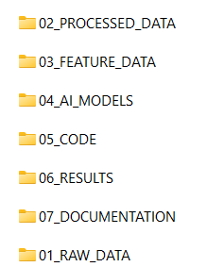
Figure A.1: Organized project folder structure of the PRJ_111 DVB-S2 analysis project.

Appendix B — Architecture Diagram

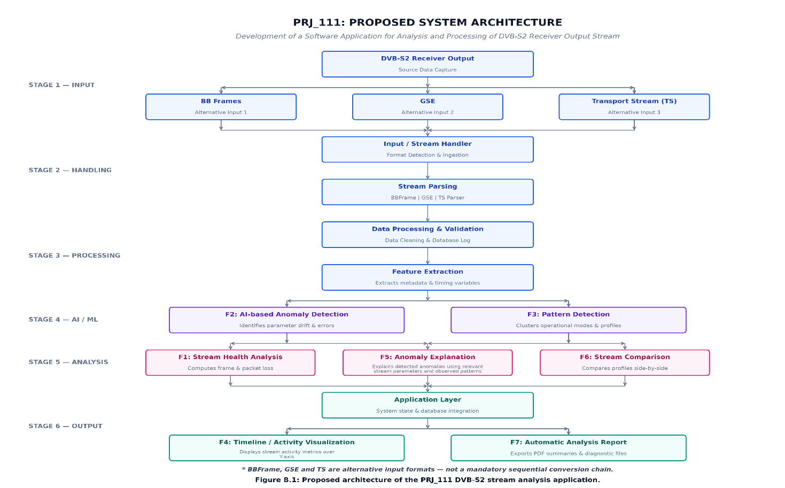

Appendix C — Gantt Chart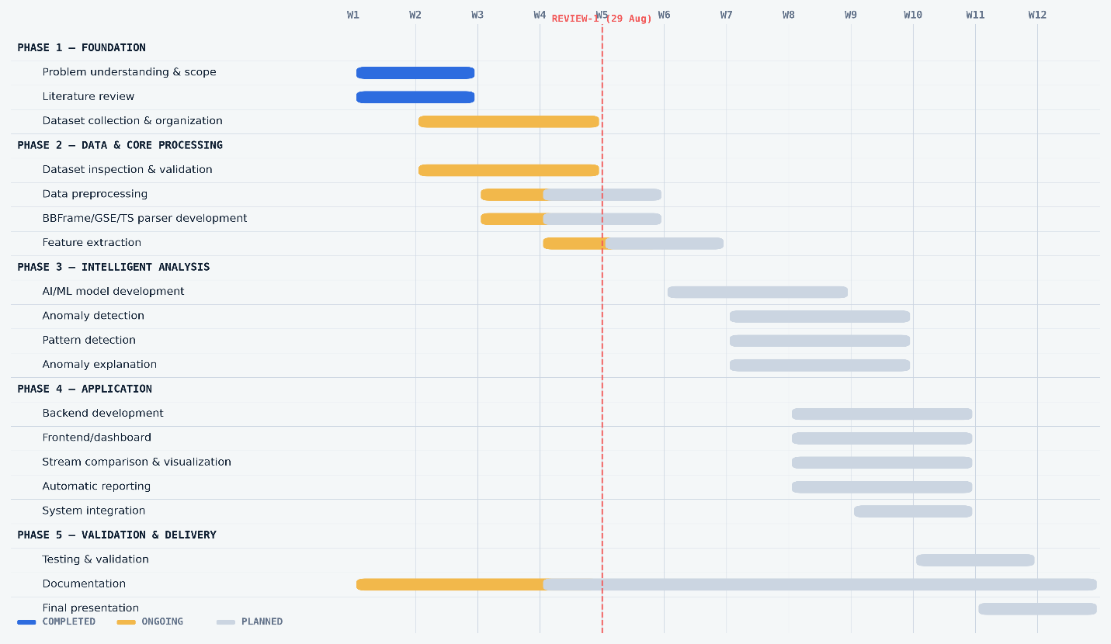Figure C.1: Project planning and development roadmap with Review-1 checkpoint

Appendix D — Dataset Screenshots
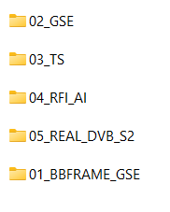
Figure D.1: Categorization of raw datasets collected for the PRJ_111 project.

Appendix E — Code Screenshots

Code implementation screenshots will be added as development progresses.

Appendix F — Application Screenshots

Application screenshots will be added after the application interface and core functionality are implemented.

Appendix G — Testing Evidence

Testing evidence will be added after implementation and validation activities are completed.

