What is Snowflake
Snowflake is a fully managed, cloud-native data platform provided as Software-as-a-Service (SaaS), designed for data warehousing, analytics, and AI.
Cloud native means it is available of AWS, Azure, Google Cloud.

Feature of snowflake:
- Cloud-native architecture: Runs entirely on AWS, Azure, and Google Cloud. No hardware or software installation needed.
- Separation of storage and compute: You can scale them independently, which means you only pay for what you use.
- Elastic scalability: Instantly scale up or down depending on workload, without downtime.
- Zero maintenance: No need to manage infrastructure, tuning, or patching—Snowflake handles it automatically.
- Data sharing: Securely share data across teams or organizations without duplication.
- structured & semi-structured data support: Works seamlessly with JSON, Avro, Parquet, and other formats.
- Concurrency handling: Multiple users can query and work simultaneously without performance bottlenecks.
- Security & compliance: Built-in encryption, role-based access control, and compliance with standards like HIPAA, GDPR.

Note:
We can not use Snowflake as on-premise data warehouse because: -
- Architecture dependency: Snowflake relies on cloud infrastructure services (object storage, elastic compute) that don’t exist in on‑prem environments.
- Service model: It’s delivered as a fully managed service — updates, scaling, and maintenance are handled by Snowflake, not by customer IT teams.
- No binaries or hardware appliances: Unlike traditional databases (Oracle, Teradata, SQL Server), Snowflake doesn’t provide software you can install locally.

Distributed Architecture
- Shared-Disk
- Shared nothing

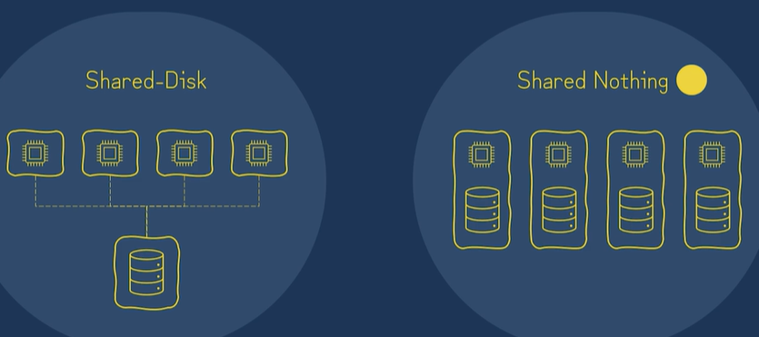

Shared Disk Architecture (SD)
- Shared disk (SD) architecture allows multiple database nodes to access a central shared storage. Nodes share no memory, only storage disks.
- Pros: High fault tolerance (if one node fails, others access the disk), easier for applications requiring centralized data.
- Cons: Expensive hardware, limited scalability compared to SN, potential bottlenecks at the storage level.

Shared Nothing Architecture
- Shared nothing (SN) architecture ensures each node has its own private CPU, memory, and disk, offering linear scalability, lower cost, and high fault tolerance, used by systems like Teradata.
- Nodes communicate via a network; data is typically partitioned (sharded) across nodes.
- Pros: High scalability (unlimited growth by adding nodes), lower hardware costs, no single point of contention for data.
- Cons: Complex to manage data distribution and rebalancing, complex recovery if a node fails.

Multi-cluster shared data architecture
It is a hybrid of traditional shared-disk and shared-nothing database architectures.
Similar to shared-disk architectures, Snowflake uses a central data repository for persisted data that is accessible from all compute nodes in the platform.
similar to shared-nothing architectures, Snowflake processes queries using massively parallel processing (MPP) compute clusters, where each node in the cluster stores a portion of the entire data set locally.

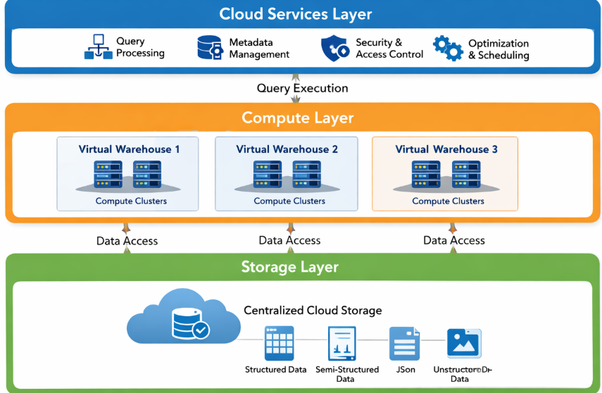

Cloud Agnostic Layer
- This layer is responsible to run the Snowflake data warehouse cloud independent.
- Data is stored in services like AWS S3, Azure Blob Storage, or Google Cloud Storage, leading to infinite storage.
- Handles structured (tables), semi-structured (JSON, Avro, Parquet), and unstructured data

Data Storage layer
- Stores all tables data organised in databases, similar to shared disk architecture.

Quey Processing layer
- this is made of separate compute clusters called for virtual warehouses that process SQL query.
- It has consistent access to centralized data storage.
- It has capability to cache data locally.
- It is similar to shared nothing

Compute layer
- The compute layer in Snowflake is where the actual data processing happens.
- It consists of Virtual Warehouses, which are independent clusters of compute resources (CPU, memory, temporary storage.
- Key Characteristics
  - Virtual Warehouses: Each warehouse is a separate compute cluster that can run queries, load data, or perform transformations.
  - Shared-Nothing Architecture: Warehouses don’t share compute resources; each has its own CPU/memory.
  - Elastic Scaling: You can scale warehouses up (more powerful nodes) or out (more clusters) instantly.
  - Workload Isolation: Different teams or tasks can use separate warehouses without interfering with each other.
  - Concurrency Handling: Multiple warehouses can query the same centralized storage simultaneously.

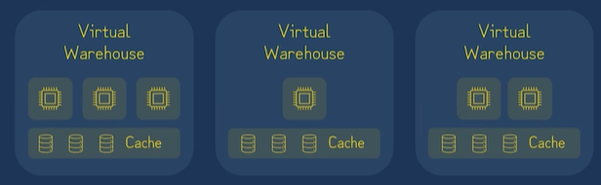

Query Processing Layer
- Parses, optimizes, and coordinates queries before sending them to compute.
- Characteristics:
  - SQL parsing & optimization using metadata and statistics.
  - Transaction management (ACID compliance).
  - Access control, security, and metadata management.
  - Caching for faster repeated queries.

Aspect | Query Processing Layer (Brain) | Compute Layer (Muscle)
Function | Parses, optimizes, coordinates | Executes queries, processes data
Location | Cloud services layer | Virtual Warehouses
Resources | Metadata, optimizer, cache | CPU, memory, temp storage
Architecture Style | Centralized control | Shared-nothing clusters
Key Benefit | Efficiency & consistency | Scalability & isolation
Cloud Service Layer
- It is the top-most layer of the architecture that manages the entire lifecycle of user requests, from login to final query output.
- It coordinates activities across the entire system, linking the storage layer and compute layer together, ensuring security, performance optimization, and metadata.
- It takes care of coordination and management.

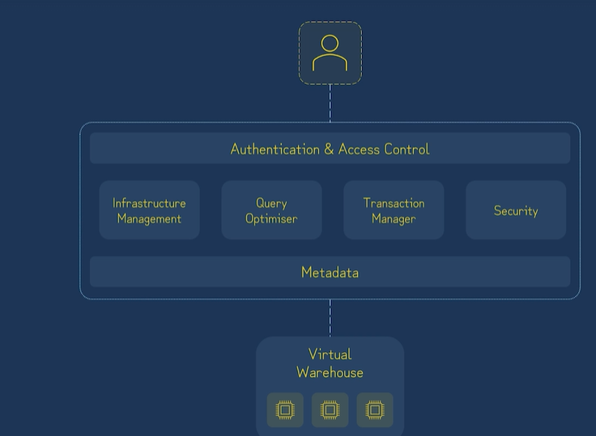

Functions Managed by the Services Layer
- Authentication & Access Control
- Infrastructure Management
- Transaction Management
- Metadata Management
- Query Parsing and Optimization
- Security

Layer | Role | Key Features
Storage Layer | Centralized cloud object storage | Micro-partitioning, compression, infinite scalability
Compute Layer | Virtual Warehouses (shared-nothing clusters) | Query execution, workload isolation, elastic scaling
Service Layer (Cloud Services) | Coordination & management | Query parsing, optimization, metadata, security, transactions

What is ACID property in DB
- Atomicity (All or Nothing): Transactions are indivisible. If any part fails, the entire transaction rolls back, preventing partial updates.
- Consistency (Valid State): Data must adhere to all defined rules, constraints, and triggers, ensuring the database moves from one valid state to another
.
- Isolation (Independent): Concurrent transactions do not interfere with each other. Operations appear to run sequentially, preventing issues like dirty reads or uncommitted data corruption.
- Durability (Permanent): Once a transaction is committed, it is permanently saved, even in the event of a system crash or power loss.

Snowflake object model
The Snowflake Object Model is the hierarchical framework that organizes all entities inside a Snowflake account—from the top-level account down to individual tables, views, and columns. It defines how data, roles, and resources are structured and managed.

