**Capstone Final Project**

Data

The data for this study was scrapped from the following websites:

1. <https://en.wikipedia.org/wiki/List_of_postal_codes_of_Canada:_M>
2. <https://www12.statcan.gc.ca/census-recensement/2016/dp-pd/hlt-fst/pd-pl/Table.cfm?Lang=Eng&T=1201&SR=1&S=22&O=A&RPP=9999&PR=0>
3. <http://cocl.us/Geospatial_data>

Here are the first 12 rows of the data.

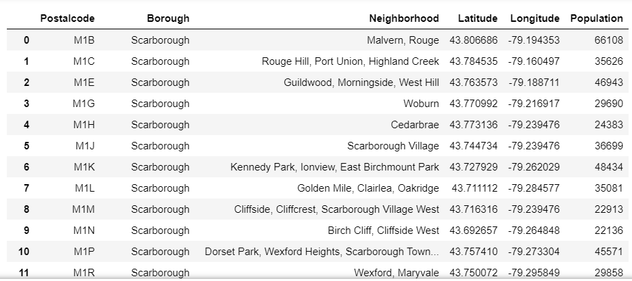

Basically, this dataset gives a selected neighbourhoods, geographical locations, population and borough based on the different postal codes of the city of Toronto, Canada.

Foursquare API will be used at the end of the study (and presented in a separate section of this report) to identify the closest parks to the kmeans centroid cluster