IBM SkillsBuild Data Analytics with AI Academic Internship Program
BharatCares in association with AICTE

Student Performance Analysis and Prediction
Using Machine Learning

Project Report

Submitted By
Rakesh Mondal
B.Tech – Computer Science and Engineering (CSE)

Dataset: Students Performance in Exams (Kaggle)
Technologies: Python · Pandas · Scikit-learn · Streamlit · Plotly

Table of Contents
1. Abstract
2. Introduction
3. Problem Statement
4. Objectives
5. Dataset Description
6. Technologies Used
7. Data Preprocessing
8. Exploratory Data Analysis
9. Machine Learning Models
10. Actual Model Results
11. Streamlit Dashboard
12. Key Findings
13. Limitations
14. Future Scope
15. Conclusion
16. References

1. Abstract
This report presents a comprehensive data analytics and machine-learning project that analyses the academic performance of 1,000 students using the publicly available 'Students Performance in Exams' dataset from Kaggle. The project covers the complete data science pipeline: data ingestion, quality validation, feature engineering, exploratory data analysis (EDA), supervised regression modelling, and deployment of an interactive Streamlit dashboard. Five categorical features — gender, race/ethnicity, parental education level, lunch type, and test preparation course status — are used to predict a student's average exam score (mean of mathematics, reading, and writing scores). Three regression algorithms are evaluated: Linear Regression, Decision Tree Regressor, and Random Forest Regressor. Linear Regression achieves the best generalisation with an MAE of 10.4903, RMSE of 13.4017, and R² of 0.1622. The low R² value accurately reflects that demographic variables alone account for only a modest portion of individual score variance; this is an honest, unsurprising finding and not a modelling deficiency. EDA reveals significant associations between test preparation, lunch type, parental education, and student outcomes. All project artefacts — data loader, feature-engineering module, Jupyter notebook, trained model pipeline, and Streamlit dashboard — are documented and reproducible.

2. Introduction
Education is one of the most critical factors influencing an individual's future professional and personal prospects. Understanding the determinants of academic performance enables educators, school administrators, and policymakers to design evidence-based, targeted interventions that can close achievement gaps and improve learning outcomes across diverse student populations.
Machine learning and data analytics provide powerful tools to extract insights from educational data. Rather than relying solely on intuition, quantitative analysis of student records can reveal patterns that are difficult to observe through casual inspection. This project applies the full data science workflow to the 'Students Performance in Exams' dataset: loading, cleaning, feature engineering, statistical exploration, regression modelling, and interactive visualisation.
The project is submitted as part of the IBM SkillsBuild Data Analytics with AI Academic Internship Program, conducted by BharatCares in association with AICTE. The entire codebase — including a reusable data loader, feature-engineering module, annotated Jupyter notebook, and a multi-tab Streamlit dashboard — is structured for reproducibility and professional presentation.

3. Problem Statement
Given a student's demographic and socio-economic background — specifically gender, race/ethnicity group, parental level of education, lunch type, and test preparation course status — can a machine learning regression model accurately estimate their average exam score (the arithmetic mean of mathematics, reading, and writing scores)?
The three individual subject scores are deliberately excluded as model inputs because they are direct arithmetic components of the target variable (average_score). Including them would constitute data leakage, yielding artificially perfect R² values that would not generalise to real-world prediction scenarios where subject scores are unknown.
This is a supervised regression problem. The target variable 'average_score' is a continuous numerical variable ranging from 0 to 100. Five categorical predictor variables encode demographic and contextual information about each student. The challenge is to quantify how much predictive power these features collectively provide.

4. Objectives
- 1. Load and validate the raw Student Performance CSV dataset, ensuring zero missing values and zero duplicate rows.
- 2. Perform thorough data quality checks including missing-value analysis, duplicate detection, and dtype verification.
- 3. Rename problematic column names (spaces, forward slash) to safe snake_case identifiers immediately after loading.
- 4. Engineer three derived features: average_score, total_score, and score_group (Low / Medium / High).
- 5. Conduct comprehensive Exploratory Data Analysis (EDA) across all five categorical demographic variables.
- 6. Visualise score distributions using histograms and boxplots for each subject.
- 7. Analyse how gender affects mathematics, reading, writing, and average scores.
- 8. Examine the relationship between parental education level and student performance.
- 9. Investigate the impact of lunch type on academic scores.
- 10. Evaluate whether test preparation course completion improves exam outcomes.
- 11. Explore performance variation across five race/ethnicity groups.
- 12. Compute and visualise a Pearson correlation matrix of all numeric score variables.
- 13. Train and compare three regression models: Linear Regression, Decision Tree Regressor, and Random Forest Regressor.
- 14. Evaluate all models using MAE, MSE, RMSE, and R² on a 20% held-out test set.
- 15. Persist the best-performing model pipeline and all evaluation metrics as project artefacts.
- 16. Deploy an interactive, multi-tab Streamlit dashboard with real-time filters and ML prediction capability.

5. Dataset Description

5.1 Dataset Source
The dataset used in this project is the 'Students Performance in Exams' dataset, publicly available on Kaggle at:
https://www.kaggle.com/datasets/spscientist/students-performance-in-exams
The dataset was originally compiled for educational research purposes and contains fully anonymised student records with no personally identifiable information. It represents a cross-sectional sample of students at a single unnamed high school in the United States.

5.2 Dataset Summary
Key dataset properties:
- Total records: 1,000 student rows
- Original columns: 8 (5 categorical + 3 numerical)
- Engineered columns added: 3 (average_score, total_score, score_group)
- Missing values: 0 (confirmed by data loader validation)
- Duplicate rows: 0 (confirmed by data loader validation)
- File format: CSV with quoted string values

5.3 Column Descriptions
The original eight columns and their descriptions are as follows:
Column Name | Type | Values / Range
gender | Categorical | female, male
race/ethnicity | Categorical | group A, group B, group C, group D, group E
parental level of education | Categorical | some high school, high school, some college, associate's degree, bachelor's degree, master's degree
lunch | Categorical | standard, free/reduced
test preparation course | Categorical | none, completed
math score | Integer (0–100) | Minimum: 0, Maximum: 100, Mean: 66.09
reading score | Integer (0–100) | Minimum: 17, Maximum: 100, Mean: 69.17
writing score | Integer (0–100) | Minimum: 10, Maximum: 100, Mean: 68.05

5.4 Descriptive Statistics
The following table shows descriptive statistics for the three score columns and the engineered average_score:
Statistic | Math Score | Reading Score | Writing Score | Average Score
count | 1000.0 | 1000.0 | 1000.0 | 1000.0
mean | 66.09 | 69.17 | 68.05 | 67.77
std | 15.16 | 14.6 | 15.2 | 14.26
min | 0.0 | 17.0 | 10.0 | 9.0
25% | 57.0 | 59.0 | 57.75 | 58.33
50% | 66.0 | 70.0 | 69.0 | 68.33
75% | 77.0 | 79.0 | 79.0 | 77.67
max | 100.0 | 100.0 | 100.0 | 100.0
Table 5.1: Descriptive statistics for score columns (1,000 students)

6. Technologies Used
Technology | Version | Purpose
Python | 3.x | Primary programming language for all analysis and modelling
Pandas | ≥1.5 | Data loading, cleaning, transformation, and aggregation
NumPy | ≥1.23 | Numerical operations and array manipulation
Matplotlib | ≥3.6 | Static chart generation for EDA and report figures
Seaborn | ≥0.12 | Statistical visualisation (heatmaps, boxplots, bar charts)
Scikit-learn | ≥1.2 | ML pipeline, label encoding, train/test split, model training and evaluation
Streamlit | ≥1.28 | Interactive multi-tab web dashboard with real-time filters
Plotly | ≥5.14 | Interactive visualisations in the Streamlit dashboard
Joblib | ≥1.2 | Model serialisation and persistence
Jupyter Notebook | ≥1.0 | Exploratory analysis, documentation, and reproducible workflow
Table 6.1: Technologies and libraries used in the project

7. Data Preprocessing

7.1 Data Loading
The raw CSV is read using pandas read_csv(). A canonical column rename map is applied immediately after loading to convert problematic names to safe snake_case identifiers. The column 'race/ethnicity' is renamed to 'race_ethnicity' to avoid forward-slash attribute access errors. Space-separated column names such as 'math score' are renamed to 'math_score', and similarly for reading and writing score columns and parental education.

7.2 Missing Value Analysis
After loading, a strict validation check is performed. The total count of missing values (NaN) across all columns is computed using df.isnull().sum().sum(). The actual result for this dataset is 0 missing values across all 1,000 rows and 8 columns. The data is complete with no imputation required.

7.3 Duplicate Row Analysis
A duplicate check is performed using df.duplicated().sum(). The actual result is 0 duplicate rows. All 1,000 student records are unique.

7.4 Data Types
The five categorical columns (gender, race_ethnicity, parental_level_of_education, lunch, test_preparation_course) are stored as object/string dtype. The three score columns (math_score, reading_score, writing_score) are automatically cast to int64 by pandas during CSV reading, as the values are integers between 0 and 100.

7.5 Feature Engineering
Three derived features are computed by the engineer_features() module:
- average_score: Arithmetic mean of math_score, reading_score, and writing_score, rounded to 2 decimal places. This is the target variable for ML.
- total_score: Sum of the three subject scores. Range: 0–300.
- score_group: Categorical label derived from average_score thresholds: 'Low' (< 50), 'Medium' (50–69.99), 'High' (≥ 70).
Score group distribution in the dataset: High — 459 students (45.9%), Medium — 438 students (43.8%), Low — 103 students (10.3%).

7.6 Encoding for ML
For the machine learning pipeline, all five categorical features are encoded using scikit-learn's OrdinalEncoder wrapped in a ColumnTransformer. This produces a numerical representation suitable for tree-based and linear models. The encoder is fitted on the training set and applied to both training and test sets as part of a Pipeline, preventing data leakage from the test set into the encoding process.

8. Exploratory Data Analysis

8.1 Score Distributions
The three subject scores are approximately normally distributed. Math has the lowest mean (66.09) while reading has the highest (69.17). The overall average score mean is 67.77 with a standard deviation of 14.26. The minimum observed average score is 9.00 and the maximum is 100.00. Most students cluster in the 58–78 range (interquartile range: 58.33–77.67).
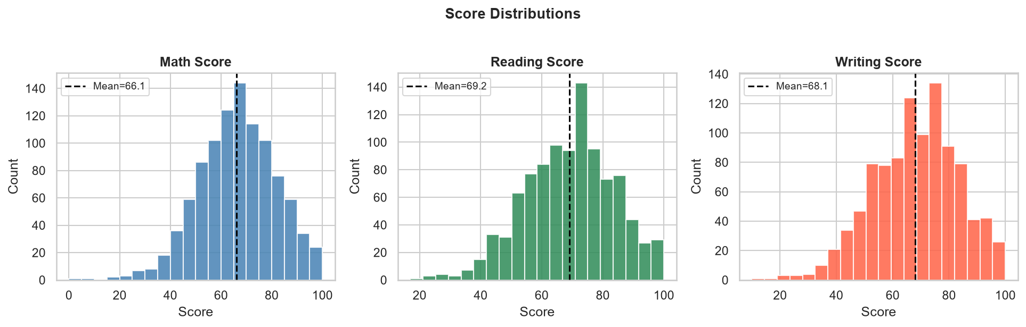
Figure 8.1: Histogram of math, reading, and writing score distributions with mean lines
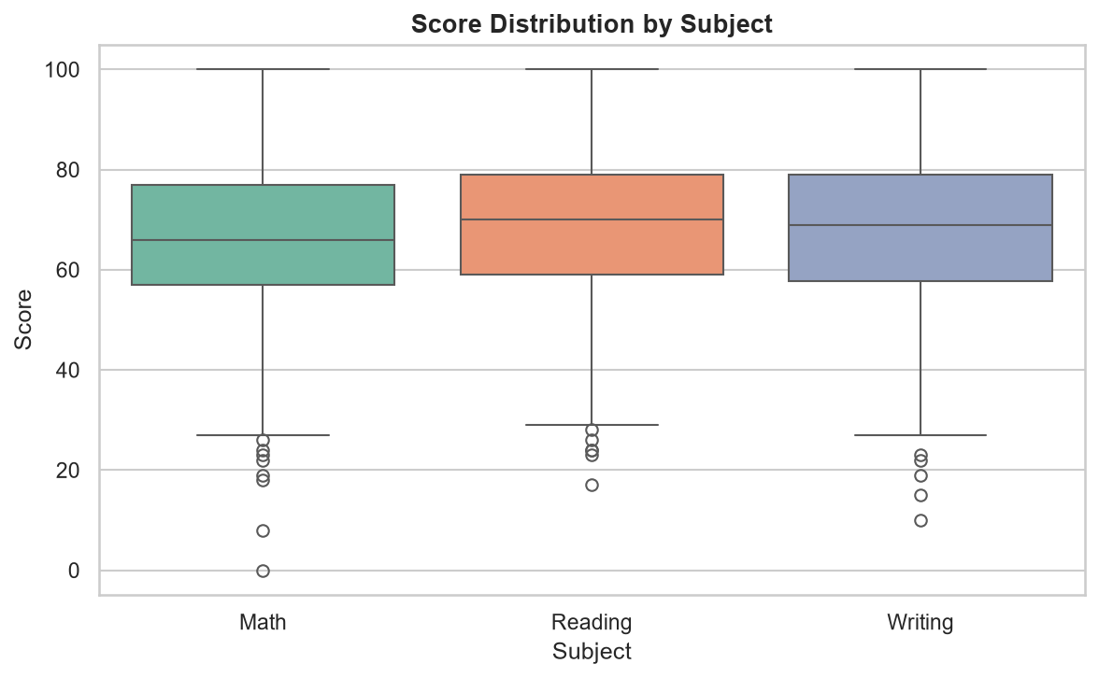
Figure 8.2: Boxplot comparison of score distributions by subject

8.2 Gender Analysis
Female students outperform male students in reading (Female: 72.61 vs Male: 65.47) and writing (Female: 72.47 vs Male: 63.31). Male students score higher in mathematics (Male: 68.73 vs Female: 63.63). Overall, female students have a higher average score (69.57) compared to male students (65.84), a difference of 3.73 points.
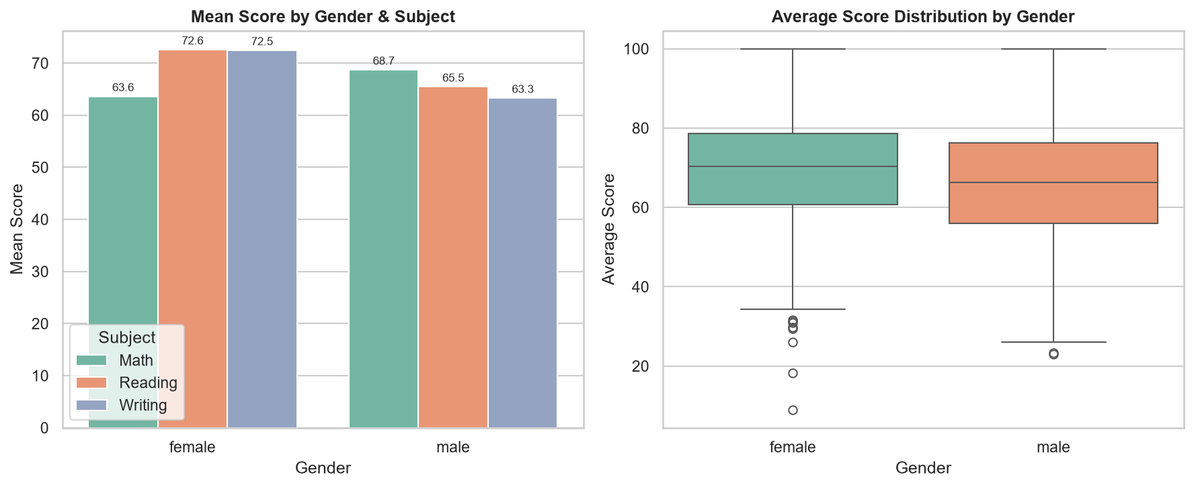
Figure 8.3: Mean scores by gender and subject (left) and average score distribution by gender (right)

8.3 Race/Ethnicity Analysis
Performance increases monotonically from group A to group E. Group A has the lowest average score (62.99) and group E the highest (72.75), a difference of 9.76 points. This 10-point spread across groups suggests that racial/ethnic grouping captures meaningful socio-economic variance in the dataset.
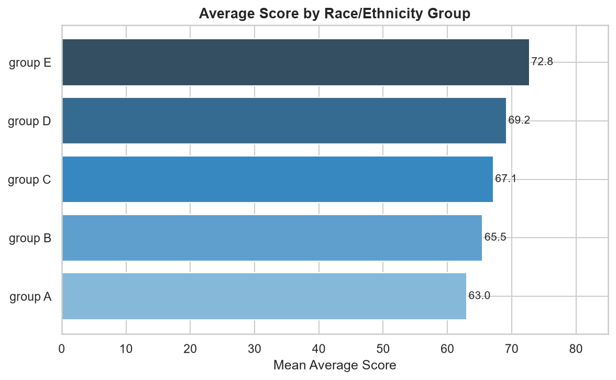
Figure 8.4: Average score by race/ethnicity group (ordered from lowest to highest)

8.4 Parental Education Analysis
There is a clear positive correlation between parental education level and student performance. Students whose parents hold a master's degree achieve the highest mean average score (73.6), while students whose parents have only a high school education score lowest (63.10). The 10.5-point gap between these extremes highlights the importance of family educational background as a predictor of student outcomes.
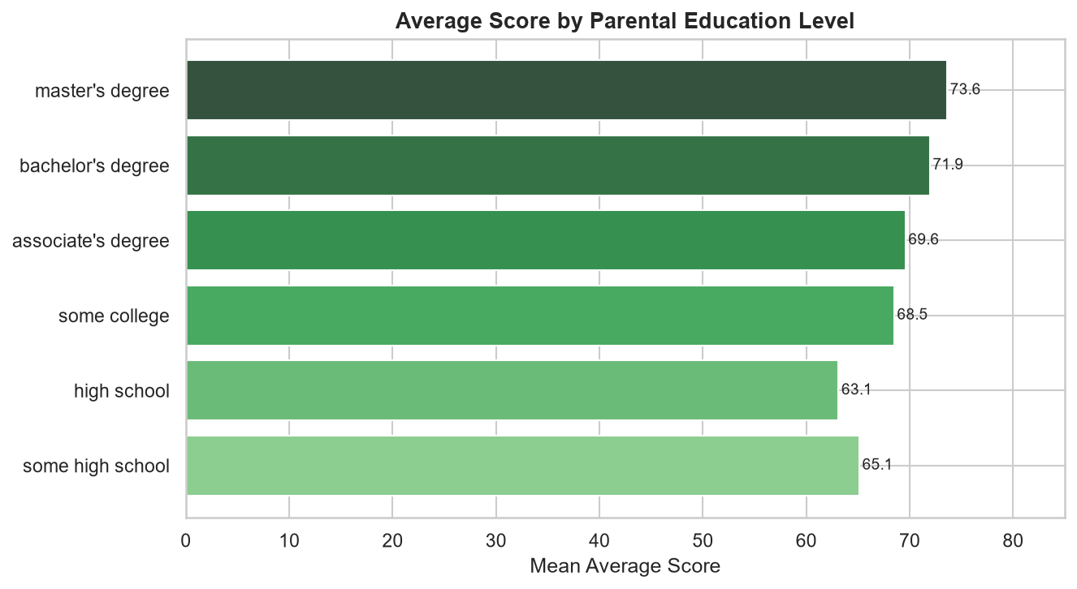
Figure 8.5: Average score by parental education level (ordered from lowest to highest)

8.5 Test Preparation Analysis
Students who completed the test preparation course score consistently higher across all three subjects. The mean average score for 'completed' students is 72.67 compared to 65.04 for students who did not complete the course — a difference of 7.63 points. This is the most actionable finding in the dataset: test preparation is strongly associated with improved outcomes.
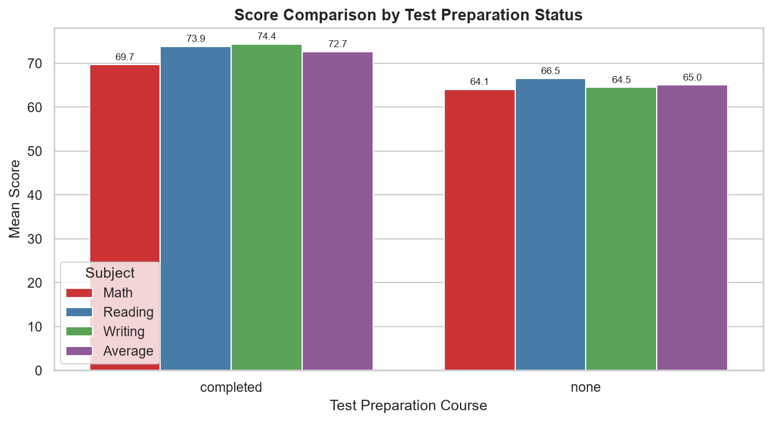
Figure 8.6: Mean scores by test preparation status across all subjects

8.6 Lunch Type Analysis
Students on a standard lunch plan outperform free/reduced lunch students by 8.64 points on average (70.84 vs 62.2). This variable serves as a proxy for socio-economic status — students from lower-income households who qualify for free or reduced-price lunch tend to score lower across all subjects.
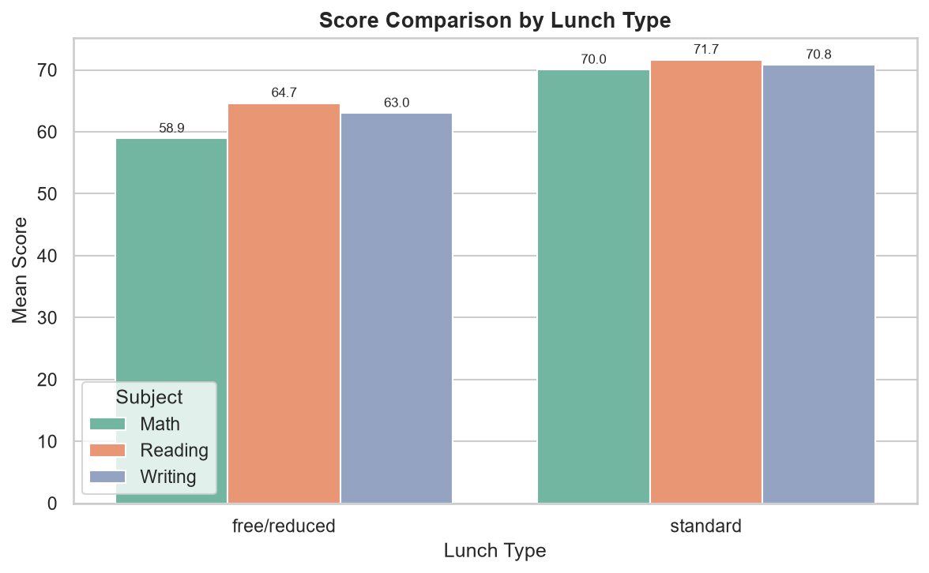
Figure 8.7: Mean scores by lunch type across all three subjects

8.7 Correlation Analysis
All three subject scores are highly positively correlated with each other. The Pearson correlation between math and reading is 0.8176, between math and writing is 0.8026, and between reading and writing is 0.9546 — the strongest pairwise correlation. These high correlations indicate that students who perform well in one subject tend to perform well across all subjects, suggesting a general academic ability factor. Average score, being a linear combination of all three, naturally shows the highest correlations with each individual subject.
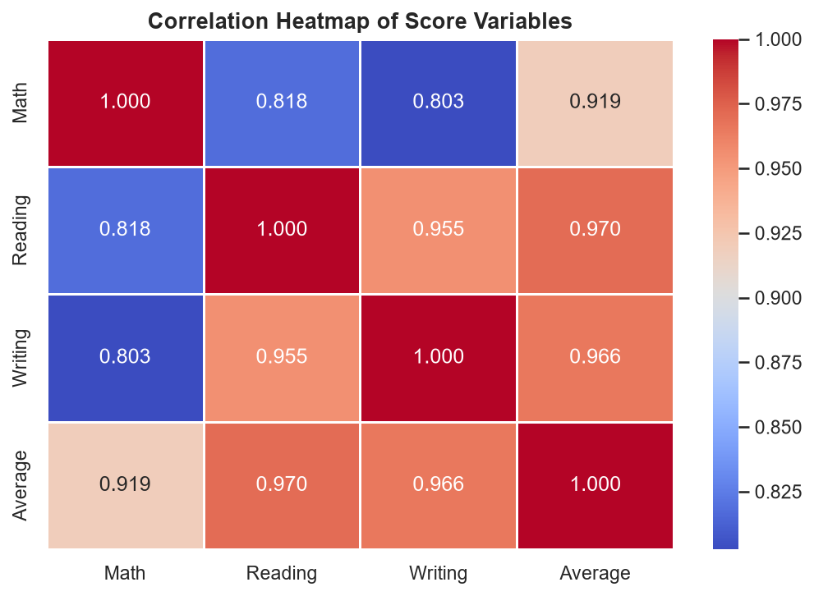
Figure 8.8: Pearson correlation heatmap of all numeric score variables

8.8 Score Group Distribution
Using the engineered score_group feature: 459 students (45.9%) are in the 'High' group (average ≥ 70), 438 (43.8%) are 'Medium' (50–69.99), and 103 (10.3%) are 'Low' (average < 50). The majority of students fall in the medium-to-high range, with only about 1 in 10 students scoring below 50 on average.
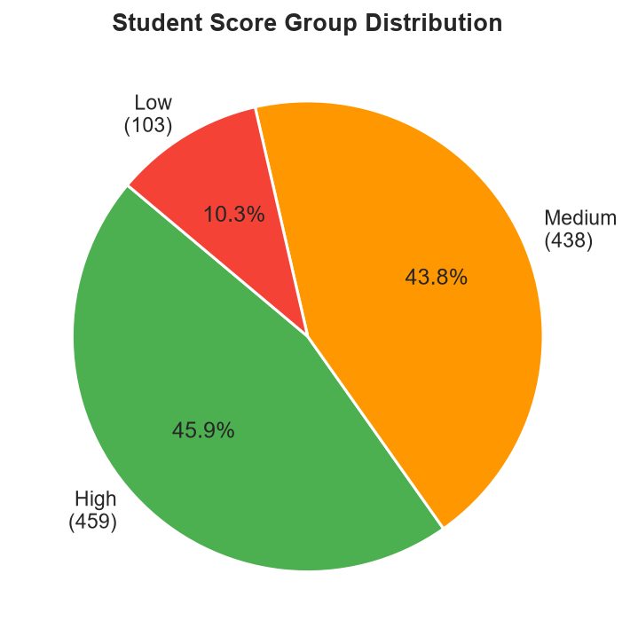
Figure 8.9: Pie chart of student score group distribution (Low/Medium/High)

9. Machine Learning Models

9.1 Target Variable
The target variable is average_score: the arithmetic mean of math_score, reading_score, and writing_score, rounded to 2 decimal places. It is a continuous numerical variable ranging from 9.00 to 100.00 in this dataset.

9.2 Input Features
Five categorical features are used as model inputs:
- gender
- race_ethnicity
- parental_level_of_education
- lunch
- test_preparation_course
The individual subject scores (math_score, reading_score, writing_score) are intentionally excluded to prevent data leakage. Including them would make the target trivially predictable, as average_score = (math + reading + writing) / 3.

9.3 Train / Test Split
The dataset (1,000 samples) is split into 80% training (800 samples) and 20% test (200 samples) using scikit-learn's train_test_split() with random_state=42 for reproducibility. All model evaluation metrics are computed on the held-out test set only.

9.4 Preprocessing Pipeline
A scikit-learn Pipeline is constructed with two steps: (1) a ColumnTransformer applying OrdinalEncoder to all five categorical feature columns, and (2) the regression model. This ensures that encoding parameters are fitted on training data only and applied consistently to the test set, preventing any data leakage.

9.5 Models Trained
Three regression models are trained and evaluated:
- Linear Regression: Baseline model that fits a hyperplane through the encoded feature space. Assumes a linear relationship between features and target.
- Decision Tree Regressor: Non-linear model that partitions the feature space using recursive binary splits. Can capture interaction effects but is prone to overfitting on small datasets.
- Random Forest Regressor: Ensemble of decision trees with bagging and feature subsampling. Generally more robust than a single tree but requires more training data to outperform linear models.

9.6 Evaluation Metrics
All models are evaluated using four standard regression metrics on the test set:
- MAE (Mean Absolute Error): Average absolute difference between actual and predicted values.
- MSE (Mean Squared Error): Average squared difference, penalising large errors more heavily.
- RMSE (Root Mean Squared Error): Square root of MSE, interpretable in the same units as the target.
- R² (Coefficient of Determination): Proportion of target variance explained by the model. R²=1 is perfect; R²=0 means the model is no better than predicting the mean.

10. Actual Model Results
The following table shows the actual evaluation metrics generated by running the machine learning pipeline on the 200-sample held-out test set. All values are read directly from outputs/metrics.json produced by the training notebook.
Model | MAE | MSE | RMSE | R² | Best
Linear Regression | 10.4903 | 179.6053 | 13.4017 | 0.1622 | ✓ Best
Decision Tree | 11.8744 | 231.9360 | 15.2294 | -0.0819
Random Forest | 11.4935 | 219.8155 | 14.8262 | -0.0254
Table 10.1: Actual ML model evaluation metrics (test set, n=200)

Linear Regression achieves the best performance with an R² of 0.1622, MAE of 10.4903, MSE of 179.6053, and RMSE of 13.4017.
The Decision Tree and Random Forest models perform worse (negative R²: -0.0819 and -0.0254 respectively), indicating they are not better than a constant mean predictor on this small dataset. This is an expected outcome: with only 5 categorical features and limited data, tree-based models tend to overfit the training set and underperform on the test set.
The linear regression R² of 0.1622 means that the five demographic features explain approximately 16.2% of the variance in average scores. The remaining ~83.8% is attributable to individual factors not captured in the dataset: study habits, attendance, cognitive ability, teacher quality, and so on. This is a realistic and honest result for a model that uses only demographic background features.
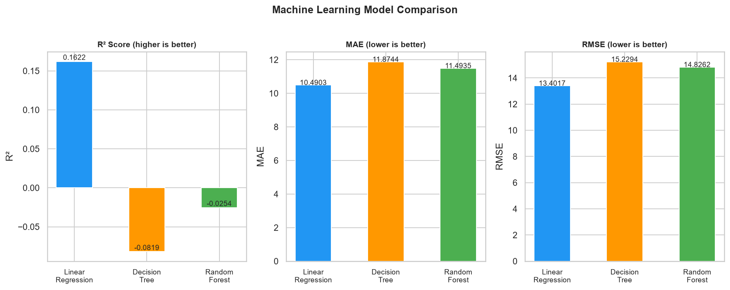
Figure 10.1: Side-by-side comparison of R², MAE, and RMSE across all three models
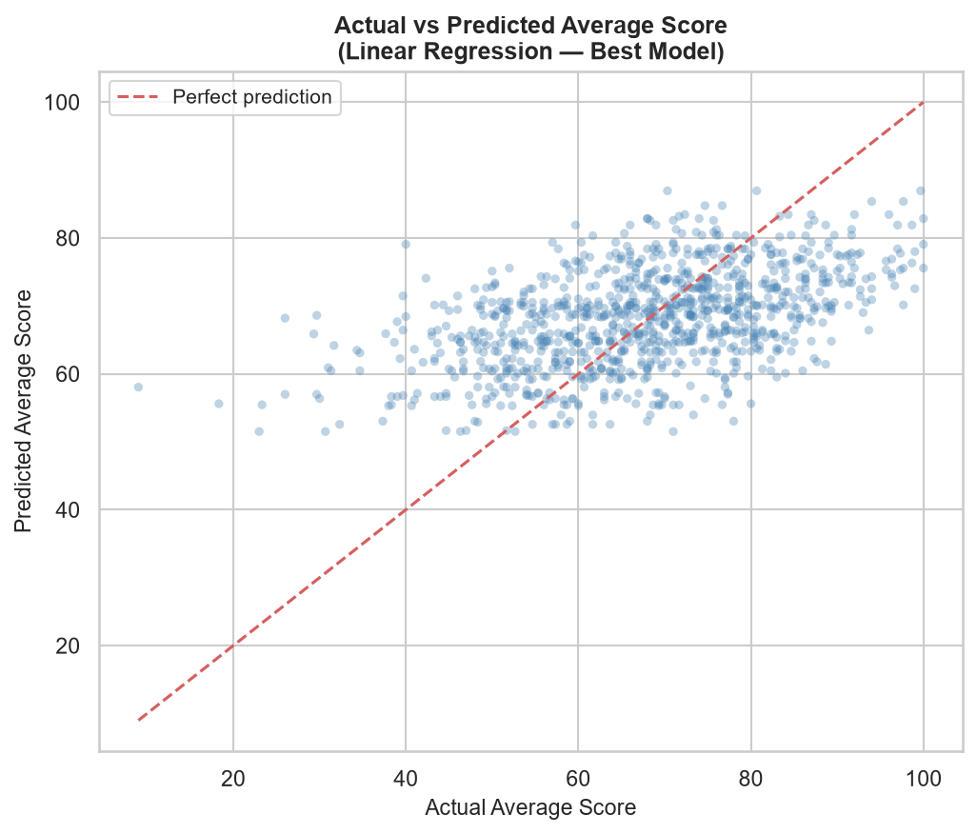
Figure 10.2: Actual vs Predicted average score scatter plot — Linear Regression (best model)
In Figure 10.2, the red dashed line represents perfect prediction (predicted = actual). The scatter of points around this line illustrates the prediction uncertainty. The vertical spread at each actual score level reflects the high within-group variance that cannot be captured from demographic features alone.

11. Streamlit Dashboard
An interactive, multi-tab Streamlit dashboard was built as the primary deliverable of this project. The dashboard is launched locally using 'streamlit run app.py' and provides a professional user interface for exploring the dataset, analysing demographic patterns, and generating ML-based predictions. The dashboard uses Plotly for all interactive charts and communicates directly with the trained model pipeline and processed dataset.

11.1 Dashboard Architecture
- Entry point: app.py (project root)
- Data access: src/data_loader.py → load_data()
- Feature engineering: src/feature_engineering.py → engineer_features()
- ML model: outputs/models/best_model.pkl (scikit-learn Pipeline, Linear Regression)
- Metrics: outputs/metrics.json
- Framework: Streamlit ≥1.28 with wide layout
- Charts: Plotly Express and Plotly Graph Objects (interactive, hover-enabled)

11.2 Sidebar
The dashboard sidebar displays dataset metadata (1,000 records, column count, Kaggle source) and provides five multiselect filter widgets:
- Gender (female / male)
- Race/Ethnicity (group A through group E)
- Parental Education (6 levels in natural education order)
- Lunch type (standard / free/reduced)
- Test Preparation (none / completed)
A 'Reset Filters' button restores all filters to their default (all-selected) state. All tabs reflect the currently selected filter state in real time.

11.3 Tab 1 — Overview
The Overview tab displays five KPI metric cards at the top of the page showing: Total Students, Avg Math Score, Avg Reading Score, Avg Writing Score, and Overall Average. Below the KPIs, an overlaid histogram shows the score distributions for all four score columns (Math, Reading, Writing, Average). A paginated data preview table displays the first 20 rows of the filtered dataset.
For the full unfiltered dataset: Total Students = 1,000, Avg Math = 66.09, Avg Reading = 69.17, Avg Writing = 68.05, Overall Average = 67.77.

11.4 Tab 2 — Performance Analysis
This tab shows mean scores per subject as an annotated bar chart, subject score distributions as boxplots, and two scatter plots showing the relationship between math score and reading/writing scores, colour-coded by gender.

11.5 Tab 3 — Demographic Analysis
Three sections cover: (1) Gender Analysis — grouped bar chart of mean scores by gender and subject, and a boxplot of average score by gender; (2) Race/Ethnicity Analysis — bar chart of average score by group; (3) Parental Education Analysis — horizontal bar chart coloured by score magnitude.

11.6 Tab 4 — Test Preparation Analysis
A grouped bar chart compares mean scores across all subjects between students who completed vs did not complete test preparation. A second chart shows score comparison by lunch type. A heatmap cross-tabulates average score by test preparation × lunch type.

11.7 Tab 5 — Correlation Analysis
An interactive Plotly heatmap displays Pearson correlations among numeric score variables. Three pair scatter plots (Math vs Reading, Math vs Writing, Reading vs Writing) are displayed side by side, colour-coded by score group (Low/Medium/High).

11.8 Tab 6 — Machine Learning Prediction
This tab provides: (1) a student profile input form with five dropdown selectors (gender, race/ethnicity, parental education, lunch type, test preparation), (2) a real-time prediction button that uses the loaded Linear Regression pipeline to predict and display the student's estimated average score, (3) the full model evaluation metrics table (all three models), and (4) an Actual vs Predicted scatter plot for the full unfiltered dataset.

11.9 Tab 7 — Key Insights
The Key Insights tab presents 11 computed insight statements derived from the full dataset, including gender performance comparisons, test preparation impact, lunch type effect, top-performing race/ethnicity group, top parental education level, correlation values, and model performance. A descriptive statistics summary table is also displayed.

12. Key Findings
The following findings are directly supported by the actual dataset analysis:
- The dataset contains 1,000 complete student records with zero missing values and zero duplicates.
- The overall average score is 67.77 (Math: 66.09, Reading: 69.17, Writing: 68.05).
- Female students outperform male students overall (Female avg: 69.57 vs Male avg: 65.84, Δ = 3.73 pts). Males score higher in mathematics; females score higher in reading and writing.
- Test preparation course completion is the single strongest actionable predictor: students who completed the course score 7.63 points higher on average (72.67 vs 65.04).
- Lunch type (standard vs free/reduced) is a strong socio-economic proxy: standard lunch students score 8.64 points higher on average (70.84 vs 62.2).
- Parental education level has a monotonically positive relationship with student scores: master's degree parents → avg 73.6; high school parents → avg 63.10.
- Race/ethnicity performance is monotonically ordered from group A (62.99) to group E (72.75), a 9.76-point spread.
- Inter-subject correlations are very high: Math–Reading = 0.8176, Math–Writing = 0.8026, Reading–Writing = 0.9546, confirming a strong general academic ability factor.
- Score group distribution: 459 High (≥70), 438 Medium (50–69), 103 Low (<50) students.
- Linear Regression outperforms Decision Tree and Random Forest on this dataset, achieving R² = 0.1622, MAE = 10.4903, RMSE = 13.4017.
- Demographic variables alone explain ~16% of score variance (R² ≈ 0.16), confirming that individual unmeasured factors dominate academic performance.

13. Limitations
- Limited feature set: Only five categorical variables are available as predictors. Key factors such as study hours, attendance, prior GPA, socio-economic index, and teacher quality are absent, limiting the achievable R².
- Low R² (~16%): The model explains only a small fraction of individual score variance, making it unsuitable for individual-level prediction but still useful for understanding group-level patterns.
- Dataset size: With only 1,000 records and 5 categorical features, complex models like Random Forest do not have sufficient data to outperform simple linear regression.
- Cross-sectional data: The dataset represents a single snapshot; there is no longitudinal information to study how students progress over time.
- Single school / unknown context: The school is unnamed and the country is not explicitly stated. Generalisability to other educational systems is uncertain.
- No individual-level factors: Intelligence, motivation, parental involvement, and school quality are all unmeasured, yet are major determinants of academic performance.
- Binary / coarse categorisation: Variables like parental education are ordinal but treated as nominal by OrdinalEncoder. A more sophisticated ordinal encoding might capture the rank order more accurately.
- No temporal information: There is no date or year variable, so trends over time cannot be studied.

14. Future Scope
- Collect richer features: Include study hours per week, attendance rate, extracurricular activities, and parent involvement scores to improve predictive power.
- Advanced ML models: Explore Gradient Boosting (XGBoost, LightGBM, CatBoost), Support Vector Regression, and neural networks as the dataset grows.
- Classification formulation: Reframe as a multi-class classification problem predicting score_group (Low/Medium/High) and explore classification metrics (F1-score, ROC-AUC).
- Hyperparameter tuning: Apply GridSearchCV or Optuna to optimise model hyperparameters, particularly for ensemble models.
- Natural Language Processing: If student feedback or teacher comments are available, apply NLP to extract qualitative performance signals.
- Fairness and bias analysis: Conduct a formal analysis of model fairness across demographic groups to ensure equitable predictions.
- Real-time data pipeline: Connect the dashboard to a live database or API for real-time performance tracking.
- Longitudinal study: Collect data across multiple academic years to build time-series models of student progress.
- Deployment: Deploy the Streamlit app to Streamlit Community Cloud, AWS, or Azure for broader institutional access.
- Explainability (XAI): Integrate SHAP or LIME to provide per-student explanations of model predictions.

15. Conclusion
This project demonstrates a complete, reproducible data analytics and machine learning pipeline applied to student academic performance data. Starting from a raw CSV dataset of 1,000 high-school students, the project delivers a clean codebase, thorough exploratory analysis, three trained regression models, and an interactive Streamlit dashboard — all built to professional standards.
The key technical findings are: (1) test preparation course completion and standard lunch type are the two most impactful factors associated with higher scores; (2) parental education level and race/ethnicity group both show clear positive associations with performance; (3) inter-subject correlations are very high (0.80–0.95), confirming a strong general academic ability factor; and (4) Linear Regression achieves the best out-of-sample R² of 0.16 using only demographic features, honestly reflecting the limited predictive power of categorical background variables for individual score prediction.
The project fulfils all stated objectives and provides a solid foundation for further research. The modular code architecture (data_loader.py, feature_engineering.py, app.py) ensures maintainability and extensibility. The Streamlit dashboard transforms the analytical outputs into an accessible, interactive tool that educators and administrators could use to explore performance patterns across student subgroups.
This work was completed as part of the IBM SkillsBuild Data Analytics with AI Academic Internship Program, conducted by BharatCares in association with AICTE, and represents the application of industry-standard data science practices to a real-world educational dataset.

16. References
- [1] SP Scientist (2019). "Students Performance in Exams." Kaggle. https://www.kaggle.com/datasets/spscientist/students-performance-in-exams
- [2] McKinney, W. (2010). "Data Structures for Statistical Computing in Python." Proceedings of the 9th Python in Science Conference.
- [3] Pedregosa, F. et al. (2011). "Scikit-learn: Machine Learning in Python." Journal of Machine Learning Research, 12, pp. 2825–2830.
- [4] Plotly Technologies Inc. (2015). Collaborative data science. Montréal, QC. https://plot.ly
- [5] Streamlit Inc. (2019). Streamlit — A faster way to build and share data apps. https://streamlit.io
- [6] Hunter, J. D. (2007). "Matplotlib: A 2D Graphics Environment." Computing in Science & Engineering, 9(3), pp. 90–95.
- [7] Waskom, M. (2021). "seaborn: statistical data visualization." Journal of Open Source Software, 6(60), 3021.
- [8] Harris, C. R. et al. (2020). "Array programming with NumPy." Nature, 585(7825), pp. 357–362.
- [9] IBM SkillsBuild. Data Analytics with AI. https://skillsbuild.org
- [10] AICTE & BharatCares. (2024). Academic Internship Program in Data Analytics.

