

**Software Engineering CA -1 Windows Form Application**

**By,Rakesh Neginhal(10506981) & Raviteja Gadde (10517744) Module Title: Software Engineering B9IS118 Module Lecturer: Mr. Harnaik Dhoot**

[18-April-2019]



**Introduction-**

File Manipulator is a windows form Application that provides user to sort the file contents and also provides mathematical operations. User need to select root directory and destination directory. The root directory should contain contents which needs to be sorted. Whereas destination directory will have all the sorted files. Also, there is an option to look for all the sorted files and directories. In addition to this, the application also provides to calculate the mathematical operations based on mathematical operations provided in the file. It will read only the file which are having ‘.calc’ extension.

**Design: -**

This windows form application consists of 2 parts

**(A)SORTING MODULE**

**(B)CALCULATION MODULE**

**(A) SORTING MODULE**

1. User selects the root directory where he will be directed to browse and selects a folder. In selected folder all the text files will be considered for sorting. After successful selection of folder select destination directory will be enabled. Where user can select the destination folder for writing sorted files . This button is to make sure that all the sorted files are written to a folder selected by user.

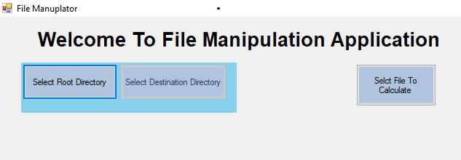

1. On successfully selecting root and destination folder the sort files button will be enabled. On click of this button sortFiles() method will be called by passing root path and destination path. The method will sort the files and writes the file in selected destination folder by appending “sorted” to the original file name.

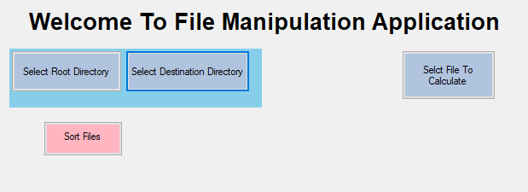

1. There is an option to view the history of sorted files and directories. A dropdown box is displayed showing of all directories, list of all files for a given directory and list all sorted files. This enables users to view history of Directories and sorted files easily.(list of dropdown)

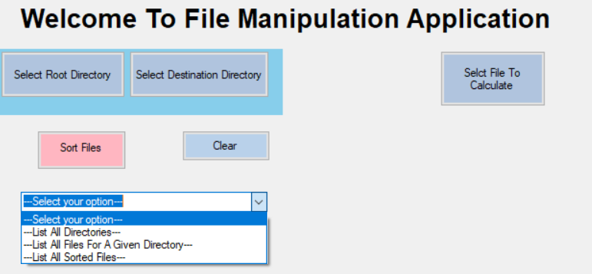

3.1 After sorting of file the selected destination directory written into a local file and the path of local file is given as a key value pair inside app.configfile. On select of list all directories, all the previous directories selected (destination directory) is displayed in a text area.

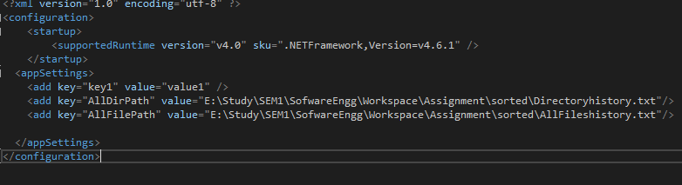

App.Config

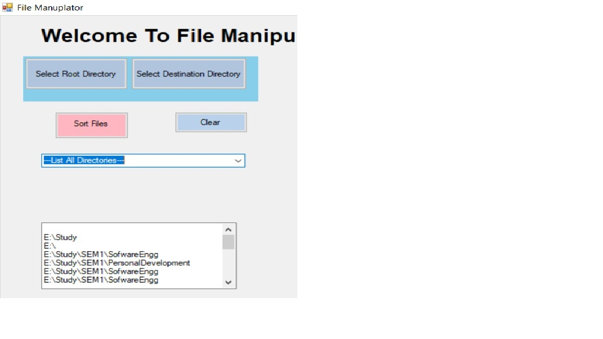

* 1. OnClick of list all files for a given directory a select directory button will be displayed where user will browse to select a directory which contains list all sorted files. These directories are stored in a dictonary as key value pairs. The same is iterated and displayed on text area. By using Dictonary the destination directory and sorted file are stored as key value pairs respectively

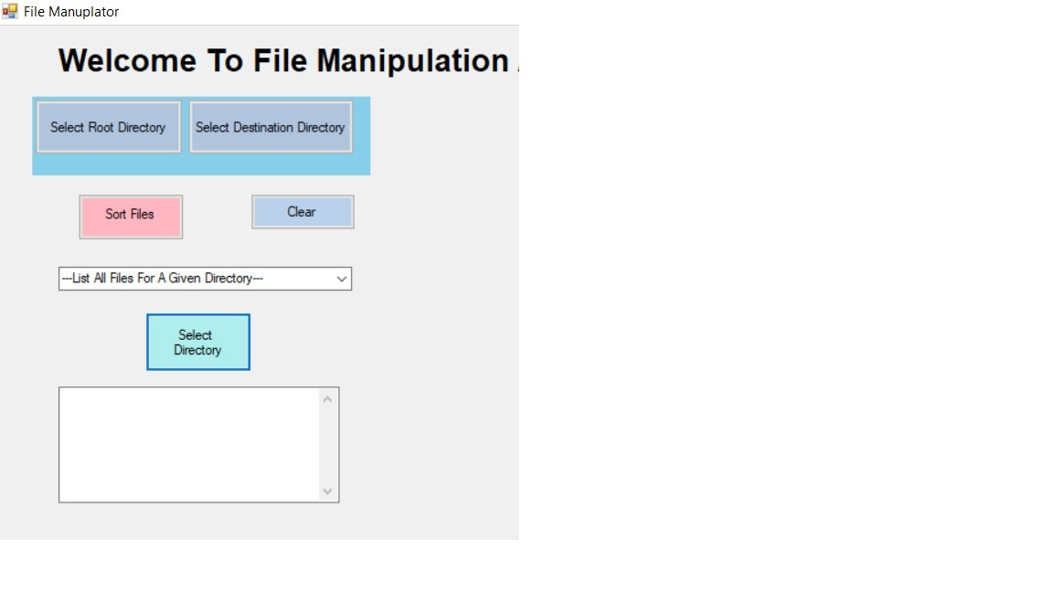

* 1. On Click of list all sorted files, all the sorted files for all the selected destination directory will be displayed in the text area. All these sorted files are stored in a local file and the path of local file is configured as a value in app.config file.

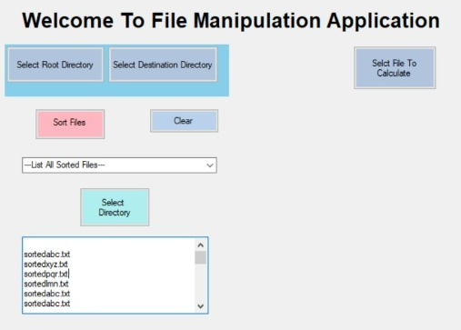

**(B)Calculation Module**

1. when user selects the “select file to calculate” button, the user is enabled to select the folder from any directory. All files which are having ‘.calc’ extension are retrieved from the user selected directory.

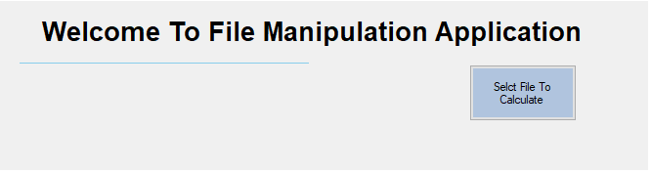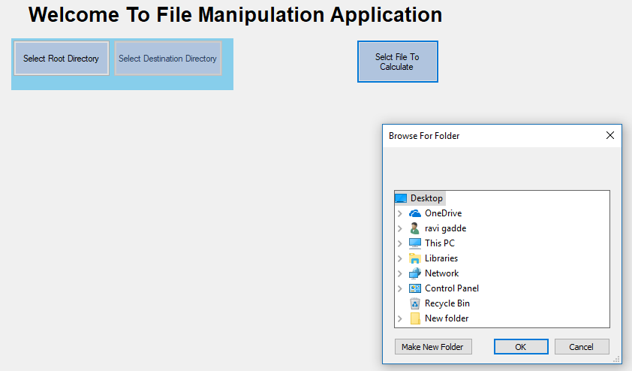

1(a). We are using Stream Reader to read the files user specified Directory.

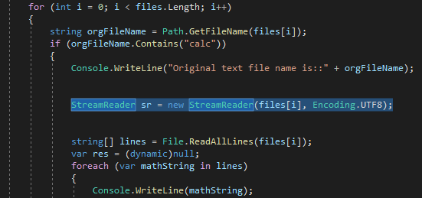

1. After successful selection of files, for calculation the calculate button is enabled. On Click of calculate button the calculate method is called by passing original file path selected by user. Next, it will read all the lines from the files and performs the mathematical operations based on the contents and writes the result to a new file created with current-date and .answ.

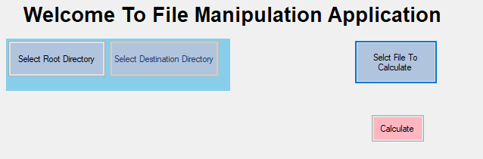

2(a) There is a calculate method which performs the business logic. Each ‘.clalc’ files are taken and each line is passed to evaluate function as a parameter.

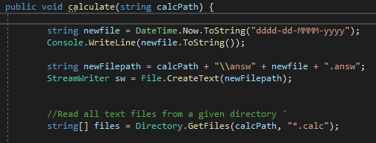

2(b). There is a evaluate method which performs mathematical operations based on the parameters passed and returns the result.

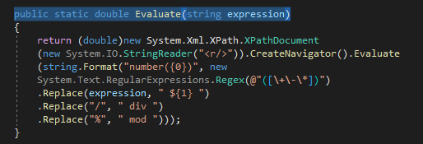

2(c). Next using Stream Writer the results obtained from above point are written to text file. This text file is named with current date with an extension of ‘.answ’

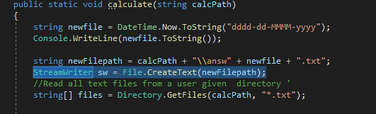

1. On successful completion of calculation a pop up window is displayed showing “completed”.

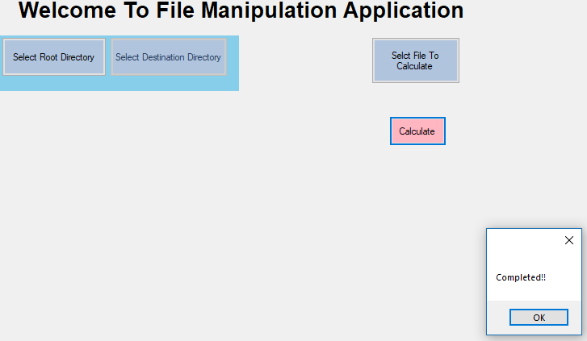

**Class Diagram: -**

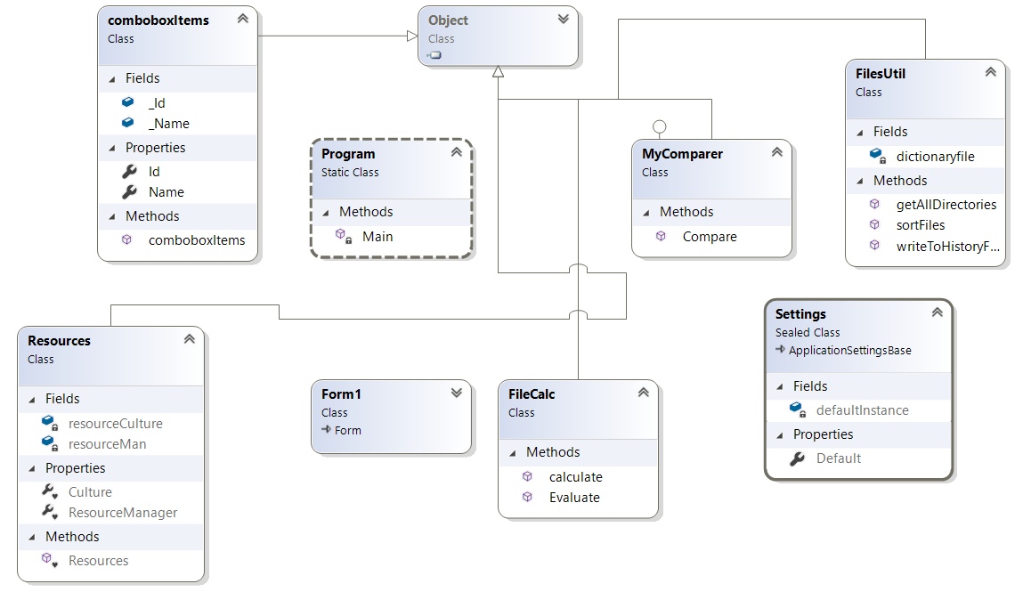

**Sequence Diagrams**

1. Sequence Diagram for Sorting Module

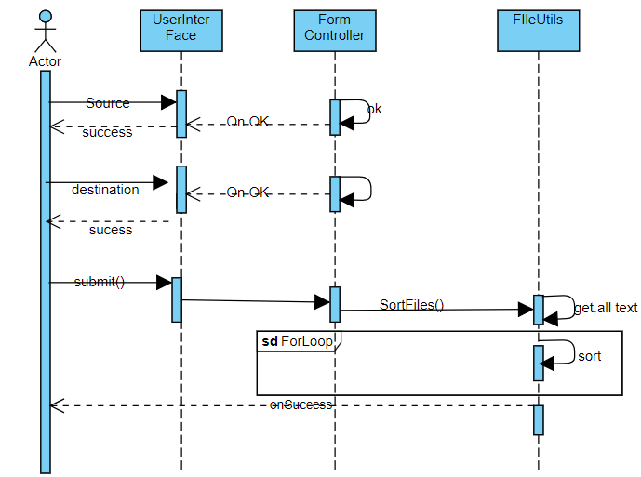

2. Sequence Diagram for Calculation Module

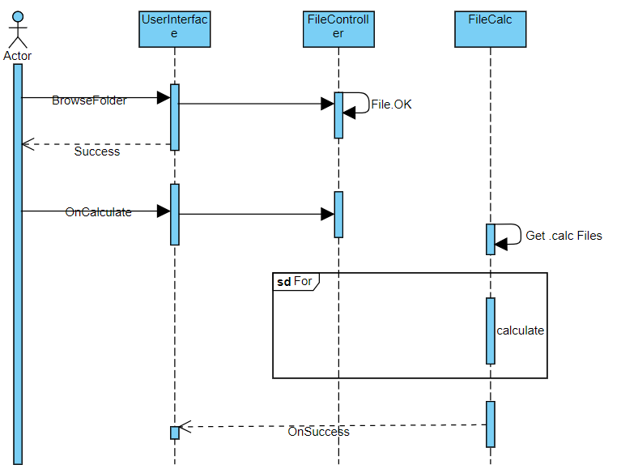

Team Responsiblities:-

|  |  |
| --- | --- |
| GitHub Repository Creation  First commit-Files Sorting  Second commit-File calculation  Final Commit | Ravi  Rakesh  Ravi  Rakesh |
| 2,3,4,5,6 | Rakesh |
| 7,8,9,10 | Ravi |
| 11,12,14 | Rakesh,Ravi |
| User Interface | Rakesh,Ravi |