Terraform-02

1). Watch the Terraform-02 video.
Completed
2). Execute all the templates shown in the video.
terraform init
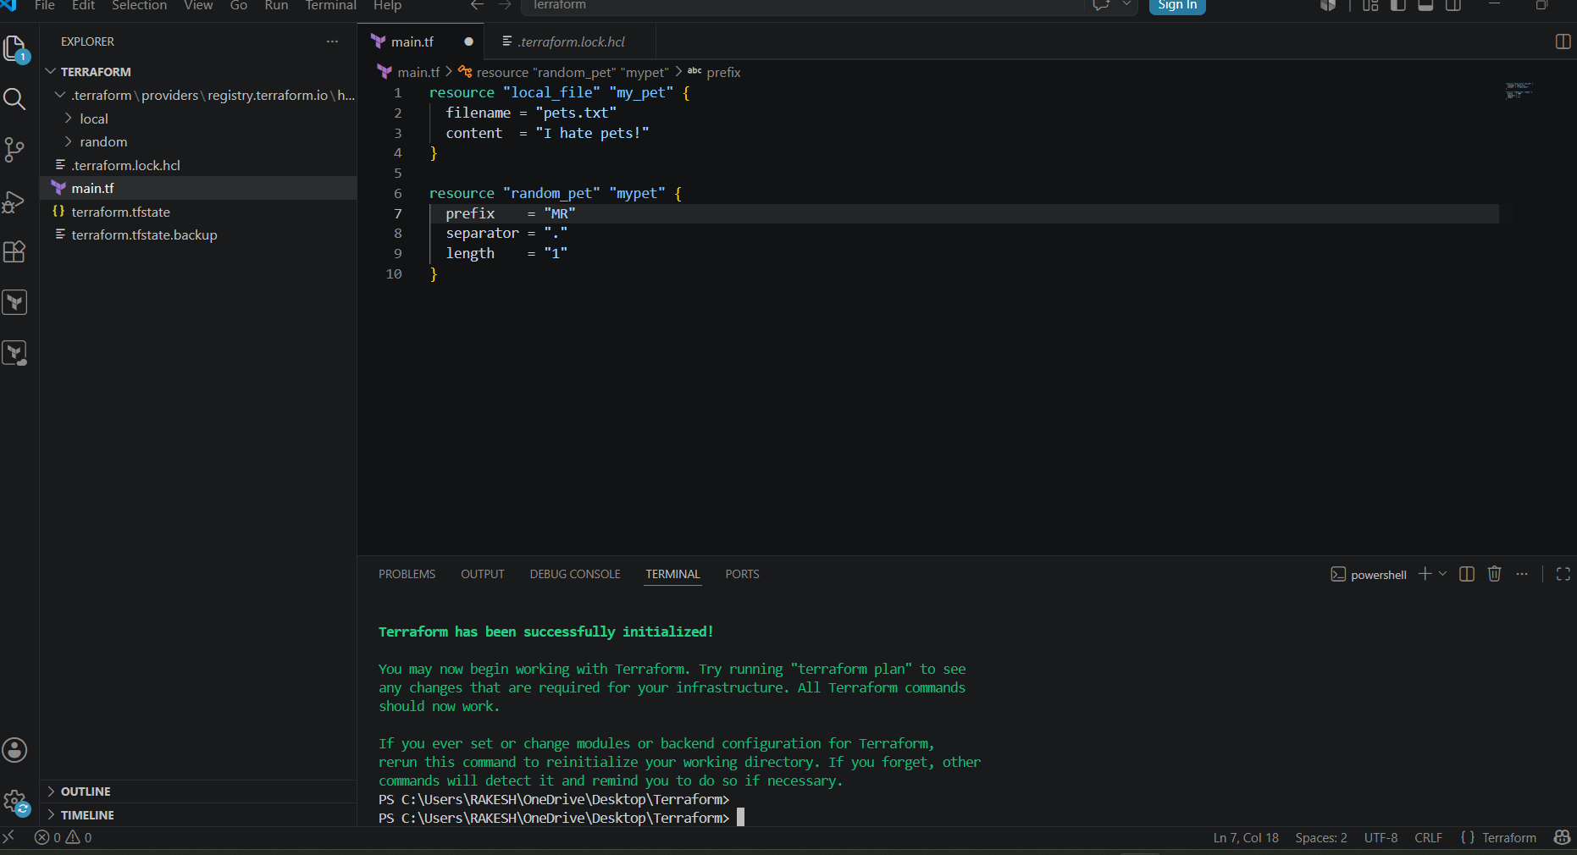
terraform plan
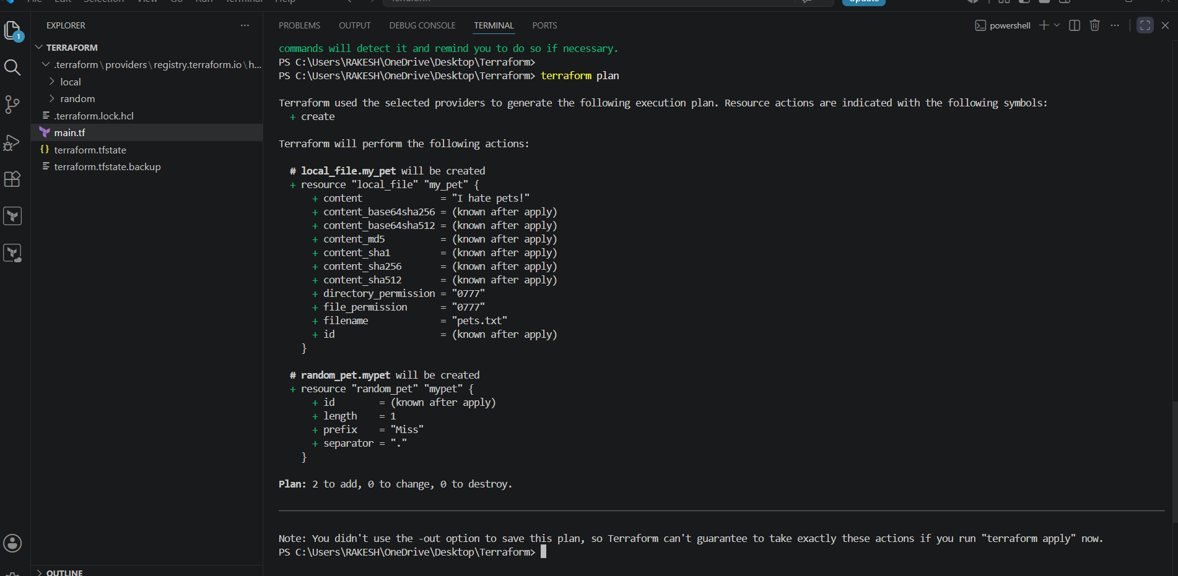

terraform apply

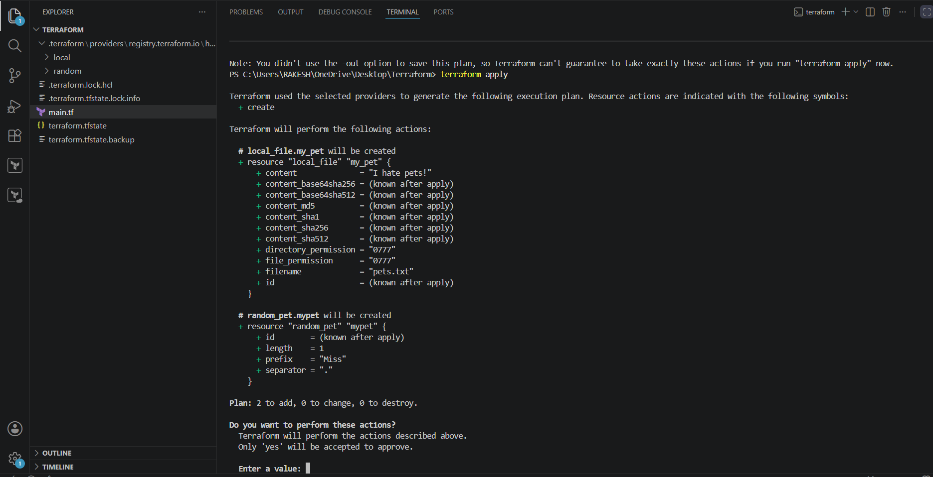
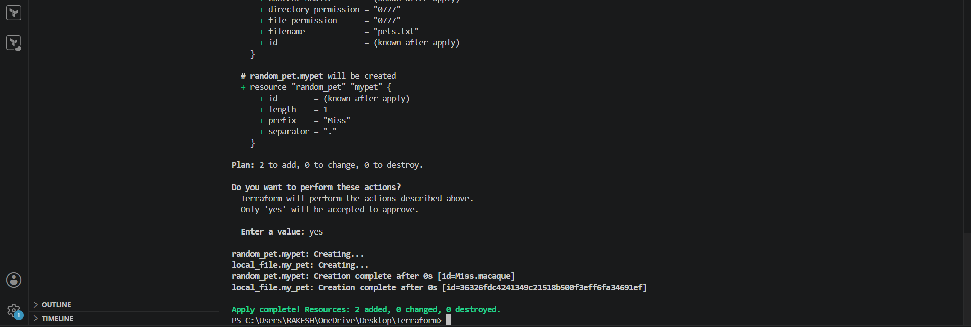

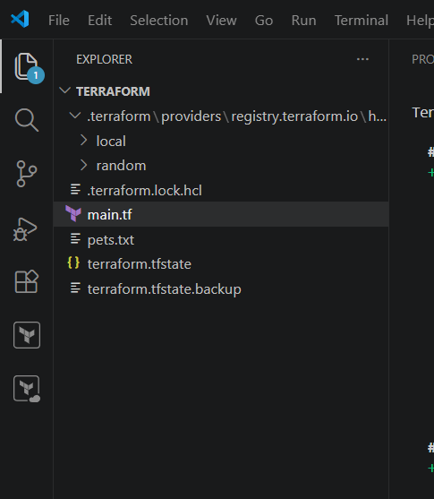

Now lets create a variable.tf file
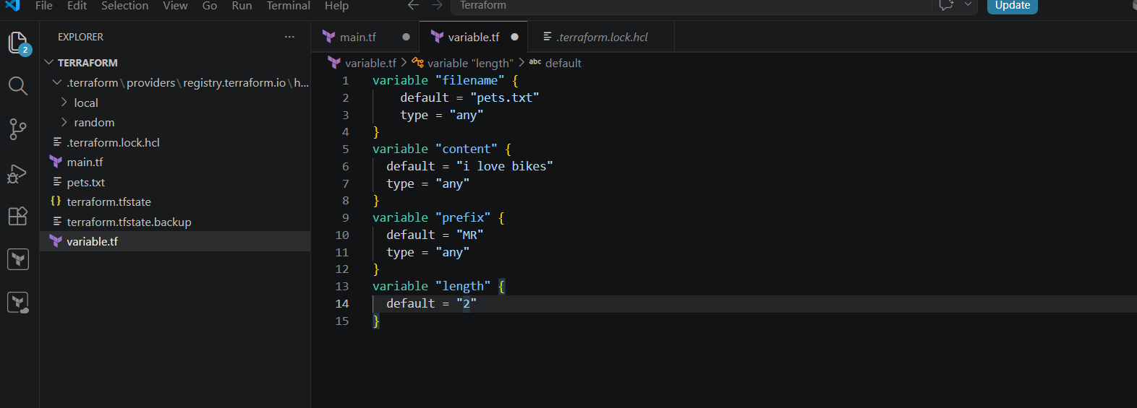
And also let's make the necessary changes in the main.tf .
The reason we are creating variable.tf files is to not hardcode the values inside the main.tf. In
main.tf files as we have created the variables.tf file now we will give filename = var.filename
and content = var.content
After making any changes in the files we need to save the file always
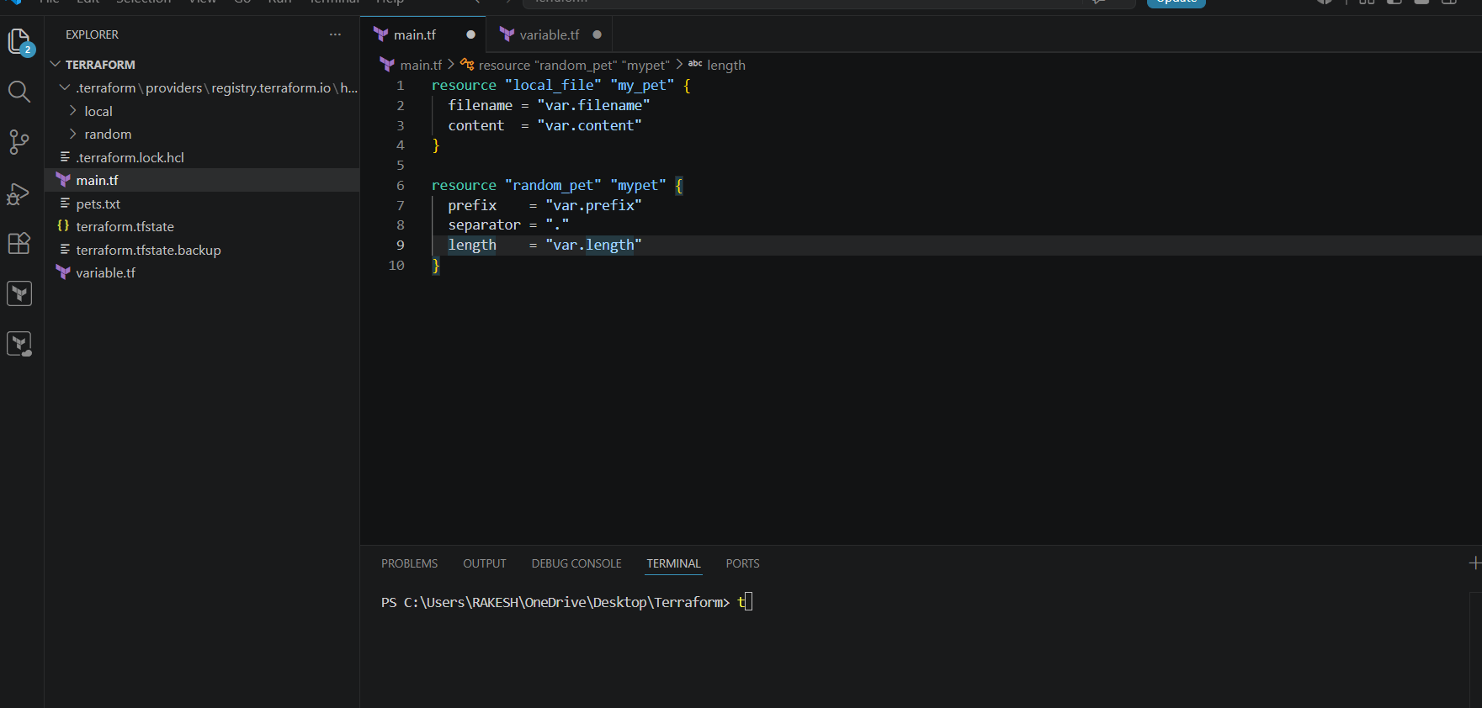
Lets apply the changes what we have made using
BEFORE
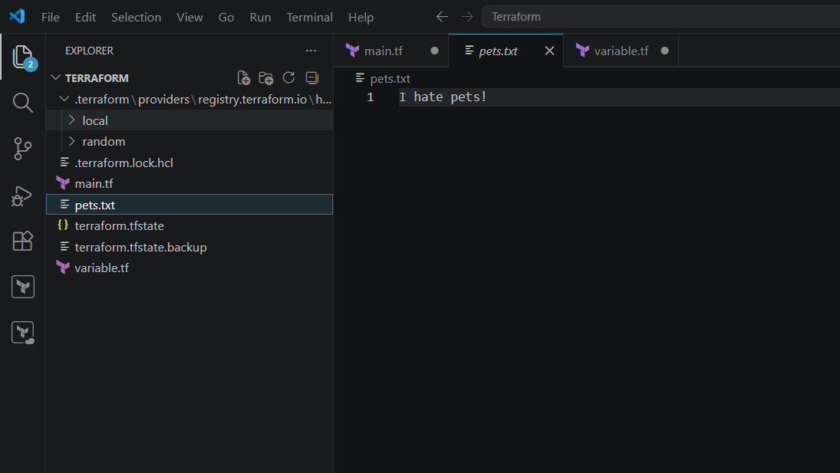
terraform apply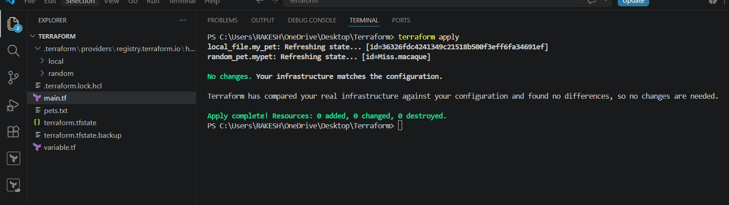
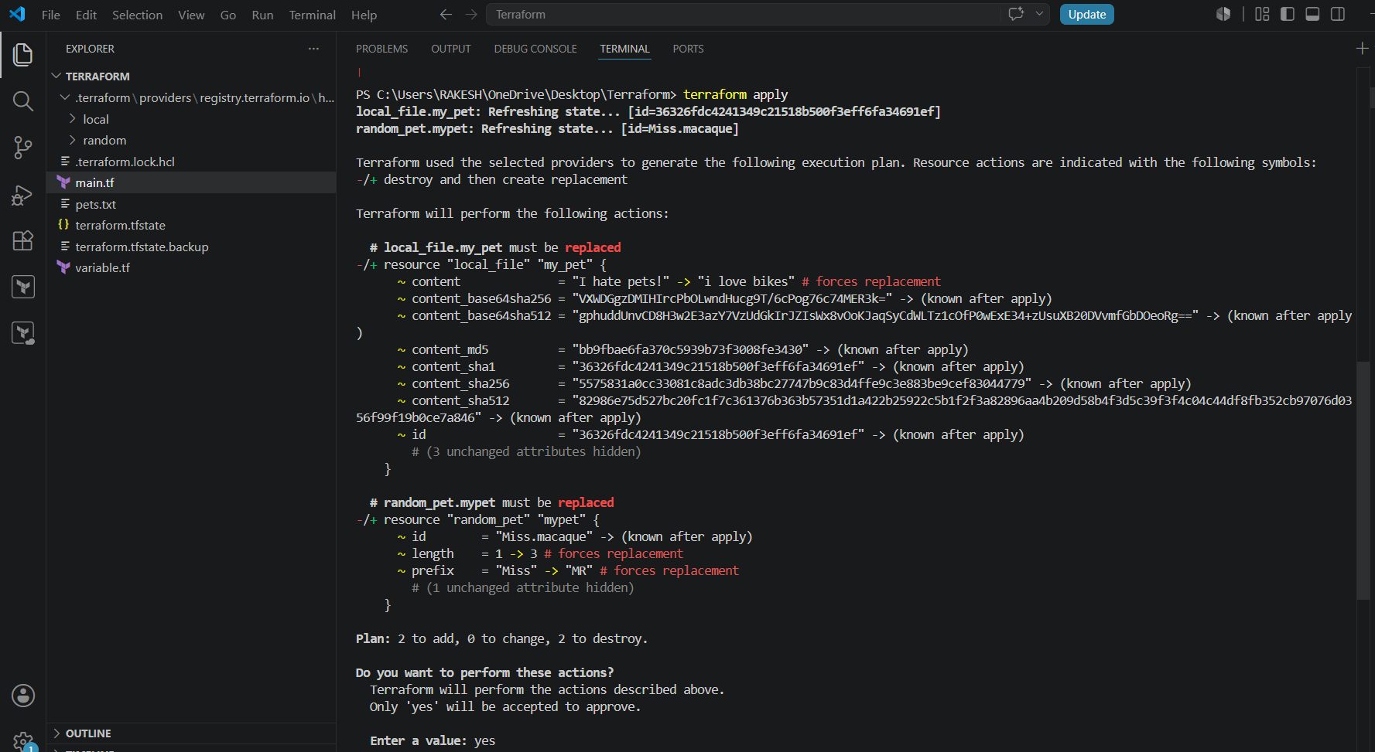
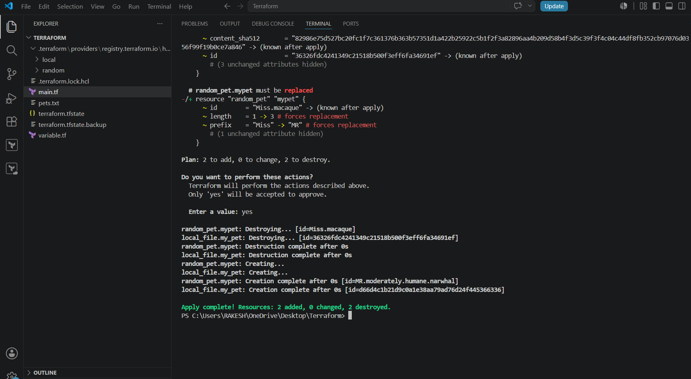
AFTER contents have been replaced
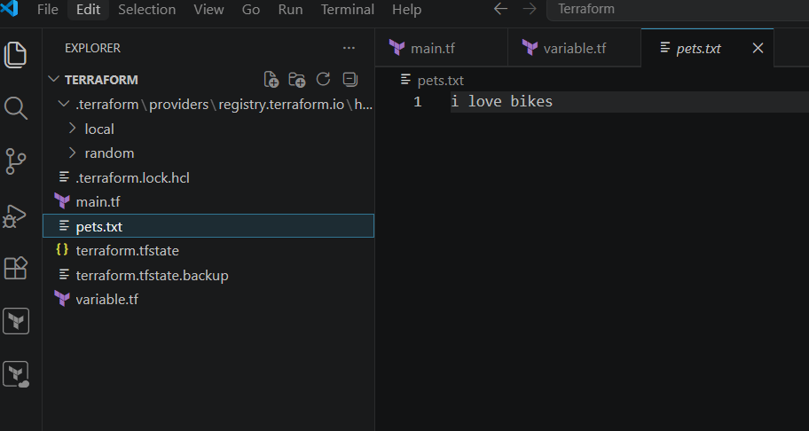
3). Integrate Terraform in Jenkins using the Terraform plugin.
Lets start Jenkins and Install the required Plugins
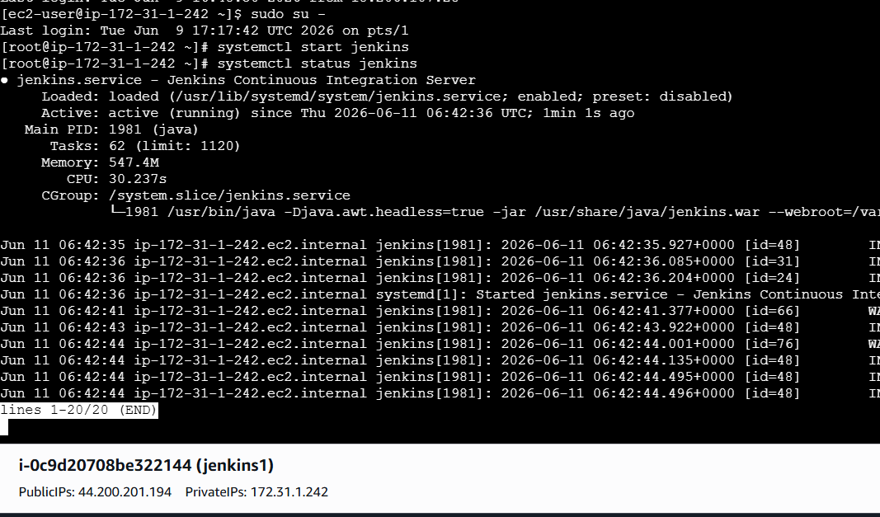
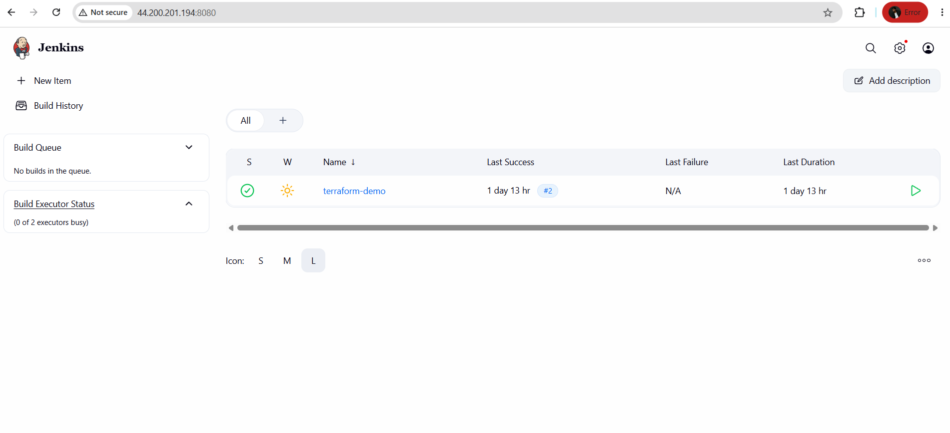
Install Plugin terraform
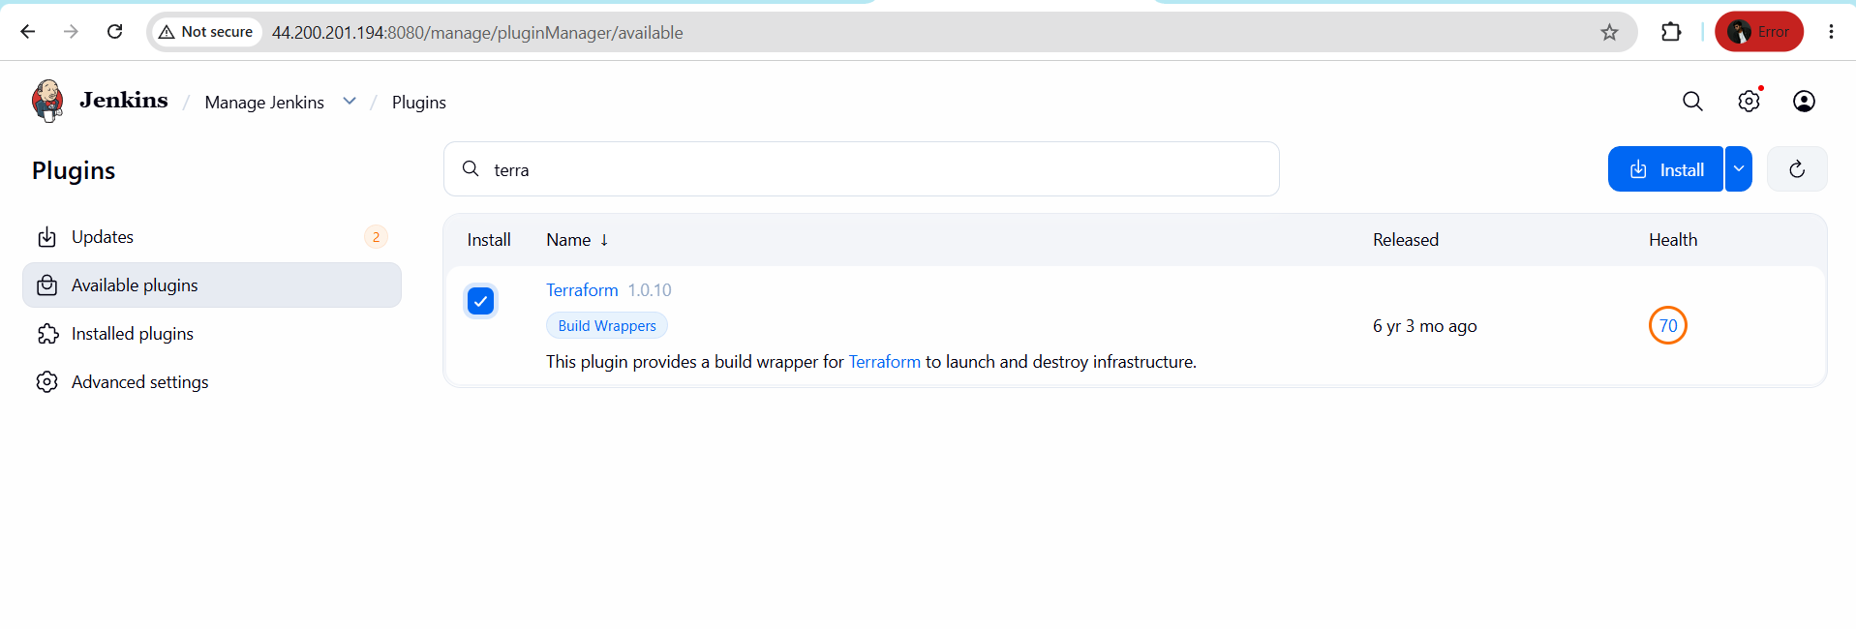
Plugin Installation Successfully
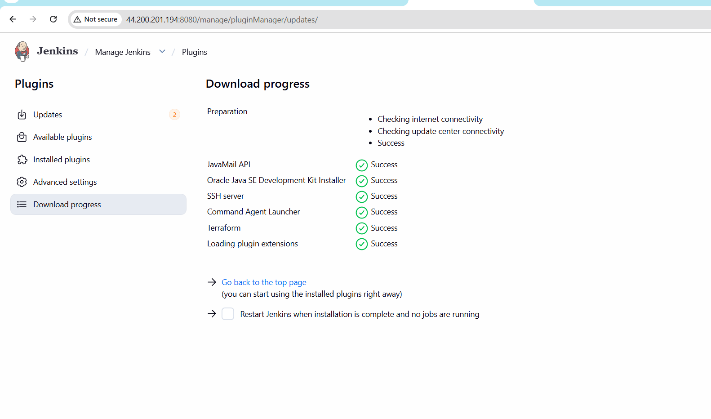
Now lets configure Terraform with Jenkins
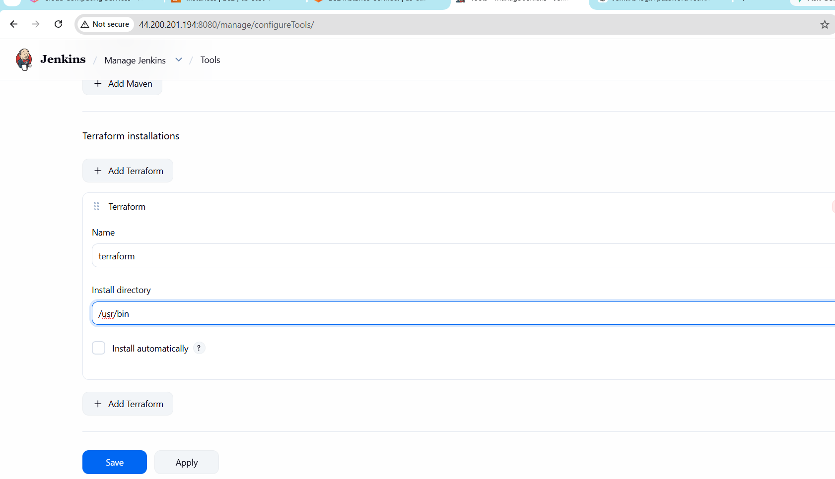
Now terraform has been configured
Now Lets create a main.tf

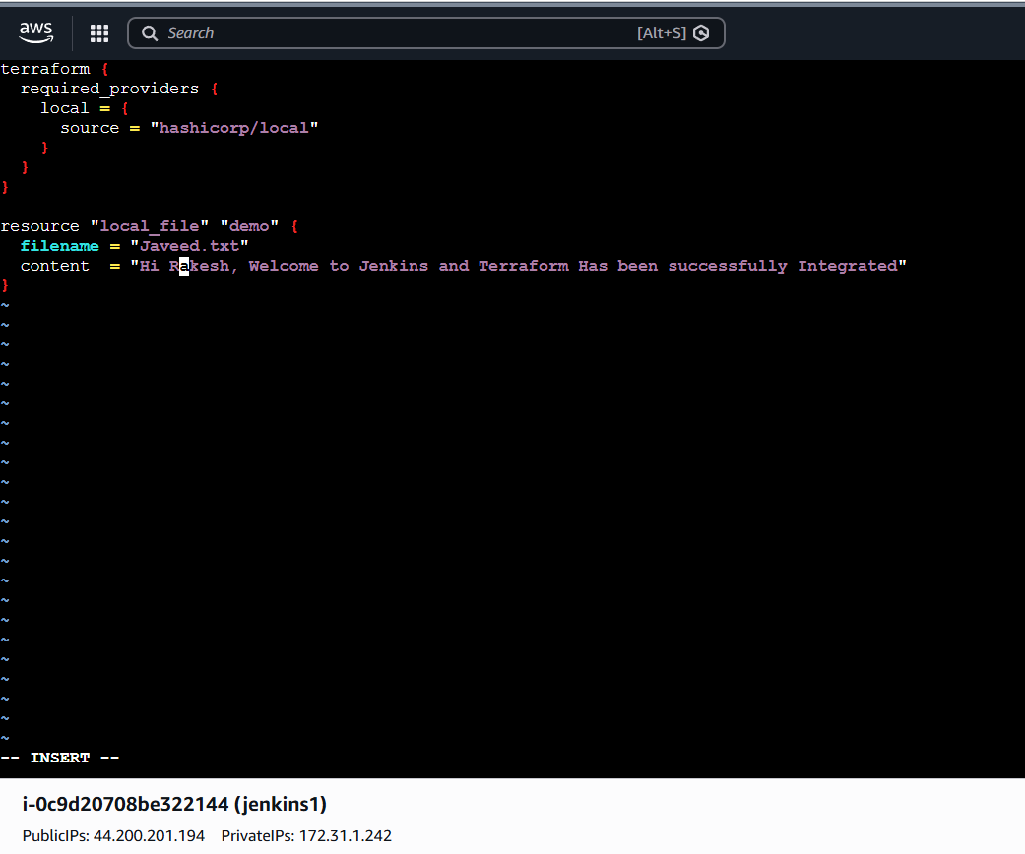
Create a test pipeline job
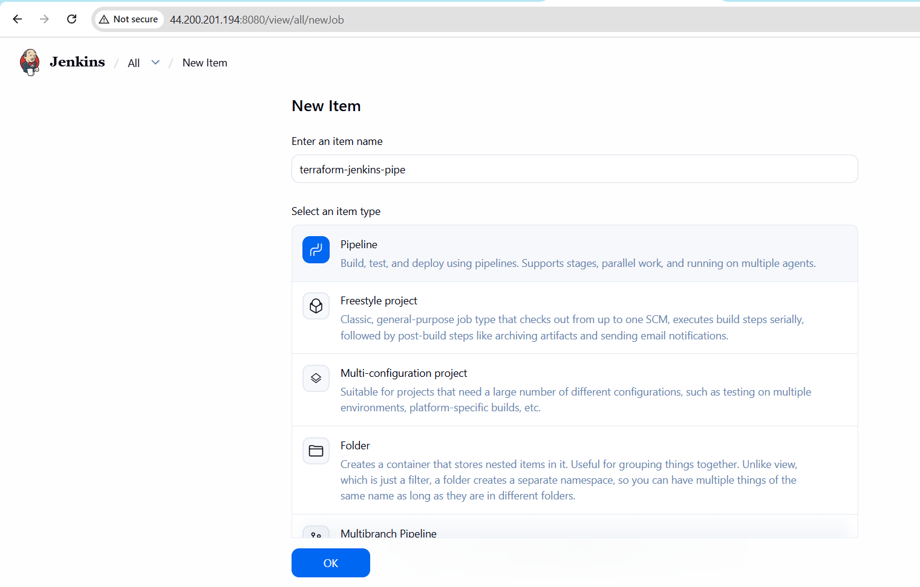
SCRIPT
pipeline {
agent any
tools {
terraform 'terraform'
}
stages {
stage('Check Terraform') {
steps {
sh 'terraform version'
}
}
stage('Terraform Init') {
steps {
sh 'terraform init'
}
}
stage('Terraform Plan') {
steps {
sh 'terraform plan'
}
}
stage('Terraform Apply') {
steps {
sh 'terraform apply -auto-approve'
}
}
}
}
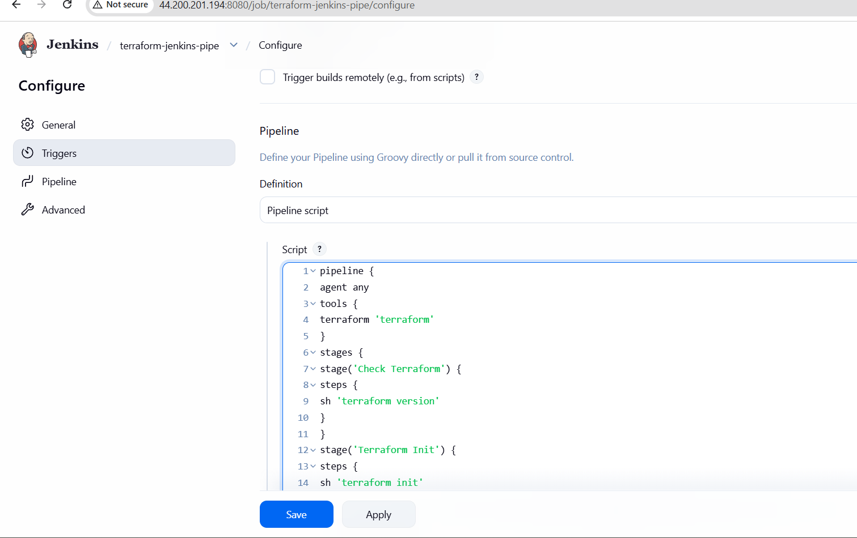
Lets Build The Job
Console Output

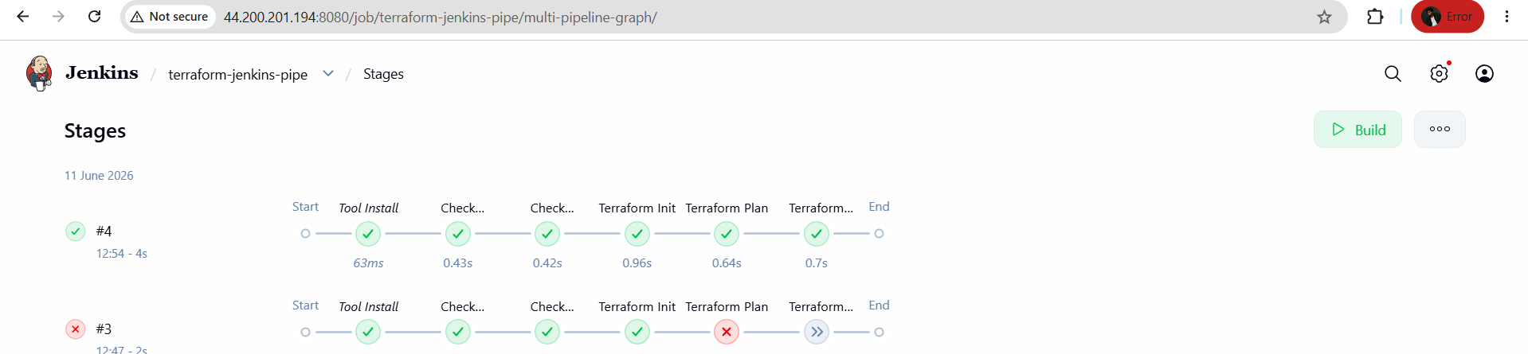

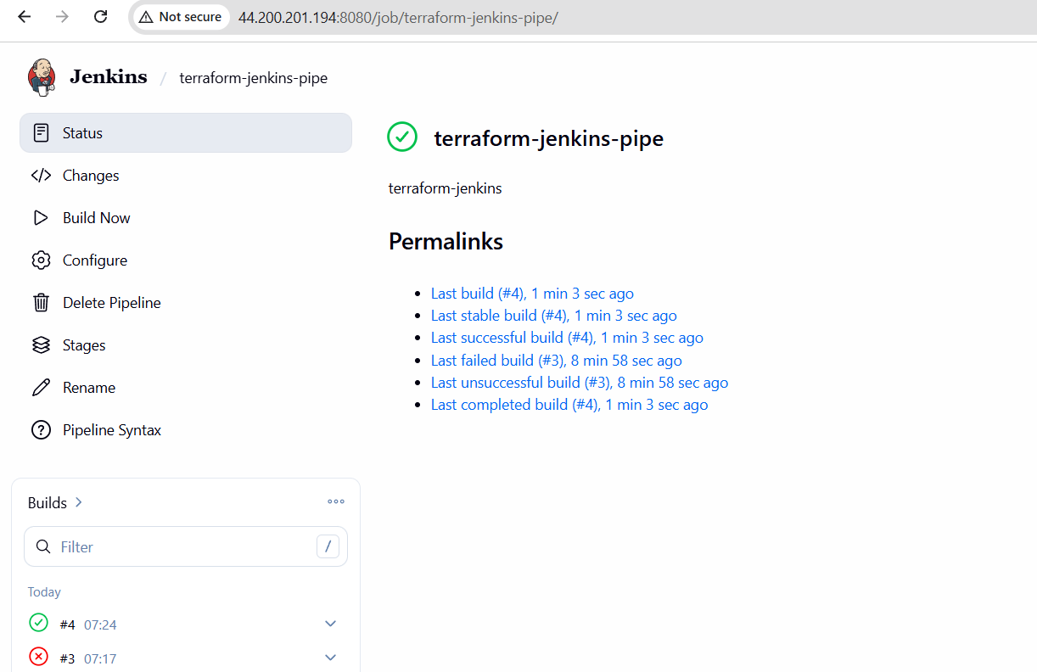

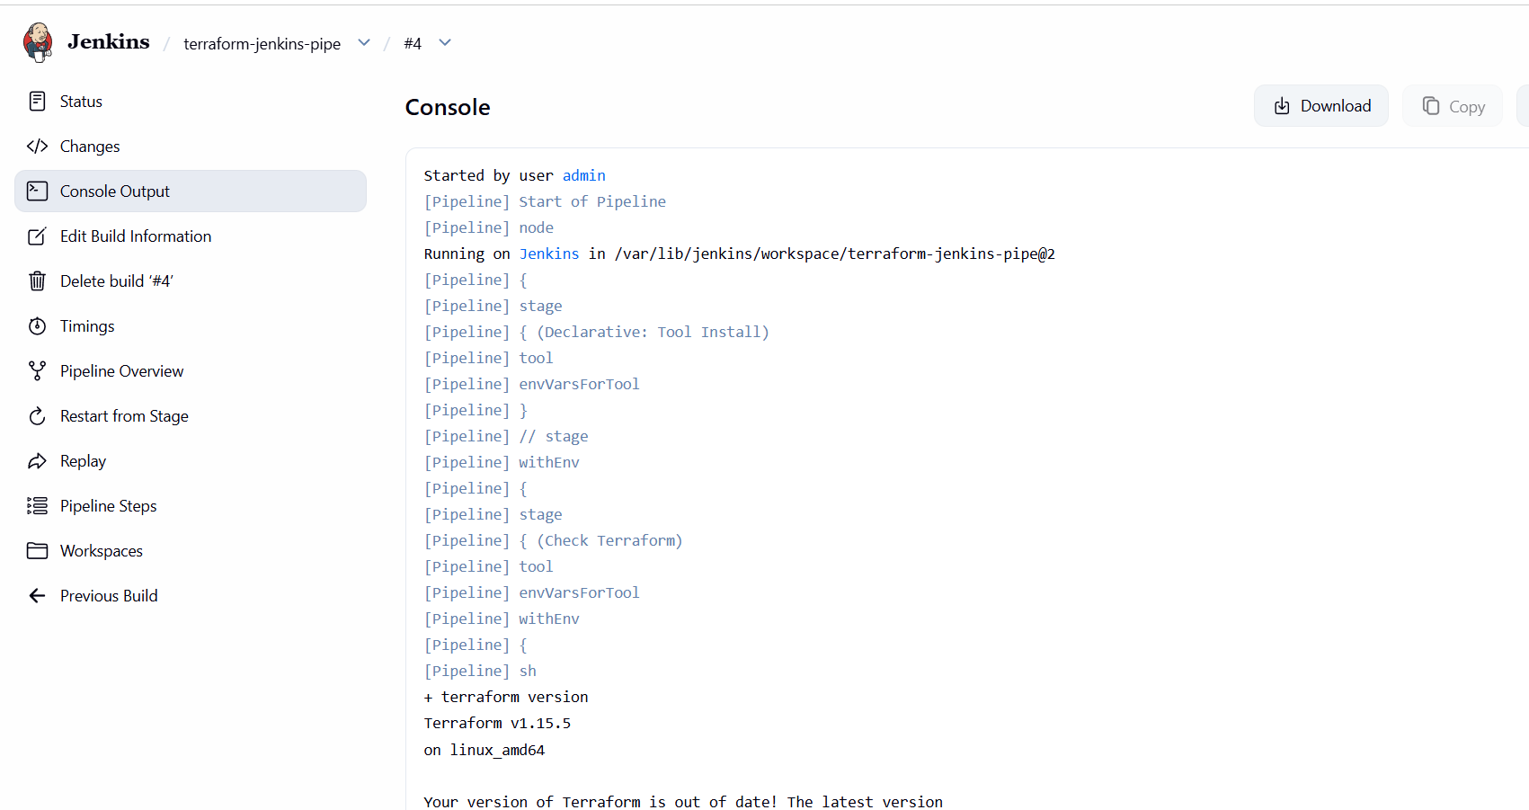
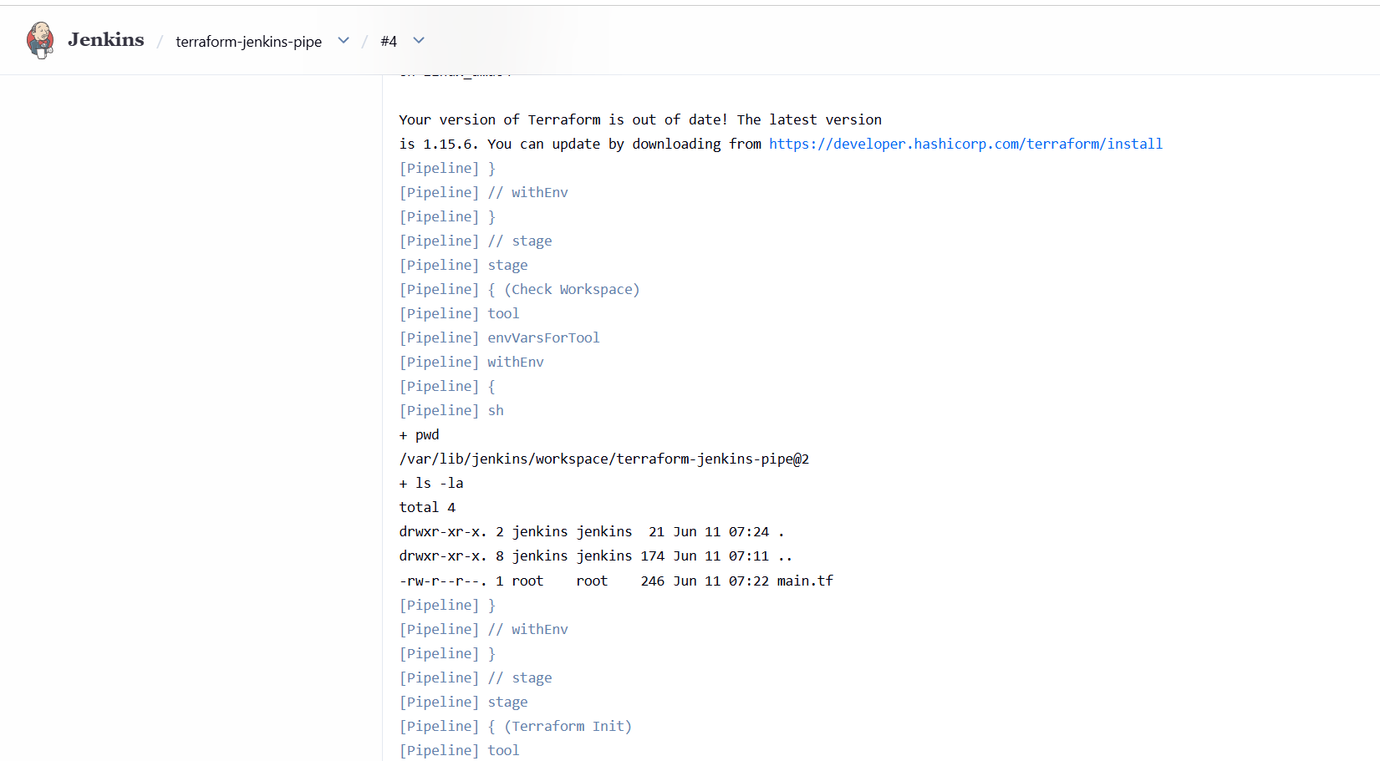
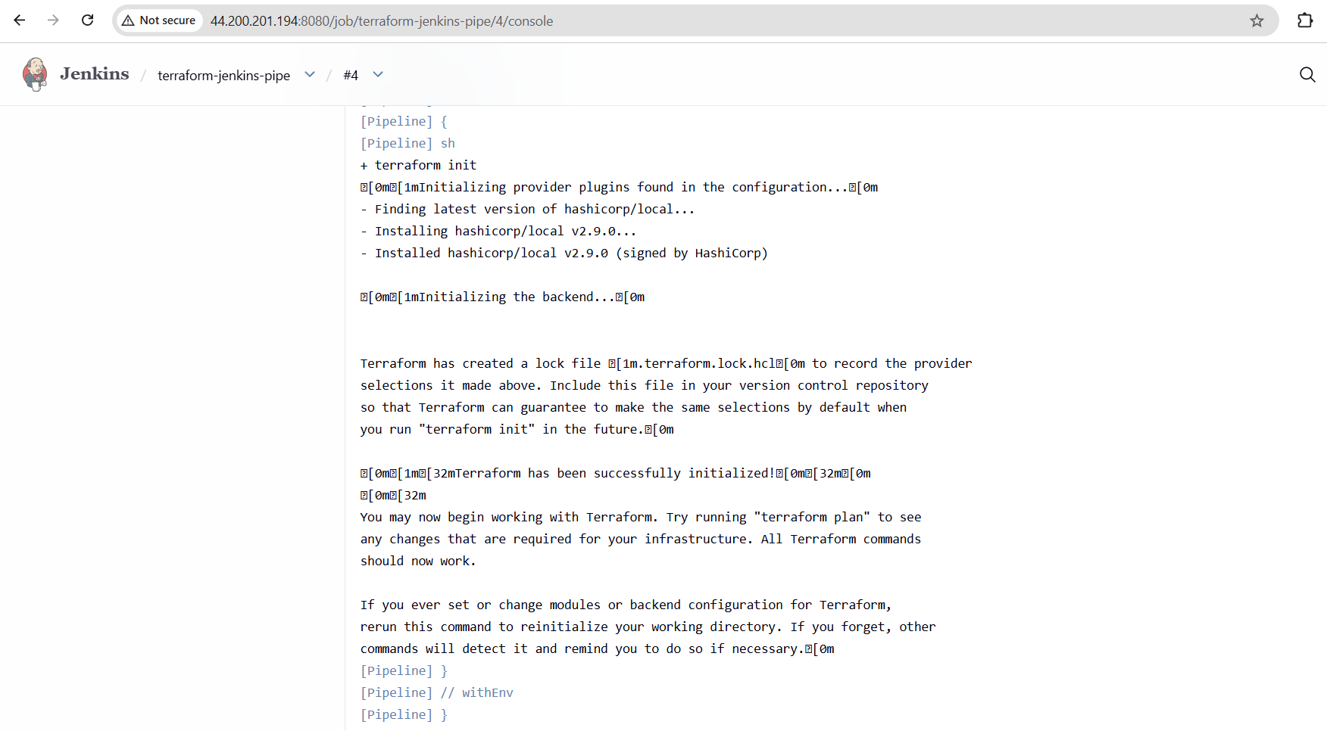
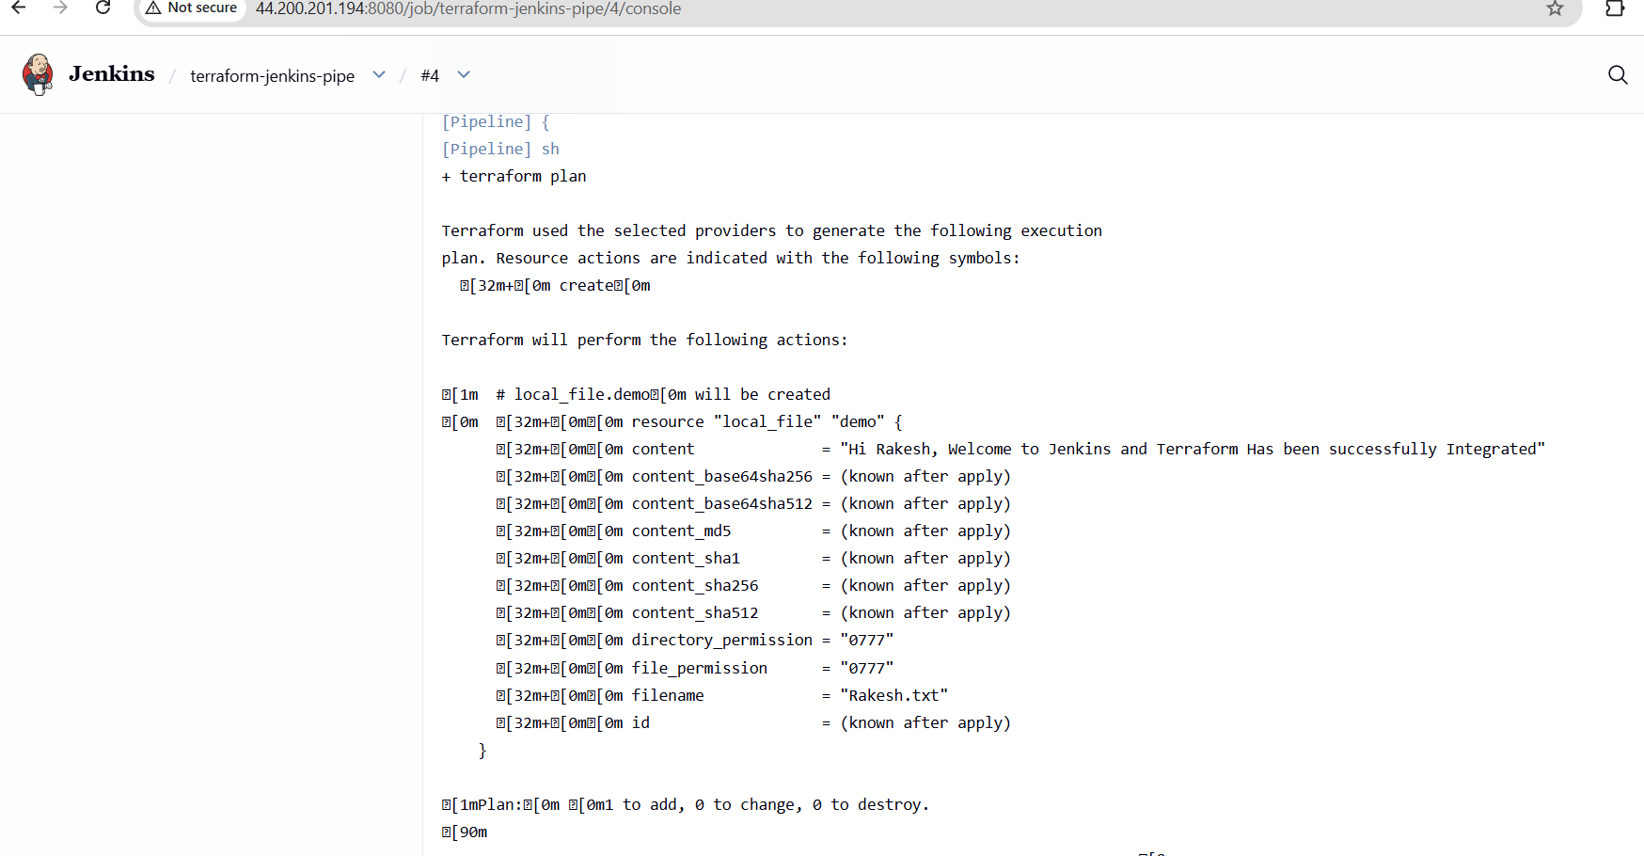
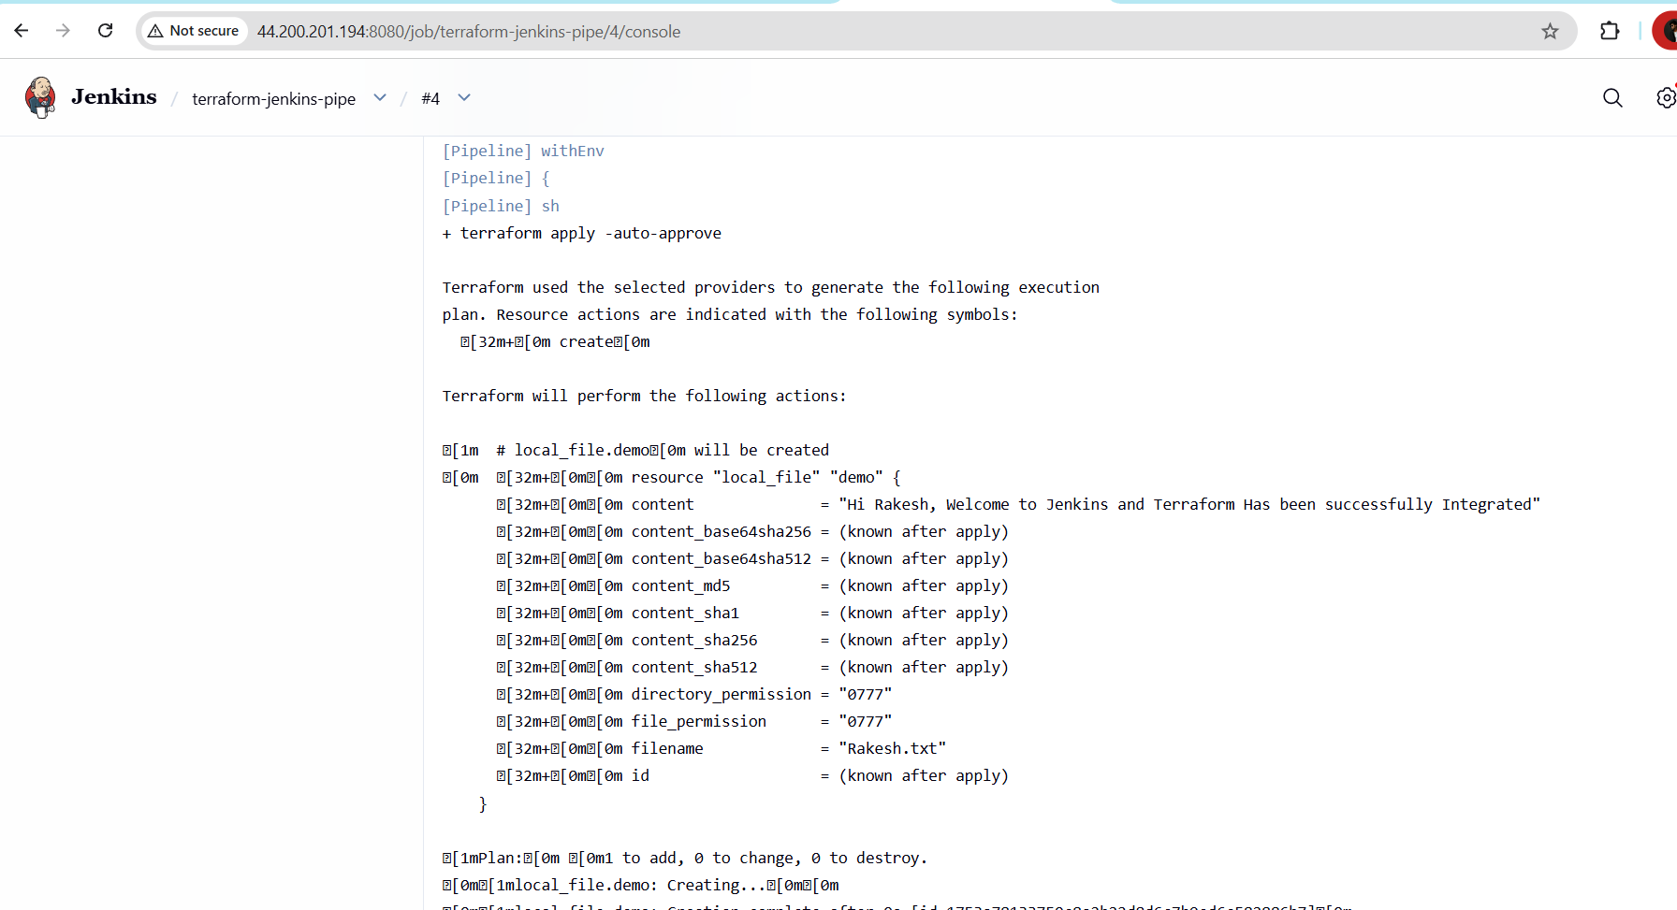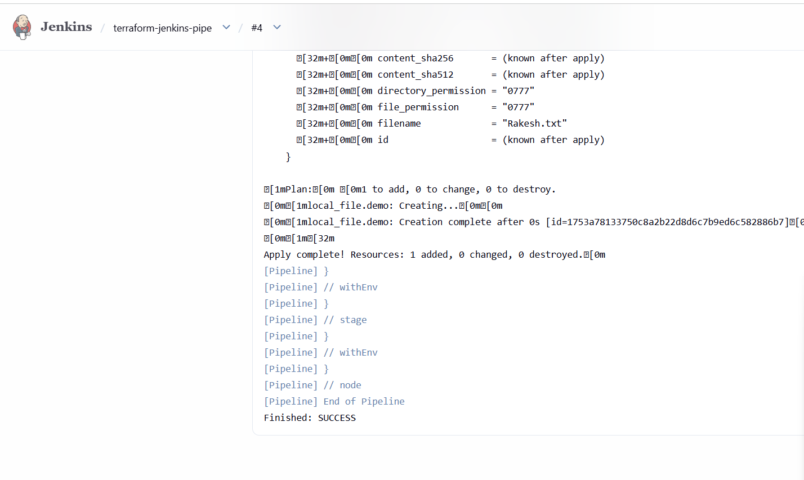

Now the folder has been created

