Terraform -04
1). Watch Terraform-04 video.
Completed
2). Execute the script shown in the video.
Restricting the Provider
By using the which version of terraform we are using
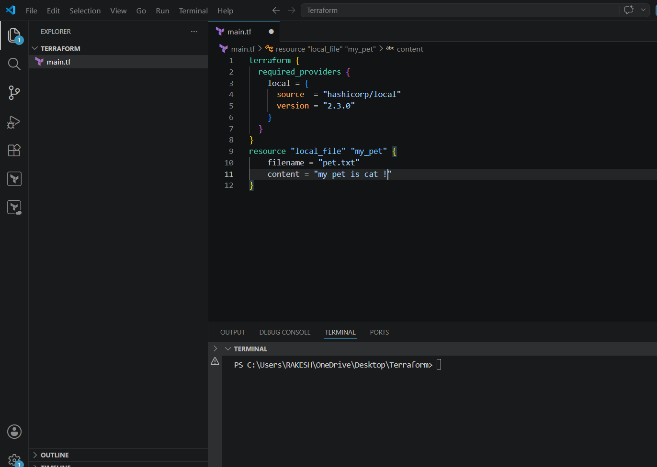
Now lets run this
Its shows version 2.3.0 as we are giving it specific
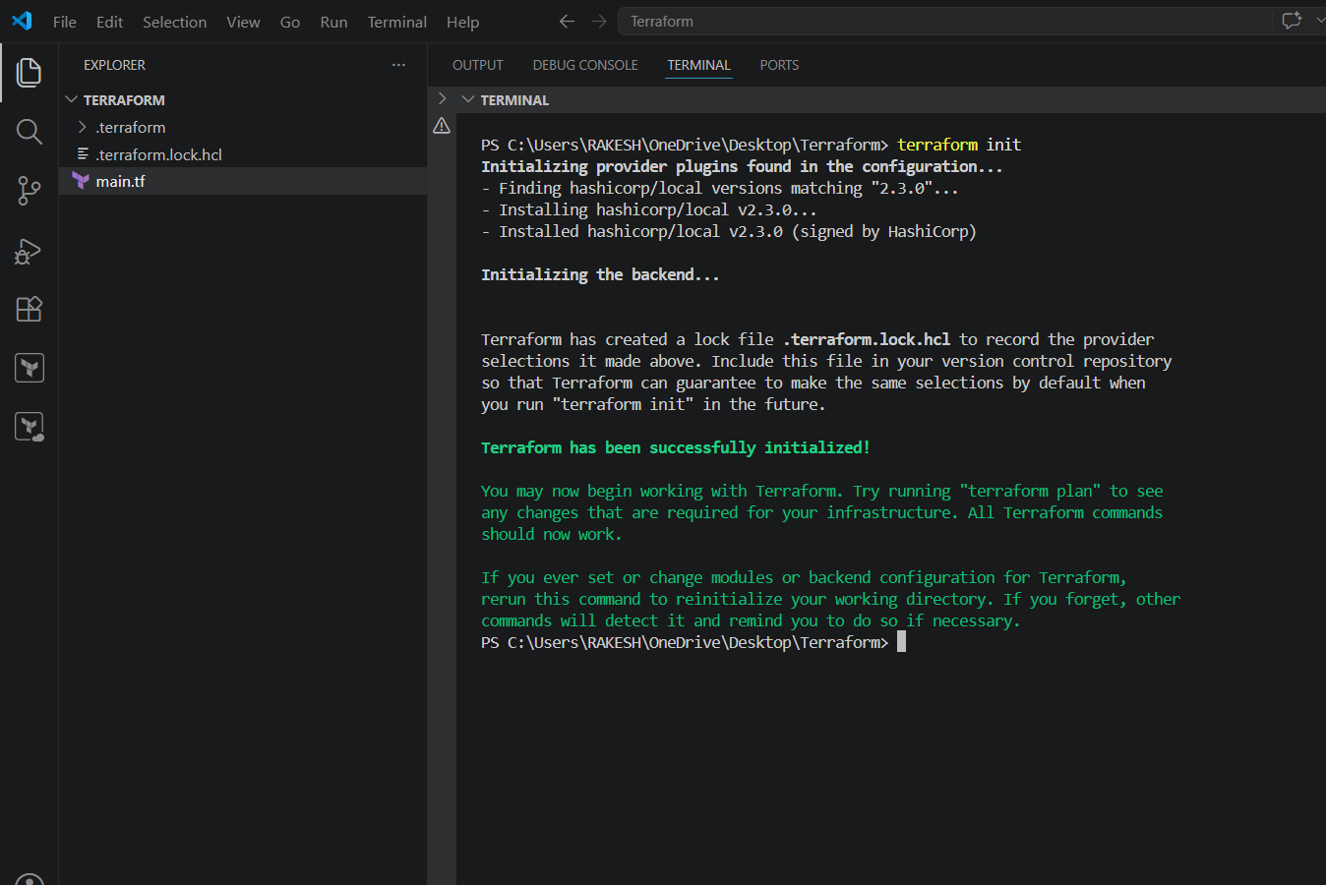
If incase if we want to download without providing the specific version it will download
the latest version
Lets check
In the below image my main.tf doesn't consist any specific version of terraform so its
downloading the latest when we do terraform init
By using specific versions of providers we can restrict the providers. That's how we can
define it in our configuration file.
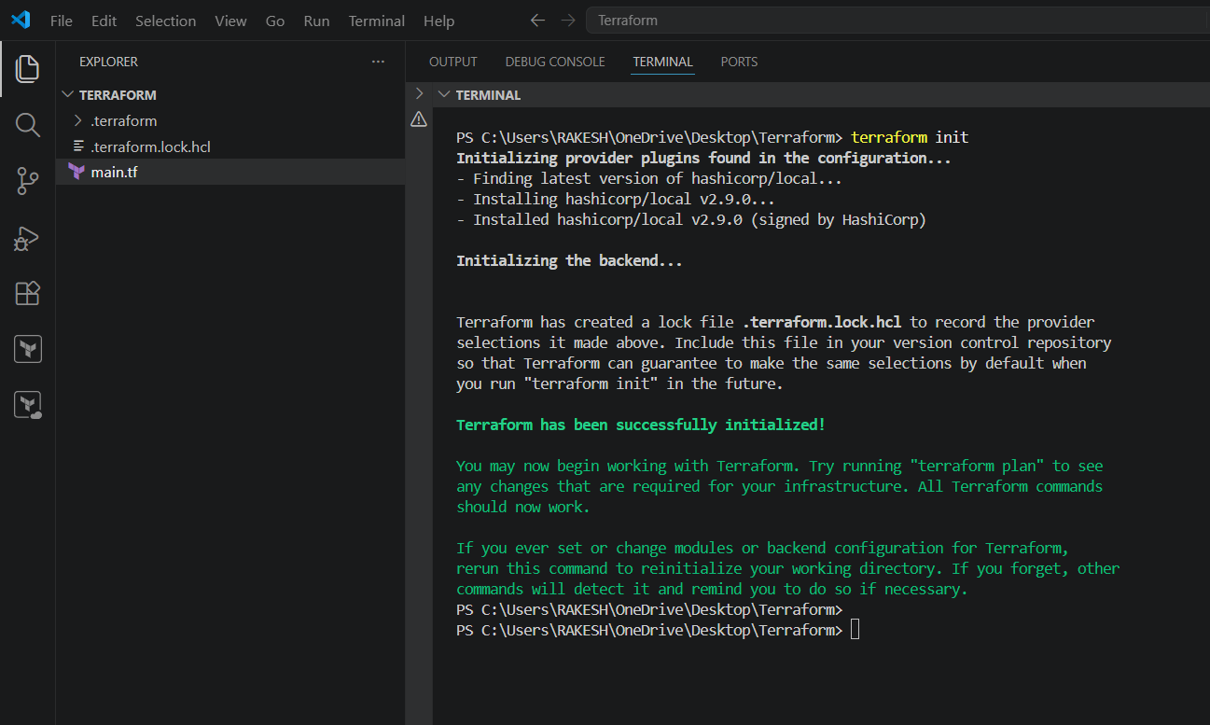
As in the above pics we have seen to restrict. Now lets see how we can change/upgrade to
different version
In the below main.tf file i have give code of 2.3.0 and executed terraform init as it was a different
version it didn’t allow me to do.
For upgrading
terraform init -upgrade
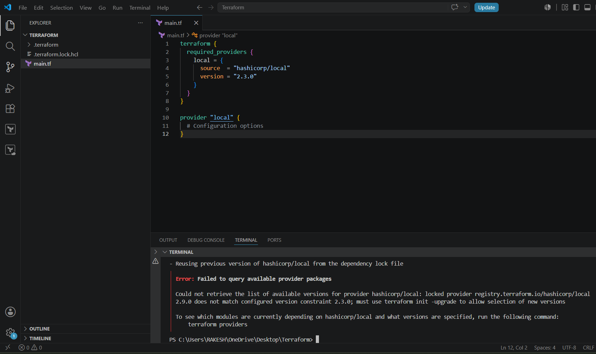
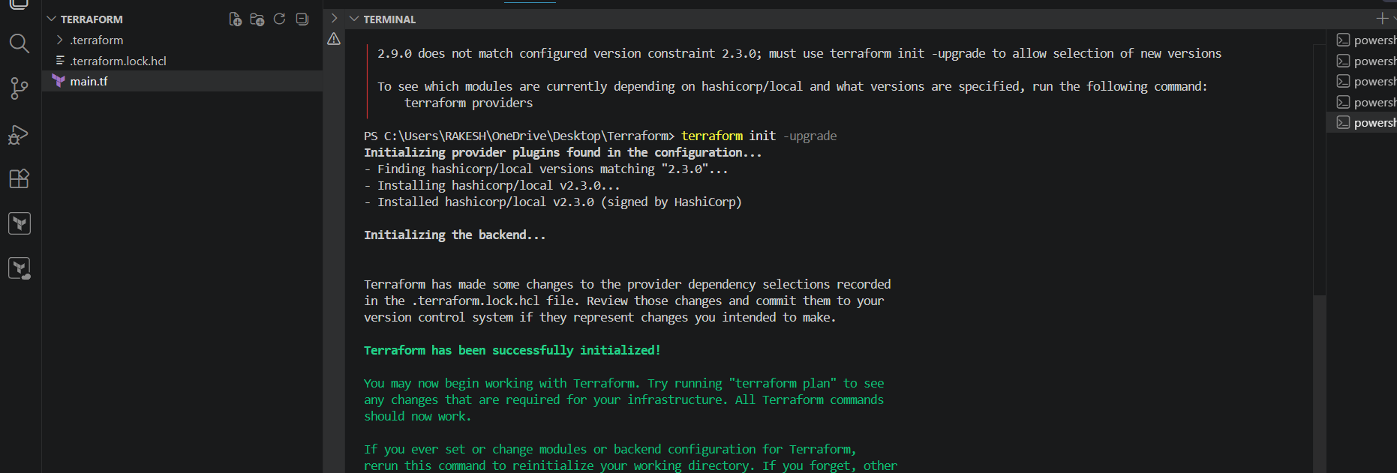

We can two versions of terraform has been in our .terraform directory
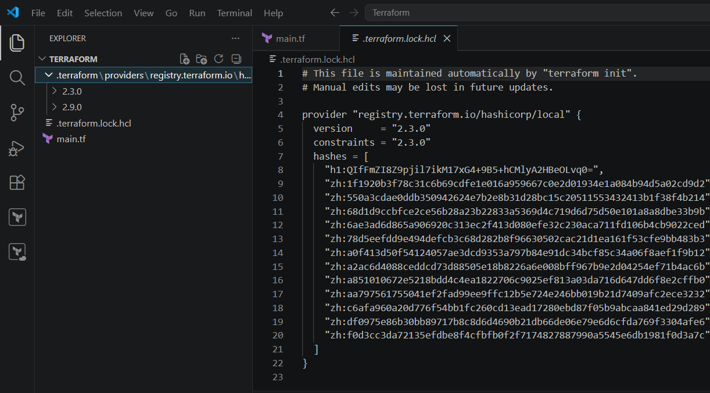
DATA BLOCK⇒ To read the content of the file.
So I created a file called dogs.txt
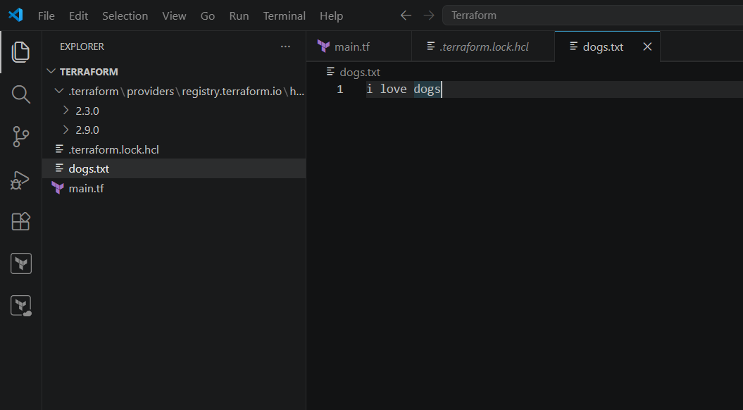
And now I’m asking it to read the content from my dogs.txt file to pets.txt
My main.tf
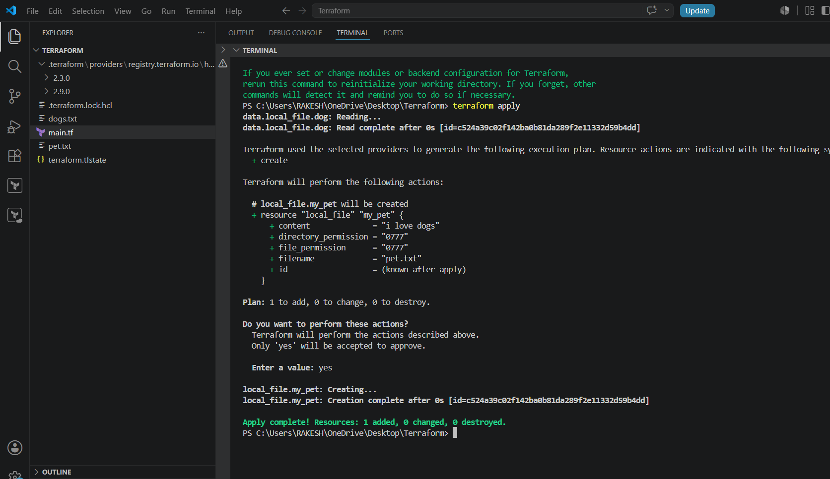
Lets check the output

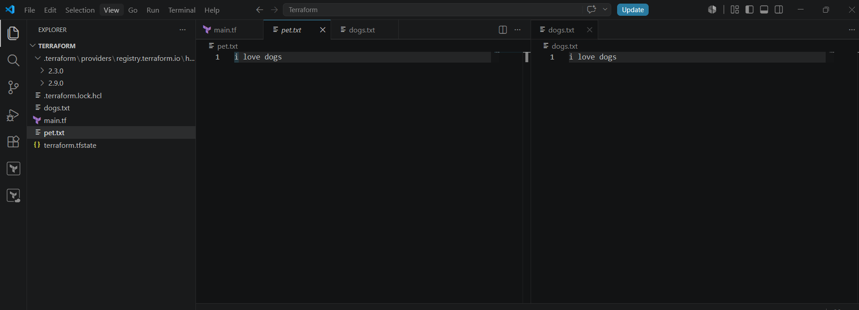
META ARGUMENTS:
Meta arguments are used if we want to create multiple resources.
● Depends on
● Lifecycle rules
1. create_before_destroy
2. prevent_destroy
3. ignore_changes
● Count
● For - each
COUNT⇒ If we want to create multiple files at a time we can use count.
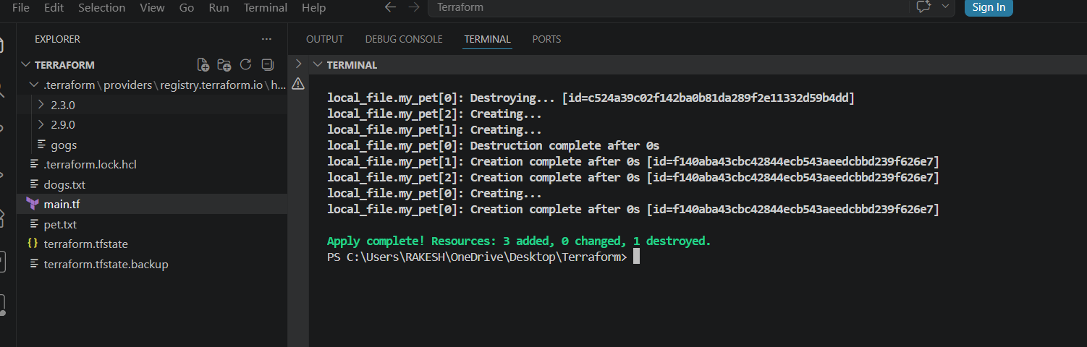
It says created, lets see if it has been created or not
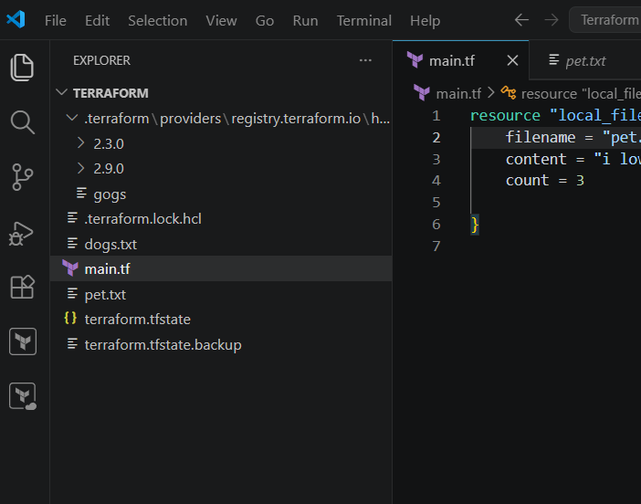
No extra file has been created, the reason is its been overwritten. So for these cases we
need to create a variable file and need to give the count index in the main.tf file then only
multiple files can be generated.
Let's see how it can be done now
First lets create a variable.tf file and give the details of file names what we want to create
and made the necessary changes in main.tf file too
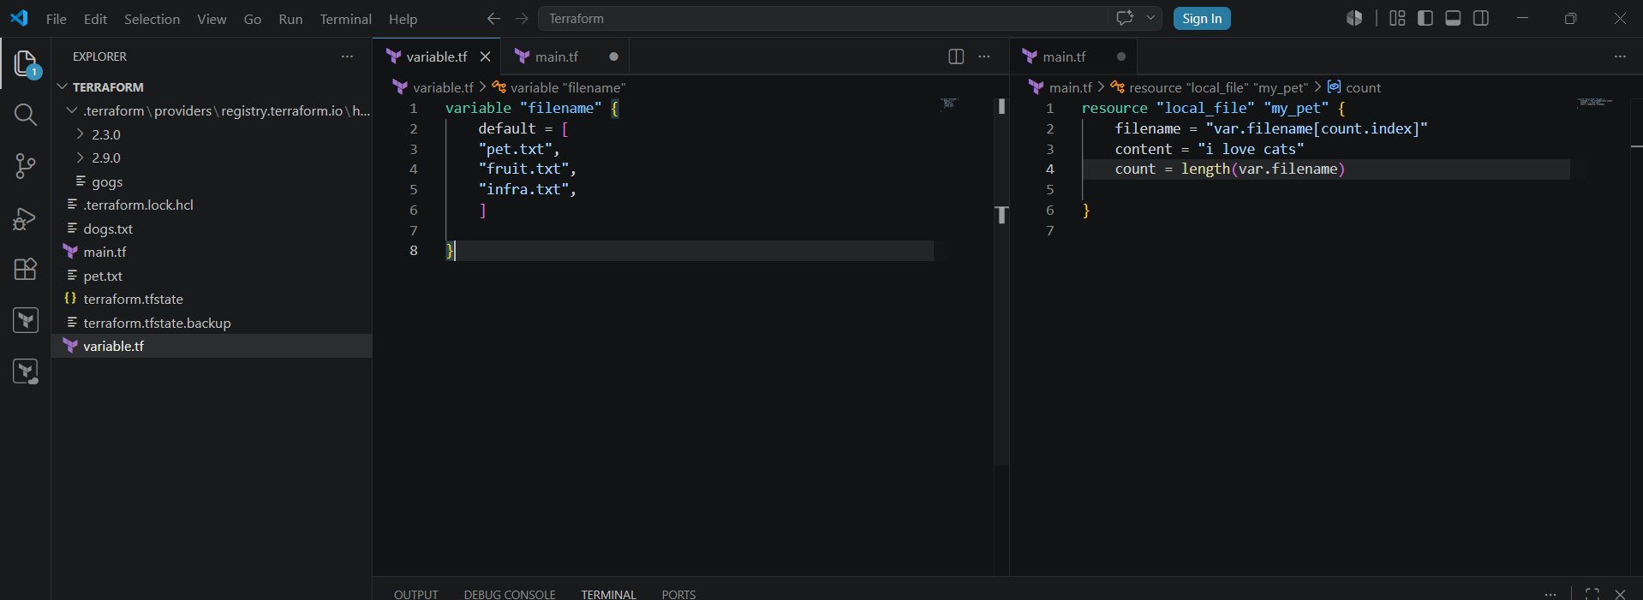

Lets execute terraform apply
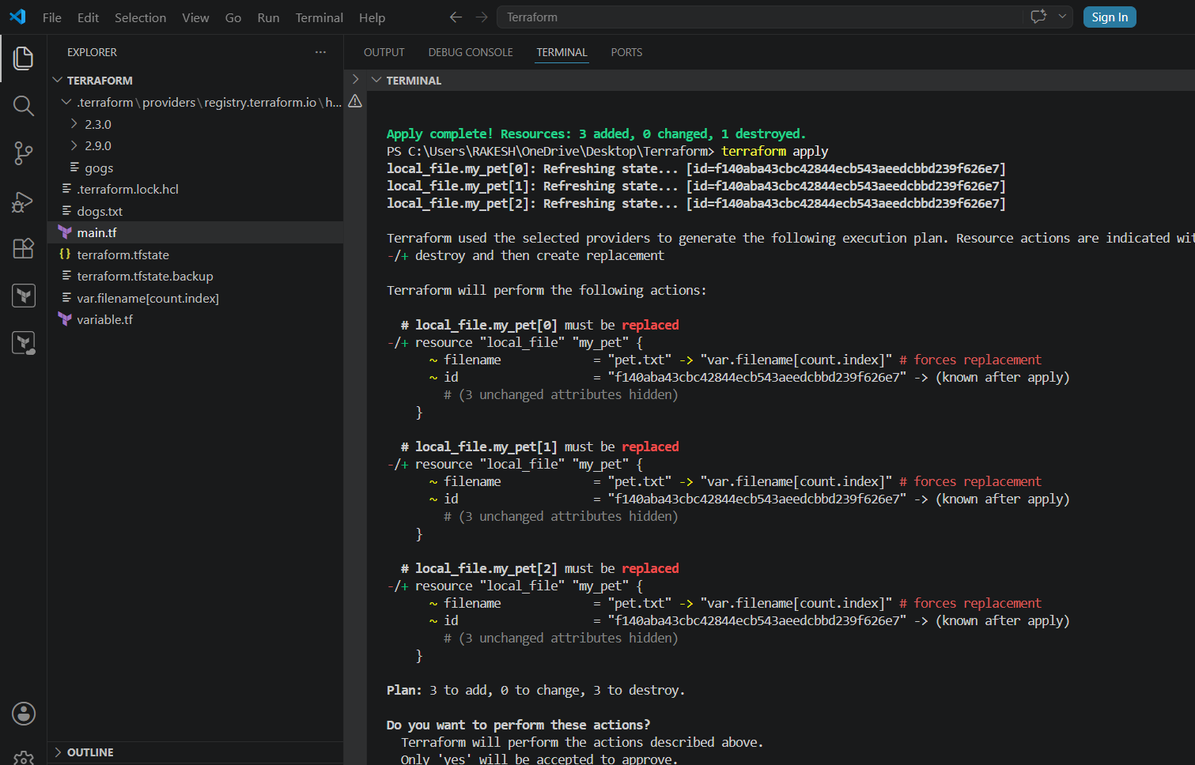
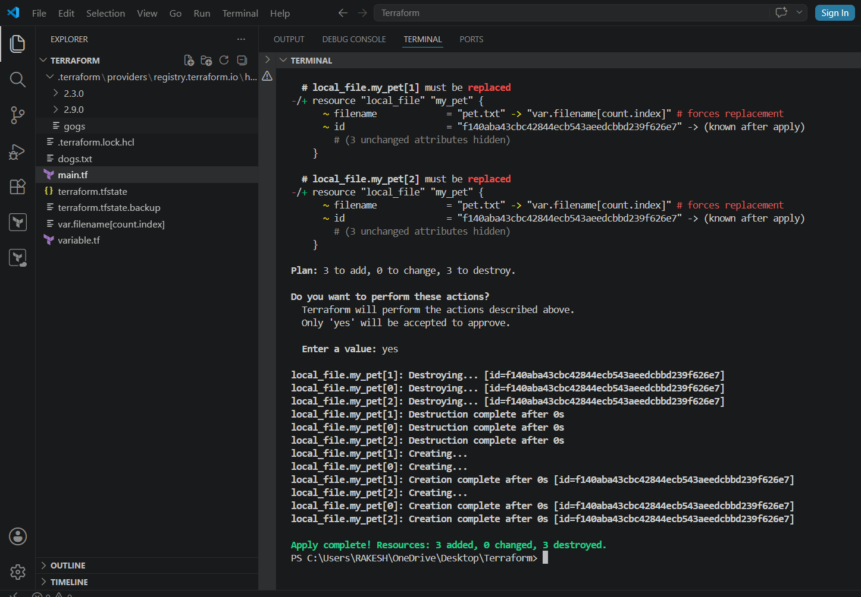
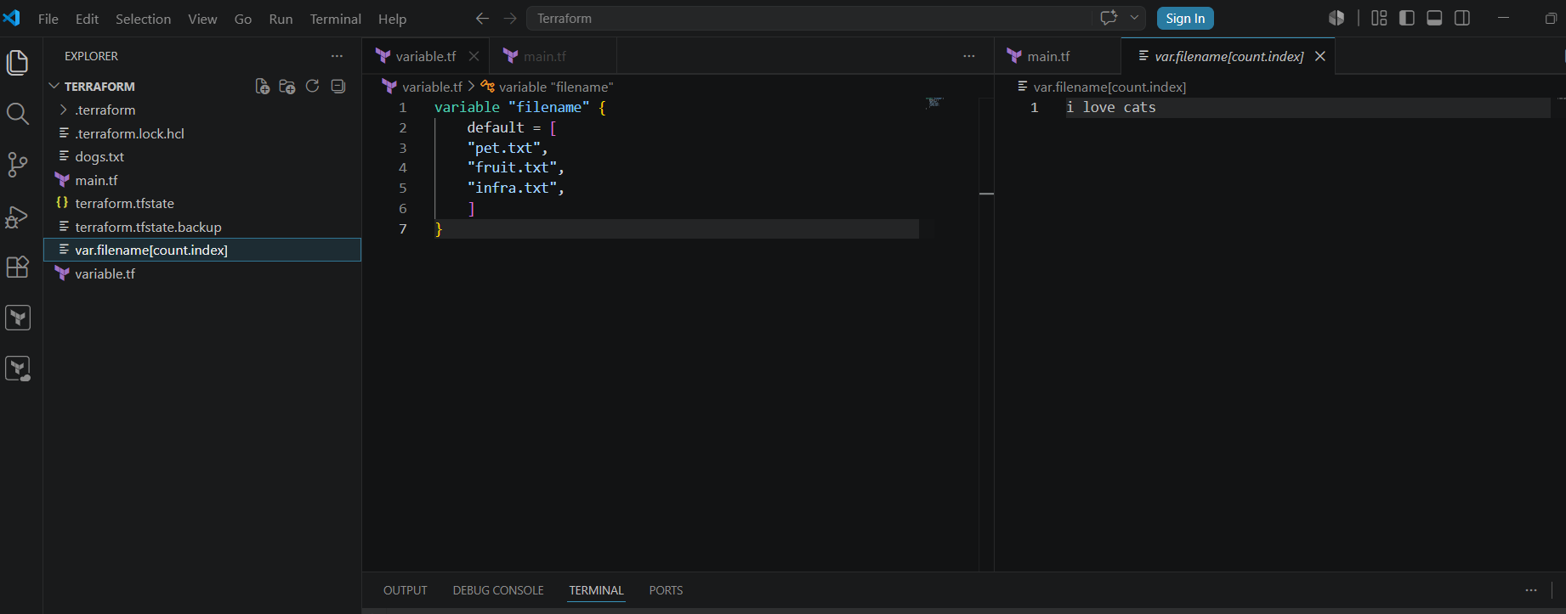
COUNT VARIABLE TYPE (LIST)⇒
FOR-EACH For creating multiple files with different attributes
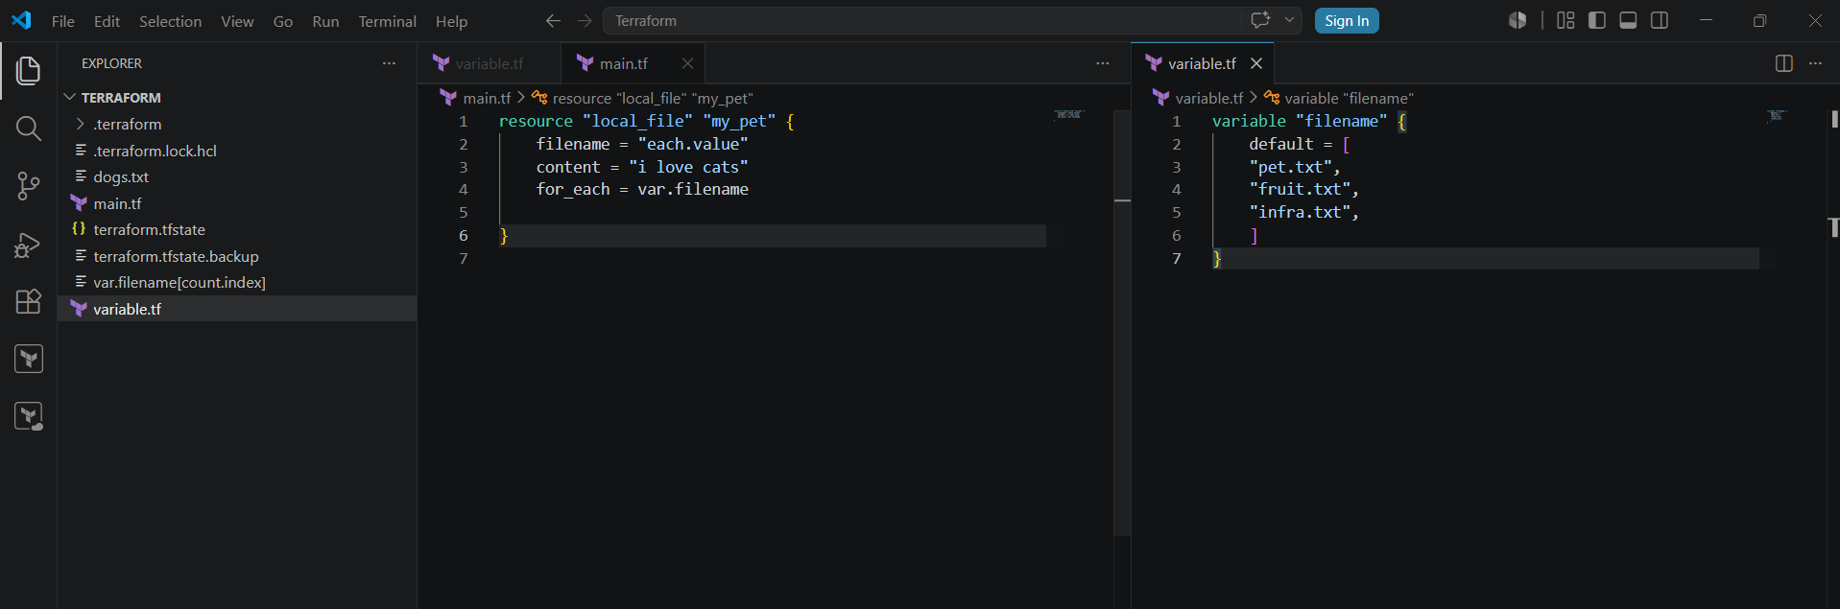
terraform apply
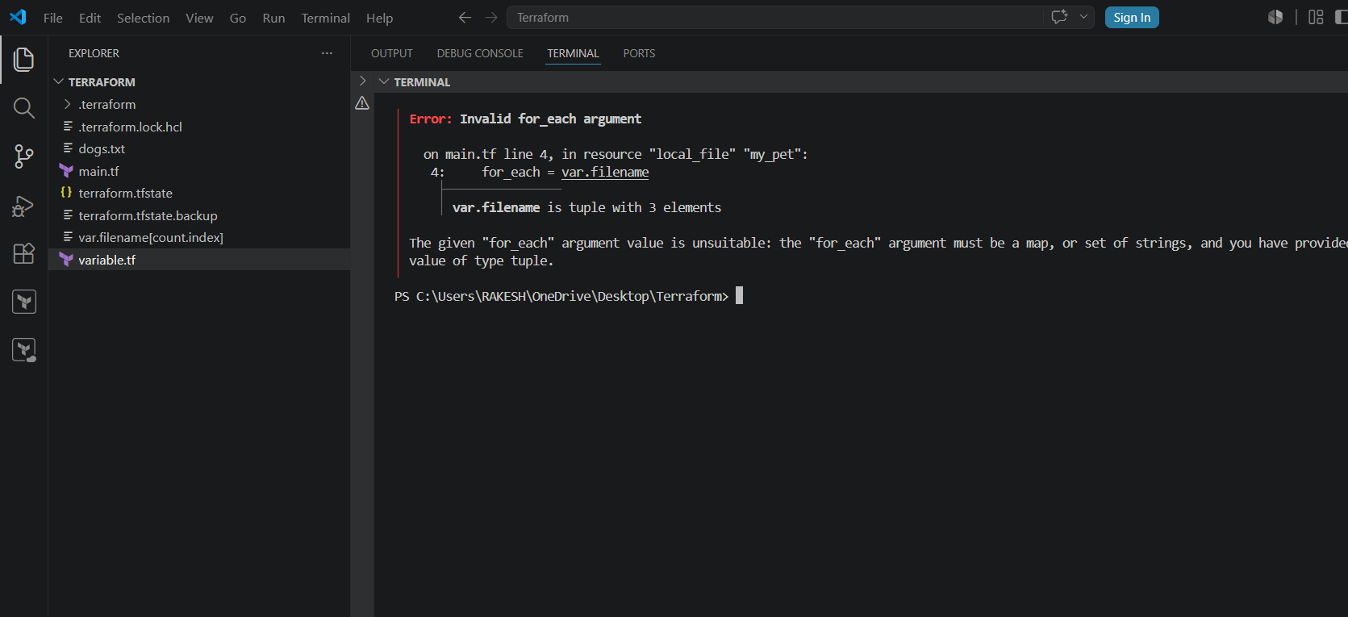
ERROR REASON:
For-Each uses different variable style it uses MAP.
So, here we can do by using two different methods like
1. In main.tf we can change for_each = toset(var.filename)
2. In variables.tf we can use type =set(String)
Both scenarios will work
First Scenario
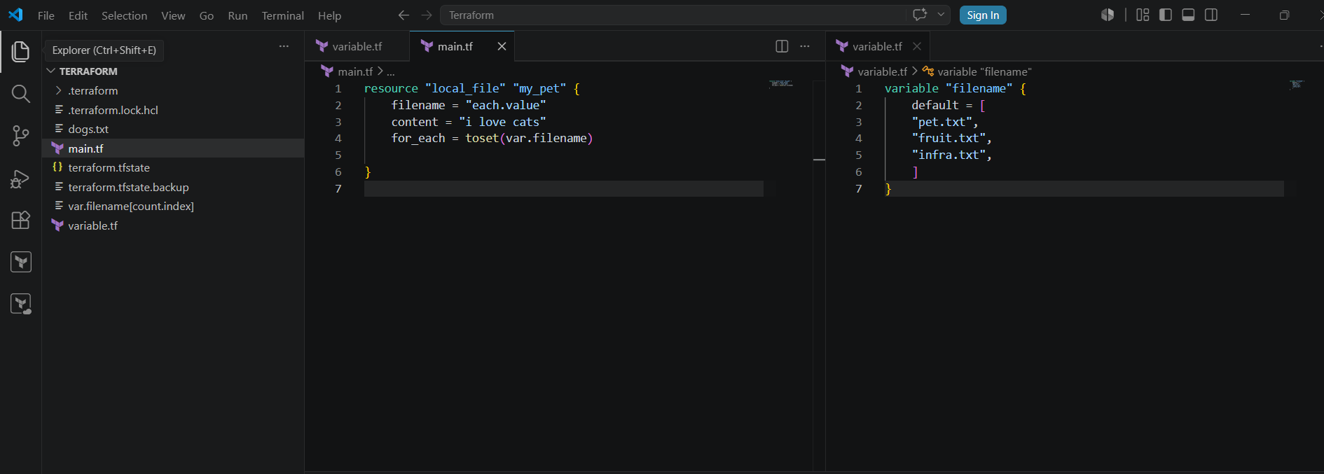
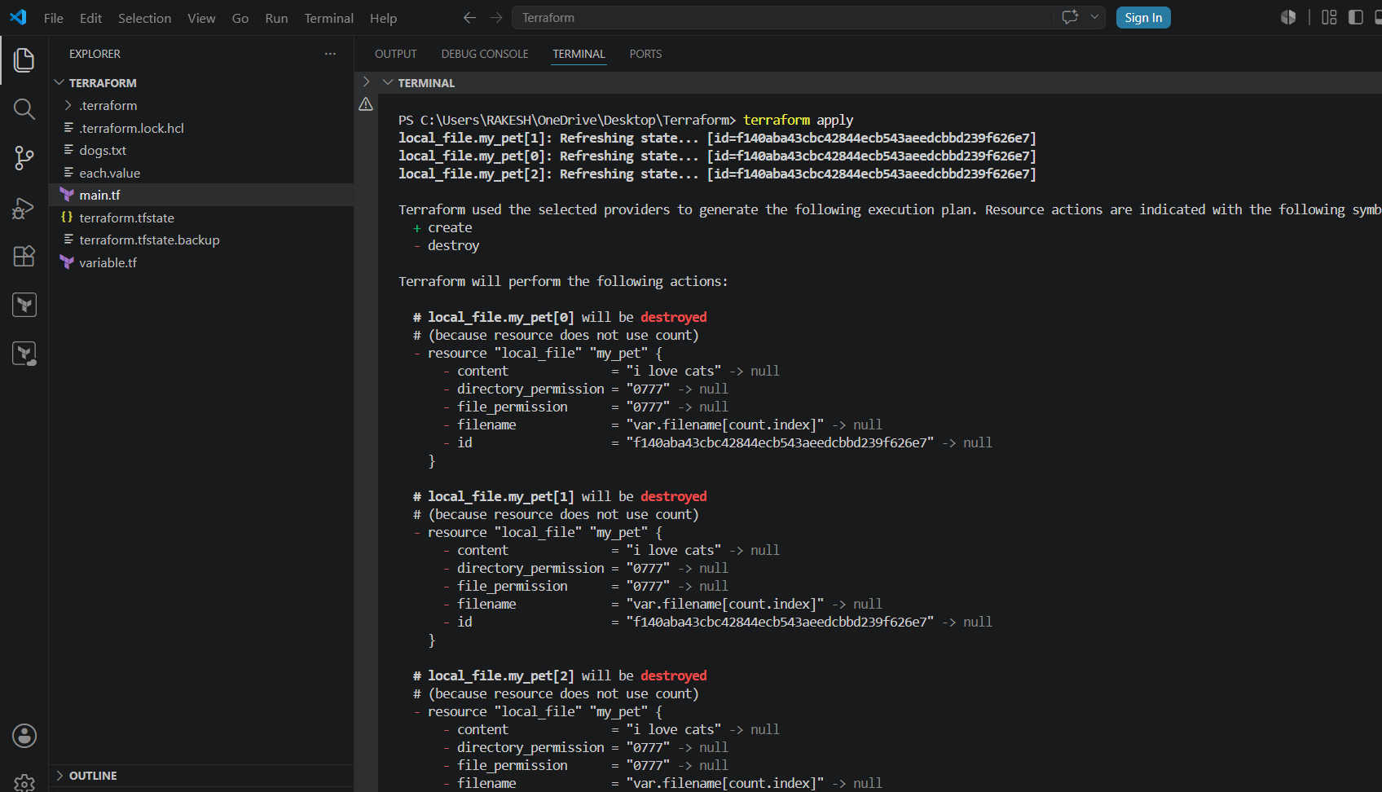
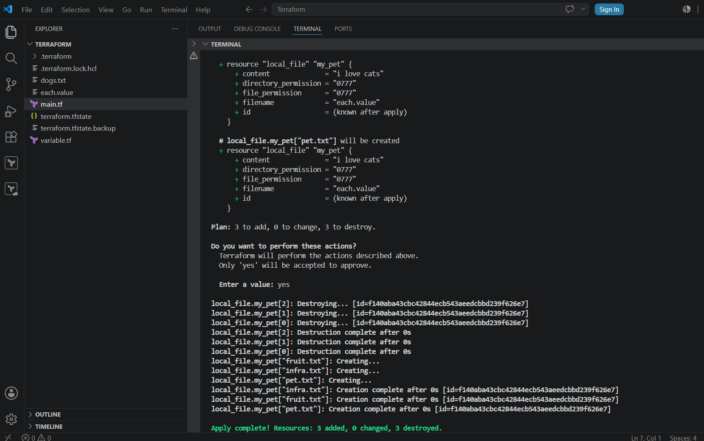

Second Scenario
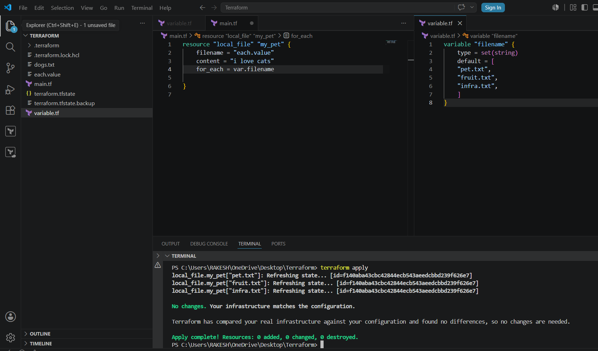
Lets create AWS services using terraform Need to configure AWS access ID and⇒
password without hardcoding in the⇒ main.tf file we can do it in cli using aws
configure
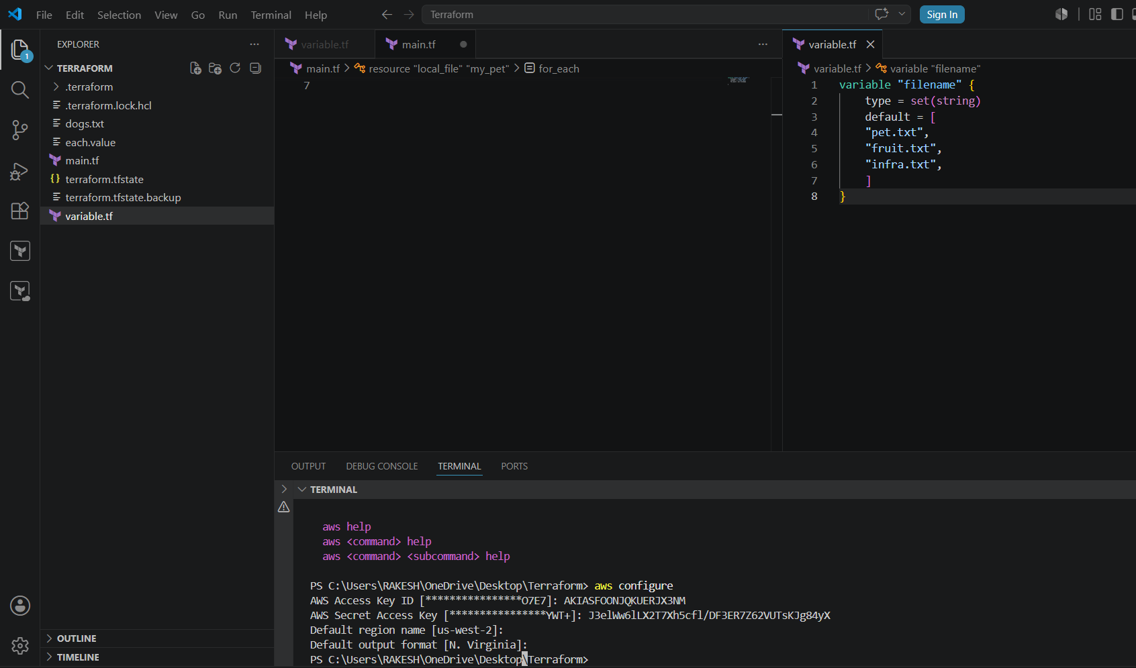
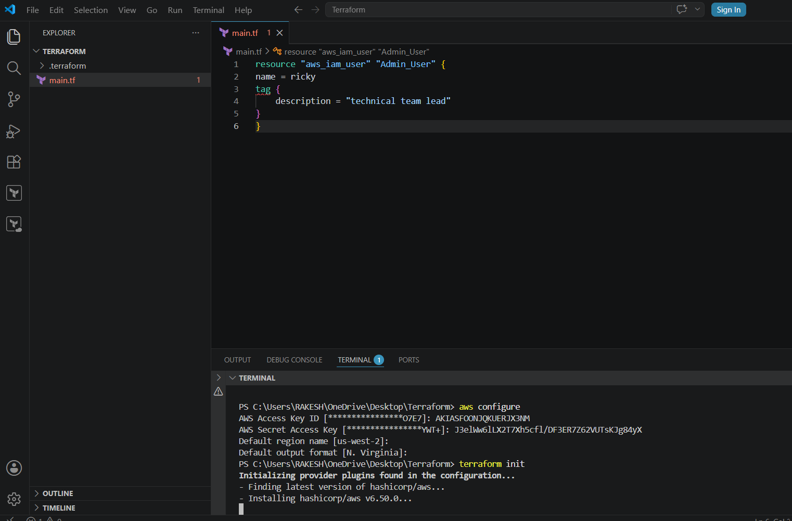
My resource block code is to create a IAM USER in AWS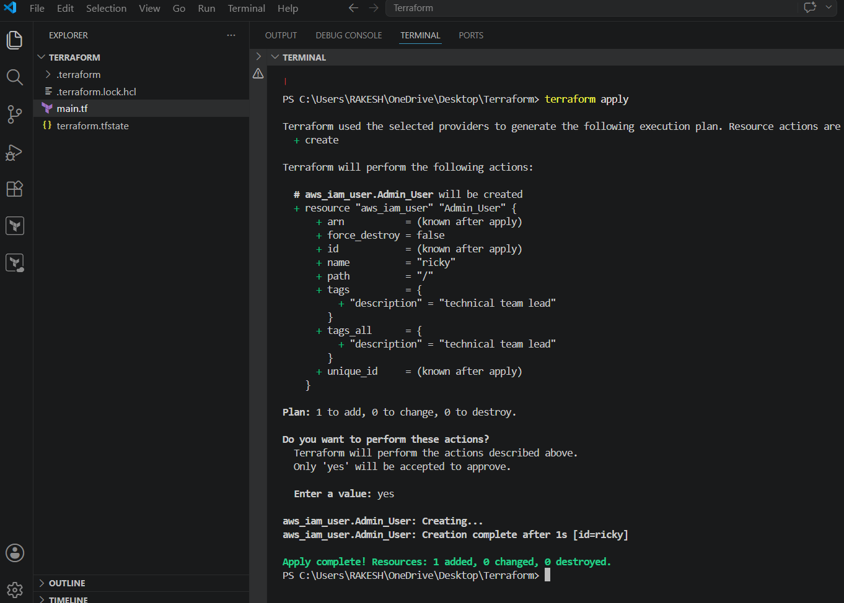
Lets check in AWS
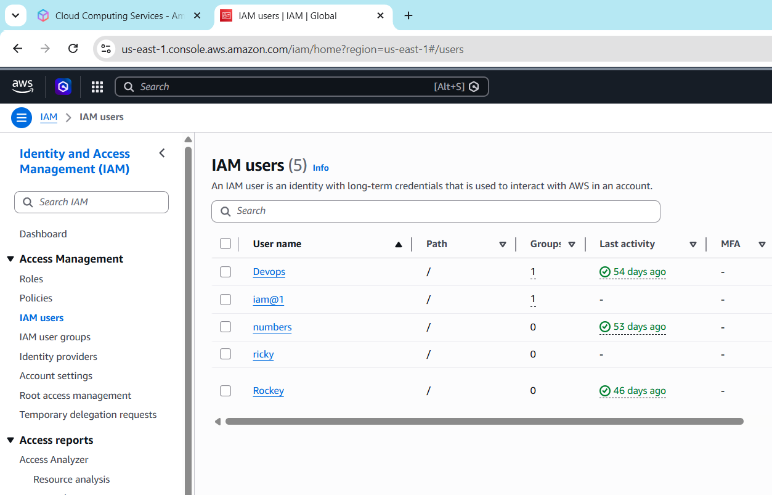
As we created user lets give him some permissions
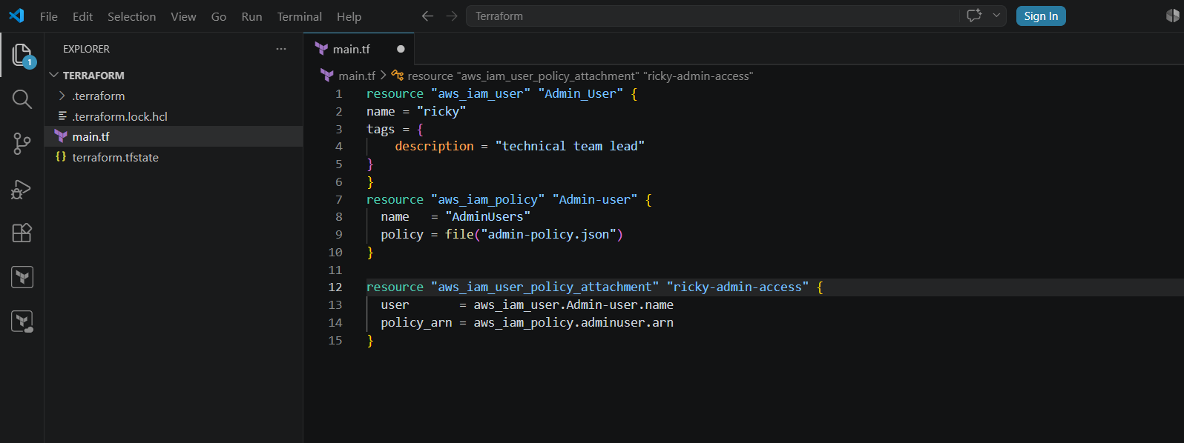
For giving him permissions lets write a policy
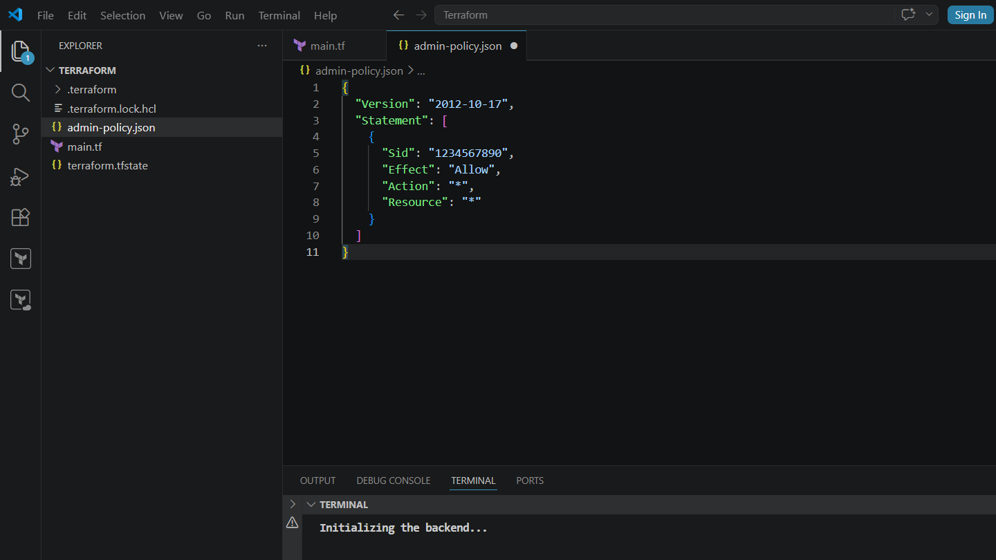
terraform apply
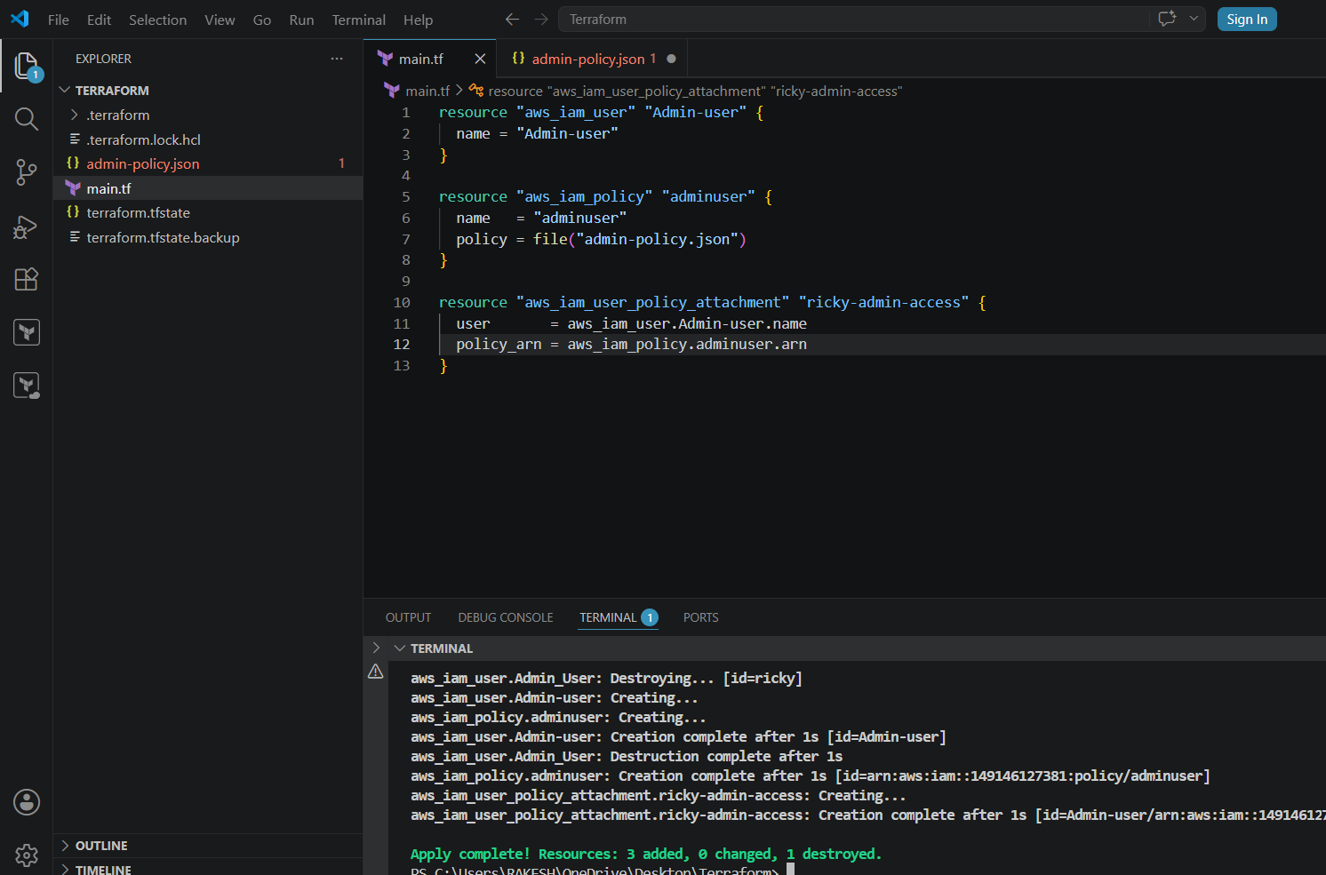
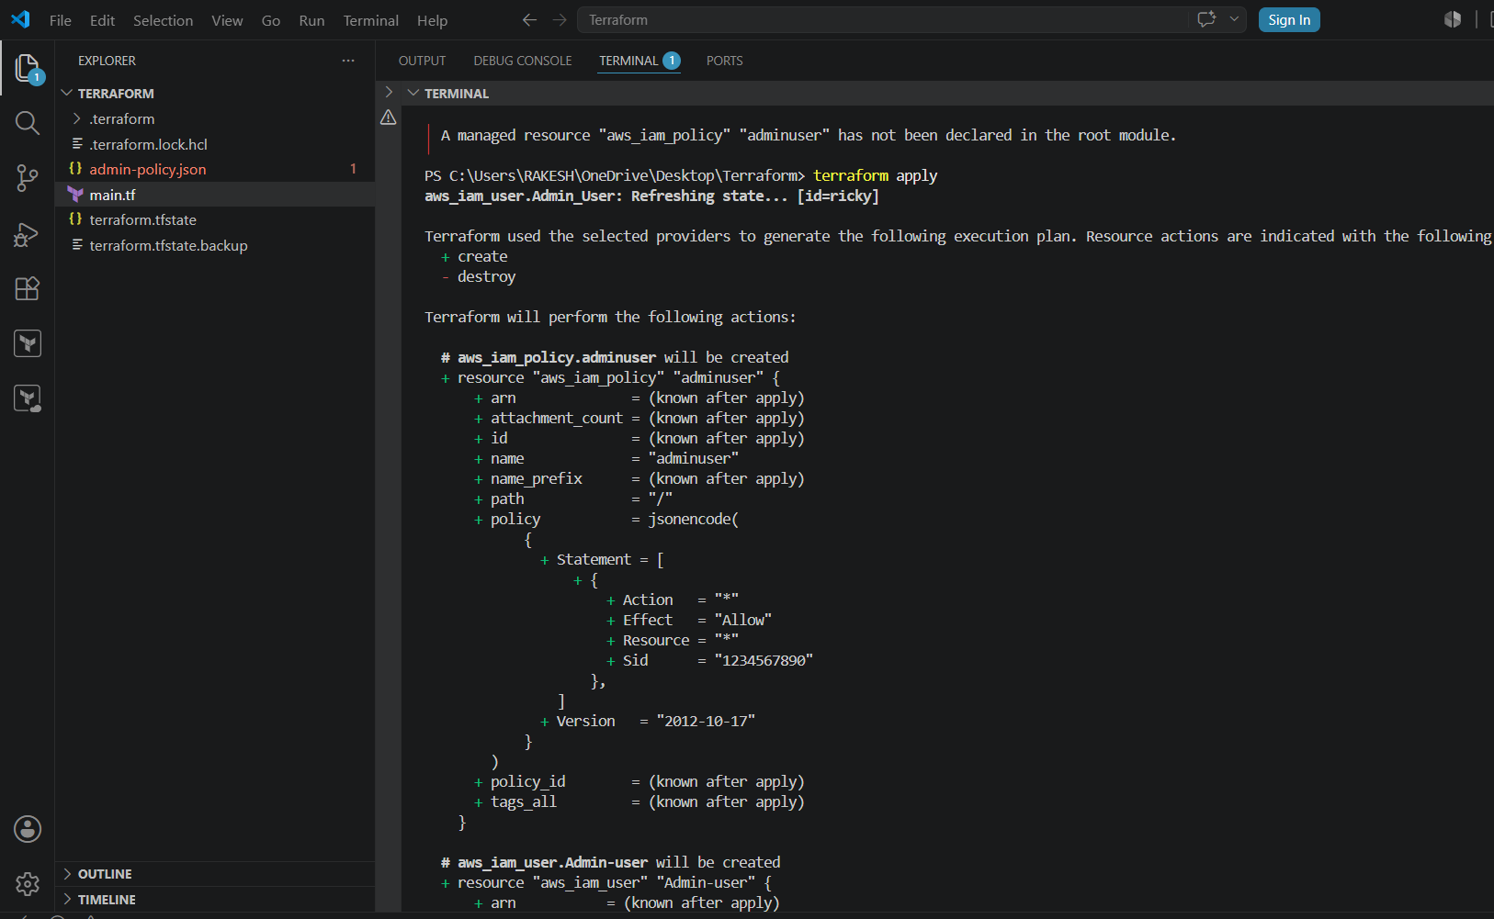
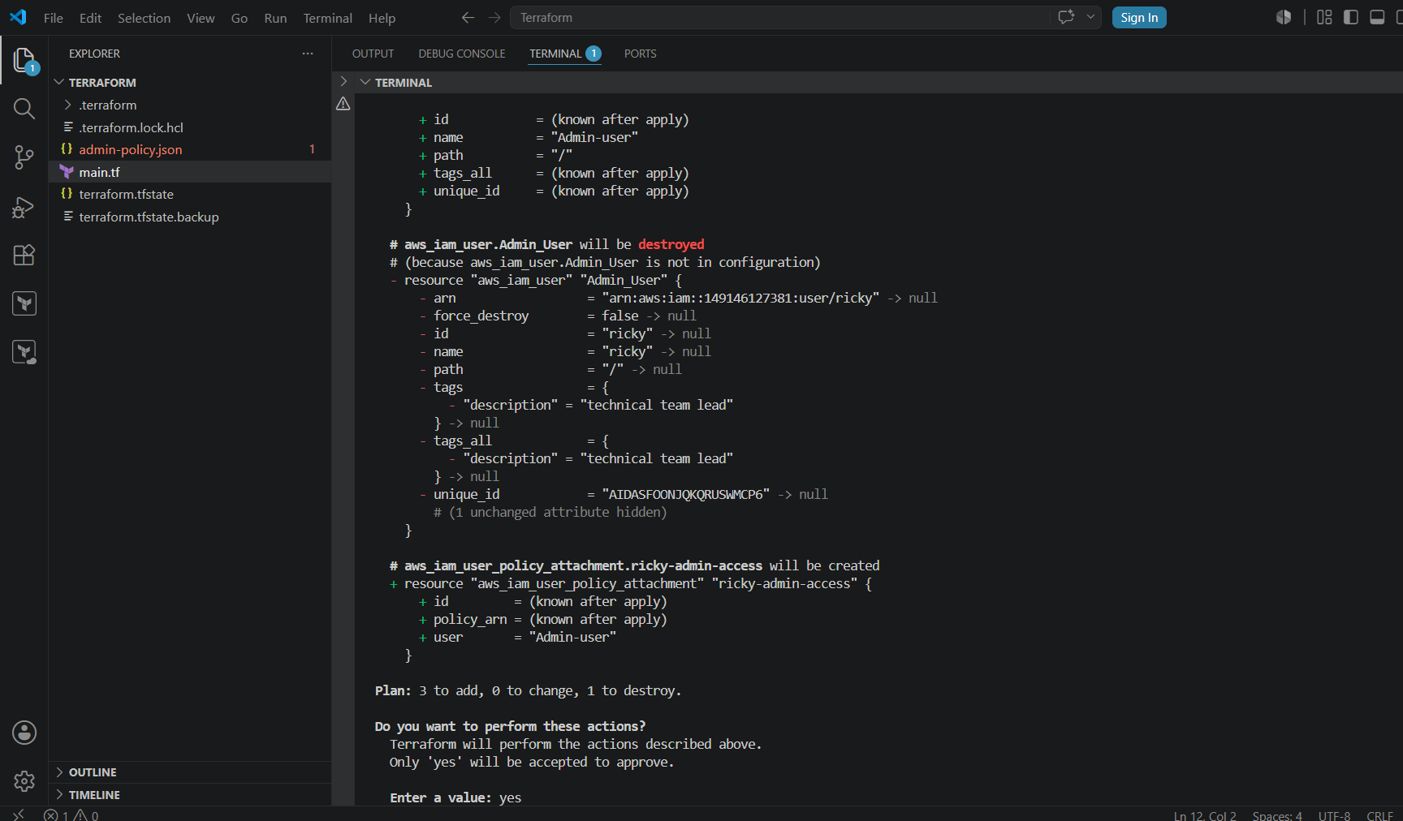
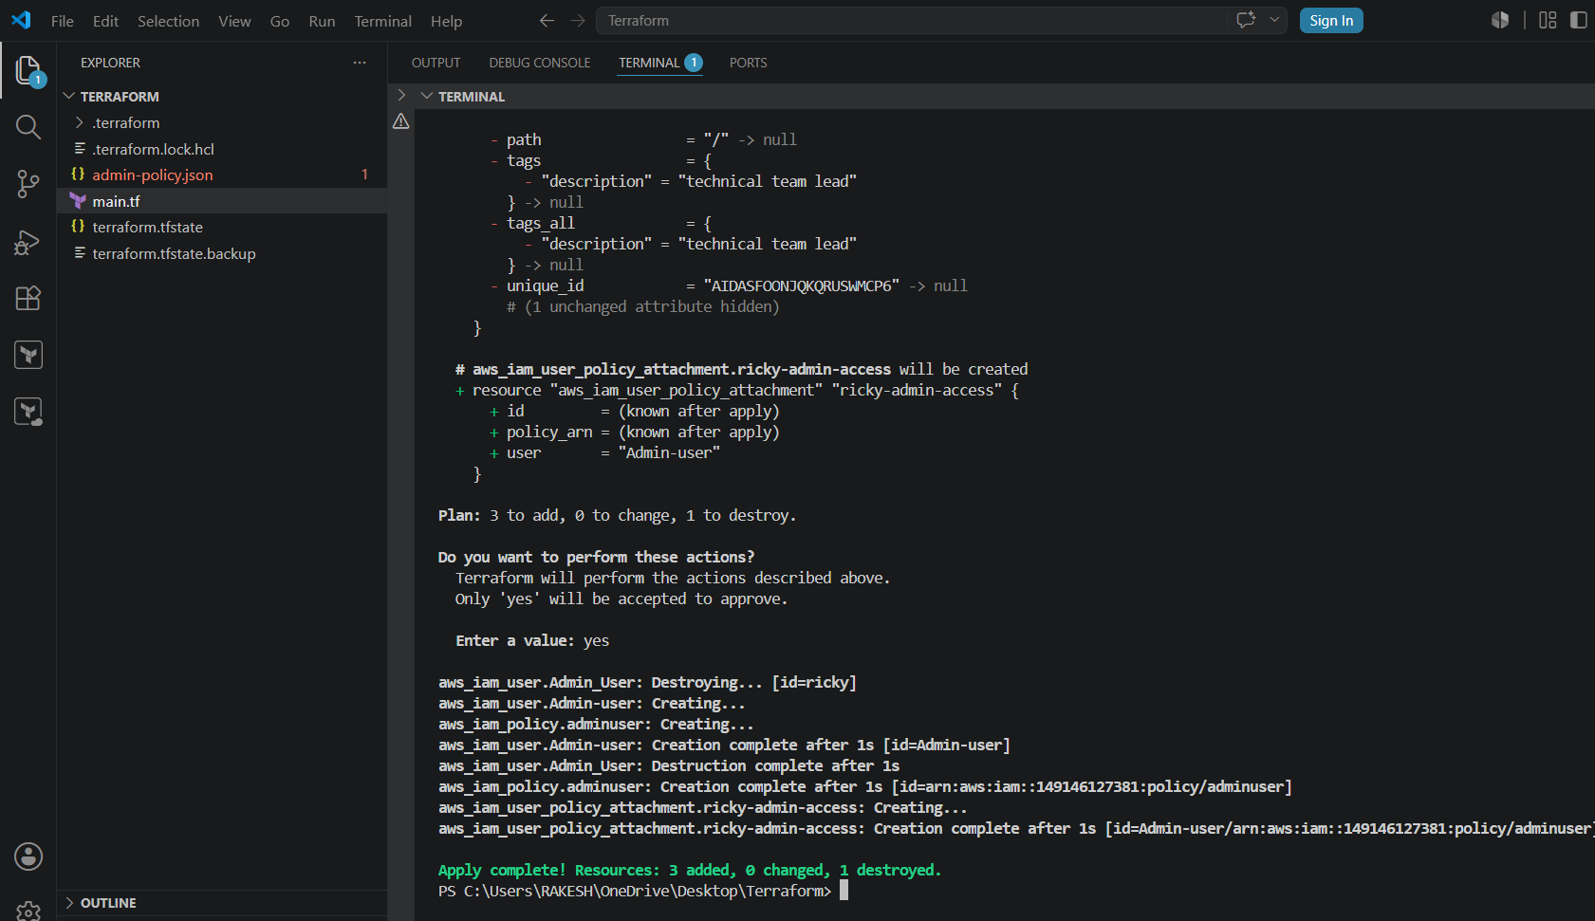
Lets see in AWS
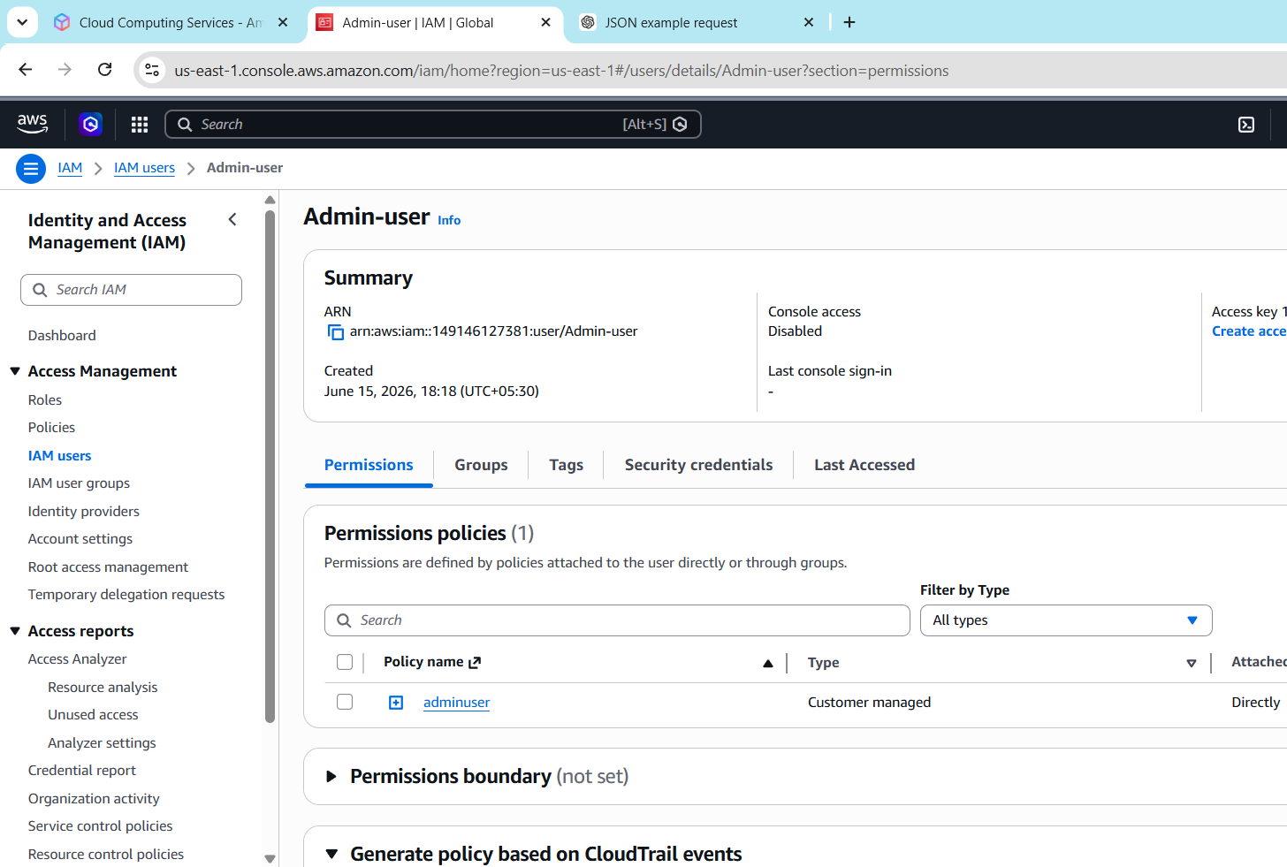
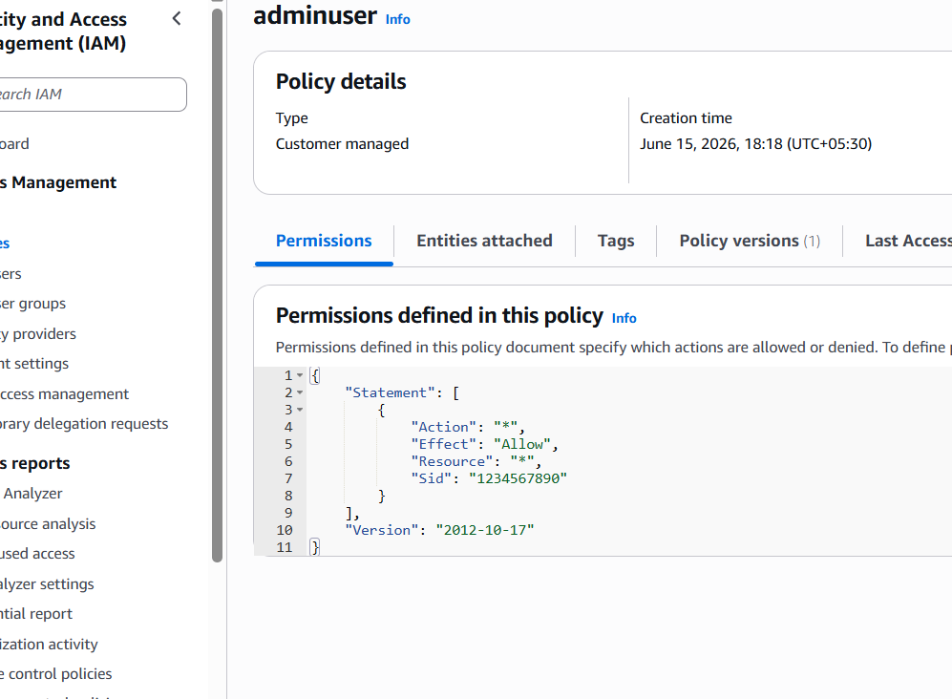

3). Integrate Terraform in Jenkins using the Terraform plugin.
Lets start Jenkins and Install the required Plugins
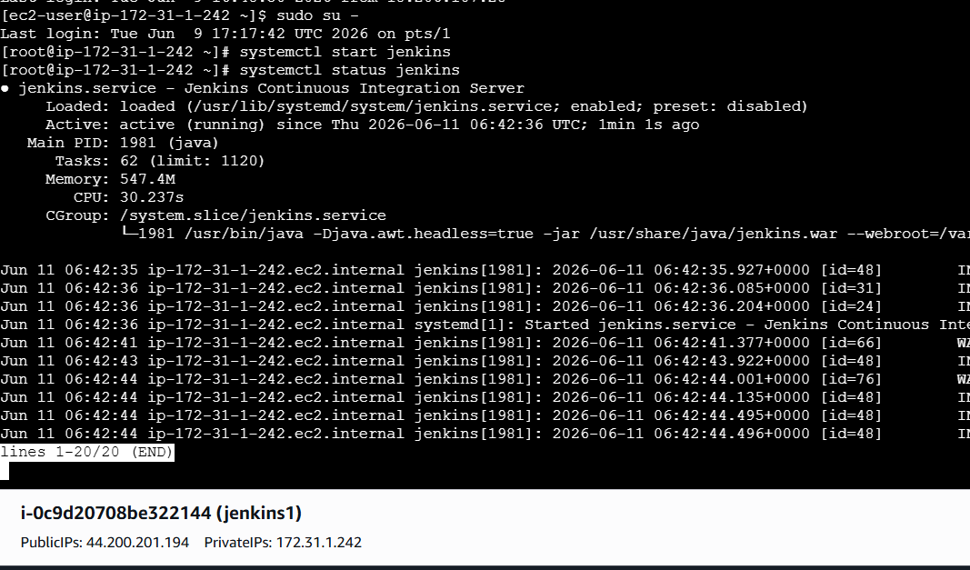
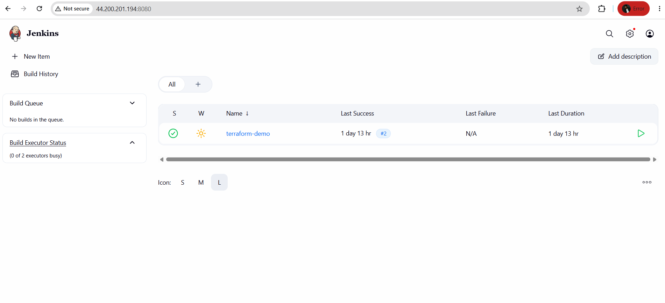
Install Plugin terraform
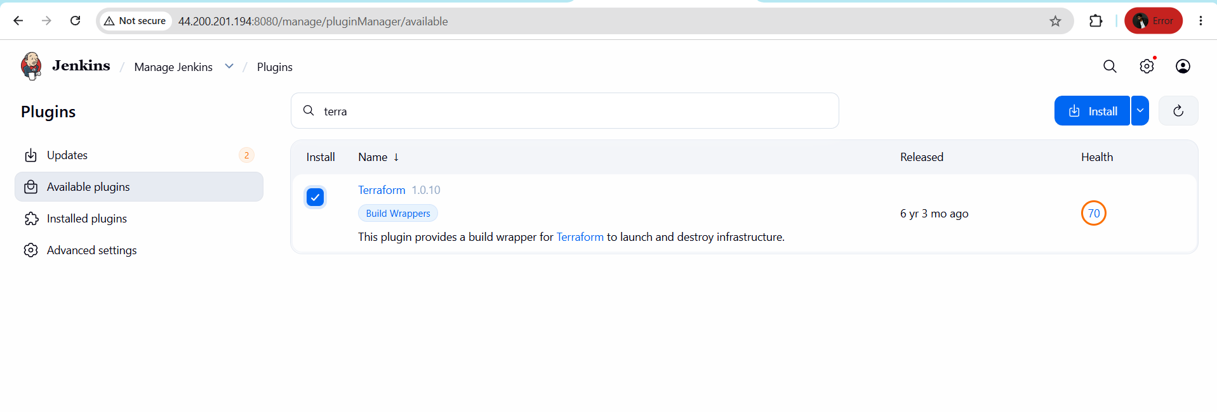
Plugin Installation Successfully
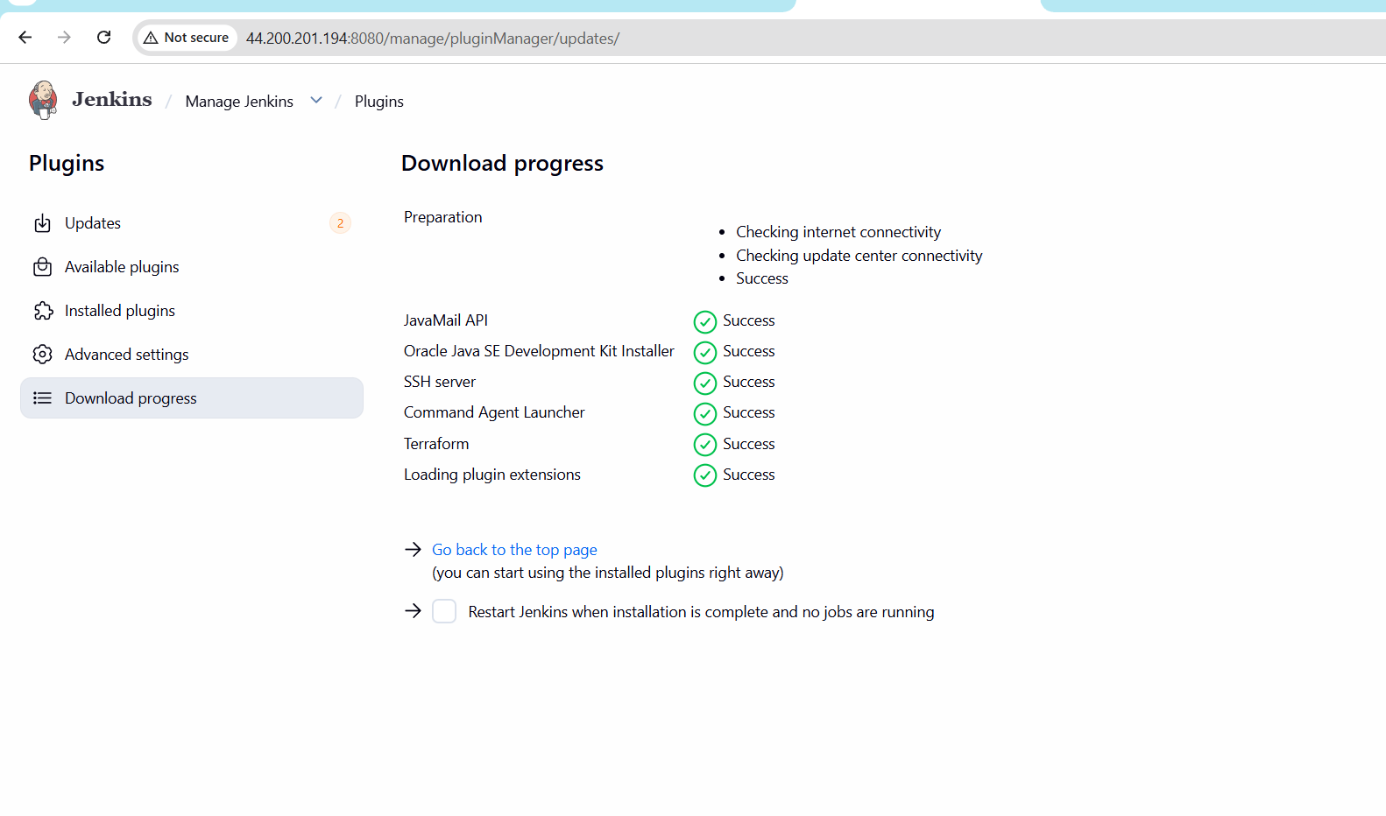
Now lets configure Terraform with Jenkins
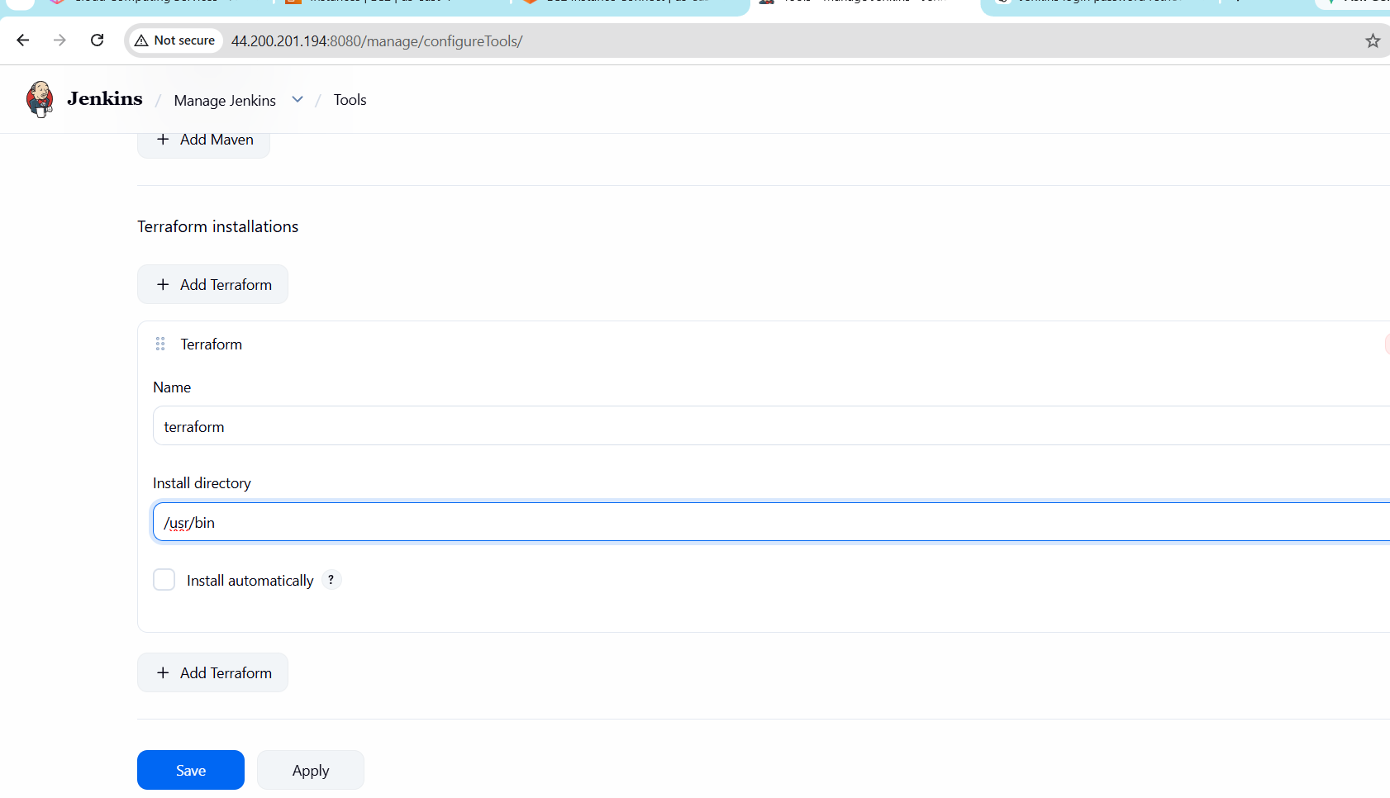
Now terraform has been configured
Now Lets create a main.tf

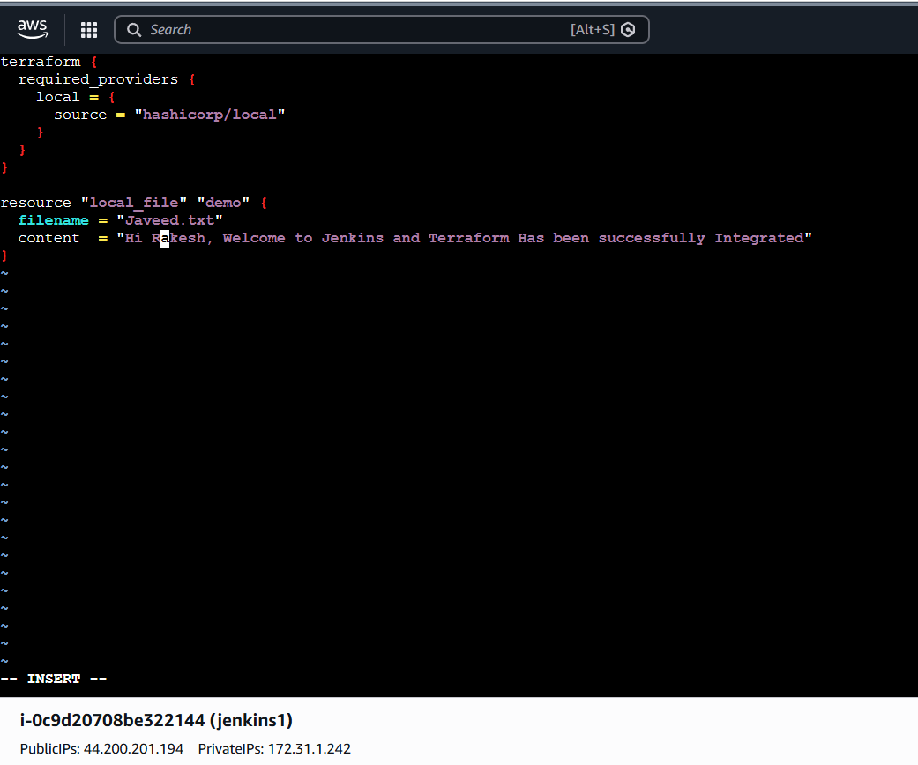
Create a test pipeline job
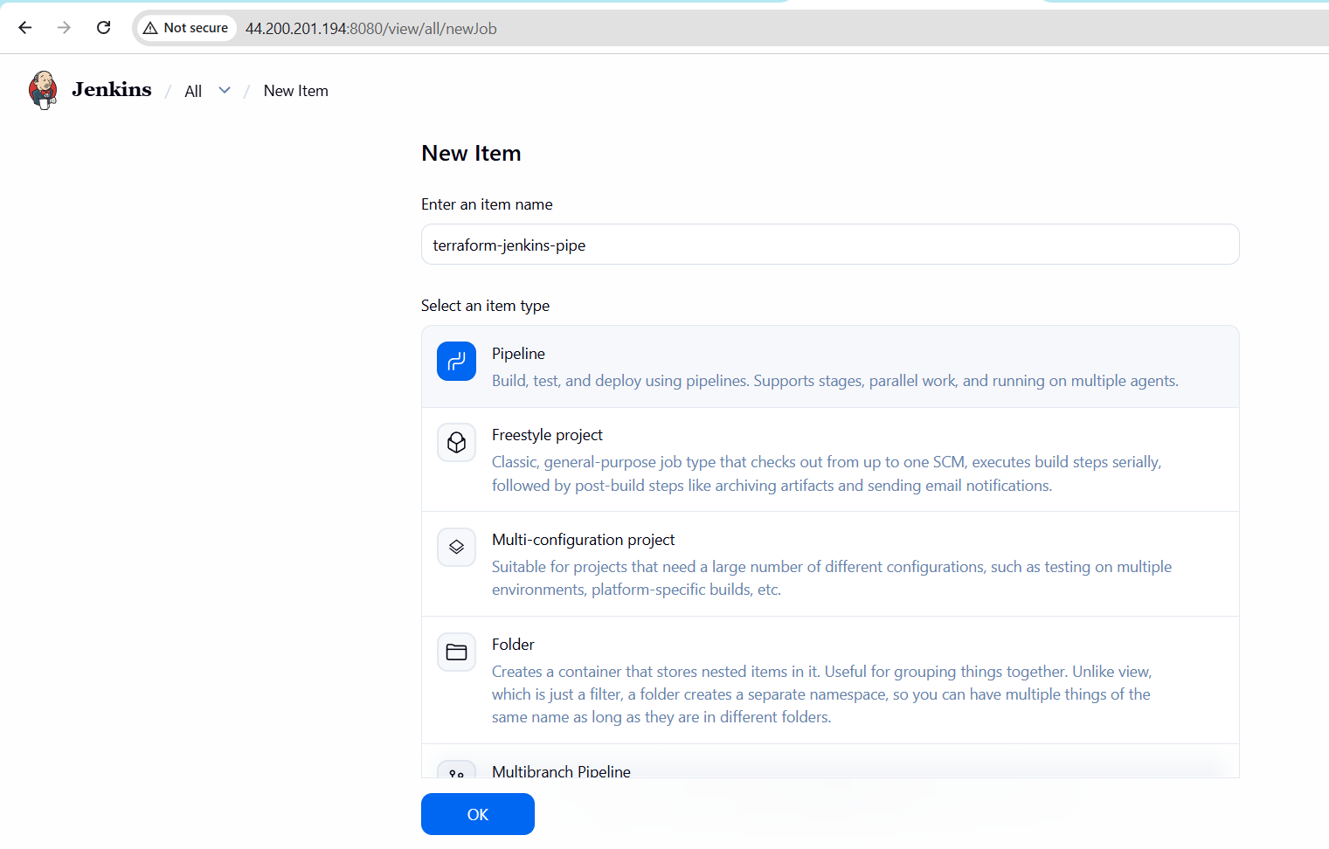
SCRIPT
pipeline {
agent any
tools {
terraform 'terraform'
}
stages {
stage('Check Terraform') {
steps {
sh 'terraform version'
}
}
stage('Terraform Init') {
steps {
sh 'terraform init'
}
}
stage('Terraform Plan') {
steps {
sh 'terraform plan'
}
}
stage('Terraform Apply') {
steps {
sh 'terraform apply -auto-approve'
}
}
}
}
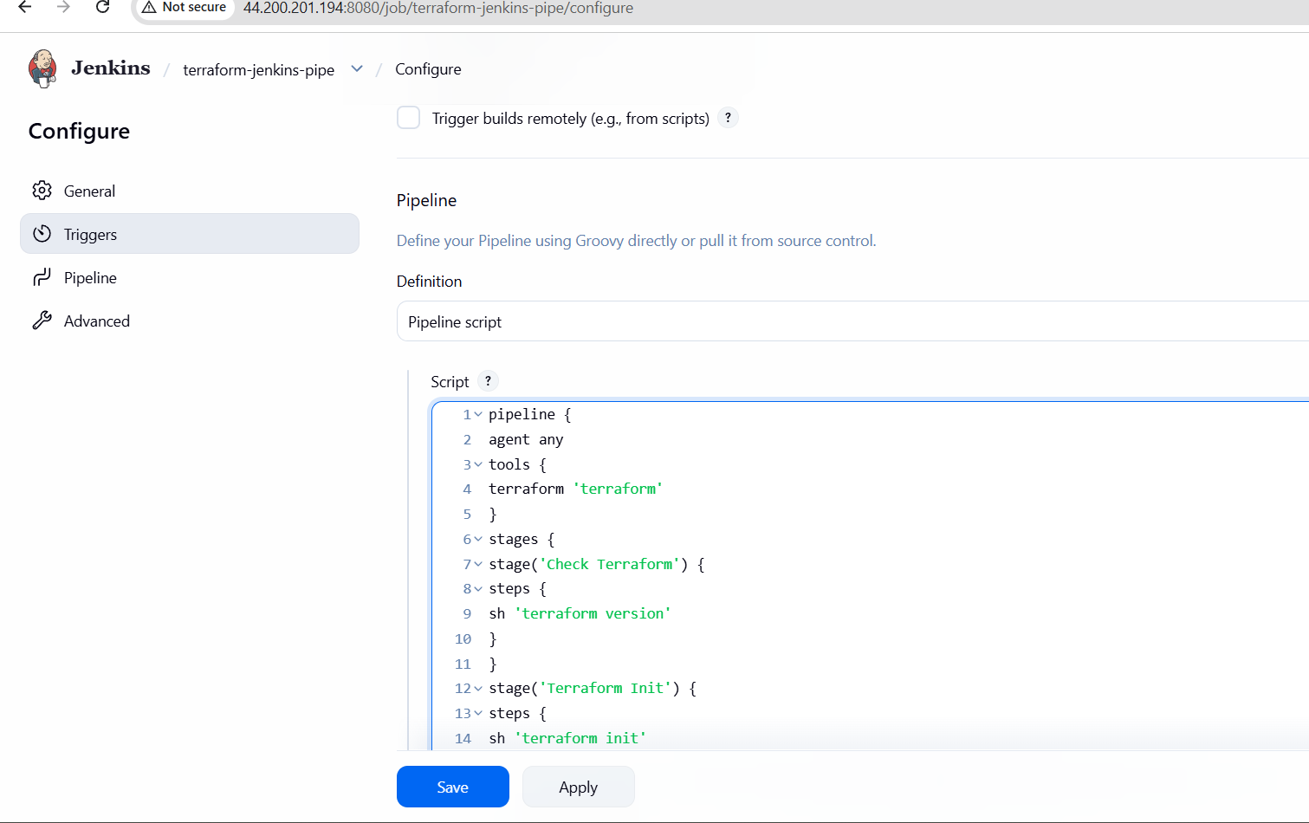
Lets Build The Job
Console Output

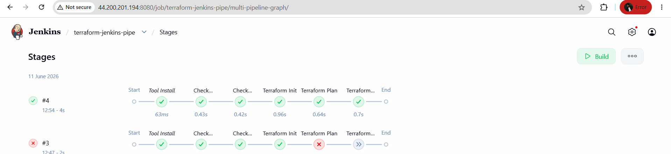

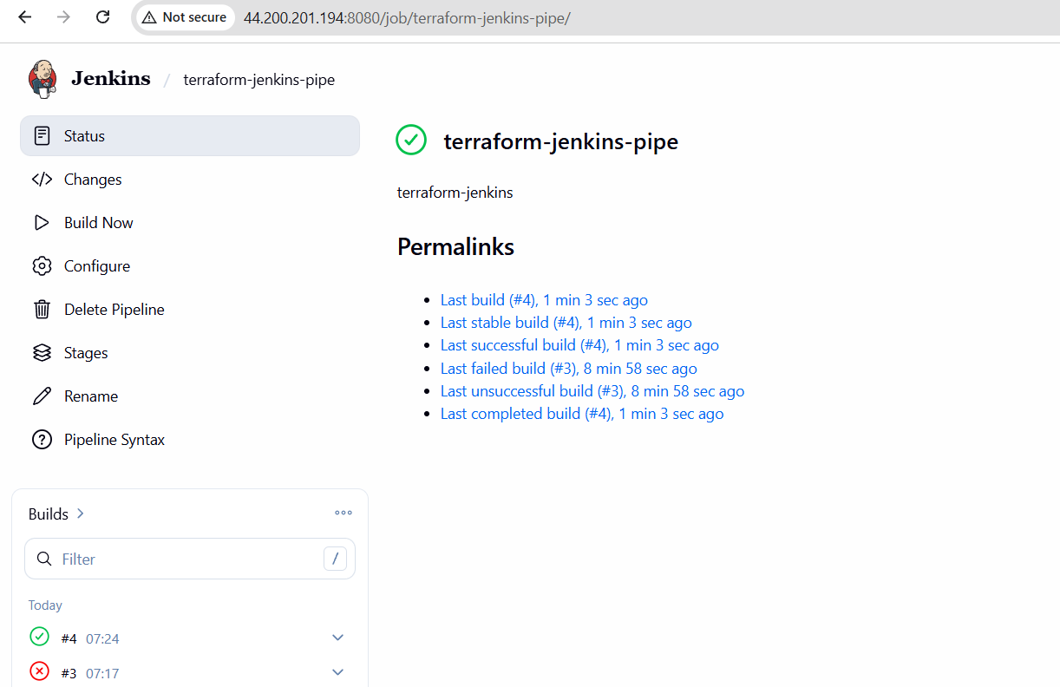

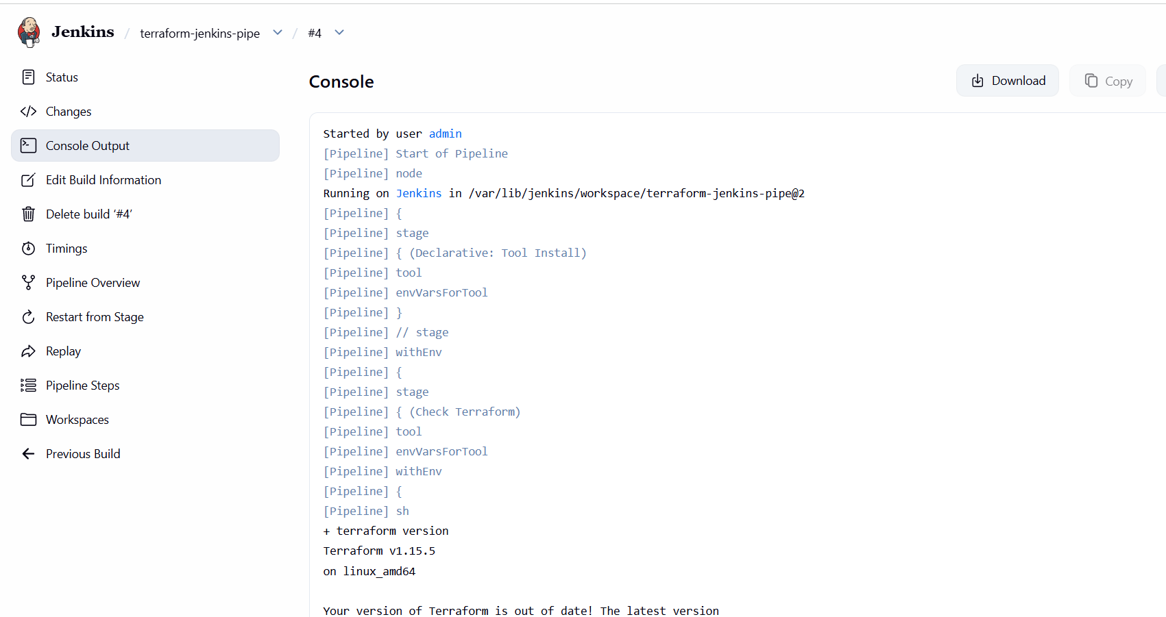
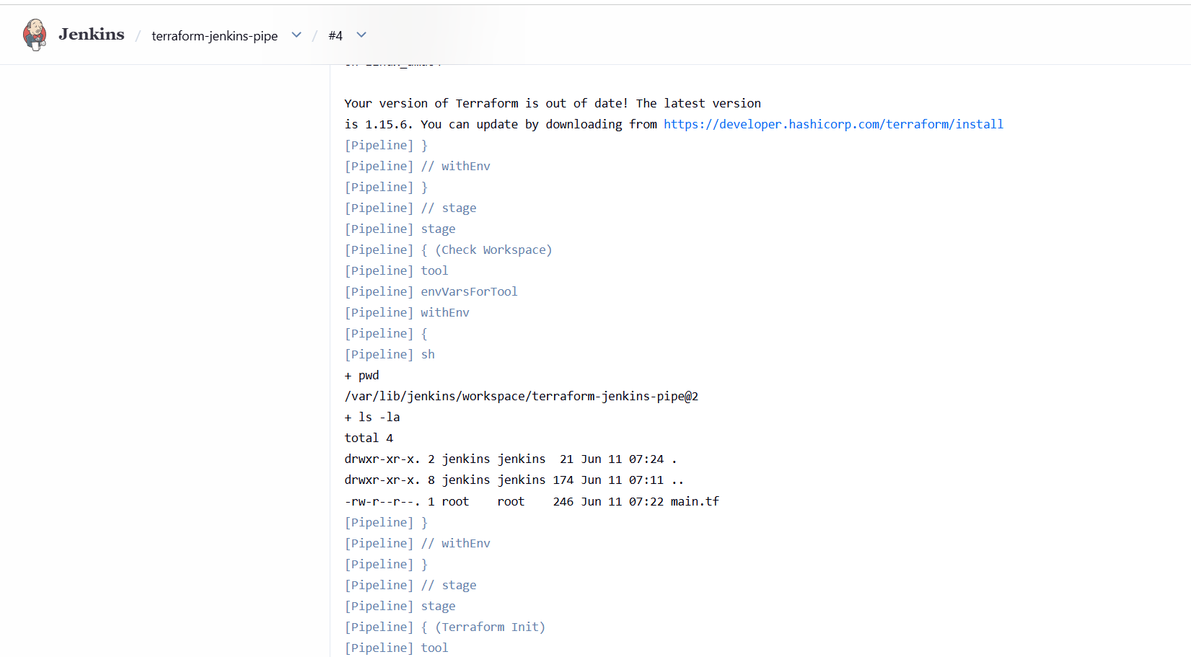
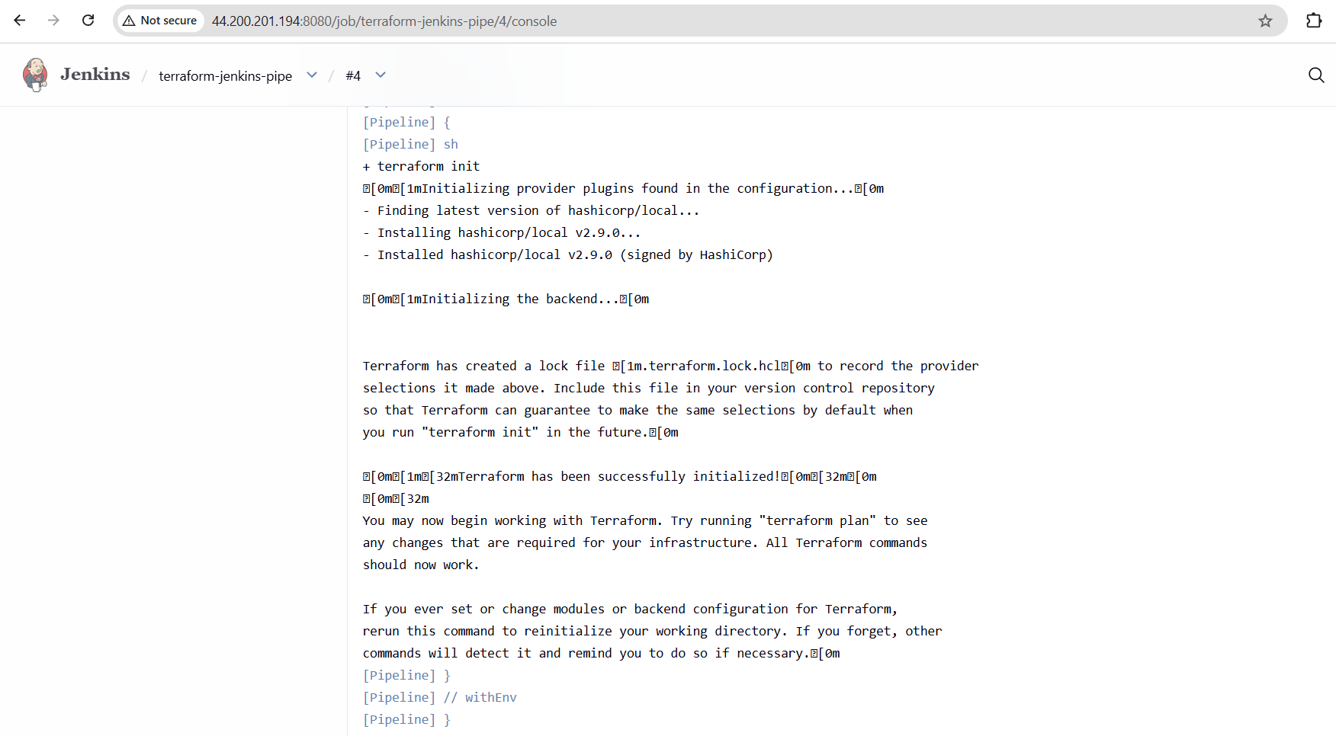
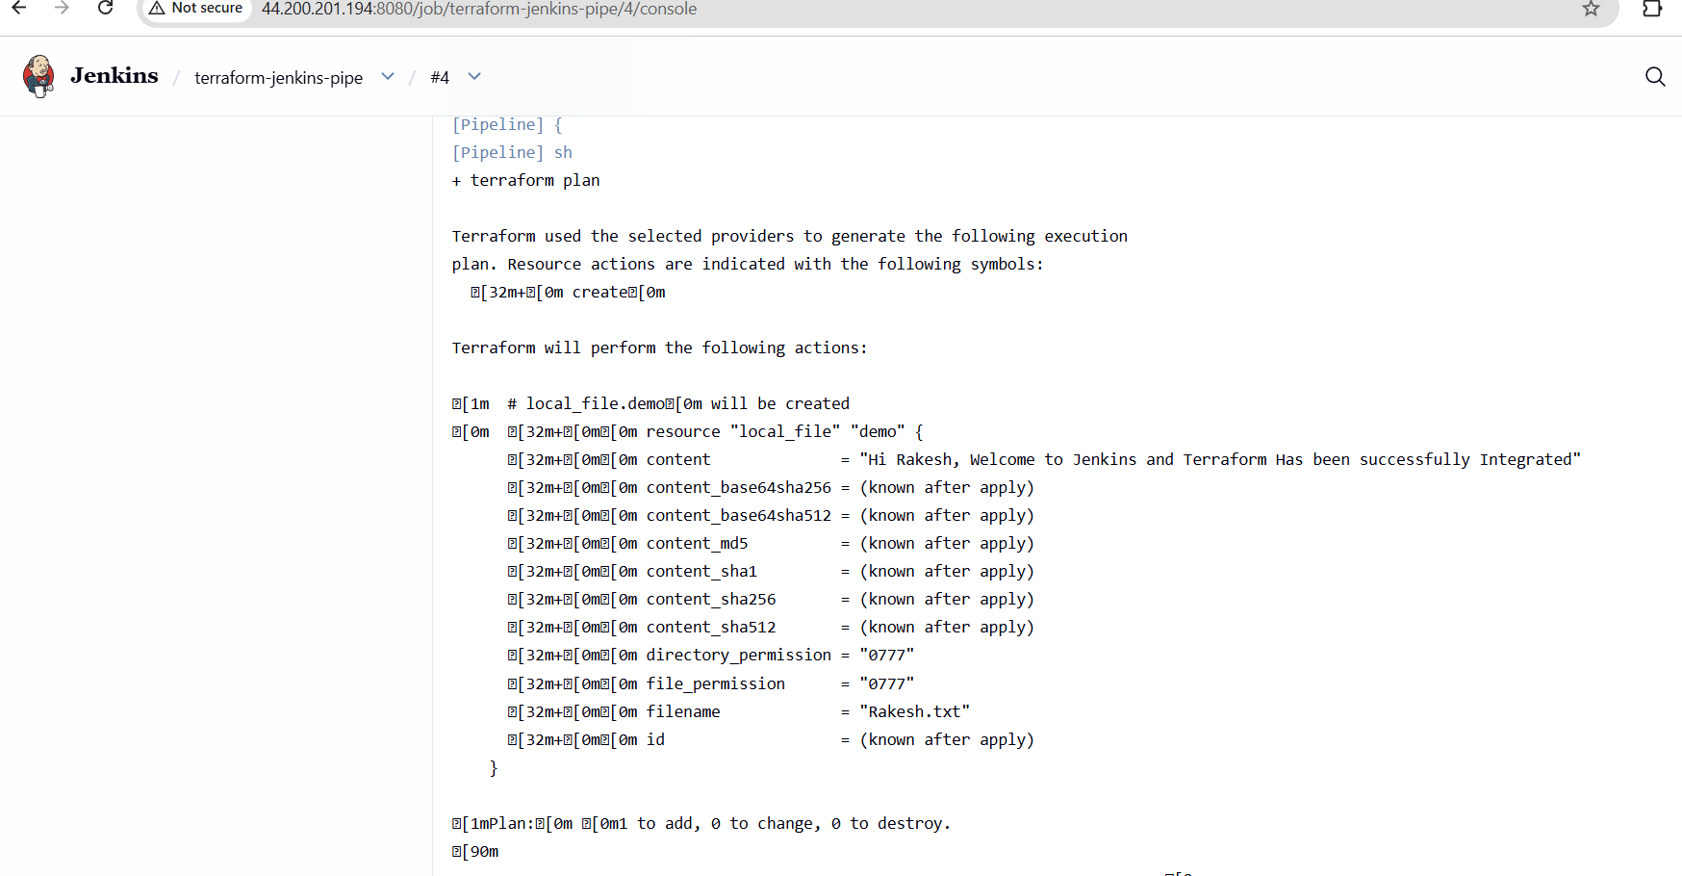
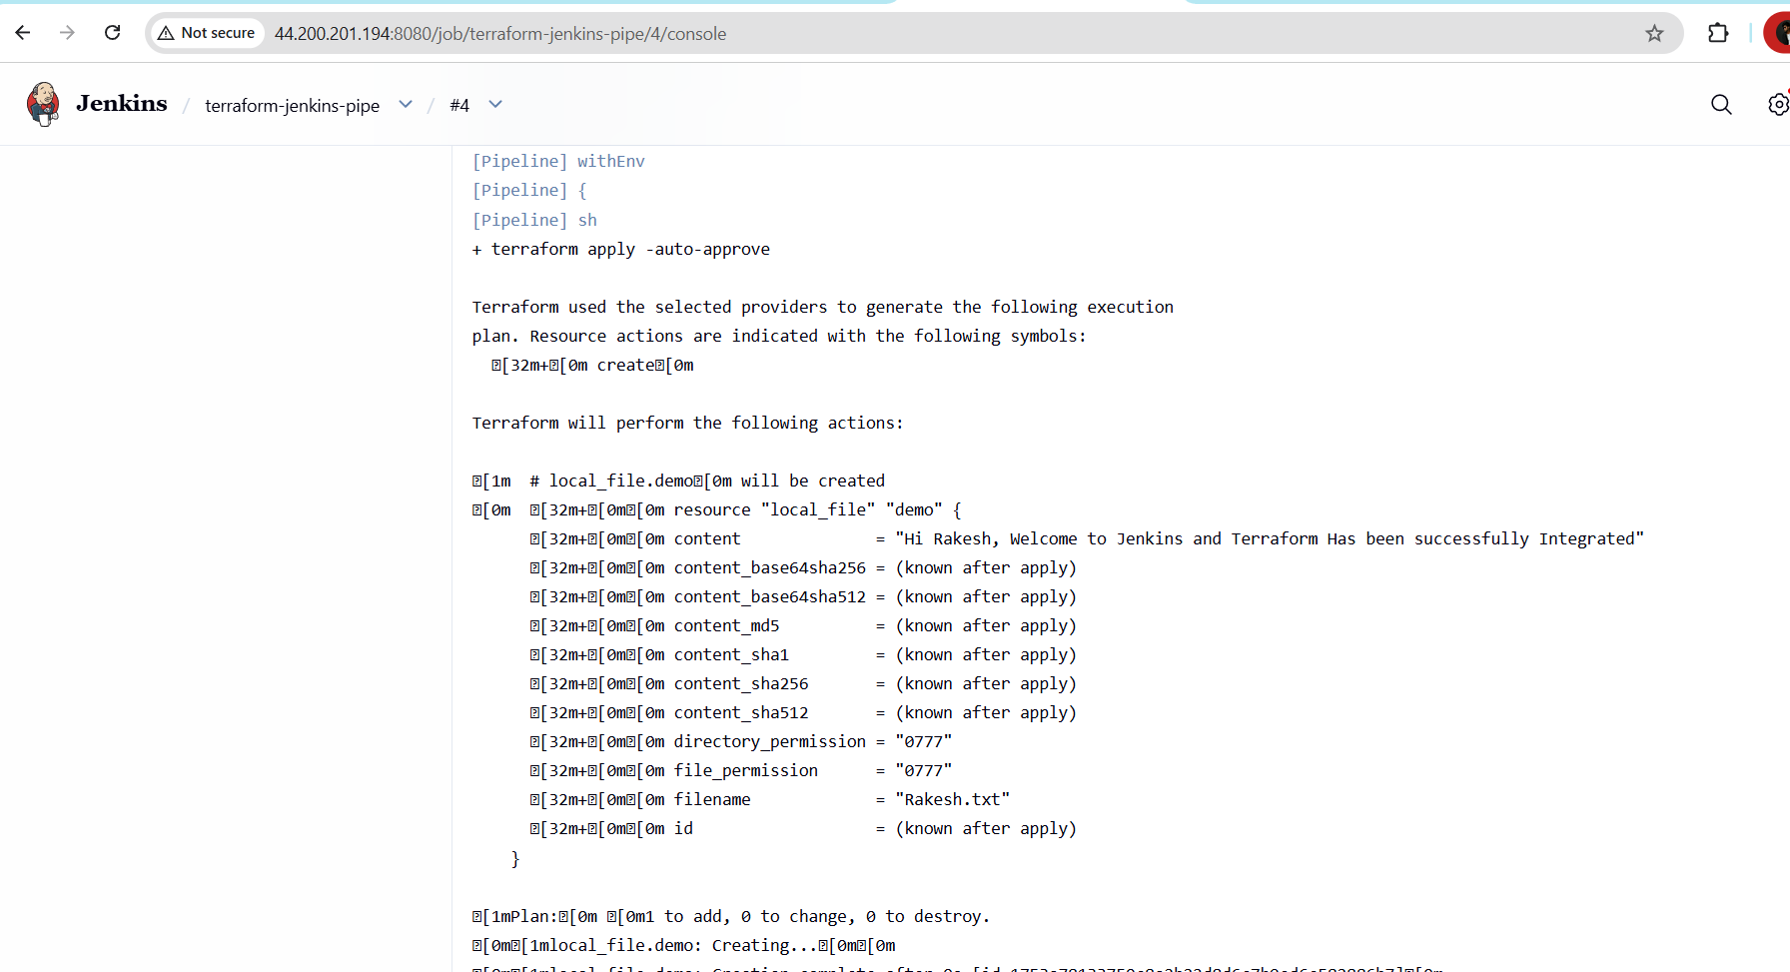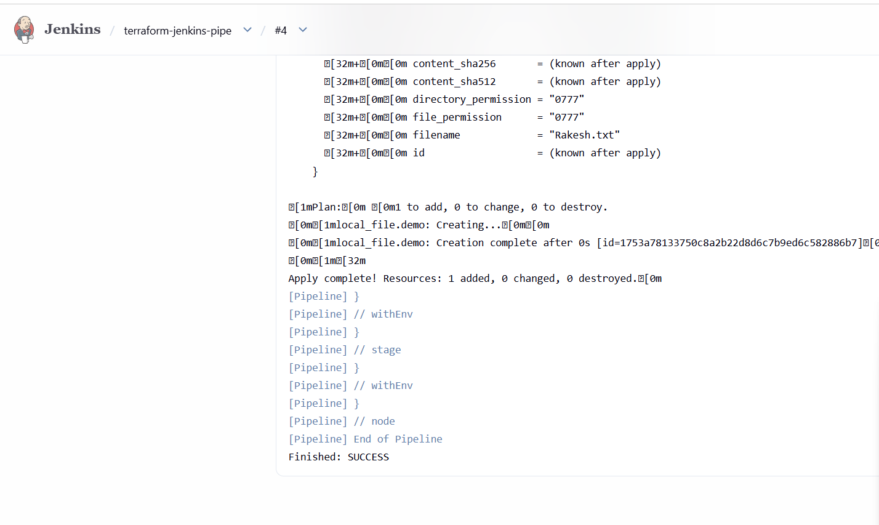

Now the folder has been created

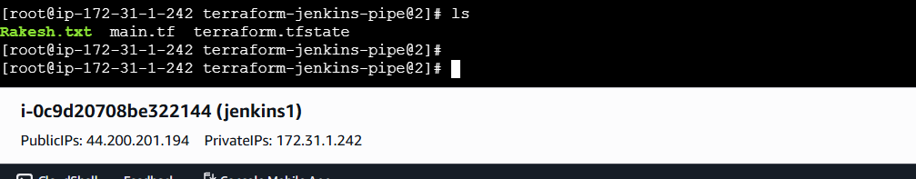
4). Create a CI/CD pipeline for a Nodejs Application: https://github.com/betawins/Trading-UI.git

Lets Install the pre-requisites in our machine first
sudo dnf update -y
sudo dnf install -y curl
curl -fsSL https://deb.nodesource.com/setup_20.x | bash -
apt install -y nodejs
npm install -g pm2
To Check the versions of what we have downloaded
node -v
npm -v
pm2 -v
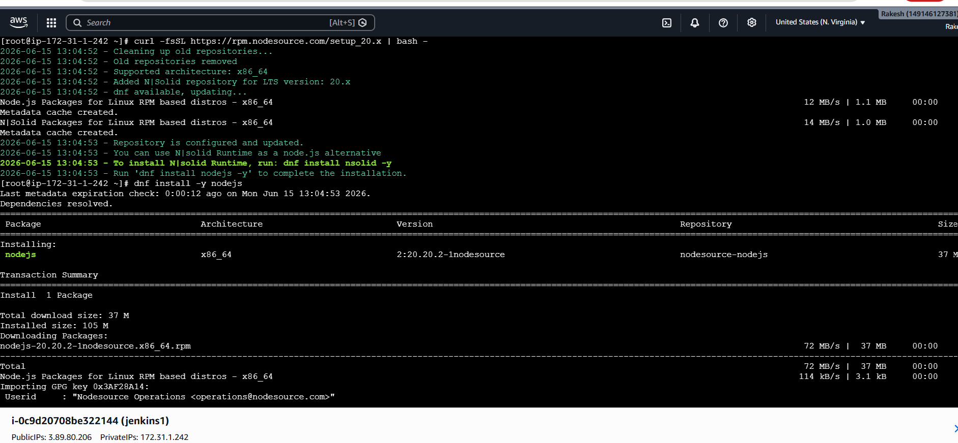
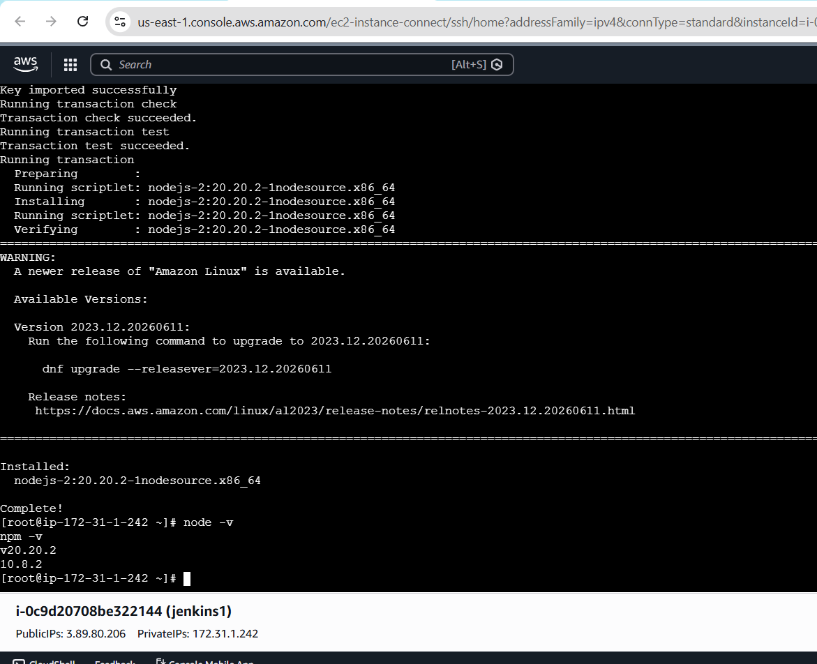
Lets start a pipeline job
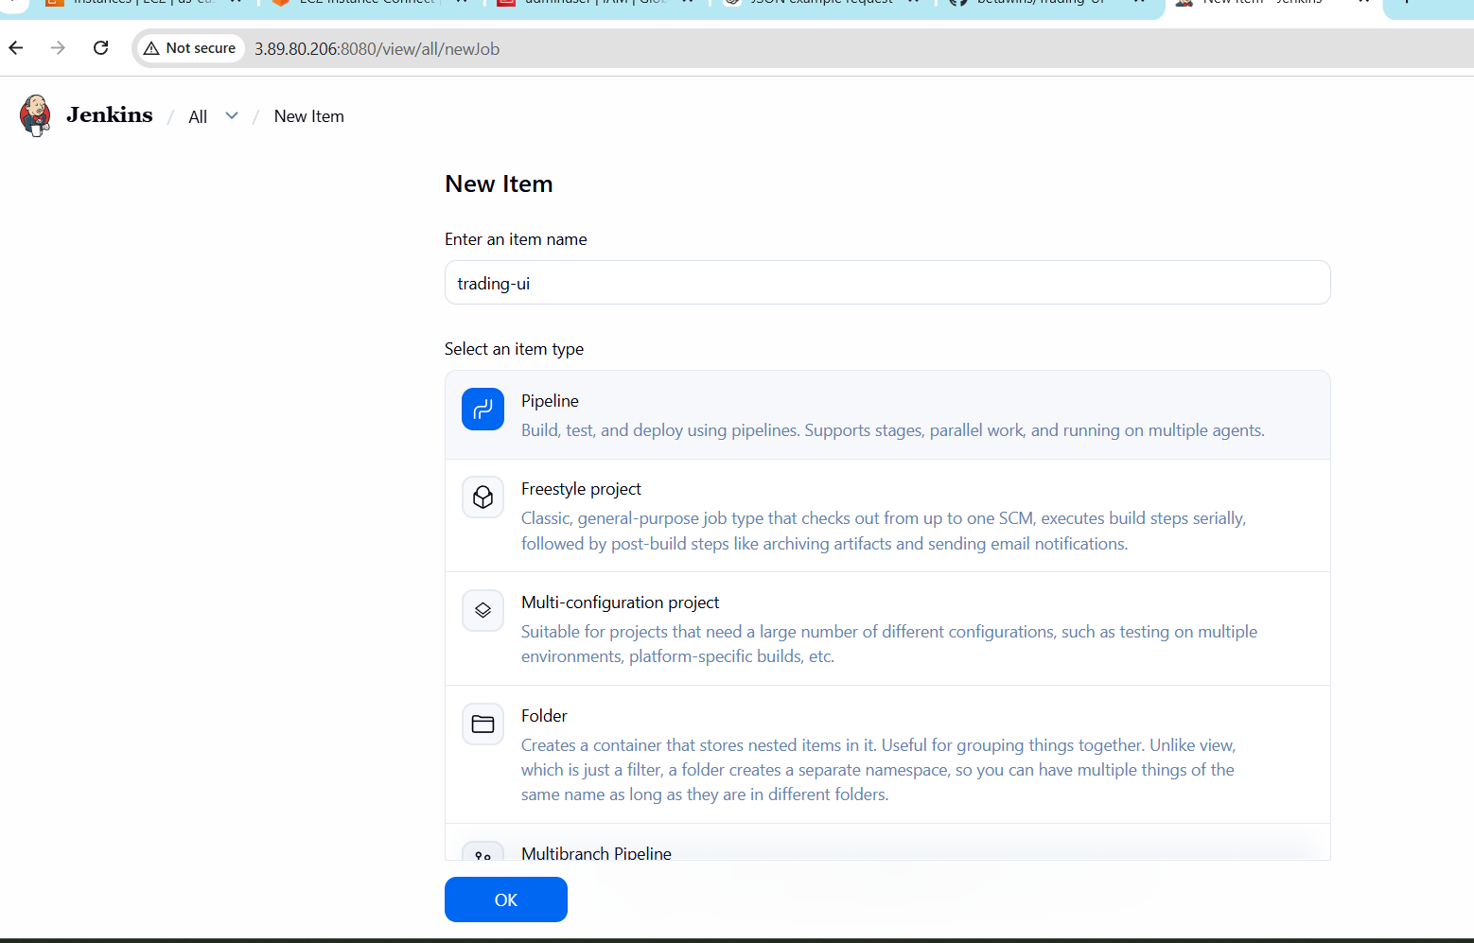

PipeLine
pipeline {
agent any

environment {
NODE_OPTIONS = "--openssl-legacy-provider"
CI = "false"
}

stages {

stage('Checkout') {
steps {
git 'https://github.com/betawins/Trading-UI.git'
}
}

stage('Install & Build') {
steps {
sh '''
npm install
npm run build
'''
}
}

stage('Deploy') {
steps {
sh '''
pm2 restart Trading-UI || pm2 start npm --name Trading-UI -- start
'''
}
}
}
}
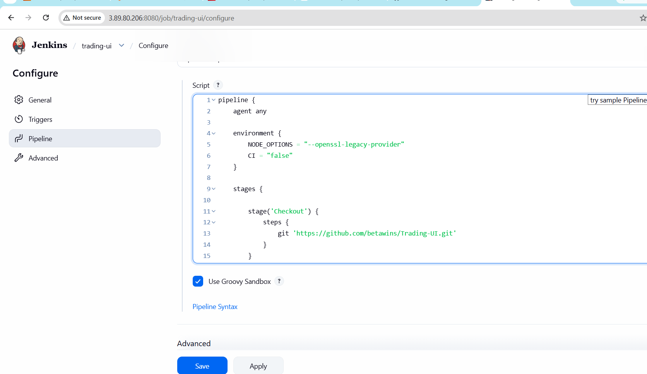
Lets Build the Job
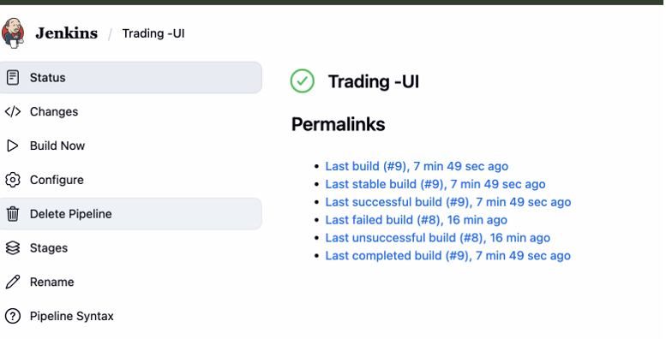
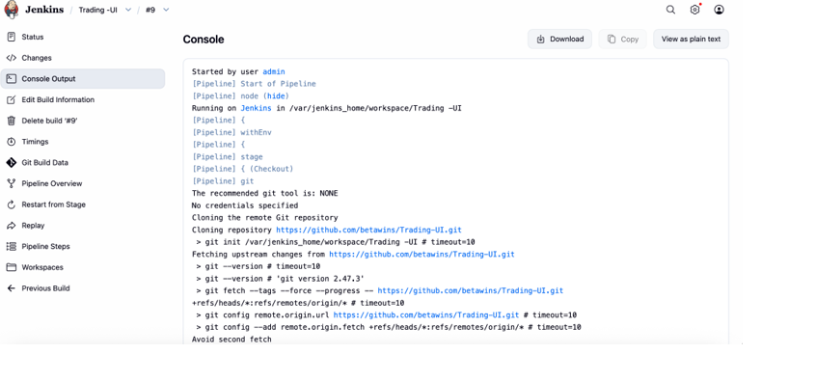
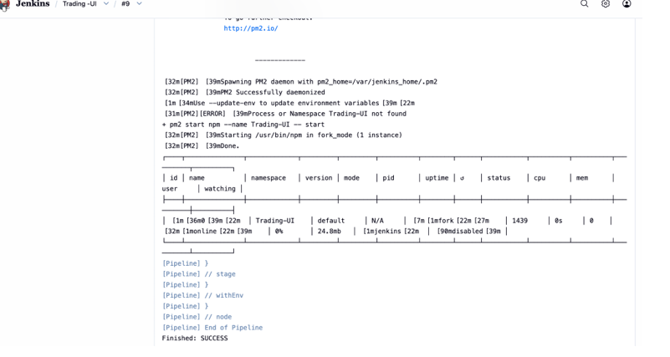

5). Explain 10 Maven commands.
Apache Maven is a popular Java build and dependency management tool. Its commands are run through the mvn CLI. Here are 10 important Maven commands and what they do:
1. mvn clean
Removes the target/ directory where compiled files and build outputs are stored. Useful to ensure a fresh build without old artifacts interfering.
2. mvn compile
Compiles the source code of your project (src/main/java). It does not run tests or package the application—only checks and compiles code.
3. mvn test
Runs unit tests defined in src/test/java using testing frameworks like JUnit. It compiles both main code and test code before execution.
4. mvn package
Takes compiled code and packages it into a distributable format like a JAR or WAR file inside the target/ directory.
5. mvn install
Installs the packaged artifact into your local Maven repository (~/.m2/repository) so it can be used as a dependency in other local projects.
6. mvn deploy
Copies the final package to a remote repository (like Nexus or Artifactory), making it available for other developers or CI/CD pipelines.
7. mvn validate
Checks whether the project structure and configuration are correct before the build starts. It ensures the project is ready to build.
8. mvn verify
Runs additional checks on the package after tests, such as integration tests or quality checks, to ensure the build is valid.
9. mvn dependency:tree
Displays the full dependency hierarchy of the project. Helpful for debugging version conflicts or unwanted transitive dependencies.
10. mvn archetype:generate
Creates a new Maven project from a template (archetype). It helps quickly scaffold standard project structures

