Docker-01
1. Setup a virtual machine using Ubuntu image.
➢ Create a new Ec2 instance and new name and AMI Ubuntu
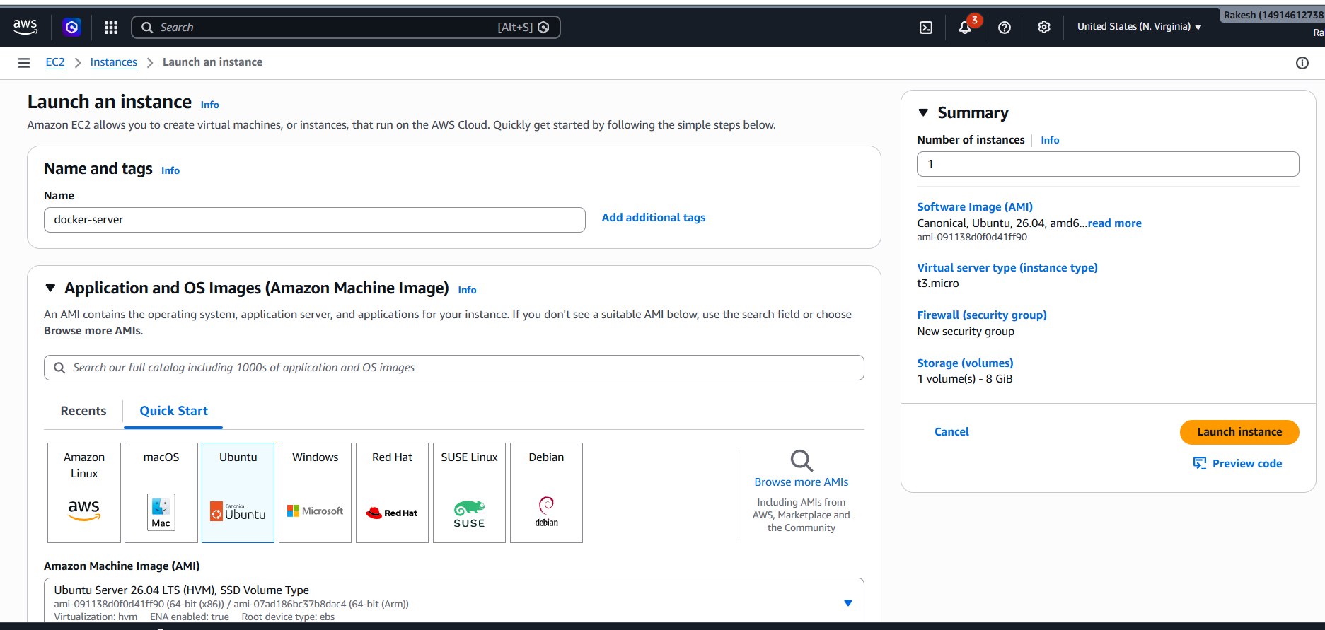
Select family size t3 small and keypair
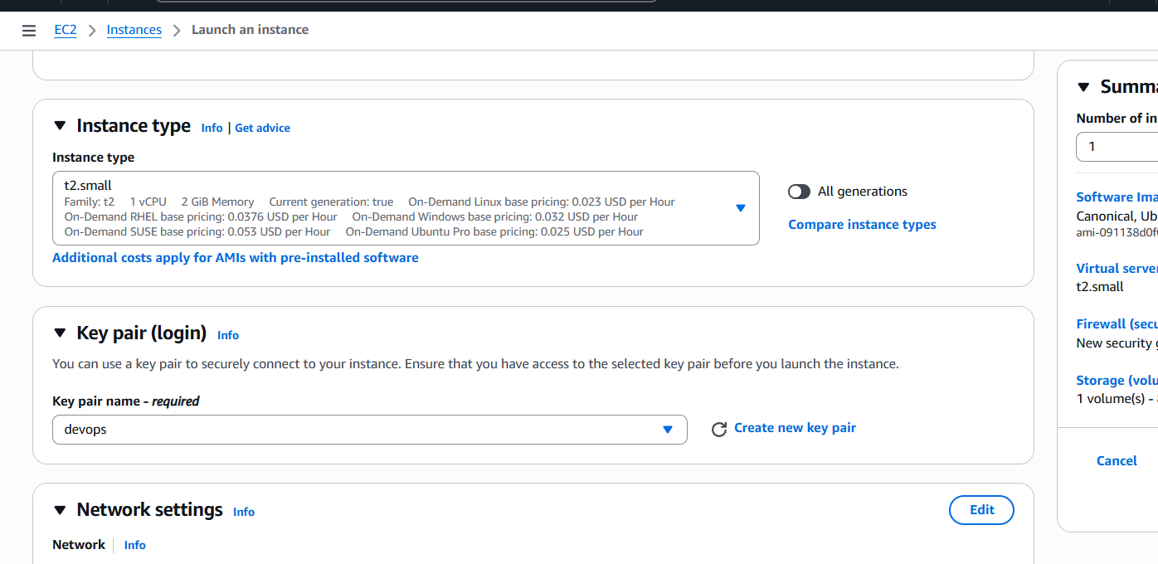
Select Networking settings
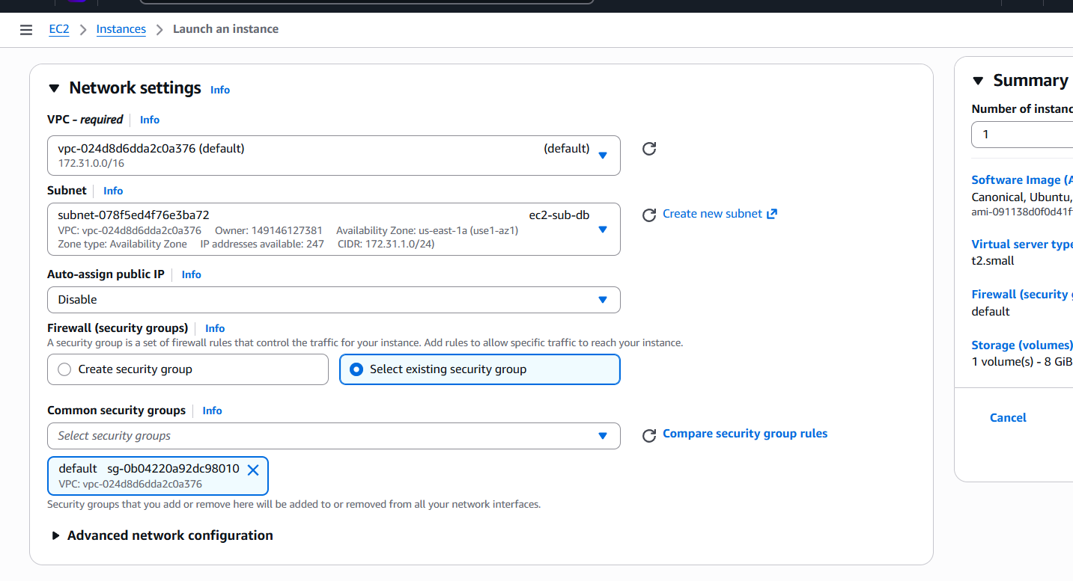
Select storage 20Gb
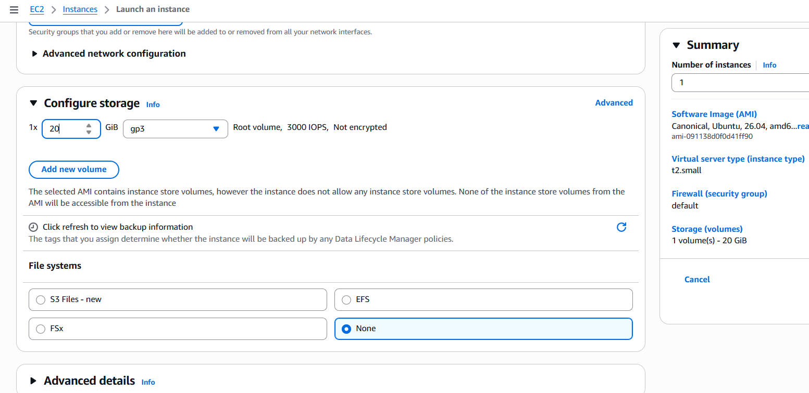
Now connect to instance
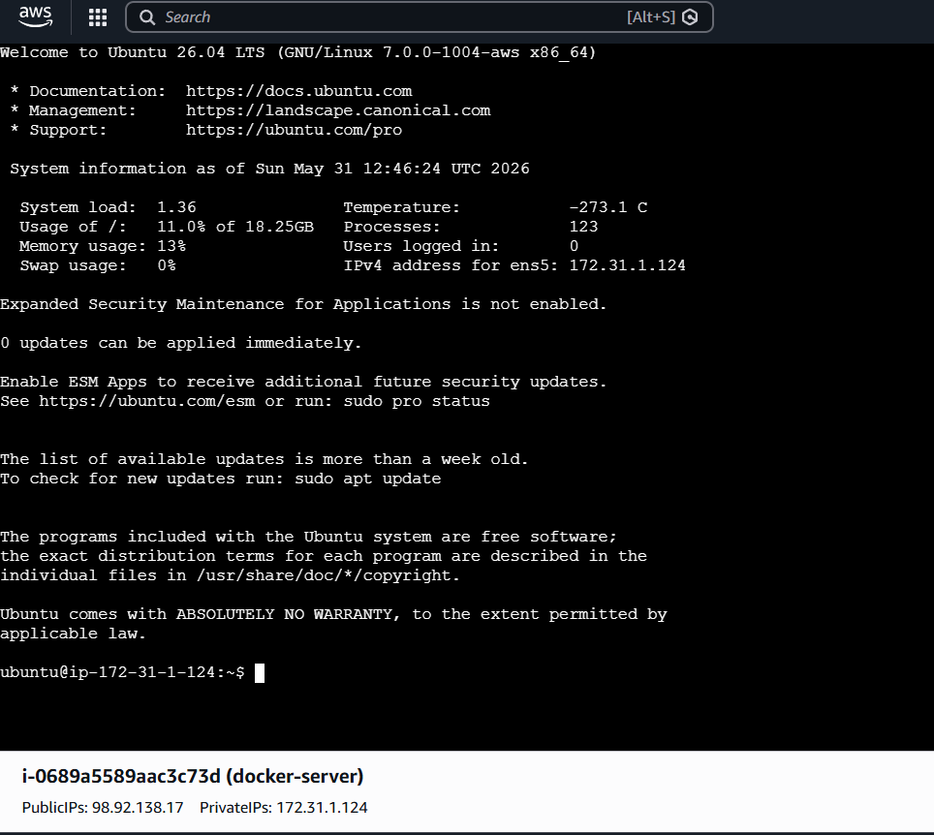

2) Install docker on ec2
Now after connect with ec2 connected and update
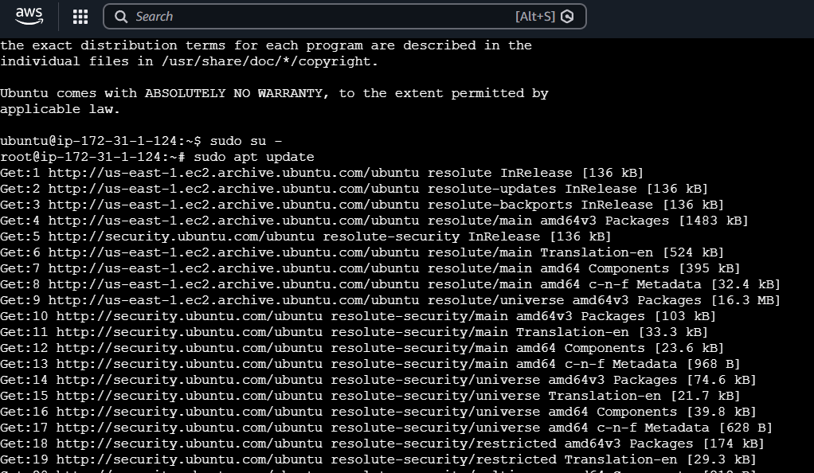
Now install docker with command : sudo apt install docker.io -y
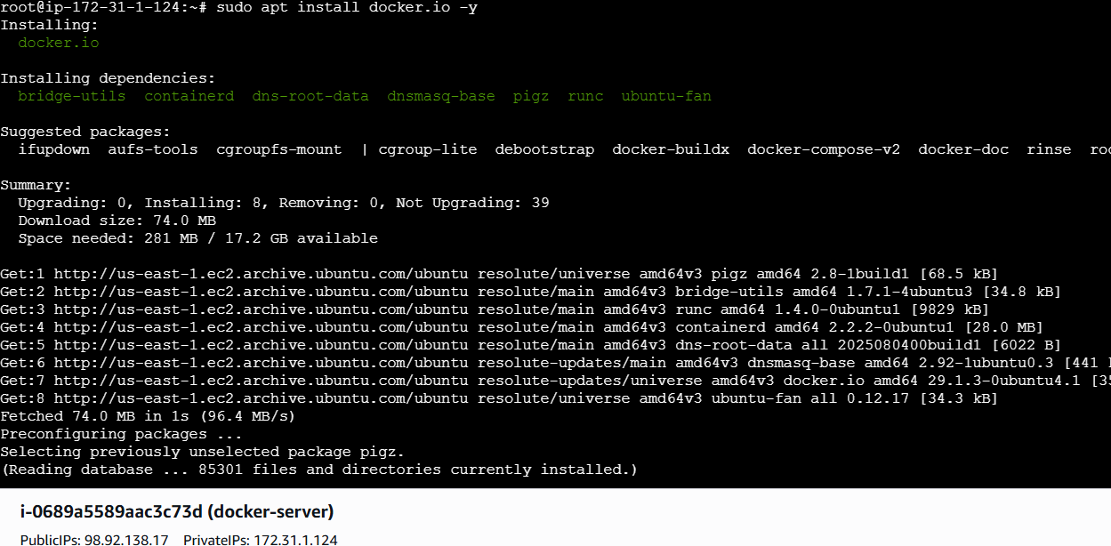
Enable and start Docker
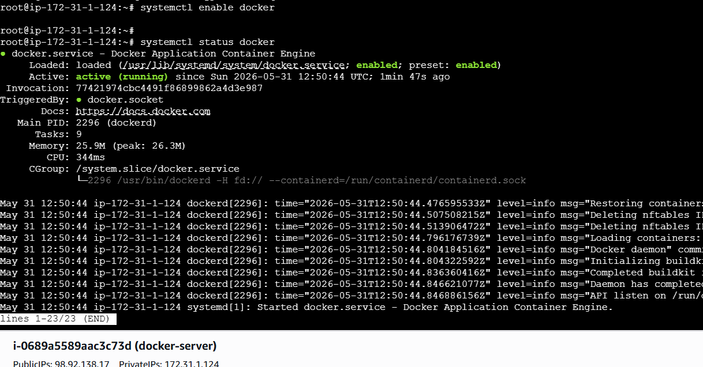
Check Docker version:
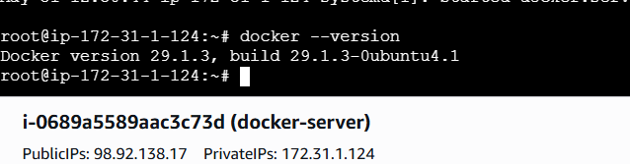
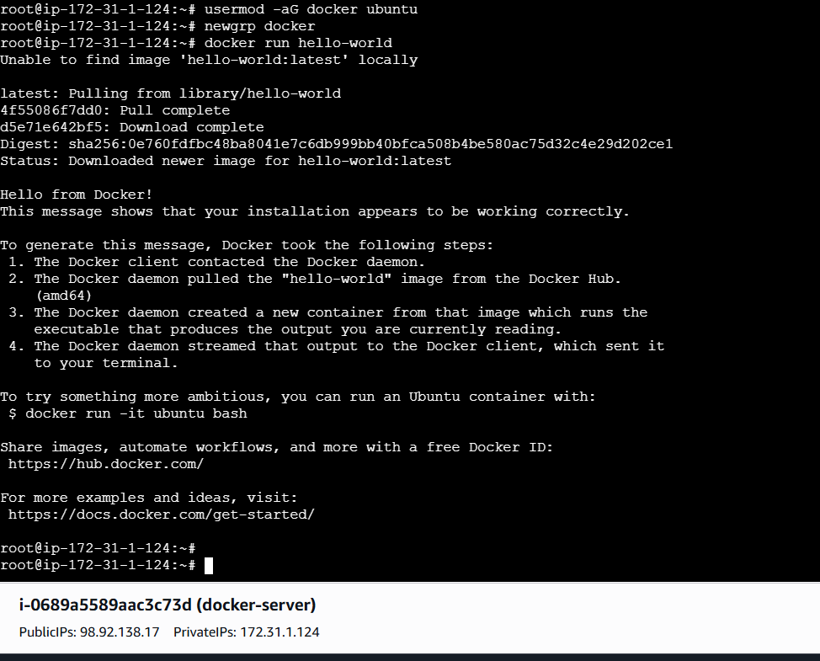

3. Pull 5 docker images. (nginx, Apache tomcat, ubuntu,
Jenkins, SonarQube)
Pull images one by one:
Nginx :docker pull nginx
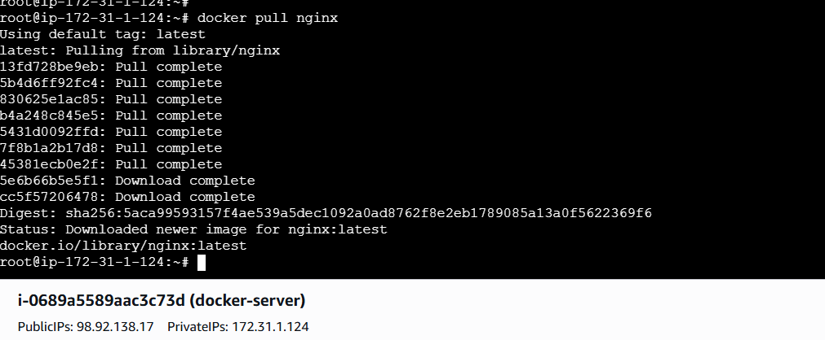
Apache Tomcat : docker pull tomcat

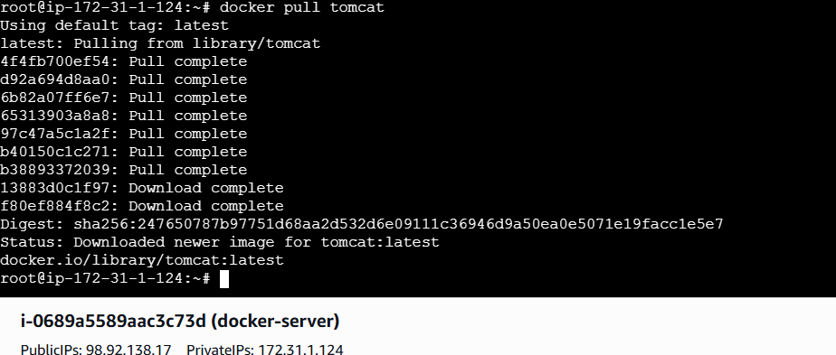
Ubuntu: docker pull ubuntu
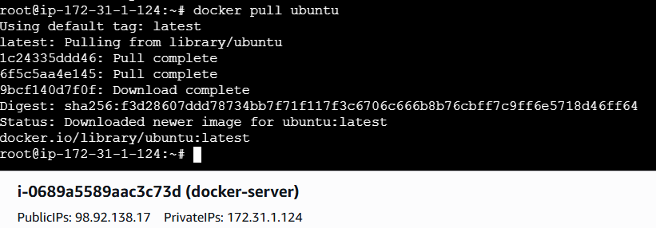
Jenkins: docker pull Jenkins
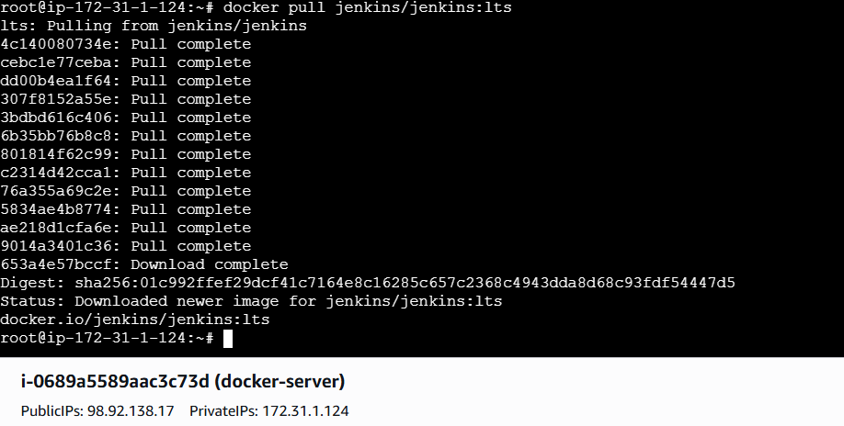
Sonarqube : docker pull sonarqube
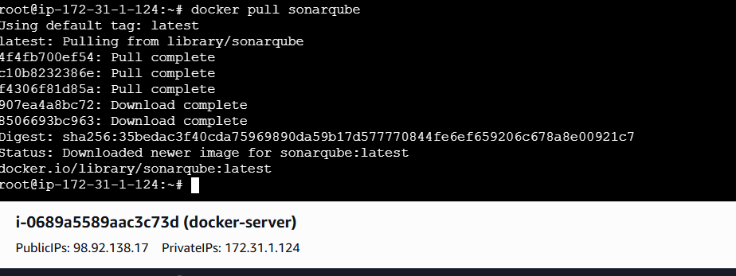
Verify images: docker images
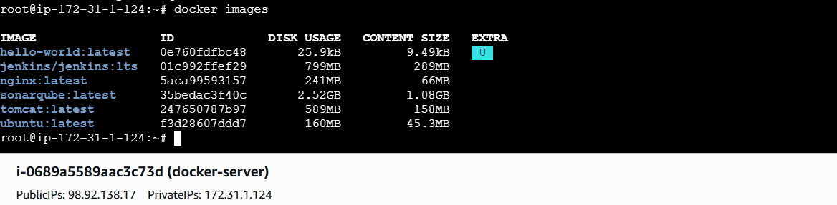
4. Run nginx container and expose on port 81.
Run container: docker run -d --name nginx-container -p 81:80 nginx
Check running containers: docker ps
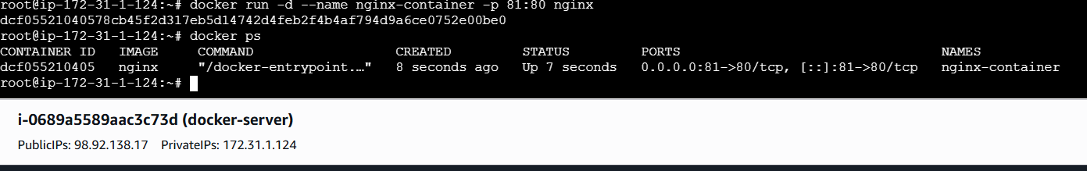

Access in browser:
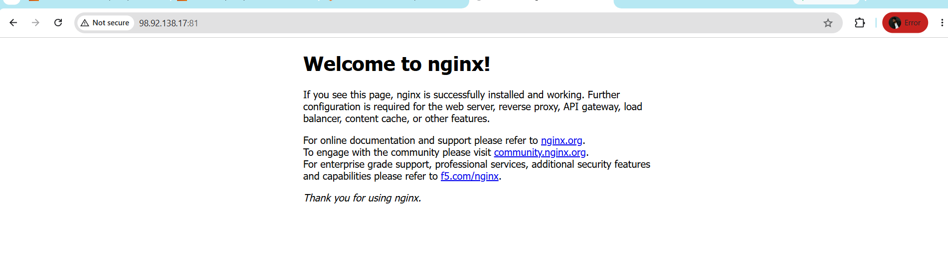
5. Delete the Apache tomcat image from local.
Delete Tomcat image: docker rmi tomcat
docker rm -f <container-id>
docker rmi tomcat
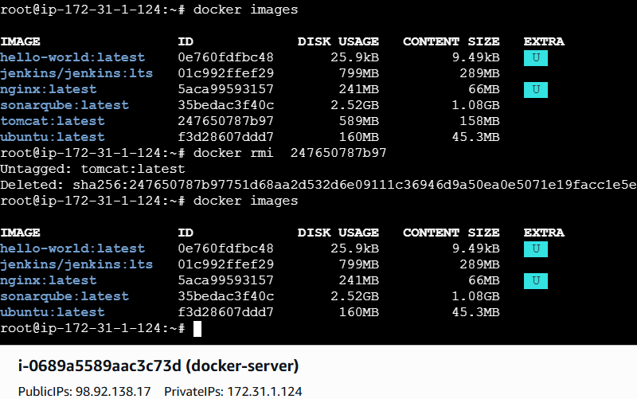

6. Inspect the Jenkins image, SonarQube image.
Inspect Jenkins Image : docker inspect jenkins/jenkins:lts
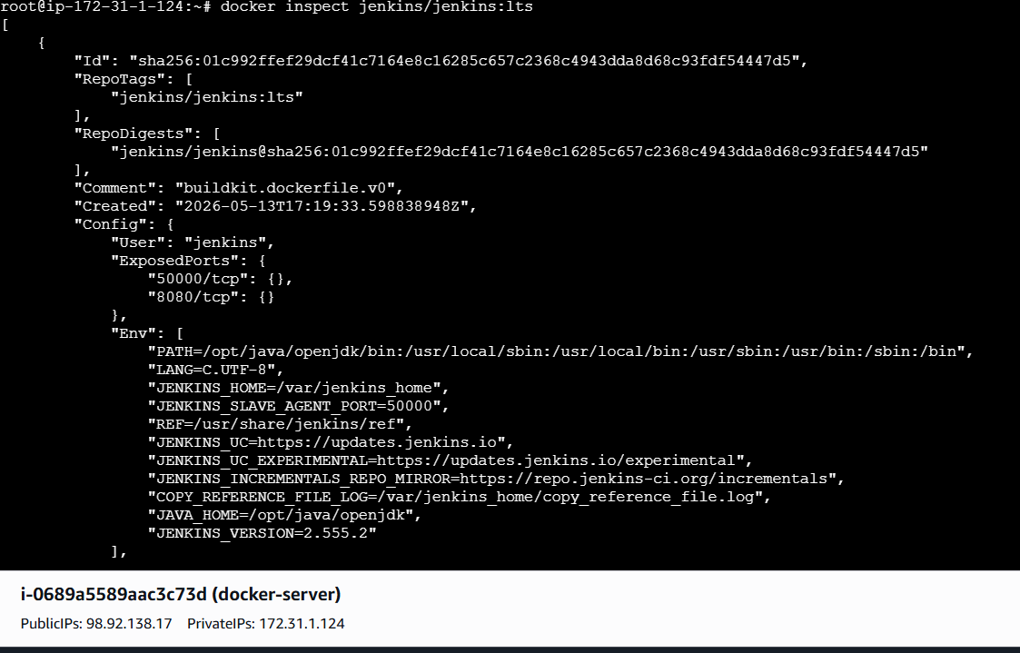
Inspect SonarQube Image : docker inspect sonarqube
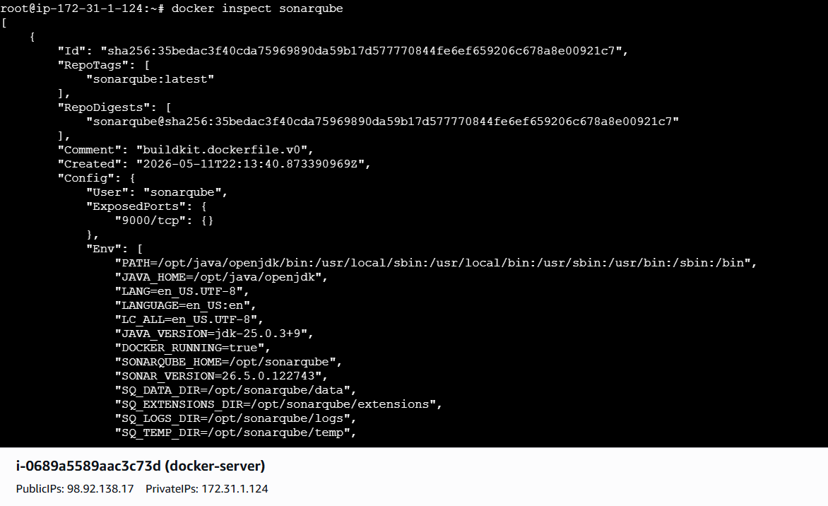
7. Run Jenkins container and run one sample job.
Run Jenkins Container
Check container
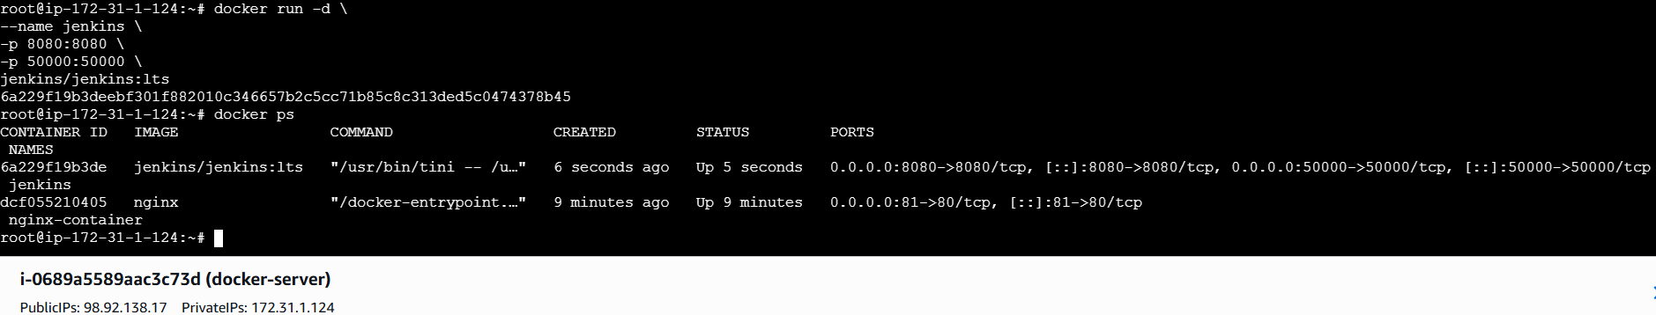
docker exec jenkins cat /var/jenkins_home/secrets/initialAdminPassword
Open Jenkins : ip:8080
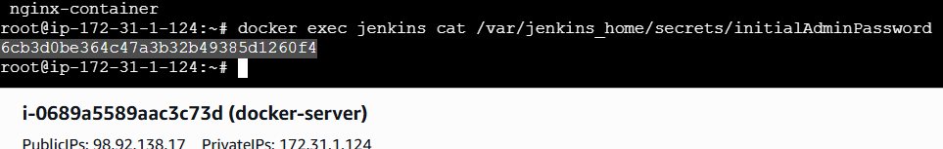
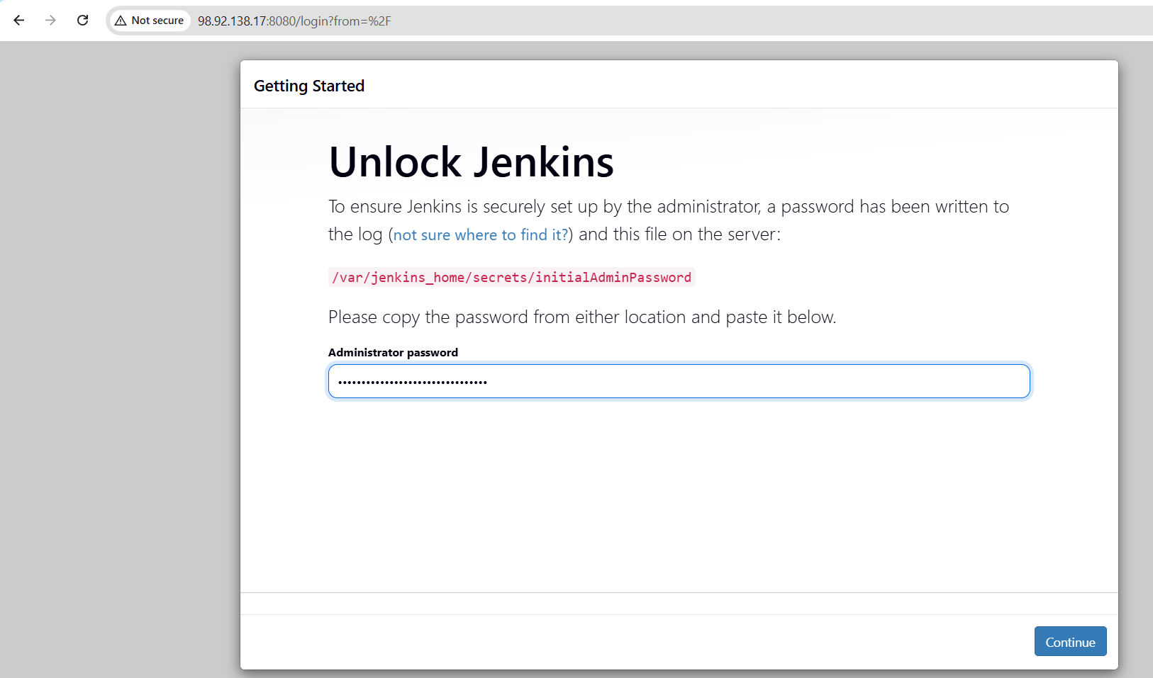
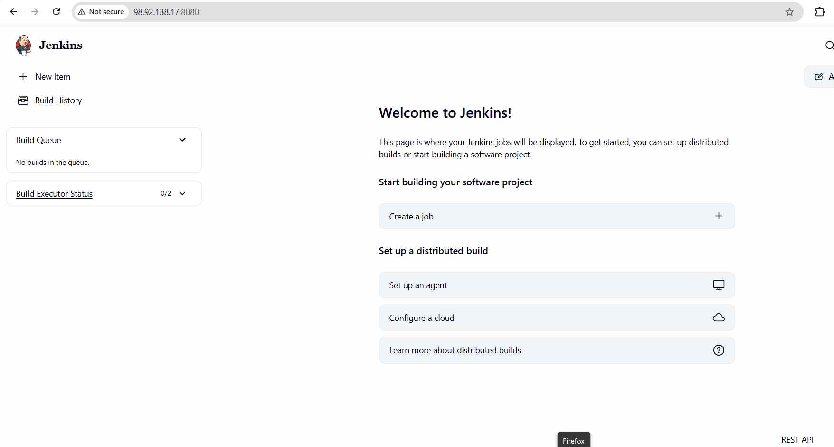

Create Sample Jenkins Job :
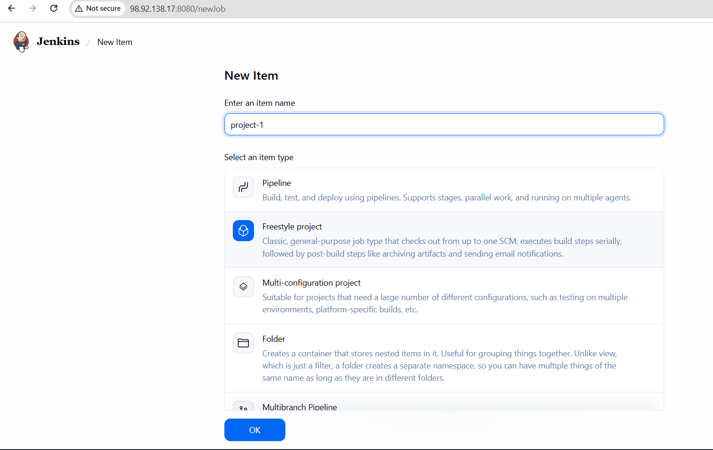

Build step:
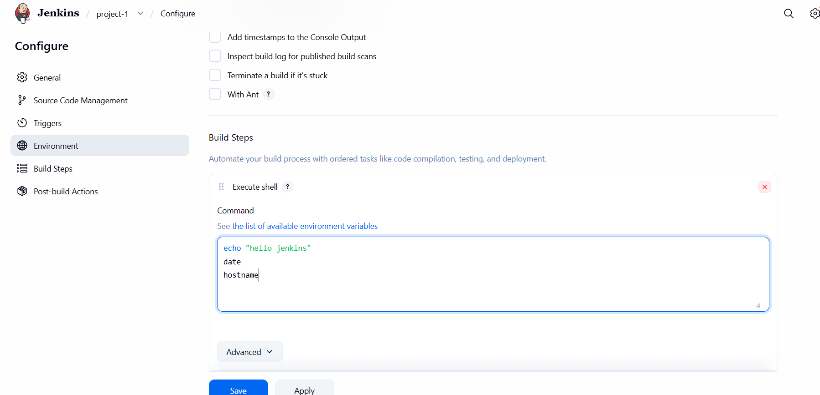

Save and bulid:
Check the console output:
